**Unity Manual Unity手册**

[Unity Manual](http://unity3d.com/support/documentation/Manual/index.html) Unity手册

Welcome to Unity. 欢迎

Unity is made to empower users to create the best interactive entertainment or multimedia experience that they can. This manual is designed to help you learn how to use Unity, from basic to advanced techniques. It can be read from start to finish or used as a reference.

Unity可以向用户提供创作最佳的互动娱乐和多媒体体验。本手册旨在帮助你了解如何从初级到高级使用Unity的技术。它可以从开始到结束阅读或作为参考使用。

The manual is divided into three sections. The first section, [User Guide](http://unity3d.com/support/documentation/Manual/User%20Guide.html), is an introduction to Unity's interface, asset workflow, and the basics of building a game. If you are new to Unity, it is recommended that you start learning by reading the [Unity Basics](http://unity3d.com/support/documentation/Manual/Unity%20Basics.html) subsection.

本手册分为三个部分。第一部分，用户手册，介绍Unity的界面、资产工作流，以及编译一个基本的游戏。如果你是新的Unity用户，建议你开始Unity 基本部分阅读学习。

The second section, [FAQ](http://unity3d.com/support/documentation/Manual/FAQ.html), is a collection of frequently asked questions about performing common tasks that require a few steps.

第二部分，常见问题解答，是一个关于公共任务需要几个步骤常见问题集合。

The third section, [Advanced](http://unity3d.com/support/documentation/Manual/Advanced.html), addresses topics such as game optimization, shaders, file sizes, and deployment.

第三部分，高级的， 编址主题，如游戏优化，阴影，文件大小以及部署。

When you're done reading, be sure to take a look at the [Reference Manual](http://unity3d.com/support/documentation/Components/index.html) and the [Scripting Reference](http://unity3d.com/support/documentation/ScriptReference/index.html) for further help while constructing your games.

当你读完，在你建作你的游戏过程中，一定要查看参考手册和脚本参考更深层的帮助。

If you find that any question you have is not answered in this manual please ask in the [forum](http://forum.unity3d.com). You'll definitely find your answer there.

如果你发现任何在手册中没有回到的问题，请在论坛询问。在那里你将明确的发现你的答案。

Happy reading, 愉快阅读

*The Unity team*  Unity程序组

**Table of Contents 目录**

* [User Guide](http://unity3d.com/support/documentation/Manual/User%20Guide.html) 用户手册
  + [Unity Basics](http://unity3d.com/support/documentation/Manual/Unity%20Basics.html) Unity基础
    - [Learning the Interface](http://unity3d.com/support/documentation/Manual/Learning%20the%20Interface.html) 学习界面
    - [Asset Workflow](http://unity3d.com/support/documentation/Manual/Asset%20Workflow.html) 资产工作流
    - [Creating Scenes](http://unity3d.com/support/documentation/Manual/Creating%20Scenes.html) 建立场景
    - [Publishing Builds](http://unity3d.com/support/documentation/Manual/Publishing%20Builds.html) 发布编译
    - [Tutorials](http://unity3d.com/support/documentation/Manual/Tutorials.html) 教程
    - [Activation](http://unity3d.com/support/documentation/Manual/Activation.html) 激活
  + [Building Scenes](http://unity3d.com/support/documentation/Manual/Building%20Scenes.html) 建立场景
    - [GameObjects](http://unity3d.com/support/documentation/Manual/GameObjects.html) 游戏物体（游戏对象）
    - [Using Components](http://unity3d.com/support/documentation/Manual/Using%20Components.html) 使用组件
    - [Prefabs](http://unity3d.com/support/documentation/Manual/Prefabs.html) 预制
    - [Lights](http://unity3d.com/support/documentation/Manual/Lights.html) 灯光
    - [Cameras](http://unity3d.com/support/documentation/Manual/Cameras.html) 摄像机
    - [Particle Systems](http://unity3d.com/support/documentation/Manual/Particle%20Systems.html) 粒子系统
    - [Terrains](http://unity3d.com/support/documentation/Manual/Terrains.html) 地形
  + [Working with Assets](http://unity3d.com/support/documentation/Manual/Working%20with%20Assets.html) 与资产合作
    - [Importing Assets](http://unity3d.com/support/documentation/Manual/Importing%20Assets.html) 引入资产
    - [Meshes](http://unity3d.com/support/documentation/Manual/Meshes.html) 网格
    - [Materials and Shaders](http://unity3d.com/support/documentation/Manual/Materials.html) 材料和阴影
    - [Texture 2D](http://unity3d.com/support/documentation/Manual/Textures.html) 2D纹理
    - [Movie Texture](http://unity3d.com/support/documentation/Manual/Video%20Files.html) 电影纹理
    - [Audio Files](http://unity3d.com/support/documentation/Manual/Audio%20Files.html) 音频文件
    - [Using Scripts](http://unity3d.com/support/documentation/Manual/Scripting.html) 使用脚本
    - [Asset Server Guide](http://unity3d.com/support/documentation/Manual/Asset%20Server.html) 资产服务器指南
    - [Behind the Scenes](http://unity3d.com/support/documentation/Manual/Behind%20the%20Scenes.html) 场景幕后
  + [Creating Gameplay](http://unity3d.com/support/documentation/Manual/Creating%20Gameplay.html) 创建游戏
    - [Instantiating Prefabs at runtime](http://unity3d.com/support/documentation/Manual/Instantiating%20Prefabs.html) 在运行时预制实例
    - [Input](http://unity3d.com/support/documentation/Manual/Input.html) 输入
    - [Transforms](http://unity3d.com/support/documentation/Manual/Transforms.html) 变换
    - [Physics](http://unity3d.com/support/documentation/Manual/Physics.html) 物理
    - [Character Animation](http://unity3d.com/support/documentation/Manual/Character-Animation.html) 角色动画
    - [Sound](http://unity3d.com/support/documentation/Manual/Sound.html) 声音
    - [Game Interface Elements](http://unity3d.com/support/documentation/Manual/Game%20Interface%20Elements.html) 游戏界面元素
    - [Networked Multiplayer](http://unity3d.com/support/documentation/Manual/Networked%20Multiplayer.html) 网络玩家
* [FAQ](http://unity3d.com/support/documentation/Manual/FAQ.html) 常见问题
  + [Game Code Questions](http://unity3d.com/support/documentation/Manual/Game%20Code%20How-to.html) 游戏代码问题
    - [How to make a simple first person walkthrough](http://unity3d.com/support/documentation/Manual/HOWTO-First%20Person%20Walkthrough.html)
    - 如何使用一个简单第一人称行走
  + [Graphics Questions](http://unity3d.com/support/documentation/Manual/Graphics%20how-tos.html) 图形问题
    - [How Do I Import Alpha Textures?](http://unity3d.com/support/documentation/Manual/HOWTO-alphamaps.html) 如何导入Alpha纹理
    - [How Do I Use Bump Maps?](http://unity3d.com/support/documentation/Manual/HOWTO-bumpmap.html) 如何使用凹凸地图
    - [How do I use Detail Textures?](http://unity3d.com/support/documentation/Manual/HOWTO-UseDetailTexture.html) 如何使用元件纹理
    - [How Do I Make a Cubemap Texture?](http://unity3d.com/support/documentation/Manual/HOWTO-MakeCubemap.html) 如何制作一个方块映射纹理
    - [How do I Make a Skybox?](http://unity3d.com/support/documentation/Manual/HOWTO-UseSkybox.html) 如何制作一个天空盒子
    - [How Do I make a Mesh Particle Emitter?](http://unity3d.com/support/documentation/Manual/HOWTO-MeshParticleEmitter.html) 如何制作一个网格粒子发射器
    - [How do I make a Splash Screen?](http://unity3d.com/support/documentation/Manual/HOWTO-SplashScreen.html) 如何制作一个溅射屏幕
    - [How do I make a Spot Light Cookie?](http://unity3d.com/support/documentation/Manual/HOWTO-LightCookie.html) 如何制作一个聚光灯Cookie
    - [How do I fix the rotation of an imported model?](http://unity3d.com/support/documentation/Manual/HOWTO-FixZAxisIsUp.html) [如何解决一个旋转输入模式？](http://translate.googleusercontent.com/translate_c?hl=zh-CN&tl=zh-CN&u=http://unity3d.com/support/documentation/Manual/HOWTO-FixZAxisIsUp.html&rurl=translate.google.com&usg=ALkJrhgUWZmidO3LN9OvLJPnMIDQ5pvpVA)
    - [How do I use Water?](http://unity3d.com/support/documentation/Manual/HOWTO-Water.html) 如何使用水
  + [How do I import objects from my 3D app?](http://unity3d.com/support/documentation/Manual/HOWTO-importObject.html) [如何导入我的三维应用程序对象？](http://translate.googleusercontent.com/translate_c?hl=zh-CN&tl=zh-CN&u=http://unity3d.com/support/documentation/Manual/HOWTO-importObject.html&rurl=translate.google.com&usg=ALkJrhglywd1hMPZlSmLPGM1M2wNqEIhMQ)
    - [Importing Objects From Maya](http://unity3d.com/support/documentation/Manual/HOWTO-ImportObjectMaya.html) 从Maya导入对象
    - [Importing Objects From Cinema 4D](http://unity3d.com/support/documentation/Manual/HOWTO-ImportObjectCinema4D.html) 从Cinema 4D导入对象
    - [Importing Objects From 3D Studio Max](http://unity3d.com/support/documentation/Manual/HOWTO-ImportObjectMax.html) 从3DMAX导入对象
    - [Importing Objects From Cheetah3D](http://unity3d.com/support/documentation/Manual/HOWTO-ImportObjectCheetah3D.html) 从Cheetah3D导入对象
    - [Importing Objects From Modo](http://unity3d.com/support/documentation/Manual/HOWTO-ImportObjectModo.html) 从Modo导入对象
    - [Importing Objects From Lightwave](http://unity3d.com/support/documentation/Manual/HOWTO-importObjectLightwave.html) 从Lightwave导入对象
    - [Importing Objects From Blender](http://unity3d.com/support/documentation/Manual/HOWTO-ImportObjectBlender.html) 从Blender导入对象
  + [Workflow Questions](http://unity3d.com/support/documentation/Manual/Workflow.html) 工作流问题
    - [How do I reuse assets between projects?](http://unity3d.com/support/documentation/Manual/HOWTO-exportpackage.html) 如何再利用项目间的资产
    - [How do I install or upgrade Standard Assets?](http://unity3d.com/support/documentation/Manual/HOWTO-InstallStandardAssets.html) 如何安装与更新标准资产
* [Advanced](http://unity3d.com/support/documentation/Manual/Advanced.html) 高级
  + [Loading Resources at Runtime](http://unity3d.com/support/documentation/Manual/Loading%20Resources%20at%20Runtime.html) 在运行时装入资源
  + [Modifying Source Assets Through Scripting](http://unity3d.com/support/documentation/Manual/Modifying%20Source%20Assets%20Through%20Scripting.html) 通过脚本修改源资产
  + [Update Order](http://unity3d.com/support/documentation/Manual/Update%20Order.html) 更新指令
  + [Shadows in Unity](http://unity3d.com/support/documentation/Manual/Shadows.html) Unity中阴影
    - [Directional Shadow Details](http://unity3d.com/support/documentation/Manual/DirectionalShadowDetails.html) 方向阴影元件
    - [Troubleshooting Shadows](http://unity3d.com/support/documentation/Manual/Shadow%20Troubleshooting.html) 阴影疑难解答
    - [Shadow Size Computation](http://unity3d.com/support/documentation/Manual/Shadow%20Size%20Details.html) 阴影大小计算
  + [Optimizing Graphics Performance](http://unity3d.com/support/documentation/Manual/Optimizing%20Graphics%20Performance.html) 优化图形性能
    - [Modeling Optimized Characters](http://unity3d.com/support/documentation/Manual/Modeling%20Optimized%20Characters.html) 模拟优化人物
    - [Optimizing for integrated graphics cards](http://unity3d.com/support/documentation/Manual/OptimizeForIntegratedCards.html) 优化集成图形卡
    - [Rendering Statistics Window](http://unity3d.com/support/documentation/Manual/RenderingStatistics.html) 渲染统计窗口
  + [Reducing File Size](http://unity3d.com/support/documentation/Manual/Reducing%20File%20size.html) 减小文件大小
  + [Web Player Streaming](http://unity3d.com/support/documentation/Manual/Web%20Player%20Streaming.html) WEB流播放器
  + [Web Player Deployment](http://unity3d.com/support/documentation/Manual/Web%20Player%20Deployment.html) WEB播放器配置
    - [HTML code to load Unity content](http://unity3d.com/support/documentation/Manual/HTML%20code%20to%20load%20Unity%20Web%20Player%20content.html) HTML代码装入Unity内容

[Customizing the Unity Web Player loading screen](http://unity3d.com/support/documentation/Manual/Customizing%20the%20Unity%20Web%20Player%20loading%20screen.html)自定义Unity WEB播放器装入屏幕

* + - [Customizing the Unity Web Player's Behavior](http://unity3d.com/support/documentation/Manual/WebPlayerBehaviorTags.html) 自定义Unity WEB播放器行为
    - [Unity Web Player and browser communication](http://unity3d.com/support/documentation/Manual/Unity%20Web%20Player%20and%20browser%20communication.html) Unity WEB播放器和浏览通信

[Detecting the Unity Web Player using browser scripting](http://unity3d.com/support/documentation/Manual/Detecting%20the%20Unity%20Web%20Player%20using%20browser%20scripting.html) 适应浏览脚本检测Unity WEB播放器

* + - [Publishing active content](http://unity3d.com/support/documentation/Manual/Publishing%20active%20content.html) 发布活动内容
  + [Web Player Debugging](http://unity3d.com/support/documentation/Manual/Web%20Player%20Debugging.html) WEB播放器调试
  + [Plugins - Pro only feature](http://unity3d.com/support/documentation/Manual/Plugins.html) 插件—专业唯一功能
  + [Build Player Pipeline](http://unity3d.com/support/documentation/Manual/Build%20Player%20Pipeline.html) 编译播放器管道
  + [Command line arguments](http://unity3d.com/support/documentation/Manual/Command%20Line%20Arguments.html) 命令行参数
  + [Shaders](http://unity3d.com/support/documentation/Manual/Shaders.html) 阴影
    - [Shaders: Getting started](http://unity3d.com/support/documentation/Manual/ShaderTut1.html) 阴影：开始
    - [Shaders: Vertex and Fragment Programs](http://unity3d.com/support/documentation/Manual/ShaderTut2.html) 阴影：顶点和片段程序
  + [Graphics Emulation](http://unity3d.com/support/documentation/Manual/GraphicsEmulation.html) 图形仿真
  + [Network Emulation](http://unity3d.com/support/documentation/Manual/NetworkEmulation.html) 网络仿真

**User Guide 用户手册**

[Unity Manual](http://unity3d.com/support/documentation/Manual/index.html) > [User Guide](http://unity3d.com/support/documentation/Manual/User%20Guide.html)

Unity手册->用户手册

This section of the Manual is focused on the features and functions of Unity. It focuses on the interface, core Unity building blocks, asset workflow, and basic gameplay creation. By the time you are done reading the user guide, you will have a solid understanding of how to use Unity to put together an interactive scene and publish it.

手册的这个部分集中了Unity的特点和功能。它集中了界面、核心Unity建造构件、资产工作流、和基本游戏可玩性创造物。当读完这个用户指南时，你将有一个固定的了解如何使用Unity把互动场景放在一起并发布它。

It is recommended that new users begin by reading the [Unity Basics](http://unity3d.com/support/documentation/Manual/Unity%20Basics.html) section.

强烈建议新用户从Unity基础部分开始阅读。

* + [Unity Basics](http://unity3d.com/support/documentation/Manual/Unity%20Basics.html) Unity基础
    - [Learning the Interface](http://unity3d.com/support/documentation/Manual/Learning%20the%20Interface.html) 学习界面
    - [Asset Workflow](http://unity3d.com/support/documentation/Manual/Asset%20Workflow.html) 资产工作流
    - [Creating Scenes](http://unity3d.com/support/documentation/Manual/Creating%20Scenes.html) 建立场景
    - [Publishing Builds](http://unity3d.com/support/documentation/Manual/Publishing%20Builds.html) 发布编译
    - [Tutorials](http://unity3d.com/support/documentation/Manual/Tutorials.html) 教程
    - [Activation](http://unity3d.com/support/documentation/Manual/Activation.html) 激活
  + [Building Scenes](http://unity3d.com/support/documentation/Manual/Building%20Scenes.html) 建立场景
    - [GameObjects](http://unity3d.com/support/documentation/Manual/GameObjects.html) 游戏物体（游戏对象）
    - [Using Components](http://unity3d.com/support/documentation/Manual/Using%20Components.html) 使用组件
    - [Prefabs](http://unity3d.com/support/documentation/Manual/Prefabs.html) 预制
    - [Lights](http://unity3d.com/support/documentation/Manual/Lights.html) 灯光
    - [Cameras](http://unity3d.com/support/documentation/Manual/Cameras.html) 摄像机
    - [Particle Systems](http://unity3d.com/support/documentation/Manual/Particle%20Systems.html) 粒子系统
    - [Terrains](http://unity3d.com/support/documentation/Manual/Terrains.html) 地形
  + [Working with Assets](http://unity3d.com/support/documentation/Manual/Working%20with%20Assets.html) 与资产合作
    - [Importing Assets](http://unity3d.com/support/documentation/Manual/Importing%20Assets.html) 引入资产
    - [Meshes](http://unity3d.com/support/documentation/Manual/Meshes.html) 网格
    - [Materials and Shaders](http://unity3d.com/support/documentation/Manual/Materials.html) 材料和阴影
    - [Texture 2D](http://unity3d.com/support/documentation/Manual/Textures.html) 2D纹理
    - [Movie Texture](http://unity3d.com/support/documentation/Manual/Video%20Files.html) 移动纹理
    - [Audio Files](http://unity3d.com/support/documentation/Manual/Audio%20Files.html) 音频文件
    - [Using Scripts](http://unity3d.com/support/documentation/Manual/Scripting.html) 使用脚本
    - [Asset Server Guide](http://unity3d.com/support/documentation/Manual/Asset%20Server.html) 资产服务器指南
    - [Behind the Scenes](http://unity3d.com/support/documentation/Manual/Behind%20the%20Scenes.html) 场景幕后
  + [Creating Gameplay](http://unity3d.com/support/documentation/Manual/Creating%20Gameplay.html) 创建游戏
    - [Instantiating Prefabs at runtime](http://unity3d.com/support/documentation/Manual/Instantiating%20Prefabs.html) 在运行时预制实例
    - [Input](http://unity3d.com/support/documentation/Manual/Input.html) 输入
    - [Transforms](http://unity3d.com/support/documentation/Manual/Transforms.html) 变换
    - [Physics](http://unity3d.com/support/documentation/Manual/Physics.html) 物理
    - [Character Animation](http://unity3d.com/support/documentation/Manual/Character-Animation.html) 人物动画
    - [Sound](http://unity3d.com/support/documentation/Manual/Sound.html) 声音
    - [Game Interface Elements](http://unity3d.com/support/documentation/Manual/Game%20Interface%20Elements.html) 游戏界面元素
    - [Networked Multiplayer](http://unity3d.com/support/documentation/Manual/Networked%20Multiplayer.html) 网络玩家

**Unity Basics Unity 基础**

This section is your key to getting started with Unity. It will explain the Unity interface, menu items, using assets, creating scenes, and publishing builds.

这部分是你开始使用Unity的关键。它将讲解Unity界面、菜单项、使用资产、创建场景以及发布编译。

When you are finished reading this section, you will understand how Unity works, how to use it effectively, and the steps to put a basic game together.

当你读完本节时，你将了解Unity如何工作、如何有效的使用Unity、以及安置基本游戏的步骤。

Learning the Interface 学习界面

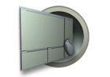

There is a lot to learn, so take the time you need to observe  
and understand the interface. We will walk through each  
interface element together.

有很多内容去学习，所以需要花时间观察和了解界面。我们将一起

走过每一个界面元素。

Asset Workflow 资产工作流



Here we'll explain the steps to use a single asset with Unity.  
These steps are general and are meant only as an overview  
for basic actions.

在这里我们将一步一步说明利用Unity使用一个简单的资产。 这些步骤对基本动作是常规的综述。

Creating Scenes 创建场景

Scenes contain the objects of your game. In each Scene, you  
will place your environments, obstacles, and decorations,  
essentially designing and building your game in pieces.

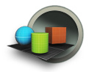

场景包括你游戏的物体（对象）。在每个场景里，你将放置你的环境、障碍物以及装饰品，主要设计和建设你的游戏作品。

Publishing Builds发布编译



At any time while you are creating your game, you might want to see  
how it looks when you build and run it outside of the editor as a  
standalone or web player. This section will explain how to access  
the Build Settings and how to create different builds of your games.

在你创建你的游戏过程中的任何时间，你可能想看当你在编辑器之外建立或运行它作为独立或web播放器中它的外观。这个部分将讲解如何访问编译设置和如何建立你的游戏不同版本编译。

Tutorials 教程



These tutorials will let you work with Unity while you follow along.  
They will give you hands-on experience with building real projects.  
For new users, it is recommended that you follow the GUI Essentials  
and Scripting Essentials tutorials first

这些教程将让你与Unity一起工作。它们将给你动手的实际项目建设经验。对于新用户，强烈建议你跟随第一个GUI经典教程和脚本经典教程。

**Learning the Interface 界面学习**

[Unity Manual](http://unity3d.com/support/documentation/Manual/index.html) > [User Guide](http://unity3d.com/support/documentation/Manual/User%20Guide.html) > [Unity Basics](http://unity3d.com/support/documentation/Manual/Unity%20Basics.html) > [Learning the Interface](http://unity3d.com/support/documentation/Manual/Learning%20the%20Interface.html)

Unity 手册->用户指南->Unity基础->界面学习

**First Launch 第一次启动**

Let's begin learning Unity. If you have not yet opened Unity, you can find it inside **Applications->Unity** on Mac, or **Start->Programs->Unity** on Windows. When it launches for the first time, the Unity **Editor** will appear:

让我们开始学习Unity。如果你还没有打开Unity，你可以发现它在Mac 操作系统上的**Applications->Unity**或在windows系统的 **Start->Programs->Unity。**当它第一次启动时，Unity编辑器将显示：

*By default, the "Islands" scene of the Tropical Paradise project will appear 默认，热带天堂群岛项目将出现*

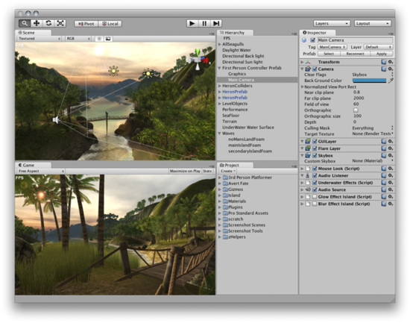

Take your time to look over the Unity Editor interface and familiarize yourself with it. The **Main Editor Window** is made up of several **Tabbed Windows**, called **Views**. There are several types of Views in Unity, each with a specific purpose.

花费你的一点时间查看Unity编辑器的界面并熟悉它。主编辑器窗口有几个选项卡式的窗口组成，称为视图。在Unity中有几个视图类型，每个带有特定的目的。

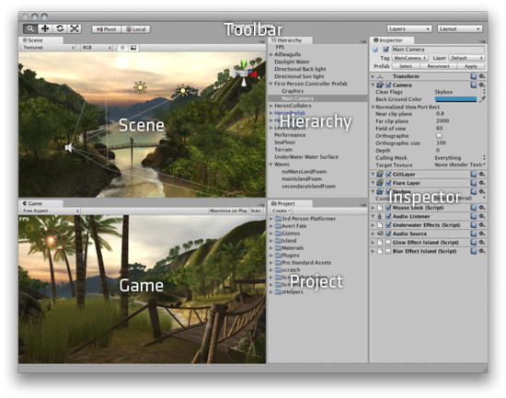

Now we'll look at each View in detail. 现在，我们详细查看每个视图。

**Project View 项目视图（个人认为翻译为项目面板比较合适）**

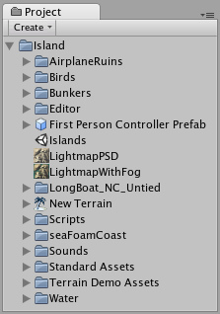

Every Unity project contains an **Assets** folder. The contents of this folder are presented in the Project View. This is where you store all the assets that make up your game, like scenes, [scripts](http://unity3d.com/support/documentation/Manual/Scripting.html), [3D models](http://unity3d.com/support/documentation/Manual/Meshes.html), [textures](http://unity3d.com/support/documentation/Manual/Textures.html), [audio files](http://unity3d.com/support/documentation/Manual/Audio%20Files.html), and [Prefabs](http://unity3d.com/support/documentation/Manual/Prefabs.html). If you right-click on any asset in the Project View, you can choose **Reveal in Finder** (**Reveal in Explorer on Windows**) to actually see the asset itself in your file system.

每一个Unity项目包含一个资产文件夹。这个文件夹的内容呈现在项目面板中（项目视图）。这是编辑你的游戏的所有资产存储的地方，像场景、脚本、3D模型、纹理、音频文件以及预制品。在项目面板（项目视图）里的任何资产上点击鼠标右键，你可以选择显示定位程序（文件）（在windows上定位资源管理器）在你的文件系统中去查看资产本身。

**Important Note:** You should **never** move project assets around using the OS since this will break any metadata associated with the asset. **Always** use the Project View to organize your assets.

重要提示：你应该从不使用系统到处移动项目资产，因为这将断开任何元数据与资产的关联。总是使用项目面板（项目视图）去组织你的资产。

To add assets to your project, you can drag any file from your OS into the Project View, or use **Assets->Import New Asset**. Your asset is now ready to be used in your game. For more information about working with assets, skip ahead to the [Asset Workflow](http://unity3d.com/support/documentation/Manual/Asset%20Workflow.html) section of the manual.

添加资产到你的项目，你可以从你的系统中拖拽任何文件到项目面板（项目视图）里，或使用**Assets->Import New Asset**.（**资产 ->引入新资产）**。你的资产现在准备好了被应用在你的游戏里。更多关于资产工作的信息，向前跳至本手册的资产工作流部分。

**Scenes** are also stored in the Project View. Think of these as individual levels. For example, the Islands Scene loads by default when Unity first launches. To create a new Scene, use **Command-N** (**Control-N** on Windows). To save the current Scene into the Project View, use **Command-S** (**Control-S** on Windows).

场景也存储在项目面板（视图）里。作为单独的层次思考这些。（独立层次思考这些）。例如，当Unity第一次启动时，默认岛屿场景装入。去建立一个新场景，使用**Command-N（在windows上使用 Ctrl +N）**,保存当前的场景到项目面板（视图），使用**Command-S（在windows上使用Ctrl+S）.**

Some game assets need to be created from within Unity. To do this, use the **Create** drop-down, or **right click->Create**.

有些游戏资产必须从Unity内部创建，要这样做，使用创建下拉框，或**right click->Create（鼠标右键->创建）**。

*The Create drop-down 创建下拉框*

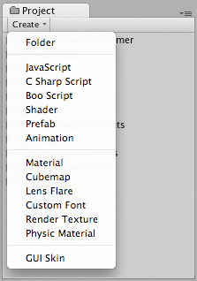

This will allow you to add scripts, Prefabs, or folders to keep your project organized. You can rename any asset/folder by pressing **Enter** on Mac, or **F2** on Windows, or with two paced clicks on the asset name. If you hold the **Alt** key while you expand or contract a directory, all subdirectories will also be expanded or contracted.

这将允许你去添加脚本、预制品、或文件夹去保持你的项目组织（去组织你的项目）。你可以在MAC上按回车键或在windows上按F2键重命名任意资产/文件夹，或在资产名称上两步单击（注意不是连续单击）。如果你按住ALT键在你展开或收缩一个目录，所有的自目录将也被展开或收缩。

**Hierarchy 层次**

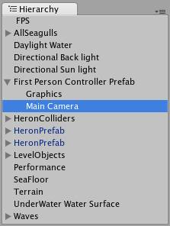

The **Hierarchy** contains every **GameObject** in the current Scene. Some of these are direct instances of asset files like 3D models, and others are instances of Prefabs -- custom objects that will make up much of your game. You can select and Parent objects in the Hierarchy. As objects are added and removed from the scene, they will appear and disappear from the Hierarchy as well.

在当前场景里，层次包含全部的游戏对象（翻译成游戏物体好？）。这些中的某些游戏对象是在资产文件里直接实例化，像3D模型、以及其它实例化的预制品—自定义对象将弥补许多你的游戏。在层次里，你可以选取和父类化对象。当对象被添加及从场景里移除时，它们将也从层次里显示及消失。

**Parenting 父类化**

Unity uses a concept called **Parenting**. To make any GameObject the child of another, drag the desired child onto the desired parent in the Hierarchy. A child will inherit the movement and rotation of its parent. You can now expand and contract the parent to see its children in the Hierarchy without affecting your game.

Unity使用一个称为父类化的概念。去处理任意游戏对象成为另一个游戏对象的子游戏对象，在层次里拖拽想要的子对象到想要的父对象。一个子对象将继承它的父对象的动作和旋转。在层次里你可以现在展开及收缩父对象去查看子对象，不会影响你的游戏。

*Two unparented objects 两个非父对象*

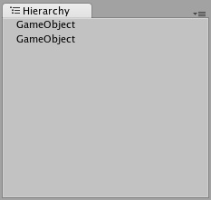

*One object parented to another 对另一个来讲的一个父对象*

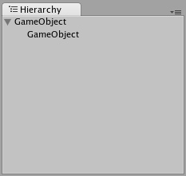

To learn more about Parenting, please review the Parenting section of the [Transform Component page](http://unity3d.com/support/documentation/Components/class-Transform.html#Parenting).

去学习更多的关于父类化，请详阅变换组件页的父类化章节。

**Toolbar 工具条**

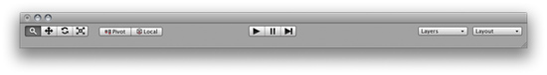

The Toolbar consists of five basic controls. Each relate to different parts of the Editor.

工具条由五个基本控制组成。每个涉及不同的编辑器部分。

Transform Tools -- used with the Scene View 变换工具—与场景视图一起使用



Transform Gizmo Toggles -- affect the Scene View display 变换辅助工具切换—影响



场景视图显示

Play/Pause/Step Buttons -- used with the Game View



播放/占停/步进 按钮—与游戏视图一起使用

[Layers](http://unity3d.com/support/documentation/Components/Layers.html) Drop-down -- controls which objects are displayed in Scene View



阶层下拉框—在场景视图里控制每个对象的显示

Layout Drop-down -- controls arrangement of all Views



版面布置下拉框—控制所有的视图排列

**Scene View 场景视图**

*The* ***Scene View 场景视图***

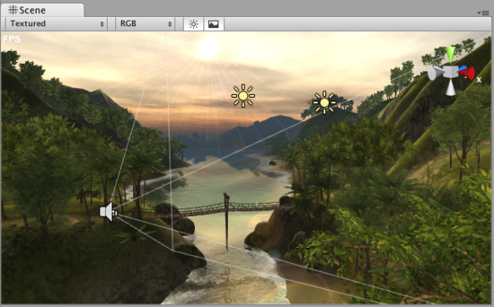

**Scene View** is your interactive sandbox. You will use the Scene View to select and position environments, the player, the camera, enemies, and all other **GameObjects**. Maneuvering and manipulating objects within the Scene View are some of the most important functions in Unity, so it's important to be able to do them quickly. Here's how:

场景视图是你的交互式的沙箱。你将使用场景视图去选取和定位工作环境，播放器、摄像机、敌人以及其它的所有游戏对象（物体）。在场景视图内部操纵和操作对象是Unity里一些十分重要的功能。重要的是能够快速的使用它们。方法是：

Hold the right mouse button to enter **Flythrough** mode. This turns your mouse and **WASD** keys into quick first-person view navigation.

按住鼠标右键进入飞越模式。这让你的鼠标和W A S D键进入快速第一人称视图导航。（在场景视图里）

Select any GameObject and press the **F** key. This will center the Scene View and pivot point on the selection.

选取任意游戏对象（物体）并按F键，依选取的坐标定为场景视图的中心。

Hold **Alt** and click-drag to orbit the camera around the current pivot point. If you're using three-button mouse you can also:

按住Alt键和点击拖拽以摄像机当前的区轴坐标旋转。如果你使用三键鼠标，你也可以：

Hold **Alt** and middle click-drag to drag the Scene View camera around.

按住Alt键与按住鼠标中间键围绕摄像机拖拽场景视图旋转。

Hold **Alt** and right click-drag to zoom the Scene View. This is the same as scrolling with your mouse wheel.

按住Alt键和鼠标邮件拖拽去伸缩场景视图。这与你的鼠标滚轮滚动相同。

If you are using a one-button mouse, you might find more use in the **Hand Tool** (shortcut: **Q**). 如果你使用一键鼠标，你可能发现更多的使用手形工具（快捷键：Q）



Hold **Alt** and click-drag to orbit. 按住Alt键及点击拖拽去旋转。



Hold **Command** (**Control** on Windows) and click-drag to zoom.按住**Command键**（windows log键在windows上）及点击拖拽去伸缩。（注：在windows上不如滚动鼠标滚轮）



**Positioning GameObjects 定位游戏对象**

When building your games, you'll place lots of different objects in your game world. To do this use the Transform Tools in the Toolbar to Translate, Rotate, and Scale individual GameObjects. Each has a corresponding Gizmo that appears around the selected GameObject in the Scene View. You can use the mouse and manipulate any Gizmo axis to alter the **Transform** Component of the GameObject, or you can type values directly into the number fields of the Transform Component in the Inspector.

当你构建你的游戏时，你将在你的游戏世界里放置许多不同的对象。要做到这一点，使用工具栏里的变换工具去平移、旋转以及缩放单个的游戏对象。每个关联的辅助工具（Gizmo）显示在已选取场景视图里的游戏对象周围。你可以使用鼠标及操作任意辅助工具的轴去改变游戏对象的变换组件，或你可以直接输入在检视器面板里的变换组件的数字字段的值。

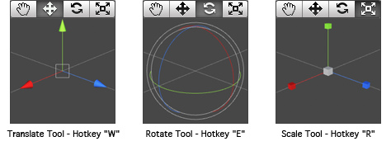

While dragging any Gizmo Axis, you can hold the **Command** key (**Control** on Windows) to snap to increments defined in the **Snap Settings**.

当拖动任意辅助工具（Gizmo）的轴时，你可以按住Command键（Ctrl在windows上）来捕捉到捕捉设置定义的增量。

You can change the Snap Settings from **Edit->Snap Settings...**

你可以从**Edit->Snap Settings...（编辑->捕捉设置…）**修改捕捉设置。

Click and drag in the center of the Gizmo to manipulate the object on all axes at once.

在辅助工具（Gizmo）的中心点击和拖动去立即操作对象的所有轴。

While dragging in the center, you can hold **Command** (**Control** on Windows) to snap the object to the intersection of any **Collider**. This makes precise positioning of objects incredibly fast.

当在拖动中心时，你可以按住Command键（Ctrl键在windows上）去捕捉对象与任何碰撞器的交集。这使准确定位对象不可思议的迅速。

If you have a three button mouse, you can click the middle button to adjust the last-adjusted axis (which turns yellow) without clicking directly on it.

如果你有一个三个按钮的鼠标，你可以点击鼠标的中间按钮去调整最后一次调整轴（那个变为黄颜色）而不用直接在上面点击它。

Be careful when using the scaling tool, as non-uniform scales (e.g. 1,2,1) can cause unusual scaling of child objects.

当使用缩放工具时要小心，因为不均匀的缩放比例（例如 1，2，1）可以引起子对象不寻常的缩放。

For more information on transforming GameObjects, please view the [Transform Component](http://unity3d.com/support/documentation/Components/class-Transform.html) page.

更多的信息在变换游戏对象（物体）章节，请查看变换组件页。

The **Gizmo Display Toggles** are used to define the location of any Transform Gizmo.

辅助工具（Gizmo）显示切换被用于定义任何变换的辅助工具位置

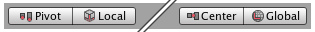

*Gizmo Display Toggles辅助工具显示切换*

* Position: 位置
  + **Center** will position the Gizmo at the center of the object's rendered bounds.
  + **中心**将定位辅助工具在对象渲染范围的中心。
  + **Pivot** will position the Gizmo at the actual pivot point of a Mesh.
  + **枢轴支点**将定位辅助工具在网格实际的枢轴点。
* Rotation: 旋转
  + **Local** will keep the Gizmo's rotation relative to the object's.
  + **本地**将保持相对于对象的辅助工具的旋转。
  + **Global** will clamp the Gizmo to world space orientation.
  + **全局**将钳住辅助工具对整个空间定位。

**Scene Gizmo 场景辅助工具**

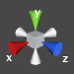

In the upper-right corner of the Scene View is the **Scene Gizmo**. This displays the Scene Camera's current orientation, and allows you to quickly modify the viewing angle. You can click on any of the arms to snap the Scene Camera to that direction and change it to **Isometric Mode**. While in Isometric Mode, you can right-click drag to orbit, and Alt-click drag to pan. To exit this mode, click the middle of the Scene Gizmo. You can also Shift-click the middle of the Scene Gizmo any time to toggle **Isometric Mode**.

在场景视图的右上角里是场景辅助工具。显示场景摄像机的当前方向，以及允许你做快速的变换视角。你可以在任意的（辅助工具）机械臂上点击去捕获场景摄像机方向以及更改它到等距模式。当在等距模式里时，你可以点击鼠标右键拖动做轨道旋转，以及按住Alt键拖动平移。（注意，在单键鼠标下与上述说明有差异，按Alt键加鼠标左键旋转；先按一下Q键，点击鼠标左键拖动平移）。退出等距模式，在场景辅助工具的中心点击一下即可。你可以在任意时间按Shift键在场景辅助工具中间点击去切换等距模式。

*Perspective mode. 透视模式*

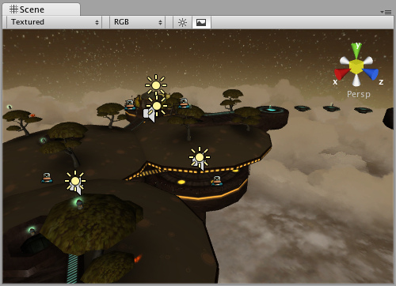

*Isometric mode. Objects do not get smaller with distance here! 等距模式，这里对象不获得小的距离。*

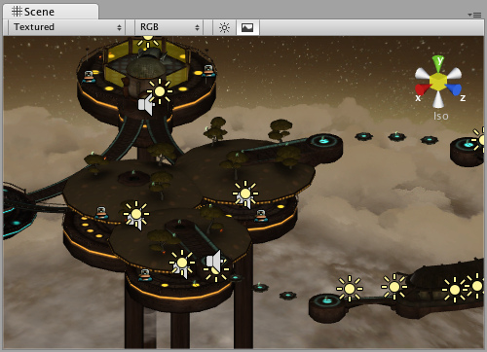

**Scene View Control Bar 场景视图控制条**



The first drop-down is for choosing a **Draw Mode**. You can choose to view the entire scene Textured, Wireframe, or Textured with Wireframe overlay. This has no effect on your game when it is published.

第一个下拉框是选择绘图模式。你可以选择去查看整个场景纹理，线框架，或纹理与线框架覆盖。在游戏发布时，它不对你的游戏有影响。

*Draw Mode drop-down 绘制模式下拉框*

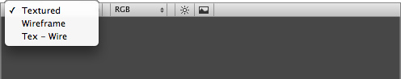

The next drop-down is for choosing one of four **Render Modes**. You can choose to fill the Scene View with **RGB**, **Alpha**, **Overdraw**, or **Mipmaps**. Again, this will not affect your published game.

下一个下拉框是四选一的渲染模式。你可以选择用RGB、阿尔法、重绘、或管道映射去填充场景视图。另外，这将不影响你发布的游戏。

*Render Mode drop-down 渲染模式下拉框*

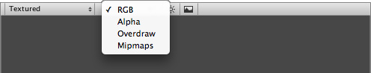

RGB is simply all the colors of your game rendered as normal.

RGB仅是作为正常渲染你游戏的所有颜色。

Alpha will render all alpha values for fine-tuning transparency or fullscreen effects that make use of alpha values.

阿尔法将渲染所有阿尔法值为了利用阿尔法值去精度调谐透明度或全屏效果。

Overdraw will indicate how much of the screen is consuming overdraw time.

重绘将表明屏幕被强制绘制多少次。

Mipmaps shows ideal texture sizes -- red means the particular texture is too large, and blue means the texture could be larger. Of course ideal texture sizes depend on the resolution the game will run.

管道映射显示理想纹理大小-红色意味着特殊的纹理太大，蓝色意味着这个纹理可能大一些。当然，理想纹理的大小依靠游戏运行时的分辨率。

Next, we have two buttons: **Scene Lighting** and **Game Overlay**.

接下来，我们有两个按钮：场景照明和游戏覆盖。



Enabling Scene Lighting will override the default Scene View lighting with whatever lights you have positioned to create your final light setup. Game Overlay will enable items like **Skyboxes** and **GUI Elements** in the Scene View.

启用场景照明将替代你拥有任何位置的灯在默认场景视图照明去创建你最最终的灯光设置。游戏覆盖将启用对象像天空盒以及**GUI元素**在场景视图里**。**

**Game View 游戏视图**

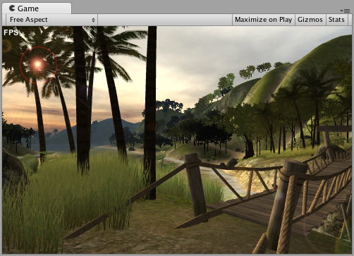

The **Game View** is rendered from the Camera(s) in your game. It is representative of your final, published game. You will need to use one or more **Cameras** to control what the player actually sees when they are playing your game. For more information about Cameras, please view the [Camera Component page](http://unity3d.com/support/documentation/Components/class-Camera.html).

游戏视图是从你的游戏的摄像机里呈现。它是你最终发布游戏的代表。你将需要使用一个或多个摄像机去控制当他们玩你的游戏的时候玩家实际看到的东西。更多关于摄像机的信息，请查看摄像机组件页。

**Play Mode 播放模式**



Use the buttons in the Toolbar to control the Editor **Play Mode** and see how your published game will play. While in Play mode, any changes you make are temporary, and will be reset when you exit Play mode. The Editor UI will darken to remind you of this.

使用工具条的按钮去控制编辑器播放模式以及查看你发布的游戏将如何扮演。当在播放模式里，你所作的任何改变都是临时的，在你退出播放模式时将被复位。编辑器用户将变暗来提醒你在播放模式下。

**Game View Control Bar 游戏视图控制条**



The first drop-down on the Game View control bar is the **Aspect Drop-down**. Here, you can force the aspect ratio of the Game View window to different values. It can be used to test how your game will look on monitors with different aspect ratios.

在游戏视图控制条上的第一下拉框是界面比例下拉框。这里，你可以强制游戏视图窗口的界面比率到不同的数值。它可以被用于测试在显示器宽度不同界面比率观看你的游戏如何。

Further to the right is the **Maximize on Play** toggle. While enabled, the Game View will maximize itself to 100% of your Editor Window for a nice full-screen preview when you enter Play mode.

往右一点的是播放时最大化开关。当启用时，游戏视图将最大化你的编辑器窗口到100%，为了更好的全屏预览当你进入播放模式时。

Continuing to the right is the **Gizmos** toggle. While enabled, all Gizmos that appear in Scene View will also be drawn in Game View. This includes Gizmos drawn using any of the **Gizmos** class functions.

继续右边的是辅助工具切换器。当启用时，所有在场景视图里显示的辅助工具将也在游戏视图里被绘制。这个绘制的辅助工具包括类函数利用辅助工具。

Finally we have the **Stats** button. This shows [Rendering Statistics](http://unity3d.com/support/documentation/Manual/RenderingStatistics.html) window that is very useful for [Optimizing Graphics Performance](http://unity3d.com/support/documentation/Manual/Optimizing%20Graphics%20Performance.html).

最后我们有一个统计按钮。这个展示渲染统计窗口为优化图形性能是非常有用的。

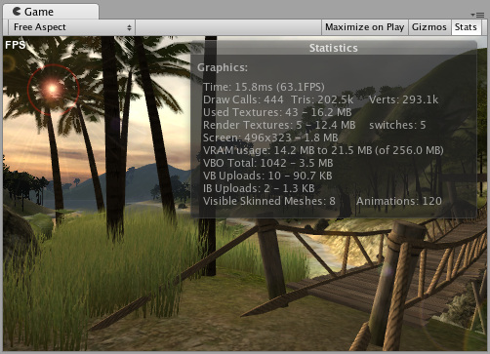

**Inspector 检视器面板（属性检视器?）**

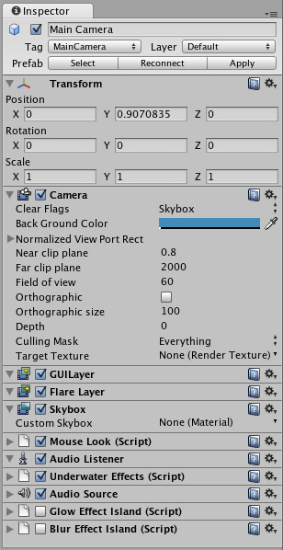

Games in Unity are made up of multiple **GameObjects** that contain meshes, scripts, sounds, or other graphical elements like **Lights**. The **Inspector** displays detailed information about your currently selected GameObject, including all attached **Components** and their properties. Here, you modify the functionality of GameObjects in your scene. You can read more about the [GameObject-Component relationship](http://unity3d.com/support/documentation/Manual/GameObjects.html#Relationship), as it is very important to understand.

在Unity里的游戏由多个的游戏对象（物体）组成，包括网格、脚本、声音或其它图形元素如光。检视器面板显示关于你当前选取的游戏对象的详细信息，包括所有的附加组件以及它们的属性。这里，你修改游戏对象（物体）的功能在你的场景里。你可以阅读更多关于游戏对象（物体）-组件关系，因为了解它是非常重要的。

Any property that is displayed in the Inspector can be directly modified. Even script variables can be changed without modifying the script itself. You can use the Inspector to change variables at runtime to experiment and find the magic gameplay for your game. In a script, if you define a public variable of an object type (like GameObject or Transform), you can drag and drop a GameObject or Prefab into the Inspector to make the assignment.

在检视器面板里显示的任何属性可以被直接修改。甚至脚本变量可以被修改而不通过脚本它自身。你可以使用检视器面板修改在运行时的变量去试验和为你的游戏发现魔法可玩性。在脚本里，如果你定义了一个对象类型的公共变量（如GameObject 或Transform），你可以拖动并放下一个游戏对象或预制品到检视器面板构成一个赋值分配。

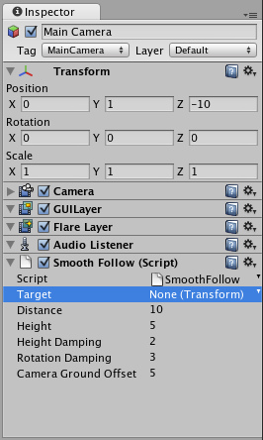

Click the question mark beside any Component name in the Inspector to load its Component Reference page. Please view the [Component Reference](http://unity3d.com/support/documentation/Components/Components.html) for a complete and detailed guide to all of Unity's Components.

在检视器面板里点击任何组件名称旁边的问号去装载该组件引用页。请查看Unity为所有组件提供的完整和详细的组件指南。

*Add Components from the* ***Component*** *menu从组件菜单添加组件*

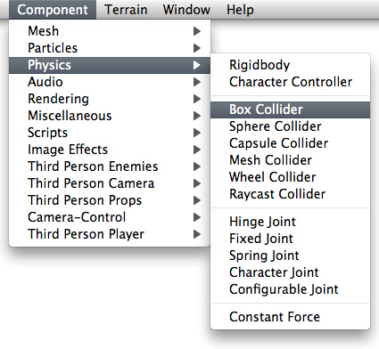

You can click the tiny gear icon (or right-click the Component name) to bring up a context menu for the specific Component.

你可以按一下小齿轮图标（或右键单击组件名称）去提出一个指定组件上下文菜单。

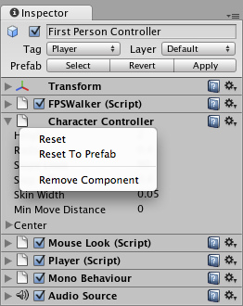

The Inspector will also show any Import Settings for a selected asset file.

检视器面板将为选择的资产文件显示所有的引入设置。（注意：这个可能有差异，使用的2.5 要在项目面板的文件点击一下，才可出现）

*Click* ***Apply*** *to reimport your asset. 点击应用重新引入你的资产*

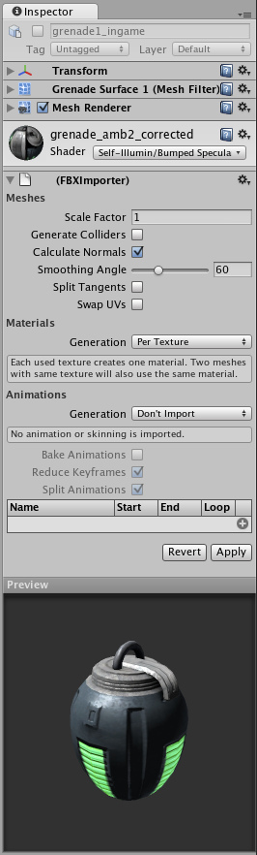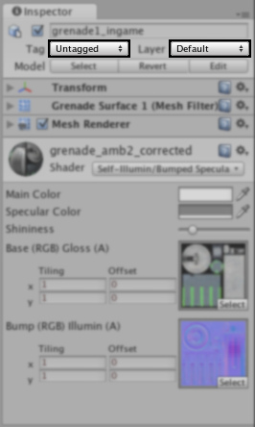

Use the **Layer** drop-down to assign a rendering Layer to the GameObject. Use the **Tag** drop-down to assign a Tag to this GameObject.

对游戏对象使用阶层下来框来指定一个渲染阶层。对这个游戏对象使用标签下来框来指定一个标签。

**Prefabs 预制品**

If you have a Prefab selected, some additional buttons will be available in the Inspector. For more information about Prefabs, please view the [Prefab manual page](http://unity3d.com/support/documentation/Manual/Prefabs.html).

如何你有一个选取的与制品，一些额外的按钮将在检视器面板里可用。更多关于预制品的信息，请查看预制品指南页。

**Status Bar 状态栏**

The **Status Bar** at the bottom of the Editor serves multiple purposes. It will display any compile errors or Debug log output. If there is a problem with your game, keeping an eye on the Status Bar is the best way to find the error. You can double-click on the Status Bar to bring up the Console window, which has all script or run-time errors visible.

在编辑器底部的状态栏提供多个用途。它将显示任何编译错误或调试日志输出。如果你的游戏有一个问题，密切注视状态栏是最好的方法找到错误。你可以在状态栏上双击去弹出控制台窗口，它所有的脚本或运行错误可见。

**Console 控制台**

Double-clicking an error in the Status Bar or choosing **Window->Console** will bring up the **Console**.

在状态栏里双击一个错误，或选择**Window->Console（窗口->控制台）**将弹出控制台。

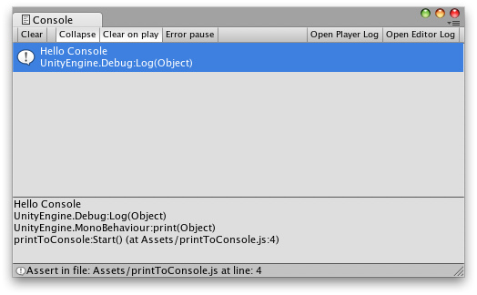

The Console shows messages, warnings, errors, or debug output from your game. You can define your own messages to be sent to the Console using either **Debug.Log()** or **Debug.Error()**. You can double-click any message to be taken to the script that caused the message. You also have a number of options on the Console Toolbar.

控制台从你的游戏里展示消息、警告、错误、或调试输出。你可以使用**Debug.Log()与** **Debug.Error()的**任何一个定义你自己的消息发送到控制台。你可以双击任意消息到达那个引起消息的脚本。你也有一个在控制台工具栏的选项。



Most of the options in the Console Toolbar are self-explanatory, but one thing should be made clear. When **Error Pause** is enabled, **Debug.Error()** will cause the pause to occur but **Debug.Log()** will not.

大多数的控制台工具栏选项是自说明的（注意：这是一个新的编程用语，指的是通过名称就可以知道其含义），但有一点必须明确。当错误占停是启用的，**Debug.Error()**将引起占停出现，而**Debug.Log()**将不会**。**

**Customizing Your Workspace 定制你工作空间**

You can customize your **Layout** of Views by click-dragging the Tab of any View to one of several locations. Dropping a Tab in the **Tab Area** of an existing window will add the Tab beside any existing Tabs. Alternatively, dropping a Tab in any **Dock Zone** will add the View in a new window.

你可以定制你的视图布局，通过点击拖动任意视图的选项卡到几个地点之一。拖动一个现有窗口的选项卡区域里的选项卡将添加在任何以存在选项卡的旁边。拖动一个在任意停放区域的选项卡将添加视图，在一个新窗口里。

*Views can be docked to the sides or bottom of any existing window*



*视图可以停放在一侧或任意存在窗口里的按钮*

Tabs can also be detached from the Main Editor Window and arranged into their own floating Editor Windows. Floating Windows can contain arrangements of Views and Tabs just like the Main Editor Window.

选项卡也可以从主编辑窗口里分离并排列到它们自己浮动器窗口里。浮动窗口可以包含视图的排列和选项卡就像主编辑器窗口。

*Floating Editor Windows are the same as the Main Editor Window, except there is no Toolbar*

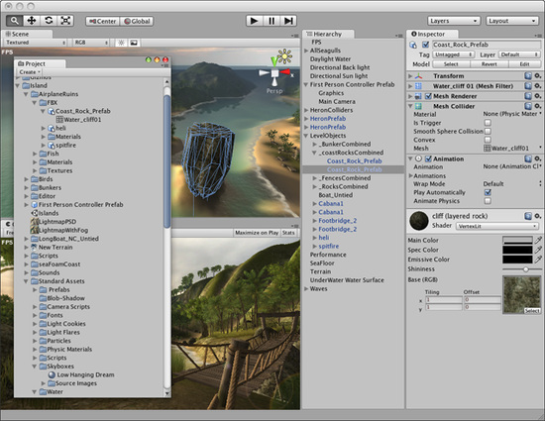

*浮动编辑器窗口是和主编器窗口一模一样的。除非它没有工具栏。*

When you've created a Layout of Editor Windows, you can Save the layout and restore it any time. You do this by expanding the Layout drop-down (found on the Toolbar) and choosing **Save Layout...**. Name your new layout and save it, then restore it by simply choosing it from the Layout drop-down.

当你已经创建了一个编辑器窗口布局，你任何时间可以保存布局和恢复它。你通过扩展布局下拉框（在工具栏上发现）和选择保存布局…做这个。命名你的新布局并保存它，然后通过从布局下拉框里简单的选择它恢复它。

*A completely custom Layout 一个完成的定制布局*

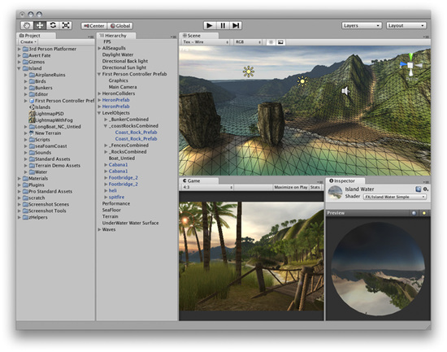

At any time, you can right-click the tab of any view to view additional options like Maximize or add a new tab to the same window.

在任意时间，你可以右键点击任意视图的选项卡去查看附件选项像最大化或增加新的选项卡到同一窗口。（注意：也可以点击图标“”做同样的功能）

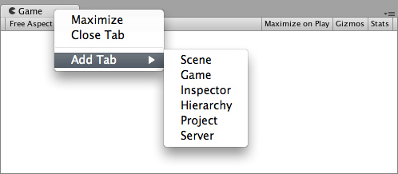

**Asset Workflow 资产工作流**

[Unity Manual](http://unity3d.com/support/documentation/Manual/index.html) > [User Guide](http://unity3d.com/support/documentation/Manual/User%20Guide.html) > [Unity Basics](http://unity3d.com/support/documentation/Manual/Unity%20Basics.html) > [Asset Workflow](http://unity3d.com/support/documentation/Manual/Asset%20Workflow.html)

Unity 手册->用户指南->Unity 基础->资产工作流

Here we'll explain the steps to use a single asset with Unity. These steps are general and are meant only as an overview for basic actions. For the example, we'll talk about using a 3D mesh.

这里我们将按步骤讲解用Unity去使用一个简单的资产。这些步骤是常用的并意味着仅作为基础功能的概述。对于这个例子，我们将讨论使用一个3D网格。

**Create Rough Asset 创建粗糙资产**

Use any supported 3D modeling package to create a rough version of your asset. Our example will use Maya. Work with the asset until you are ready to save.

使用任何支持3D建模程序包来创建一个你的资产的粗糙版本。我们的示例将使用Maya。与资产一起工作直到你准备保存它。

**Import 引入**

When you save your asset initially, you should save it normally to the **Assets** folder in your Project folder. When you open the Unity project, the asset will be detected and imported into the project. When you look in the **Project View**, you'll see the asset located there, right where you saved it.

当最初保存你的资产时，通常你应该保存它到你的项目文件夹的资产文件夹里。当你打开Unity项目的时候，资产将被确认并引入到项目里。当你在项目视图（面板）里查看时，你将看到资产已经在那里，正是你保存的地方。

**Import Settings 引入设置**

If you select the asset in the **Project View** the import settings for this asset will appear in the **Inspector**. The options that are displayed will change based on the type of asset that is selected.

如果你在项目视图里选取资产，这个资产引入的设置将在检视器面板（属性）里显示。显示的选项将基于那个选择的资产类型修改。

**Adding Asset to the Scene 添加资产到场景**

Simply click and drag the mesh from the Project View to the **Hierarchy** or **Scene View** to add it to the Scene. When you drag a mesh to the scene, you are creating a **GameObject** that has a **Mesh Renderer** **Component**. If you are working with a texture or a sound file, you will have to add it to a GameObject that already exists in the Scene or Project.

从项目视图（面板）单点和拖动网格到层次（面板）或场景视图去添加它到场景。当你拖动一个网格到场景时，你正在建立一个拥有一个网格渲染的游戏对象。如果你正在使用一个纹理或一个声音文件工作，你必须增加它到一个场景或项目已经存在的游戏对象。

**Putting Different Assets Together 组合不同的资产**

Here is a brief description of the relationships between the most common assets

这里是最常见的资产间关系的简要说明。

* A Texture is applied to a **Material**
* 纹理应用于一个材料
* A Material is applied to a GameObject (with a Mesh Renderer Component)
* 材料应用于一个游戏对象（有一个网格渲染的组件）
* An **Animation** is applied to a GameObject (with an Animation Component)
* 动画应用于一个游戏对象（有一个动画组件）
* A sound file is applied to a GameObject (with an **Audio Source** Component)
* 声音文件应用于一个游戏对象（有一个音频源组件）

**Creating a Prefab 创建预制品**

**Prefabs** are a collection of GameObjects & Components that can be re-used in your scenes. Several identical objects can be created from a single Prefab, called instancing. Take trees for example. Creating a tree Prefab will allow you to instance several identical trees and place them in your scene. Because the trees are all linked to the Prefab, any changes that are made to the Prefab will automatically be applied to all tree instances. So if you want to change the mesh, material, or anything else, you just make the change once in the Prefab and all the other trees inherit the change. You can also make changes to an instance, and choose **GameObject->Apply Changes to Prefab** from the main menu. This can save you lots of time during setup and updating of assets.

预制品是一个可以在你的场景里重复使用的游戏对象或组件的集合。几个同样的对象可以从一个简单的预制品创建，称为实例。以树为例，创建一个树预制品允许你实例化几个同样的树以及在你的场景里放置它们。因为这些树是都连接到这个预制品，任何的改变传输至这个预制品，将自动地应用于所有树的实例。因此如何你想去修改网格、材料、或别的东西，你仅需要在预制品里做一次修改，而所有其它的树继承这个修改。你也可以对一个对象做出修改，然后从主菜单里选择**GameObject->Apply Changes to Prefab**（**游戏对象->将修改应用于预制品）**。这可以在资产的配置和更新期间节省你许多的时间。

When you have a GameObject that contains multiple Components and a hierarchy of child GameObjects, you can make a Prefab of the top-level GameObject (or **root**), and re-use the entire collection of GameObjects.

当你有一个包含多个组件和一个子游戏对象的层次，你可以制作一个顶级的（或根的）游戏对象的预制品，然后重复使用整个游戏对象的集合。

Think of a Prefab as a blueprint for a structure of GameObjects. All the Prefab clones are identical to the blueprint. Therefore, if the blueprint is updated, so are all the clones. There are different ways you can update the Prefab itself by changing one of its clones and applying those changes to the blueprint. To read more about using and updating Prefabs, please view the [Prefabs](http://unity3d.com/support/documentation/Manual/Prefabs.html) page.

考虑一个预制品作为一个游戏对象架构的蓝图。所有预制品克隆是同样的蓝图。因此，如何蓝图被更新，因而是所有的克隆。There are different ways you can update the Prefab itself by changing one of its clones and applying those changes to the blueprint.有不同的方法你可以改变一个更新的克隆和应用那些蓝图更改预制品本身。 To read more about using and updating Prefabs, please view the page.要阅读更多有关使用和更新预制品，请查看[预制品](http://translate.googleusercontent.com/translate_c?hl=zh-CN&tl=zh-CN&u=http://unity3d.com/support/documentation/Manual/Prefabs.html&rurl=translate.google.com&usg=ALkJrhhjNl0DWnhLMF4-oCzPYM0jK5C_bw)页。

To actually create a Prefab from a GameObject in your scene, first create a new Prefab in your Project View. Name the new Prefab whatever you like. Then, click on the Game Object in the scene that you want to make into a Prefab. Drag it to the new Prefab, and you should see the Game Object's name text turn blue. You have now created a re-usable prefab.

在你的场景里从一个游戏对象实际创建一个预制品，首先，在你的项目视图（面板）里创建一个新的预制品。命名这个新的预制品；然后，在场景里点击你想制作成预制品的游戏对象。拖动它到新的预制品，同时，你应当看到这个游戏对象的名称文本变蓝。你现在已经创建了一个重复使用的预制品。

**Updating Assets 更新资产**

You have imported, instantiated, and linked your asset to a Prefab. Now when you want to edit your source asset, just double-click it from the Project View. The appropriate application will launch, and you can make any changes you want. When you're done updating it, just Save it. Then, when you switch back to Unity, the update will be detected, and the asset will be re-imported. The asset's link to the Prefab will also be maintained. So the effect you will see is that your Prefab will update. That's all you have to know to update assets. Just open it and save!

你已经引入、实例化和连接你的资产到一个预制品。现在，当你想去编辑你的源资产，只需从项目视图（面板）里双击它。适当的应用程序将启动，以及你可以做你想的任意修改。当你完成更新它，只需保存它。然后，当你转回到Unity，更新将被发现，以及资产将被重新引入。资产连接到的预制品将保持不变。所以，这个效果你将看到，你的预制品将更新。这就是你必须知道更新资产，只需打开并保存。

**Creating Scenes 创建场景**

[Unity Manual](http://unity3d.com/support/documentation/Manual/index.html) > [User Guide](http://unity3d.com/support/documentation/Manual/User%20Guide.html) > [Unity Basics](http://unity3d.com/support/documentation/Manual/Unity%20Basics.html) > [Creating Scenes](http://unity3d.com/support/documentation/Manual/Creating%20Scenes.html)

Unity 手册->用户指南->Unity基础->建立场景

**Scenes** contain the objects of your game. They can be used to create a main menu, individual levels, and anything else. Think of each unique Scene file as a unique level. In each Scene, you will place your environments, obstacles, and decorations, essentially designing and building your game in pieces.

场景包含你游戏的对象。它们可以被用于创建一个主菜单、个人级别、以及其它东西。思考每一个独立场景做为单一级别文件。在每个场景里，你将放置你的环境、障碍和装饰，主要设计和建造你的游戏部件。

**Instancing Prefabs 实例化预制品**

Use the method described in the last section to create a **Prefab**. You can also read more details about Prefabs [here](http://unity3d.com/support/documentation/Manual/Prefabs.html). Once you've created a Prefab, you can quickly and easily make copies of the Prefab, called an **Instance**. To create an instance of any Prefab, drag the Prefab from the **Project View** to the **Hierarchy** or **Scene View**. Now you have a unique instance of your Prefab to position and tweak as you like.

使用上一节所述方法去创建一个预制品。你还可以阅读更多关于预制品细节在这里。一旦你已经建立一个预制品，你可以快速和方便的利用预制的副本，称为一个实例。要创建任何预制品的一个实例，从项目视图拖动预制品到层次面板或场景视图，现在你有一个你预制品的一个独特的实例去安置和调整你想要的。

**Adding Component & Scripts 添加组件和脚本**

When you have a Prefab or any **GameObject** highlighted, you can add additional functionality to it by using **Components**. Please view the [Component Reference](http://unity3d.com/support/documentation/Components/Components.html) for details about all the different Components. **Scripts** are a type of Component. To add a Component, just highlight your GameObject and select a Component from the **Component** menu. You will then see the Component appear in the **Inspector** of the GameObject. Scripts are also contained in the **Component** menu by default.

当你有一个预制品或任何突出显示的游戏对象，通过使用组件，你可以添加附加的功能。请查看关于所有不同组件的组件参考详细资料。脚本是组件的一个类型。添加一个组件，只需突出显示你游戏对象和从组件菜单选择一个组件。你将看到这个游戏对象的组件显示在检视器面板里，脚本也是同样包含在组件默认菜单里。

If adding a Component breaks the GameObject's connection to its Prefab, you can always use **GameObject->Apply Changes to Prefab** from the menu to re-establish the link.

如果添加一个组件断开了游戏对象的连接到它的预制品，你总可以从菜单使用**GameObject->Apply Changes to Prefab（游戏对象->应用更改到预制品）**去重建这个链接

**Placing GameObjects 放置游戏对象**

Once your GameObject is in the scene, you can use the **Transform Tools** to position it wherever you like. Additionally, you can use the **Transform** values in the Inspector to fine-tune placement and rotation. Please view the [Transform Component page](http://unity3d.com/support/documentation/Components/class-Transform.html) for more information about positioning and rotating GameObjects.

一旦你的游戏对象在场景里，你可以使用变换功能工具去安置它到你喜欢的地方。此外，你可以使用检视器面板里变换属性值去精确调整位置和旋转。请查看更多信息关于位置和旋转游戏对象的变换组件页面。

**Working with Cameras 用摄像机工作**

**Cameras** are the eyes of your game. Everything the player will see when playing is through one or more cameras. You can position, rotate, and parent cameras just like any other GameObject. A camera is just a GameObject with a Camera Component attached to it. Therefore it can do anything a regular GameObject can do, and then some camera-specific functions too. There are also some helpful Camera scripts that are installed with the standard assets package when you create a new project. You can find them in **Components->Camera-Control** from the menu. There are some additional aspects to cameras which will be good to understand. To read about cameras, view the [Camera component page](http://unity3d.com/support/documentation/Components/class-Camera.html).

摄像机是你游戏的眼睛。播放器的每件事物在播放时是通过一个或多个摄像机看到。你可以决定位置、旋转以及子类化摄像机只需像任何其它游戏对象。一个摄像机仅是和一个游戏对象使用一个摄像机组件连接。因此它可以做一个游戏对象可做的任何事情，然后也做一些摄像机特定的功能。还有一些有用的摄像机脚本，与标准的资产包安装，当你创建一个新的项目时。 你可以发现它们从菜单You can find them in **Components->Camera-Control** from the menu.你你你从**Components->Camera-Control**（**组件->摄像机-控制**）。To read about cameras, view the [Camera component page](http://translate.googleusercontent.com/translate_c?hl=zh-CN&tl=zh-CN&u=http://unity3d.com/support/documentation/Components/class-Camera.html&rurl=translate.google.com&usg=ALkJrhj_qIKJY4u6iCtrMiXUAVEBQ31efw) .阅读关于摄像机，查看摄像机[组件页](http://translate.googleusercontent.com/translate_c?hl=zh-CN&tl=zh-CN&u=http://unity3d.com/support/documentation/Components/class-Camera.html&rurl=translate.google.com&usg=ALkJrhj_qIKJY4u6iCtrMiXUAVEBQ31efw) 。 **Lights** Next

**Lights 灯光**

Except for some very few cases, you will always need to add **Lights** to your scene. There are three different types of lights, and all of them behave a little differently from each other. The important thing is that they add atmosphere and ambience to your game. Different lighting can completely change the mood of your game, and using lights effectively will be an important subject to learn. To read about the different lights, please view the [Light component page](http://unity3d.com/support/documentation/Components/class-Light.html).

Except for some very few cases, you will always need to add **Lights** to your scene.除了一些极少数情况下，你永远需要添加光到你的场景。 There are three different types of lights, and all of them behave a little differently from each other.有三种不同类型的光，以及他们互相有一点不同行为。The important thing is that they add atmosphere and ambience to your game.重要的事情是，它们添加大气层和氛围到你的游戏。 Different lighting can completely change the mood of your game, and using lights effectively will be an important subject to learn.不同的光可完全改变你的游戏状态，以及有效地使用光将是一个重要课题学习。 To read about the different lights, please view the [Light component page](http://translate.googleusercontent.com/translate_c?hl=zh-CN&tl=zh-CN&u=http://unity3d.com/support/documentation/Components/class-Light.html&rurl=translate.google.com&usg=ALkJrhizGyq49aAuSJoVUdVOn-9zzT5suA) .要了解有关不同的光，请查看[光组件页](http://translate.googleusercontent.com/translate_c?hl=zh-CN&tl=zh-CN&u=http://unity3d.com/support/documentation/Components/class-Light.html&rurl=translate.google.com&usg=ALkJrhizGyq49aAuSJoVUdVOn-9zzT5suA) 。

**Publishing Builds 发布编译**

[Unity Manual](http://unity3d.com/support/documentation/Manual/index.html) > [User Guide](http://unity3d.com/support/documentation/Manual/User%20Guide.html) > [Unity Basics](http://unity3d.com/support/documentation/Manual/Unity%20Basics.html) > [Publishing Builds](http://unity3d.com/support/documentation/Manual/Publishing%20Builds.html)

Unity 手册->用户指南->Unity 基础->发布编译

At any time while you are creating your game, you might want to see how it looks when you build and run it outside of the editor as a standalone or web player. This section will explain how to access the **Build Settings** and how to create different builds of your games.

在任何时候，在你创建你的游戏过程中，你可能希望看到作为独立的或网格播放器外观当你编译并运行它时。本节将说明如何访问生成设置和如何创建你的游戏的不同版本。

**File->Build Settings...** is the menu item to access the Build Settings window. It pops up an editable list of the scenes that will be included when you build your game.

**File->Build Settings...（文件->生成设置…）**是菜单项用于访问生成设置窗口。它弹出一个包含当你创建你的游戏时的场景编辑列表

*The Build Settings window 生成设置窗口*

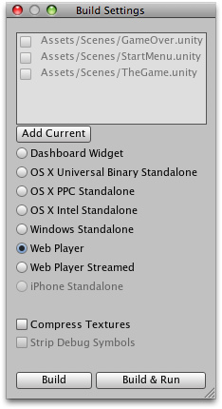

The first time you view this window in a project, it will appear blank. If you build your game while this list is blank, only the currently open scene will be included in the build. If you want to quickly build a test player with only one scene file, just build a player with a blank scene list.

首先，你在项目面板里看到这个窗口。它将显示空白。如果你创建的你的游戏当它的清单是空白时，仅当前打开的场景将被包含在生成里。如果你想快速的生成一个仅用一个场景文件的测试播放器，只需生成一个使用空白场景清单的播放器。

It is easy to add scene files to the list for multi-scene builds. There are two ways to add them. The first way is to click the **Add Current** button. You will see the currently open scene appear in the list. The second way to add scene files is to drag them from the **Project View** to the list.

很容易的添加场景文件到多场景生成的清单里。有两种方法去添加它们。第一种方法是点击**Add Current（添加当前）**按钮。你将看到当前打开的场景显示在清单里。第二种添加场景文件的方法是从项目面板拖动它们到这个清单。

At this point, notice that each of your scenes has a different index value. **Scene 0** is the first scene that will be loaded when you build the game. When you want to load a new scene, use [Application.LoadLevel()](http://unity3d.com/support/documentation/ScriptReference/Application.LoadLevel.html) inside your scripts.

在这一点上，注意每一个你的场景有一个不同的索引值。场景0是当你生成游戏时将被装入的第一个场景。

当你想装载一个新的场景，在你的脚本内部使用[Application.LoadLevel()](http://unity3d.com/support/documentation/ScriptReference/Application.LoadLevel.html)。

If you've added more than one scene file and want to rearrange them, simply click and drag the scenes on the list above or below others until you have them in the desired order.

如果你已经添加了多于一个场景文件并想重新排列它们，仅仅点击和拖动这个场景到上面或低于其它场景直到你希望的顺序。

If you want to remove a scene from the list, click to highlight the scene and press **Command-Delete**. The scene will disappear from the list and will not be included in the build.

如果你想从清单中移除一个场景，点击去突出显示这个场景并按**Command-Delete键（在windows里按Delete键）**，场景将从清单里消失并不在被包含在生成里

When you are ready to publish your build, select a **Build target** and press the **Build** button. You will be able to select a name and location for the game using the standardized Save dialog. When you click **Save**, Unity builds your game pronto. It's that simple. If you are unsure where to save your built game to, consider saving it into the projects root folder. You cannot save the build into the Assets folder.

当你准备好去发布你的生成，选择一个生成目标并按生成按钮。你将能选择一个名称和使用标准保存对话框的游戏的定位。当你点击保存，Unity快速生成你游戏。就这么简单。如果你不确定你生成的游戏保存在哪里，考虑保存它到项目的根文件夹里。你不能保存生成到资产文件夹里。

Enabling the **Compress Textures** checkbox will compress all the textures in your project when it is built. You only need to compress a texture once, but the first time you perform the compression it could take a few minutes. When you update assets after compressing them, they will need to be re-compressed the next time you build a player. Alternatively, you can enable texture compression upon import from the **Unity->Preferences** menu.

启用**压缩纹理**复选框，当它生成时将压缩项目中的所有纹理。你仅需要压缩一个纹理一次，但第一次你处理压缩可能需要几分钟。当你在压缩它们后更新资产，它们将在下一次你建立一个播放器重新被压缩。或者，你可以在引入之上启用纹理压缩，从菜单 **Unity->Preferences （参数设置）(在windows里是 Edit->Preferences)。**

Enabling the **Strip Debug Symbols** checkbox will remove debugging information from the built player. This will reduce the file size of the published game so it's optmimal for completed games. Alphas or betas should have this option disbled for debugging purposes. Your final release should always have this checkbox enabled.

启用脚本符号调式复选框，将移除调式信息重生成播放器里（File**->Build Setting…或**File**->Build &Run菜单设置**）。这将减少发布的游戏文件的大小。以便完成游戏的优化。Alphas或 betas应该用于调试目的的disbled选项。你最终发布总应该启用此选项。（注意，在Unity 2.5 for windows版本里没有找到该选项）

**Web Player Streaming Web流播放器**

Streaming Web Players allow your Web Player games to begin playing as soon as Scene 0 is finished loading. If you have a game with 10 levels, it doesn't make much sense to force the player to wait and download all assets for levels 2-10 before they can start playing level 1. When you publish a Streaming Web Player, the assets that must be downloaded will be sequenced in the order of the **Scene** file they appear in. As soon as all assets contained in Scene 0 are finished downloading, the Web Player will begin playing.

流式Web 播放器允许你的Web 玩家游戏开始播放尽快完成场景0的装载。如果你有一个10层次的游戏，在他们开始玩第一层次之前强制玩家等待和下载所有的2-10层次的资产没有多大意义。资产必须以它们显示的顺序场景的文件序列化顺序被下载。一旦包含在场景0的所有资产下载完成，Web播放器将开始播放。

Put simply, Streaming Web Players will get players playing your game faster than ever.

简单的说，流式Web播放器将使得播放器播放快速的播放你游戏。

The only thing you need to worry about is checking to make sure that the next level you want to load is finished streaming before you load it.

仅有一件事你需要关心的是，在你装载它之前，检查确保下一个层级你想去装载完成的流。

Normally, in a non-streamed player, you use the following code to load a level:

通常情况下，在一个非流式播放器，你使用如下的代码去装载一个层次：

Application.LoadLevel("levelName");

In a Streaming Web Player, you must first check that the level is finished streaming. This is done through the [CanStreamedLevelBeLoaded()](http://unity3d.com/support/documentation/ScriptReference/Application.CanStreamedLevelBeLoaded.html) function. This is how it works:

在一个流式Web播放器里，你必须检查这个层级是已经完成的流。通过[CanStreamedLevelBeLoaded()](http://unity3d.com/support/documentation/ScriptReference/Application.CanStreamedLevelBeLoaded.html)函数这样做。这是它的工作原理：

var levelToLoad = 1;

function LoadNewLevel () {

if (Application.CanStreamedLevelBeLoaded (levelToLoad)) {

Application.LoadLevel (levelToLoad);

}

}

If you would like to display the level streaming progress to the player, for a loading bar or other representation, you can read the progress by accessing [GetStreamProgressForLevel()](http://unity3d.com/support/documentation/ScriptReference/Application.GetStreamProgressForLevel.html).

如果你想显示层次流的进度在播放器里，如一个装载条或其它表现方法，通过方法[GetStreamProgressForLevel()](http://unity3d.com/support/documentation/ScriptReference/Application.GetStreamProgressForLevel.html)你可以读取进度。

**Inside the build process 内部生成过程**

The building process will place a blank copy of the built game application wherever you specify. Then it will work through the scene list in the build settings, open them in the editor one at a time, optimize them, and integrate them into the application package. It will also calculate all the assets that are required by the included scenes and store that data in a seperate file within the application package.

生成过程将放置你指定的地方生成游戏程序的一个空白副本。然后，它将通过在生成设置里的场景列表，一次一个的在编辑器里打开它们、优化它们并结合它们到应用程序包里。它也将计算包括场景和存储数据在一个独立文件在应用程序内部包里的需要的所有资产。

* Any **GameObject** in a scene that is tagged with 'EditorOnly' will be not be included in the published build. This is useful for debugging scripts that don't need to be included in the final game.
* 任何被标记为“EditorOnly”的场景里的游戏对象将不被包含在发布生成里。对于调试脚本是非常有用的，在最终游戏里不需要包含。
* When a new level loads, all the objects in the previous level are destroyed. To prevent this, use [DontDestroyOnLoad()](http://unity3d.com/support/documentation/ScriptReference/Object.DontDestroyOnLoad.html) on any objects you don't want destroyed. This is most commonly used for keeping music playing while loading a level, or for game controller scripts which keep game state and progress.
* 当一个新的层次装载，在以前层次里的所有游戏对象被销毁。为了避免这种情况，在任何你不想销毁的对象上使用[DontDestroyOnLoad()](http://unity3d.com/support/documentation/ScriptReference/Object.DontDestroyOnLoad.html)。这最常用于保持音乐播放在装载一个层次时、或为游戏控制脚本保持游戏状态或进展。
* After the loading of a new level is finished, the message: [OnLevelWasLoaded()](http://unity3d.com/support/documentation/ScriptReference/MonoBehaviour.OnLevelWasLoaded.html) will be sent to all active game objects.
* 一个新的层次装载完成后，信息：[OnLevelWasLoaded()](http://unity3d.com/support/documentation/ScriptReference/MonoBehaviour.OnLevelWasLoaded.html) 将被发送到所有活动的游戏对象。
* For more information on how to best create a game with multiple scenes, for instance a main menu, a high-score screen, and actual game levels, see the Scripting Tutorial.pdf
* 如何最佳建立一个多场景游戏的更多信息，例如：实例化一个主菜单，高分辨率屏幕以及真实的游戏层次，查看脚本教程文件。（文件Tutorial.pdf）

**Preloading 预装入**

Published builds automatically preload all assets in a scene when the scene loads. The exception to this rule is scene 0. This is because the first scene is usually a splashscreen, which you want to display as quickly as possible.

发布生成自动预装入场景里的所有资产当场景装载时。这个例外的规则是场景0.这是因为第一个场景通常是启动动画，那个你想尽可能的尽快显示。

To make sure all your content is preloaded, you can create an empty scene which calls **Application.LoadLevel(1)**. In the build settings make this empty scene's index 0. All subsequent levels will be preloaded.

为了确保你所有的内容是预装入的，你可以创建一个空的场景，调用**Application.LoadLevel(1)。**在生成设置使这个空的场景的索引为0。所有后来的层次将被预装入。

**You're ready to build games 你已准备好去生成游戏**

By now, you have learned how to use Unity's interface, how to use assets, how to create scenes, and how to publish your builds. There is nothing stopping you from creating the game of your dreams. You'll certainly learn much more along the way, and we're here to help.

现在，你已经学会了如何使用Unity的界面，如何使用资产，如何建立场景，以及如何发布你的生成。没有什么阻止你建立你的梦幻游戏。你将当然沿着这个路学习更多，我们在这里帮组。

To learn more details about using Unity itself, you can [continue reading the manual](http://unity3d.com/support/documentation/Manual/Building%20Scenes.html) or follow the [Tutorials](http://unity3d.com/support/documentation/Manual/Tutorials.html).

要学习关于使用Unity它自己的更多详细信息，你可以继续阅读本指南后面的手册。

To learn more about Components, the nuts & bolts of game behaviors, please read the [Component Reference](http://unity3d.com/support/documentation/Components/Components.html).

要了解更多组件、游戏行为的更多细节，请阅读组件参考。

To learn more about Scripting, please read the [Scripting Reference](http://unity3d.com/support/documentation/ScriptReference/index.html).

要了解更多关于脚本，请阅读脚本参考。

To learn more about creating Art assets, please read the [Assets section](http://unity3d.com/support/documentation/Manual/Working%20with%20Assets.html) of the manual.

要了解更多关于创建资产技巧，请阅读本手册的资产章节。

To interact with the community of Unity users and developers, visit the [Unity Forums](http://forum.unity3d.com). You can ask questions, share projects, build a team, anything you want to do. Definitely visit the forums at least once, because we want to see the amazing games that you make.

与Unity用户和开发者团体互动，访问Unity论坛。你可以提出问题，共享醒目、建立团队、你想做的任何事情。至少访问一次论坛，因为我们想看到你制作的惊人游戏。

**·Tutorials 教程**

[Unity Manual](http://unity3d.com/support/documentation/Manual/index.html) > [User Guide](http://unity3d.com/support/documentation/Manual/User%20Guide.html) > [Unity Basics](http://unity3d.com/support/documentation/Manual/Unity%20Basics.html) > [Tutorials](http://unity3d.com/support/documentation/Manual/Tutorials.html)

Unity 手册- > 用户指南-> Unity 基础->教程

These tutorials will let you work with Unity while you follow along. They will give you hands-on experience with building real projects. For new users, it is recommended that you follow the GUI Essentials and Scripting Essentials tutorials first. After that, you can follow any of them. They are all in PDF format, so you can print them out and follow along or read them alongside Unity.

这些教程将让你与Unity一起工作，跟随下面的内容。它们将给你利用真实的项目的内行经验。对于新用户，强烈的建议你首先跟随精华的GUI和教程教程。在此之后，你可以沿它们任何而行。它们都是PDF格式，因此可以打印出它们并跟随或在Unity旁边阅读它们。

在线资源



我们有许多在线教程。点击这里去我们最后更新的网站

（注意，此教程请在网上查看，翻译省略）

经典GUI（教程）

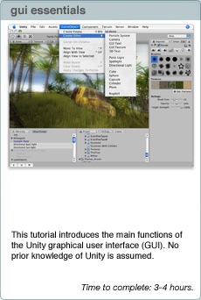

本教程介绍Unity图形用户接口（GUI）的主要功能。假定你没有Unity的知识。

完成时间：3-4个小时

经典脚本（教程）

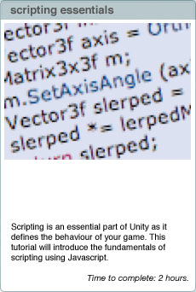

脚本是unity中的精华部分，定义你游戏的行为。本教程将介绍使用Javascript脚本的基本原理。

完成时间：2个小时。

**Introduction to the Unity Interface Unity 界面入门**

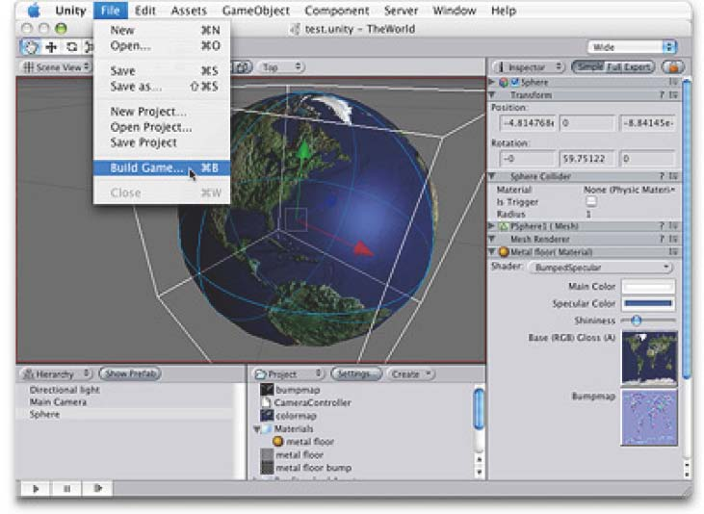

This tutorial will introduce the Unity graphical user interface(GUI).

本教程将介绍Unity的图形用户界面（GUI）

No prior knowledge of Unity isassumed.

假定没有Unity预先知识

Time to complete: 1 hour. 时间 1小时

Author: Graham McAllister

作者：Graham McAllister

**Contents 目录**

1. Aims of the tutorial本教程的目标
2. Screen layout 屏幕布局
3. Finding game objects 发现游戏对象
4. Creating game objects 创建游戏对象
5. Navigating the Scene View 定位场景视图
6. Moving game objects 移动游戏对象
7. Game View 游戏视图
8. Resizing game objects 伸缩游戏对象
9. Using assets 使用资产
10. Adding Components 添加组件
11. Duplicate 复制（对象）

**1. Aims of this tutorial 教程目标**

If you are new to Unity this should be the ﬁrst tutorial that you read. It will explain the key sections of the interface and describe how to create basic game objects and position them in 3D space.

如果你对Unity的不熟悉，这应该是你个阅读的第一个教程。它将讲解界面的关键章节和描述如何创建基本游戏对象和在3D空间定位它们。

To demonstrate the Unity interface essentials, we’ll create a simple scene which will allow a character to walk around on a surface.

示范Unity经典界面，我们将建立一个简单的场景，允许一个角色在表面行走。

Note: any text that requires the user to take an action begins with a ‘-’.

注意：需要用户创建的一个动作以“_”开始的任意字符串。

**2. Screen Layout 场景布局**

Before we start, let’s make sure our screen layout is in **2 Split** mode.

-To ensure it is, select Window->Layouts->2 Split. Your view is now split into 5 main regions:

在我们开始之前，让我们确保我们的屏幕布局在2个分割的模式。确保它是，选择Window->Layouts->2 Split（窗口->布局->2个分割模式，注意：在2.5 for windows版本里没有这个布局选项）。你的视图现在是分割成5个主要区域。

1. **Scene View** - for placing game objects 场景视图—用于放置游戏对象
2. **Game View** - this is how the game will look when run. 游戏视图—它是当游戏运行时将看到外观如何。
3. **Hierarchy View** -this is a list of all game objects currently in the scene. 层次视图（面板）--场景里所有当前游戏对象的列表（清单）
4. **Project View** -this view shows all assets that are available for use (like a palette) 项目视图（面板）--这个视图显示被应用到的可利用的所有资产（像一个选项板）。
5. **Inspector View** -this shows the properties of the currently selected game object. 检视视图（面板，翻译成属性监视器比较合适）--它显示当前选取的游戏对象的属性。

**3. Finding game objects in 3D space 在3D空间查找游戏对象**

-Start Unity. We’ll begin by creating a new project.

启动Unity，我们将通过创建一个新的项目开始。

-Select File->New Project from the main menu and give the project a name such as “GUI Tutorial” and click Create Project. Unity will now import **assets** (e.g. audio, textures, 3D models) so they are available for use.

从主菜单选择File->New Project（文件->新项目）并给项目一个名称例如“GUI Tutorial” 然后点击创建项目。Unity将引入资产（例如 音频、纹理、3D模型），以便它们成为使用可利用的。

Once importing is complete you will be presented with your game world. At present the world only contains a Main Camera (this is default), you can see this listed as the only item in the Hierarchy view.

你一旦引入完成，在你的游戏世界将被呈现。目前，这个（游戏）世界仅包含一个主摄像机（这是默认的），你可以查看作为仅有的项目这个清单，在层次视图里。

-If you can’t see the camera in your Scene View, click on the Main Camera in the Hierarchy View, move your cursor so that it’s **inside** the Scene View, then type F (**frame select**) on the keyboard. The Main Camera should now be at the centre of the Scene View. This technique can be used to ﬁnd any game object.

如果你在你的场景视图里不能看到这个摄像机，在层次视图里点击主摄像机，移动你的鼠标以至它是在场景视图里，然后在键盘上按F键（帧选择）。主摄像机现在应该在场景视图的中央。

-Any game object can be **selected** by either clicking on it in the Scene View or selecting it in the Hierarchy View. If you click on an object in the Scene View, you can conﬁrm that you’ve selected the correct object as it will also be **highlighted** in the Hierarchy view.

任意的游戏对象可以被选取通过任一方法，在场景视图点击它或在层次视图里选取它

**4. Creating game objects 创建游戏对象**

Let’s add some game objects to our world.

让我们添加一些游戏对象到我们的世界。

-Select Game Object->Create Other->Plane, this will create a plane (a 2D surface) to allow our character to walk on.

选择Game Object->Create Other->Plane,这将创建一个平面（一个2D表面），允许我们的角色在上面行走。

-Add a cube to the game world by selecting Game Object->Create Other->Cube.

添加一个方块对到游戏世界通过选择Game Object->Create Other->Cube.

-Add a point light by selecting Game Object->Create Other->Point Light.

添加一个点光源通过Game Object->Create Other->Point Light.

**5. Navigating the Scene View 定位场景视图**

You can look around your 3D objects from any angle by using the following:

你可以在任意角度（角落）查看你的3D对象通过使用下列的方法：

1. **Rotating** (Option+LMB) 旋转 （Option +鼠标左键）
2. **Panning** (Option+MMB) 平移 （Option +鼠标中键）
3. **Zooming** (Option+RMB) 缩放 （Option +鼠标右键）

**NB**: The Option key is beside the Command key (the one with the Apple logo on it) on the Mac keyboard, L/M/R MB is Left/Middle/Right Mouse Button. It is recommended that you have a 3 button mouse.

注意：选项键是在MAC键盘上Command旁边（上面带苹果标志的键），L/M/R MB是左/中/右鼠标按钮。强烈建议你有一个3按钮的鼠标。（以上苹果机器上的操作，下面的说明可以在windows平台上使用）

If you only have a one-button mouse, or are using a laptop, you can still navigate easily. Firstly, click on the **hand-shaped** tool in the upper left hand corner of the Unity GUI, then the following can be used:

如果你只有一个按钮的鼠标（注：我没有见过这样的鼠标）或使用一个膝上型电脑（笔记本电脑），你可以仍旧容易的定位。首先，在Unity GUI（图形用户界面）的左上角工具栏里点击手型按钮，然后使用下面的说明：

1. **Rotating** (Option+LMB) 旋转(Option+鼠标左键)（在windows上 按Alt+鼠标左键）
2. **Panning** (LMB) 平移 （鼠标左键）
3. **Zooming** (Command+LMB) -Try this now. 缩放（Command+鼠标左键）（在windows上 按windows旗标键+鼠标左键，或使用鼠标的滚轮，或先按R键，点击辅助工具（GIZMO）进行缩放），现在尝试。

**6. Moving game objects 移动游戏对象**

You can position any game object in 3D space by using one of the following:

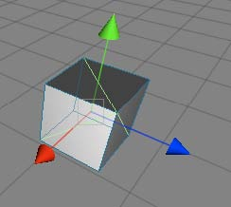

你可以在3D空间定位任意游戏对象，通过使用下列之一。

1. **Move** tool (W on the keyboard). Selecting any game object then typing W will display three arrowheads, one for each axis of 3D space. Red is the x-axis, green is the y-axis, blue is the z-axis, i.e. r,g,b, maps to x,y,z. To move an object, click the LMB on the arrowhead that represents the axis you want to move in and move the mouse as much as appropriate. As you drag the arrowheads notice the object’s position values in the Inspector Panel change also. You can enter values directly into these boxes also (3 boxes, 1 each for x,y,z values).

移动工具（在键盘上按W键）。选取任意游戏对象然后按W键，将显示三个箭头，一个3D空间轴的每个轴。红色是X轴，绿色是Y轴，蓝色是Z轴，也就是RGB映射到X,Y,Z。去移动一个对象，在箭头上鼠标左键点击表示这个轴你想去移动并恰当的移东鼠标。当你拖动箭头，注意在检视面板里这个对象的坐标值也改变。你也可以直接键入值到这些框中（3个框，1个框是各自的x，y，z值）。

You can also re-position a game object by ﬁrstly clicking on it, then move the camera to point towards the general direction of where the want the object to move to, then select Game Object->**Align with View**. The selected game object will move to where the camera now points.

你也可以重新配置一个游戏对象通过第一个单击，然后移动摄像机去朝向对象移动到希望地方的大体方向 。然后选择Game Object->Align with View.（游戏对象->对齐视图），选取的游戏对象将移动到摄像机新坐标的地方。

2. **Rotate** tool (E on the keyboard). Selecting any game object then typing E will display the rotate tool. To rotate around an axis, click the LMB on the axis of choice then move the mouse to rotate the game object. As you rotate the object notice the object’s rotation values in the Inspector Panel change also. You can enter values directly into these boxes also.

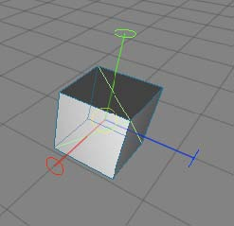

旋转工具（在键盘上按E键）。选取任意游戏对象然后按E键将显示缩放工具。围绕一个轴旋转，在选择的轴上按鼠标左键然后移动鼠标去旋转游戏对象。在你旋转对象注意在检视面板里该对象的旋转值也改变。你也可以直接键入值到这些框中。

-Let’s try a small exercise. Move the cube (move tool) so that it is outside of the Scene View. Use the Frame Select feature (click Cube in the Hierarchy View then press the F key) to ﬁnd the cube again. Finally move the cube back so it’s close to the plane.

让我们做一个小练习。移动方块（移动工具）致使它处于场景视图的外面。使用帧选择特性（在层次视图（面板）里点击方块，然后按F键）重新找到这个方块。最后，向后移动方块使它接近于平板。

-Move the point light so that it’s above the cube and the plane. 移动点光源使它处于方块和平板的上方。

**7. Game View 游戏视图**

The Game View shows how the game will look when run (complete with textures, lighting etc). If you cannot see your game world in the Game View, it’s because your camera is not looking in the right direction.

游戏视图显示当游戏运行时外观如何（连通纹理、灯光等）。如果在游戏视图里，你不能看到你的游戏世界，是因为你的摄像机不在正确的方向探测。

-Click on the Main Camera, you will notice an inverted yellow pyramid wireframe coming out from it. This is known as the camera’s **viewport** (what it can see). If the viewport is not pointing in the direction of your game objects, navigate in the scene view so that you are looking at your game objects, select the Main Camera then select Game Object->**Align With View**. Your Game View should now match your Scene View.

在主摄像机上点击，你将注意到一个倒置的黄色倒置的金字塔线框出现。这是摄像机的视口（它看到的程度）。如果视口没有指向你的游戏对象的方向，在场景视图里定位它使你看到你的游戏对象，选取主摄像机然后选取Game Object->Align With View（游戏对象->对齐视图）。你的游戏窗口现在应该匹配你的场景视图。

You can also manually adjust your camera’s settings by either using the move and rotate tools, or changing its transform values in the Inspector View.

你也可以手工调整你的摄像机的设置，通过任一的：使用移动和旋转工具或在检视视图（面板）里更改它的变换值。

You may also want to move your light to give better aesthetics.

你也同样应该移动你的灯光以提供更佳的美感。

**8. Resizing game objects 伸缩游戏对象**

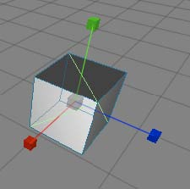

To resize an object ﬁrstly select it then press R on the keyboard (resize or scale tool). You can visually scale an object by dragging the square block at the end of the each axis, or use the Inspector View to type a precise value in.

伸缩一个游戏对象首先选取它然后在键盘上按R键（调整大小或缩放工具）。你可以直观的缩放一个对象通过拖动每个轴末端的四方块，或使用检视器视图（面板）去键入一个精确值。

We’ll now resize some objects in our game world.

我们现在将伸缩一些对象在我们的游戏世界里。

-Select the plane and set its x and z scale values to 10 in the Inspector view (the ﬁrst and third box, as the second box is for the y value).

选取平板并设置它的X和Z刻度值为10在检视器视图里。（第一个和第三个方框，对于第二个方框是Y的值）。

-Select the cube, resize it along the y-axis visually (press R and drag the green square upwards). the cube should now look like a pillar.

选取立方体，伸缩它沿着直观的Y轴（按R键向前拖动绿色的方块）。立方体现在应看起来像一个柱子。

-**Rename** the cube Pillar. Do this by selecting it in the Hierarchy View and pressing return to enter the new name. Remember it’s best to ensure game objects begin with a **capital** letter.

重命名这个立方柱。做这一点通过在层次视图（面板）里选取它并按回车键输入新的名称（在windows上，按F2键）。记住，带一个“_”首字符（名称）是一个最好确保游戏对象的名称。

**9. Using Assets 使用资产**

Computer games are created from 3D models, textures, sound ﬁles, game code etc., these are called the game’s **assets**. Unity comes with many assets shipped as standard assets (even more in the Pro version).

以3D模型、纹理、声音文件、游戏代码等创建的计算机游戏，这些被称为游戏的资产。Unity附带有许多的资产被当作标准的资产（在专业版里甚至更多）。

We’ll now add a character to our game world from the built-in assets. In the Project View expand the Standard Assets folder, then expand Prefabs. A **prefab** is collection of game objects that have been pre-assembled into a logical grouping. You should see the First Person Controller (FPS Controller) inside the Prefabs folder.

从内置的资产里，我们将现在添加一个角色到我们的游戏世界里。在项目视图（面板）里展开标准资产文件夹，然后展开预制品。一个预制品是已经被预先安装到一个逻辑组里的游戏对象集合。你应当在预制品文件夹里看到一个第一人称控制器（FPS 控制器）。

-Drag the FPS Controller prefab into the Scene View. Notice how the Game View has changed, this is because the FPS Controller prefab comes with its own camera which takes precedent over the existing Main Camera. Make sure the FPS Controller is not caught in the plane, move it so that it is above the plane.

拖动FPS控制器预制品到场景视图里。注意游戏视图如何变化的，这是因为FPS控制器预制品带有它自己的摄像机取代了先前存在的主摄像机。在平板里确保FPS控制器没有被捕获，移动它使它在平板之上。

-Delete the Main Camera as we’ll not need it now (Command+delete). The Game View is now what the player can see in-game.

现在，作为我们将不再需要的主摄像机删除（Command+delete，windows上的Delete键）。游戏视图现在是玩家可以在游戏里看到的样子。

-**Start** the game by clicking the Play button in the lower left hand side of the Unity GUI. Notice the screen stays the same, so you can see the game in the Scene View and the Game View. Use the cursor keys to move the character around (or W,S,A,D), the mouse to look around and space to jump.

开始游戏通过点击在Uniy GUI左下手边里的播放按钮（2.5版本里的播放工具条里播放按钮）。注意到屏幕同时停在使你看到在场景视图里和游戏视图里的游戏。使用箭头键移动角色（或 按W、S、A、D），鼠标旋转查看和空格键跳跃。

-**Stop** the game at any time by clicking on the Play button again.

在任何时间停止游戏通过再次点击播放按钮。

**NB**: By pressing the **space bar** while the mouse cursor is inside any of the views (Game View, Scene View etc), this makes that particular view expand to full screen. This is useful when making adjustments in the Scene View, or playing the game (Game View). Pressing space inside the full screen view returns to the previous layout mode. Note that this feature does not work if the game is currently running, either stop or pause the game ﬁrst.

注意：通过按空格键当鼠标光标在任何视图里（游戏视图，场景视图等）时，这使特定视图展开至全屏。当在场景视图里做调整时或播放游戏（游戏视图）是有用的。在全屏视图里按空格键返回以前的布局模式。注这个特性不工作，如果游戏当前正在运行，首先停止或占停游戏。

**10. Adding Components 添加组件**

Game objects can have a number of components (or behaviours) attached to them. By clicking on any game object, you can see the attached components in the Inspector View (e.g. Transform, Box Collider).

游戏对象可以有几个组件（行为）附加到它们。在任意游戏对象上点击，你可以看到附在的组件在检视器视图里（例如，Transform变换组件, Box Collider 碰撞盒组件）。

-Click on Pillar and look at its components in the Inspector View.

在柱子上点击并在检视器视图里查看它的组件。

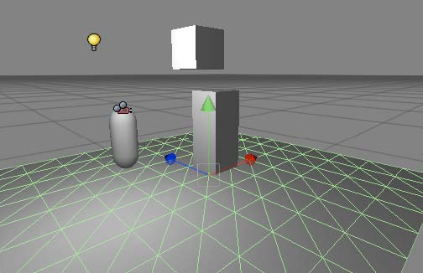

Let’s add another cube and add an extra component.

让我们添加另外一个立方体并添加额外的组件。

-Add another cube to the scene (Game Object->Create Other->Cube). Rename it PhysicsCube in the Hierarchy view.

添加另外一个立方体到场景里（Game Object->Create Other->Cube）。重命名它为PhysicsCube 在层次视图里。

Figure 1 - demonstrating Rigidbody

图1-示范碰撞体

Now we’re going to add a Rigidbody component to this cube. The **RigidBody** component allows the game object to behave as if it’s in a world with gravity, i.e. the object will fall downwards until it hits a surface with a **collider** component attached.

现在，我们去添加一个碰撞体组件到这个立方体。碰撞体组件允许游戏对象带有重力的行为在一个世界里。也就是对象将快速下降直到它碰撞一个带着附有碰撞组件表面。

-Making sure PhysicsCube is selected, select Component->Physics->Rigidbody. This adds the Rigidbody component to the currently selected game object. Notice that in the Inspector View the Rigidbody component has been added.

确保PhysicsCube被选取，选取Component->Physics->Rigidbody。添加碰撞体组件到当前选取的游戏对象上。注意，在检视器视图里这个碰撞体组件已经被添加。

-Move PhysicsCube so that it is above Pillar but slightly offset (see Figure 1). We want to set the scene up so that when we press play, PhysicsCube will collide with Pillar and fall to the ground.

移动PhysicsCube使它在柱子的上方，但有些偏移（看图1）。我们应该设置场景抬高以便当我们按播放时，PhysicsCube将与柱子碰撞并落在地上。

-Press Play, PhysicsCube should collide with Pillar and land on the plane.

按播放，PhysicsCube应该与柱子碰撞并降落在地上。

**11. Duplicate 复制**

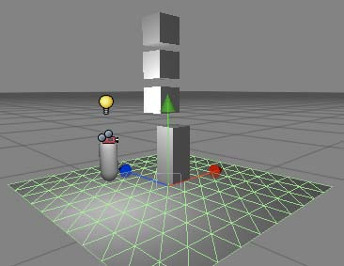

Duplicating a game object is one of the most powerful features of Unity. When duplicating an object, all features and behaviours of the object are also copied. It’s a very fast way to create complex scenes. We’ll now add more PhysicsCubes to our scene.

复制一个游戏对象是Unity许多强大的功能之一。当复制一个游戏对象，这个游戏对象的所有功能和行为也被复制。它是一个非常快速的完成场景创建的方法。我们现在将添加更多的PhysicsCube到我们的场景。

图2-使用复制

-Click on PhysicsCube and press Command+D (or do this from the Edit menu). Notice an extra PhysicsCube entry has appeared in the Hierarchy menu, however you cannot see it as it has been created at the same position as the ﬁrst PhysicsCube.

在PhysicsCube上点击并按Command+D（windows上按Ctrl+D）（或从编辑菜单做这个）。注意到一个额外的PhysicsCube条目已经出现在层次菜单里。然而，你不能看到它（在场景视图里）因为它被创建在与第一个PhysicsCube相同的坐标点。

-Move the new PhysicsCube by selecting the move tool (W) and move it upwards (y-axis).

移动新建立的PhysicsCube通过选取移动工具（或按W键）并向上移动它（y轴）。

-Repeat this process so there are now 3 PhysicsCube game objects (see Figure 2).

重复这个处理以至现在有3个PhysicsCube 游戏对象（看图2）

-Run the game and all 3 PhysicsCube game objects should interact and behave naturally.

运行游戏，所有3个PhysicsCube游戏对象将自然的相互影响行为。

This tutorial has introduced the fundamentals of the Unity GUI. You should now try the scripting tutorial to look beneath the surface of Unity.

本教程已经介绍了Unity GUI的基本原理。你应该现在尝试在Unity界面下查看脚本指南。

**Introduction to scripting with Unity Unity脚本入门**

Scripting is an essential part of Unity as it defines the behaviour of your game. This



tutorial will introduce the fundamentals of scripting using Javascript. No prior knowledge

of Javascript or Unity is required.

脚本是Unity的经典部分。它定义你游戏的行为。本教程将使用Javascript介绍脚本的基本原理。不需要Javascript或Unity的预先知识。

Time to complete: 2 hours. 完成时间：2个小似乎

Author: Graham McAllister 作者：Graham McAllister

**Contents 目录**

1. Aims of this tutorial 本教程的目标

2. Prerequisites 先决条件

3. Naming conventions 命名约定

4. Player Input 玩家输入

5. Connecting variables 连接变量

6. Accessing components 访问组件

7. Instantiate 实例创建

8. Debugging 调试

9. Common Script Types 公共脚本类型

**1. Aims of this tutorial**

Scripting is how the user defines a game’s behaviour (orrules) in Unity. The recommended programming

language for Unity is **Javascript**, however C# or Boo can also be used. This tutorial will cover the fundamentals of scripting in Unity and also introduce key elements of the Application Programming Interface (API).You can think of the API as code that has already been written for you which lets you concentrate on your game design and also speeds up development time.

脚本是用户定义一个游戏的行为（规则）的方法在Unity里。建议Unity（脚本）的程序语言是**Javascript，**然而，C#或Boo也可以被使用。本教程将覆盖Unity的脚本基本原理也同样介绍应用程序接口（API）的关键元素。你可以认为API是已经为你编写好代码让你集中于你的游戏设计以及加速开发时间。

A good understanding of these basic principles is essential in order to harness the full power of Unity.

这些基本原理的一个好的解释是为了利用Unity的全部功能的精华。

**2. Prerequisites 先决条件**

This tutorial focuses on the scripting element of Unity, it is assumed you are already familiar with Unity’s interface(if not you should read the Unity GUI tutorial).

本手册关注在Unity的脚本元素，它假定你已经熟悉了Unity的界面（如果不熟悉，你应该阅读Unity GUI教程）。

In order to make scripting easier to understand, it is preferable to have a code editor that has syntax highlighting support for Javascript. This means that reserved words (syntax used by Javascript itself) are coloured differently than user defined words. One such editor is SubEthaEdit.

为了使脚本更容易的理解，一个优越的编辑器拥有语法高亮支持 Javascript。这意味着保留字（语法用Javascript它自己的）是不同的着色与用户定义的字比较。一个这样的编译器是SubEthaEdit.

**NB**: any text that requires the user to take an **action** begins with a ‘-’. 注意：需要用户去采取行动的任何字符串应以“_”开头。

**3. Naming Conventions 命名约定**

Before we begin, it is worth mentioning some conventions in Unity.

我们开始之前，一些Unity里的命名约定是值得提及。

**Variables** - begin with a lowercase letter. Variables are used to store information about any aspects of a game’s state.

变量-以一个小写字母开始。变量被用于存储关于许多游戏状态的信息。

**Functions** - begin with an uppercase letter. Functions are blocks of code which are written once and can then be reused as often as needed.

函数-以大写字母开头。函数是编写一次和可以重复使用的代码块。

**Classes** - begin with an uppercase letter. These can be thought of as collections of functions.

类-以大写字母开头。这些可以认为是函数的集合。

**Tip:** When reading example code or the Unity API, pay close attention to the first letter of words. This will help you better understand the relationship between objects.

技巧：当阅读示例代码或Unit API时，注意字符串的首字符。这将帮组你更好的理解对象之间的关系。

**4. Player Input 玩家输入**

For our first program we’re going to allow the user to move around in a simple game world.



对于我们的第一个程序，我们将允许用户在一个简易的游戏世界里来回行走。

Setting the scene 设置场景

- Start Unity. 启动Unity

Firstly, let’s create a surface for the user to walk on. The surface we’re going to use is a flattened cube shape.

首先，让我们创建一个使用户在上面行走的表面。

- Create a cube and scale its x,y,z dimensions to 5, 0.1, 5 respectively, it should now resemble a large flat plane. Rename this object ‘Plane’ in the Hierarchy View.

创建一个立方体并分别缩放它的x，y，z的尺寸为5，0.1，5。它现在应该像一个巨大的平台。

- Create a 2nd cube and place it at the centre of this plane. If you can’t see the objects in your Game View, alter the main camera so they’re visible. Rename the object to Cube1.

创建第二个立方体并把它放置在这个平台的中心。如果你不能看到这个对象（物体）在你的游戏视图里，改变主摄像机以使它们可见。重命名这个对象为Cube1。

- You should also create a point light and place it above the cubes so that they’re more easily visible.

你应该同样创建一个点光源并放置它在立方体的上方使它们更容易的可见。

* **Save** the scene by selecting File->Save As and give the game a name.

**保存场景** 通过选取 File->Save As 并指定一个游戏的名称。

Our first script 我们第一个脚本

We’re now ready to start game programming. We’re going to allow the player to move around the game world by controlling the position of the main camera. To do this we’re going to write a script which will read input from the keyboard, then we attach (associate) the script with the main camera (more on that in the next section).

我们现在准备好了开始游戏编程。我们将允许玩家在游戏世界里来回走动通过控制主摄像机的位置。做到这一点，我们将编写一个脚本从键盘里读取输入，然后我们把这个脚本和主摄像机（更多的在下一节）连接（关联）。

- Begin by creating an empty script. Select Assets->Create->Javascript and rename this script to Move1 in the Project Panel.

开始创建一个空白脚本。选取 Assets->Create->Javascript 并重名这个脚本为Move1 在项目面板里。

* Double-click on the Move1 script and it will open with the **Update()** function already inserted (this is default behaviour), we’re going to insert our code inside this function.

在Move1脚本上双击，它将带着已经插入**Update()函数**（这是一个默认的行为）被打开，我们将插入我们的代码在这个函数里。

Any code you insert inside the Update() function will be executed every **frame**.

你在Update()函数里插入的任何代码将被每个的帧执行。

In order to move a game object in Unity we need to alter the position property of its transform, the **Translate** function belonging to the transform will let us do this. The Translate function takes 3 parameters, x, y and z movement. As we want to control the main camera game object with the cursor keys, we simply attach code to determine if the cursor keys are being pressed for the respective parameters:

为了在Unity里移动一个游戏对象我们只需要改变它的**transform的坐标属性**，隶属于transform的这个**Translate函数** 将让我们做这件事。

function Update () {

transform.Translate(Input.GetAxis("Horizontal"), 0, Input.GetAxis("Vertical"));

}

The Input.GetAxis() function returns a value between -1 and 1, e.g. on the horizontal axis, the left cursor key maps to -1, the right cursor key maps to 1. Notice the 0 parameter for the y-axis as we’re not interested in moving the camera upwards. The Horizontal and Vertical axis are pre-defined in the Input Settings, the names and keys mapped to them can be easily changed in Edit->Project Settings->Input.

函数Input.GetAxis()返回一个在-1与1之间的值，举例来说，在水平轴左箭头映射为-1，右箭头映射为1（注：左右箭头是指键盘上左右方向键），注意到0参数对应的y轴对我们向前移动摄像机没有兴趣。水平和垂直轴是在输入设置里预定义的，名称和键映射到它们可以容易更改在Edit->Project Settings->Input.里。

* Open the Move1 Javascript and type in the above code, pay close attention to capital letters.

打开Move1 Javascript 脚本并键入上面的代码，注意字符的大小写。

Attaching the script 连接脚本

Now that our first script is written, how do we tell Unity which game object should have this behaviour? All we have to do is to attach the script to the game object which we want to exhibit this behaviour.

现在我们第一个脚本已经编写，我们如何告诉Unity 哪个游戏对象应该有这个行为？我们必须使这个脚本到关联那个我们想展示这个行为的游戏对象上。

- To do this, first click on the game object that you wish to have the behaviour as defined in the script. In our case, this is the Main Camera, and you can select it from either the Hierarchy View or the Scene View.

做到这一点，首先在那个你希望拥有这个行为的游戏对象上点击当作在脚本里的定义。在我们的示例里，这是主摄像机，你可以从层次视图或场景视图里选取它。

* Next select Components->Scripts->Move1 from the main menu. This attaches the script to the camera, you should notice that the Move1 component now appears in the Inspector View for the main camera.

接下来，从主菜单中选取Components->Scripts->Move1。关联脚本到摄像机，你应该注意到这个主摄像机的Move1组件现在显示在检视器视图里。

**Tip:** You can also assign a script to an game object by **dragging** the script from the Project View onto the object in the Scene View.

技巧：你也可以分配一个脚本给一个游戏对象，通过从项目视图里拖动这个脚本到一个在场景视图里的对象。

* Run the game (press the play icon at the lower left hand corner), you should be able to move the main camera with the cursor keys or W,S,A,D. You probably noticed that the camera moved a little too fast, let’s look at a better way to control the camera speed.

运行这个游戏（按播放图标在左手角落的底部，2.5 版本 windows上的播放条上的播放按钮），你应能够利用方向键或W,S,A,D键移动主摄像机。你也许注意到摄像机移动的有点快，让我们找到一个更好的方法去控制摄像机的速度。

Delta time 时间延迟

As the previous code was inside the Update() function, the camera was moving at a velocity measured in meters per **frame**. It is better however to ensure that your game objects move at the more predictable rate of meters per **second**. To achieve this we multiply the value returned from the Input.GetAxis() function by Time.deltaTime and also by the velocity we want to move per second:

作为在Update()里的先前的代码，摄像机以标准的速率移动在仪表里，每帧。一个更好的无论如何确保你的游戏对象移动在超过可预定的米每秒速率，完成这个目标，我们从Input.GetAxis()函数里返回大值通过Time.deltaTime和通过我们每秒应该移动的速率。

var speed = 5.0;

function Update () {

var x = Input.GetAxis("Horizontal") * Time.deltaTime * speed;

var z = Input.GetAxis("Vertical") * Time.deltaTime * speed;

transform.Translate(x, 0, z);

}

* Update the Move1 script with the above code. Notice here that the variable speed is declared outside of the function Update(), this is called an **exposed variable**, as this variable will appear in the Inspector View for whatever game object the script is attached to (the variable gets exposed to the Unity GUI).

利用上面的代码更新Move1脚本。注意，这里在函数Update()外面声明了一个speed变量，这被称为外部变量，无论什么游戏对象脚本被关联上（变量接触到Unity GUI）该变量将显示在检视器视图里。

Exposing variables are useful when the value needs to be tweaked to get the desired effect, this is much easier than changing code.

暴露的变量是有用的当变量值需要被修改去获得想得到的效果，这是比更改代码容易的操作。

**5. Connecting Variables 连接变量**

Connecting variables via the GUI is a very powerful feature of Unity. It allows variables which would normally be assigned in code to be done via **drag and drop** in the Unity GUI. This allows for quick and easy prototyping of ideas. As connecting variables is done via the Unity GUI, we know we always need to expose a variable in our script code so that we can assign the parameter in the Inspector View.



经由GUI连接变量是Unity的强大功能。它允许在代码里去做正常关联的那个变量，经由在Unity GUI里拖放完成。这涉及敏捷的概念原型。作为连接变量经由Unity GUI完成，我们知道我们总要需要暴露一个变量在我们的脚本代码里，因此，我们可以链接这个参数在检视器视图里。

We’ll demonstrate the connecting variables concept by creating a spotlight which will follow the player

(Main Camera) around as they move.

我们将示范连接变量概念通过创建一个聚光灯将跟随摄像机（主摄像机）周围当它们移动时。

- Add a **spotlight** to the Scene View. Move it if necessary so it’s close to the other game objects.

添加一个聚光灯到场景视图。如果必要的话移动它使它接近于其它游戏对象。

* Create a new Javascript and rename it to Follow.

建立一个新的Javascript脚本并重命名为Follow。

Let’s think what we want to do. We want our new spotlight to look at wherever the main camera is. As it happens, there’s a built in function in Unity to do this, transform.LookAt(). If you were beginning to think ‘how do I do this?’ and were already imagining a lot of code, then it’s worth remembering to always check the Unity **API** for a function that already exists. We could also make a good guess at looking in the ‘transform’ section of the API as we’re interested in altering the position or rotation of a game object. Now we come to the connecting variables section; what do we use as a parameter for LookAt()? Well we could hardcode a game object, however we know we want to assign the variable via the GUI, so we’ll just use an exposed variable (of type Transform).

让我们思考我们应该做什么。我们想要我们的新聚光灯去查看主摄像机在哪里。恰好出现，有一个在Unity里的现成函数去做到这一点，它是 transform.LookAt()。如果你已经开始思考“我如何处理它?”，以及已经设想了许多代码，那么一个值得记住是总要检查Unity API，查看是否已经存在这样的一个函数。我们同样实现一个好的猜测是在API 的‘transform’ 章节里查找，我们感兴趣修改坐标位置或旋转一个对象。 现在，我们继续连接变量章节；我们为LookAt()提供什么参数？那么，我们能硬编码一个游戏对象，然而，我们知道我们想连接变量经由GUI，因此我们正好使用暴露变量（类型是Transform）

Our Follow.js script should look like this:

我们Follow.js脚本看起来应像这个样子：

var target : Transform;

function Update () {

transform.LookAt(target);

}

- Attach the script to the spotlight and notice when the component gets added, the “target” variable is exposed.

连接这个脚本到聚光灯并注意当组件获得添加，“target”变量是暴露的。

- With the spotlight still selected, drag the Main Camera from the Hierarchy View onto the “target” variable in the Inspector View. This **assigns** the target variable, i.e. the spotlight will now follow the Main Camera. If we wanted the spotlight to follow a different game object we could just drag in a different object (as long as it was of type Transform of course).

仍旧选取聚光灯,从层次视图拖动主摄像机到在检视器视图里的“target”变量上。这就连接了“target”变量。也就是聚光灯现在将跟随主摄像机。如果我们想这个聚光灯去跟随一个不同的游戏对象，我们可以只需拖动一个不同的对象（当然只要它是Transform类型）。

- Play the game. If you watch the Scene View you should see the spotlight following the Main Camera around. You may want to change the position of the spotlight to improve the effect.

播放游戏，如果你观看场景视图，你应该看到聚光灯跟随在主摄像机周围。你也需想改变聚光灯的位置（坐标）改进效果。

**6. Accessing Components 访问组件**

As a game object can have multiple scripts (or other components) attached, it is often necessary to access other component’s functions or variables. Unity allows this via the GetComponent() function. We’re now going to add another script to our spotlight which will make it look at Cube1 whenever the jump button (spacebar by default) is pressed. Let’s think about this first, what do we want to do:

作为一个游戏对象可以有多个连接的脚本（或其它的组件），是常常必要的去访问其它的组件的功能或变量。Unity允许这样做，经由GetComponent()函数。我们现在将要添加另外的脚本到我们的聚光灯，无论何时只要按跳跃按钮（默认空白键）将使它看到Cube1。让我们首先思考一下，我们想要做什么：

1. Detect when the jump button has been pressed.

检测，当跳跃键已经被按下时。

2. When jump has been pressed make the spotlight look at Cube1. How do we do this?

当跳跃键已经被按下，使聚光灯看到Cube1，我们如何做到？

Well, the Follow script contains a variable “target” whose value determines which game object the spotlight should look at. We need to set a new value for this parameter. We could hardcode the value for the cube (see the section ‘Doing it with code’ later), however we know that exposing the variable and assigning this via the GUI is a better way of doing this.

好，Follow脚本包含一个“target”变量-求出聚光灯应该看到哪个游戏对象是谁的值。我们需要设置一个新的值为这个参数。我们能硬编码这个值为cube（稍后看本节“利用代码”），然而，我们知道那个暴露的变量和分配它，经由GUI是一个好的方法做这个。

* Create a new Javascript and name it Switch. Add the following code to Switch.js:

创建一个新的Javascript脚本并命名它为Switch，添加如下的代码到Switch.js:

var switchToTarget : Transform;

function Update () {

if (Input.GetButtonDown("Jump"))

GetComponent(Follow).target = switchToTarget;

}

Notice in particular how Follow is the parameter to GetComponent(), this returns a reference to the Follow script which we can then use to access its “target” variable.

特别注意Follow是如何使用参数给GetComponent()，它返回一个引用到Follow脚本那个我们能使用访问它的“target”变量。

- Add the Switch script to the spotlight and assign Cube1 to the switchToTarget parameter in the Inspector View.

添加Switch 脚本到聚光灯并链接Cube1到switchToTarget参数在检视器视图里。

* Run the game. Move around and verify that the spotlight follows you as usual, then hit the spacebar and the spotlight should focus on the Cube1.

运行游戏，来回走到和核对那个聚光灯正常跟随你，然后，敲击空白键，聚光灯应该聚焦在Cube1上。

Doing it with code 使用代码



Earlier in the tutorial we mentioned that it would be possible to assign the variables via code (as opposed to the Unity GUI), let’s take a look at how you would do that.

早先在手册里，我们提及它将可能连接变量经由代码（反对Unity GUI），让我们看看你将如何做。

Remember this is only for comparison, assigning variables via the GUI is the recommended approach.

记住，这仅仅是一个对比，分配变量经由GUI是推荐的途径。

The problem we were interested in earlier was how do we tell the spotlight to look at Cube1 when the jump button was pressed. Our solution was to expose a variable in the Switch script which we could then assign by dropping Cube1 onto it from the Unity GUI. There are two main ways to do this in code:

早期我们比较感兴趣的问题是我们如何告诉聚光灯看到Cube1 当跳跃键被按下时。我们的方案是暴露一个变量在Switch脚本里，我们可以通过拖动Cube1到它上面从Unity GUI里。有两种主要方法做到这一点在代码里：

1. Use the **name** of the game object.

使用游戏对象的名称

2. Use the **tag** of the game object.

使用游戏对象的标志

1. Game object name 游戏对象名称

A game object’s name can be seen in the Hierarchy View. To use this name with code we use it as a parameter in the GameObject.Find() function. So if we want the jump button to switch the spotlight from Main Camera to Cube1, the code is as follows:

一个游戏对象的名称可以在层次视图里被看到。使用名称和代码，我们用它作为参数在GameObject.Find()函数里。因此，如果我们想按跳跃键去切换聚光灯从主摄像机到Cube1，代码如下：

function Update () {

if (Input.GetButtonDown("Jump"))

{

var newTarget = GameObject.Find("Cube").transform;

GetComponent(Follow).target = newTarget;

}

}

Notice how no variable is exposed as we name it directly in code. Check the API for more options using Find().

注意，没有变量是暴露的而是我们直接在代码里命名它。检查API更多选项，使用Find()

2. Game object tag 游戏对象标签

A game object’s tag is a string which can be used to identify a component. To see the built-in tags click on the Tag button in the Inspector View, notice you can also create your own. The function for finding a component with a specific tag is GameObject.FindWithTag () and takes a string as a parameter. Our complete code to do this is:

一个游戏对象的标签是一个字符串，那个可以被使用于识别一个组件。查看内置的标签，在检视器视图里标签按钮上点击，注意你也可以创建你自己的标签。发现一个带有指定标签的组件的函数是GameObject.FindWithTag ()并带有一个字符串作为参数。我们完成的代码做到这一点：

function Update () {

if (Input.GetButtonDown("Jump"))

{

var newTarget = GameObject.FindWithTag("Cube").transform;

GetComponent(Follow).target = newTarget;

}

}

**7. Instantiate 实例创建**

It is often desirable to **create** objects during run-time (as the game is being played). To do this, we use the Instantiate function. Let’s show how this works by instantiating (creating) a new game object every time the

user presses the fire button (either the left mouse button or left ctrl on the keyboard by default). So what do we want to do? We want the user to move around as usual, and when they hit the fire button, instantiate a new object. A few things to think about:

这是经常令人愉快的去创建对象在运行期间（当游戏正在播放），做到这一点，我们使用Instantiate功能。让我们展示如何工作，通过实例创建一个新的游戏对象每次用户按发射按钮（任一的方法：鼠标左键或默认的键盘上的左Ctrl键）。因此，我们应该做什么？我们想用户通常来回走动，当它们点击发射按钮，实例创建和一个新的对象。有几件事情要考虑：

1. Which object do we instantiate?

我们实例创建哪个对象？

2. Where do we instantiate it?

在哪里我们实例创建它？

Regarding which object to instantiate, the best way of solving this is to expose a variable. This means we can state which object to instantiate by using drag and drop to assign a game object to this variable. As for where to instantiate it, for now we’ll just create the new game object wherever the user (Main Camera) is currently located whenever the fire button is pressed. The Instantiate function takes three parameters; (1) the object we want to create, (2) the 3D position of the object and (3) the rotation of the object.

The complete code to do this is as follows (Create.js):

关于哪个对象去实例创建，最好的解决方是暴露一个变量。这意味着我们可以规定哪个对象去实例创建通过使用拖放去连接一个游戏对象到这个变量上。作为在哪里实例创建它，现在，我们将正确的创建一个新的游戏对象无论用户（主摄像机）的当前位置在哪里，无论发射键在哪里被按下。实例创建函数需要三个参数：（1）我们想要创建的对象，（2）对象的3D坐标以及（3）对象的旋转。

完成的代码如下所示：（Create.js）

var newObject : Transform;

function Update () {

if (Input.GetButtonDown("Fire1")) {

Instantiate(newObject, transform.position, transform.rotation);

}

}

Don’t forget that transform.position and transform.rotation are the position and rotation of the transform that the script is attached to, in our case this will be the Main Camera. However, when an object is instantiated, it is usual for that object to be a **prefab**. We’ll now turn the Cube1 game object into a prefab.

不要忘记transform.position和transform.rotation 是变换组件的坐标与旋转 那个脚本连接的，在我们的方案里，它将是主摄像机。然而，当一个对象是实例创建的，它通常是一个预制品的对象。我们现在将转换Cube1游戏对象到一个预制品。

- Firstly, let’s create an empty prefab. Select Assets->Create->Prefab. Rename this prefab to Cube.

首先，让我们建立一个空的预制品，选取 t Assets->Create->Prefab，重命名这个预制品为Cube.

* Drag the Cube1 game object from the Hierarchy View onto the Cube prefab in the Project view. Notice the prefab **icon** changes.

从层次视图里拖动Cube1游戏对象到Cube预制品里在项目视图里。注意预制品图标的变化。

Now we can create our Javascript code.

现在，我们建立我们的Javascript代码

- Create a new Javascript and name it Create. Insert the above code.

建立一个新的Javascript脚本 并命名它为Create，插入上面的代码。

- Attach this script to the Main Camera and assign the Cube prefab to the newObject variable of Main Camera.

关联这个脚本到主摄像机和关联Cube预制品到主摄像机的newObject变量

- Play the game and move around as usual. Each time the fire button is clicked (LMB or left ctrl) and you should notice a new cube appearing.

播放游戏并正常来回走动。每次发射按钮被点击（鼠标左键，或键盘左Ctrl键）你应当注意到一个新立方体出现。

**8. Debugging 调试**

Debugging is the skill of finding and fixing human errors in your code (ok let’s call them mistakes!). Unity provides help via the Debug class, we’ll now look at the Debug.Log() function.

调试是发现和修复人为错误的技能在你的代码里（好，让我们称它们错误吧！）。Unity支持帮组经由Debug类，我们现在将看到Debug.Log()函数。

Log 记录

The Log() function allows the user to send a message to the Unity Console. Reasons for doing this might include:

Log()函数允许用户发送一个消息个Unity控制台，这样做的理由包括：

1. To prove that a certain part of the code is being reached during run-time.

证明代码的某一部分在运行期间存在。

2. To report the status of a variable.

报告变量的状态。

We’ll now use the Log() function to send a message to the Unity Console when the user clicks the fire button.

我们现在将使用 Log()函数去发送一个消息给Unity控制台当用户点击发射按钮时。

* Open the Create script and add the following line after the ‘Instantiate’ code inside the ‘if’ block:

打开Create脚本并添加下面一行在‘Instantiate’代码里的‘if’块之后：

Debug.Log("Cube created");

* Run the game and click the fire button, you should see a line appear at the bottom of the Unity GUI saying “Cube created”, you can click on this to examine the Unity Console.

运行游戏并点击发射按钮，你应该看到一行显示在Unity GUI底部说明“Cube created”，你可以在这个上面点击去控制台检验。

Watch 监视

Another useful feature for debugging is exposing a private variable. This makes the variable visible in the Inspector View when the **Debug** mode is selected, but it cannot be edited.

另外有用的特性为调式暴露一个私有变量。这使变量可见在检视器视图里当在调试模式被选取，但不能被编辑。

To demonstrate this, we’ll expose a private variable to count the number of cubes that we instantiate.

去示范它，我们将暴露一个私有变量去计算我们实例创建立方体的数量。

- Open the Create script again and add two lines:

再次打开Create脚本并添加两行：

(1) Add a private variable called cubeCount

添加一个私有变量称为cubeCount

(2) Increment this variable whenever a cube is instantiated.

无论何时一个立方体被实例创建，这个变量增加1.

The complete code is a follows (Create.js):

完成的代码如下：

var newObject : Transform;

private var cubeCount = 0;

function Update () {

if (Input.GetButtonDown("Fire1")) {

Instantiate(newObject, transform.position, transform.rotation);

Debug.Log("Cube created");

cubeCount++;

}

}

* Run the game and click the fire button to create some cubes. Notice in the Inspector View how the cubeCount variable is incremented whenever a new cube is instantiated.

运行游戏并点击发射按钮去建立一些立方体。注意到在检视器视图里cubeCount变量如何增加无论何时一个新的立方体被实例创建.

Notice also how the number appears greyed out, this denotes that it’s a read-only variable (cannot be edited).

也要注意到数值显示为灰色，这不能修改，它是一个只读的变量（不能被编辑）。

**9. Common script types 公共脚本类型**

Whenever a new Javascript is created, by default it contains an Update() function. This section will discuss other common options available, simply replace the name of the Update() function with one from the list below.

FixedUpdate() Code placed inside this function is executed at regular intervals (a fixed framerate). It is

common to use this function type when applying forces to a Rigidbody.

无论何时，一个新的Javascript被建立，它默认包括一个Update()函数。本节将讨论其它公共可用的选项，利用从下面列表里之一完全替代Update()函数的名称。

// Apply a upwards force to the rigid body every frame 每一帧允许一个向上力去固定物体 function FixedUpdate () {

rigidbody.AddForce (Vector3.up);

}

Awake()

Code inside here is called when the script is initialized.

代码在这里被条用当脚本被初始化时。

Start()

This is called before any Update() function, but after Awake(). The difference between the Start () and Awake() functions is that the Start() function is only called if the script is enabled (if its checkbox is enabled in the Inspector View).

在任何Update()函数之前被调用，但在Awake()之后。在Start () 和 Awake()函数之间的差别是指Start()是单独调用，如果脚本启用。（如果它的检验框是启用的，在检视器视图里）

OnCollisionEnter()

Code inside here is executed when the game object the script belongs to collides with another game object.

代码在这里被执行当游戏对象脚本隶属于与其它游戏对象碰撞时

OnMouseDown()

Code inside here is executed when the mouse hovers over a game object which contains a GUIElement or a Collider.

代码在这里被执行当鼠标盘旋在一个包含GUIElement或碰撞体的游戏对象的顶部时

// Loads the level named "SomeLevel" as a response 装载"SomeLevel"级别作为用户在对象上

// to the user clicking on the object 点击的一个应答

function OnMouseDown () {

Application.LoadLevel ("SomeLevel");

}

OnMouseOver()

Code inside here is executed when the mouse hovers over a game object which contains a GUIElement or a Collider.

代码在这里被执行当鼠标盘旋在一个包含GUIElement或碰撞体的游戏对象的顶部时

// Fades the red component of the material to zero 使材质的红色成分

// while the mouse is over the mesh

function OnMouseOver () {

renderer.material.color.r -= 0.1 * Time.deltaTime;

}

Check the Unity API for more information on all of these functions.

检查Unity API 获得所有这些函数上的更多信息。

**Summary 结束语**

This tutorial has introduced the essential scripting concepts in Unity. You should now read other Unity tutorials or try experimenting yourself!

这个教程已经介绍了必要的脚本概念在Unity里。你应该现在阅读其它Unity教程或你自己做实验！

**Activation（如何激活Unity以及公共问题，翻译省略）**

[Unity Manual](http://unity3d.com/support/documentation/Manual/index.html) > [User Guide](http://unity3d.com/support/documentation/Manual/User%20Guide.html) > [Unity Basics](http://unity3d.com/support/documentation/Manual/Unity%20Basics.html) > [Activation](http://unity3d.com/support/documentation/Manual/Activation.html)

The Unity editor requires activation before it can be used. The trial download available from the [Unity website](http://unity3d.com/unity/download) can be used for 30 days without activation. After 30 days this version will expire. At this point you will need to purchase the Indie or Pro version to continue using Unity. Note that the trial version is intended to allow potential customers to evaluate the product and come to a decision to purchase. Please use the 30-day trial period accordingly.

Activation uses an Activation code. You will receive an Activation code from Unity by email when you make a purchase. An Activation code is a string of characters and looks like XY-ABCD-1234-EFGH-5678-IJ90. An Activation code is unique to each customer and should not be lost or shared with anyone! When you activate Unity you need to enter your Activation code. The licensing system will take a finger-print of your hardware and system software and send this finger print to our activation server. The activation server ties your Activation code and this finger-print together. This locks your computer to your Activation code. The end-user license agreement permits you to use the Activation code on up to two computers. If you attempt to activate Unity on a third computer you will be told that your activation limit has been exceeded.

**Note:** The finger-printing is affected by many things. For example, if you were to re-install your operating system, or re-format a hard drive, or change the network card, these things will cause the unique finger-print of your computer to change.

When you attempt to re-activate Unity you may find that you are told you are unable to reactivate because your activation limit has been exceeded. This is not an error but reflects the fact that our server sees that your computer has changed. To help customers who have suffered from catastrophic computer failure we offer a Unity *migration service*. To take advantage of this service please email support@unity3d.com and provide as much information as possible about what has happened to your computer. Please also provide your unique Activation code. A Unity support person will then help you with the migration.

**Common Questions**

**My computer cannot talk to your activation server. What can I do?** Please activate Unity using manual activation. To do this, please contact support who will guide you through the process.

**I need to migrate Unity from one machine to another. What do I need to do?** Firstly, uninstall Unity from your "old" machine. Then contact support asking for assistance with migration. Ensure that you give your current activation code. If you are mid-way through a critical period in your game development, please plan carefully for this migration. In addition to moving your project from your old machine to your new one, re-installing applications and so on, plan ahead for contacting support. Bear in mind that you can use Unity on two machines, so there should be no time when you are unable to continue development.

**My hard drive has died. What do I need to do?** If you cannot uninstall Unity because your hard drive has failed write and tell the support team who will try to help. Note that it remains your responsibility to protect your assets and project by using a regular back-up strategy, and Unity support can only help once you have a working computer again.

**How many activations can I make?** Your activation code is good for 2 (two) activations.

**I have received an activation code when I upgraded to Unity iPhone. Why does the old one no longer work?** The iPhone products are an extension to your Indie or Pro products. When you upgrade to Unity iPhone the activation code you receive *replaces* your original activation code. Your old activation code is marked as inactive following the upgrade. Please only use the new iPhone activation code. It activates Unity as well as Unity iPhone.

**Can I use the same activation code on a PC and a Mac?** Yes, the same activation code can be used on a PC or a Mac. As per your end-user license agreement you can use Unity on two machines that you own and have exclusive use of. These two machines could be two Macs, two PCs or one PC and one Mac, whatever works best for you.

**Can I use the same activation code on a laptop and a desktop?** Yes, the activation code will work on laptops and desktops.

**Building Scenes 建立场景**

[Unity Manual](http://unity3d.com/support/documentation/Manual/index.html) > [User Guide](http://unity3d.com/support/documentation/Manual/User%20Guide.html) > [Building Scenes](http://unity3d.com/support/documentation/Manual/Building%20Scenes.html)

Unity 手册->用户指南 ->建立场景

This section will explain the core elements you will work with to build scenes for complete games.

本节将讲述核心元素，你将利用它去建立完整的游戏场景。

* [GameObjects](http://unity3d.com/support/documentation/Manual/GameObjects.html) 游戏对象（物体）
* [Using Components](http://unity3d.com/support/documentation/Manual/Using%20Components.html) 使用组件
* [Prefabs](http://unity3d.com/support/documentation/Manual/Prefabs.html) 预制品
* [Lights](http://unity3d.com/support/documentation/Manual/Lights.html) 光源
* [Cameras](http://unity3d.com/support/documentation/Manual/Cameras.html) 摄像机
* [Particle Systems](http://unity3d.com/support/documentation/Manual/Particle%20Systems.html) 粒子系统
* [Terrains](http://unity3d.com/support/documentation/Manual/Terrains.html) 地形

**GameObjects 游戏对象（物体）**

[Unity Manual](http://unity3d.com/support/documentation/Manual/index.html) > [User Guide](http://unity3d.com/support/documentation/Manual/User%20Guide.html) > [Building Scenes](http://unity3d.com/support/documentation/Manual/Building%20Scenes.html) > [GameObjects](http://unity3d.com/support/documentation/Manual/GameObjects.html)

Unity 手册->用户指南->建立场景->游戏对象（物体）

**GameObjects** are the most important objects in Unity. It is very important to understand what a GameObject is, and how it can be used. This page will explain all that for you.

游戏对象（物体）是Unity里最重要的对象。了解一个游戏对象（物体）是什么以及如何使用它是非常重要的。本页将为你解释一切。

**What are GameObjects?游戏对象是什么？**

Every object in your game is a GameObject. However, GameObjects don't do anything on their own. They need special properties before they can become a character, an environment, or a special effect. But every one of these objects does so many different things. If every object is a GameObject, how do we differentiate an interactive power-up object from a static room? What makes these GameObjects different from each other?

你的游戏中的每个物体是一个游戏对象。然而，游戏对象它们自己不做任何事情。在它们能成为一个人物、一个环境或有一个特殊效果之前它们需要指定属性。但是任意一个这样的对象能做一样多的不同事情。如果每个对象（物体）是一个游戏对象（物体），我们如何从一个静态空间区分加电的互动对象？什么使得这些游戏对象彼此互不相同？

The answer to this question is that GameObjects are containers. They are empty boxes which can hold the different pieces that make up a lightmapped island or a physics-driven car. So to really understand GameObjects, you have to understand these pieces; they are called **Components**. Depending on what kind of object you want to create, you will add different combinations of Components to the GameObject. Think of a GameObject as an empty cooking pot, and Components as different ingredients that make up your recipe of gameplay. You can read more about Components [here](http://unity3d.com/support/documentation/Manual/Using%20Components.html), but we recommend you finish reading this page first.

这个问题的答案是GameObjects（游戏对象（物体））是容器。它们是那个可以容纳组成一个灯光映射的岛屿的不同事项或一个物理驱动的汽车的空箱。因此要真正理解GameObjects（游戏对象），你必须理解这些事项；它们被称为**Components（组件）。**根据你想创建什么样的对象，你将添加不同成分的组件到GameObject（游戏对象（物体）里）。把一个GameObject（游戏对象（物体））想象成一个空的烹饪锅，而组件作为组成你游戏玩法食谱的不同成分。你可以阅读更多的组件在这里。但是我们建议你首先阅读完本页。

注意：据上面的翻译理解，GameObject 译成游戏物体比较合适。以下翻译成游戏物体

**The GameObject-Component Relationship 游戏物体（对象）-组件关系**

We now know that a GameObject contains Components. We'll explore this relationship by discussing the most common Component -- the **Transform** Component. With any Unity Scene open, create a new GameObject (using **Shift-Control-N** on Windows or **Shift-Command-N** on Mac), select it and take a look at the **Inspector**.

我们现在知道一个游戏物体（对象）包含组件。我们将探讨这种包含关系，通过讨论常见的公共组件- **Transform 组件（变换组件）**。利用任何Unity打开的场景，创建一个新的游戏物体（对象）（在windows上使用Shift+Ctrl+N键或在MAC上Shift+Command+N键），选取它并关注（属性）检视器。

*The Inspector of an Empty GameObject 一个空的游戏物体的（属性）检视器*

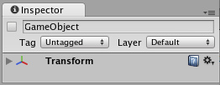

Notice that an empty GameObject still contains a Name, a [Tag](http://unity3d.com/support/documentation/Components/Tags.html), and a [Layer](http://unity3d.com/support/documentation/Components/Layers.html). Every GameObject also contains a [Transform Component](http://unity3d.com/support/documentation/Components/class-Transform.html). It is impossible to create a GameObject in Unity without a Transform Component. All of the GameObject's Transform properties are enabled by its use of the Transform Component. The Transform Component just happens to be critical to all GameObjects, so each GameObject has one. But GameObjects can contain other Components as well.

注意一个空的游戏物体（对象）仍就包含一个名称、标签以及涂层。

*The Main Camera, added to each scene by default 主摄像机，默认添加到每个场景*

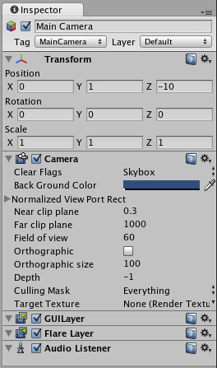

Taking a look at the Main Camera GameObject, we can see that it contains a different collection of Components. Specifically, a [Camera Component](http://unity3d.com/support/documentation/Components/class-Camera.html), a [GUILayer](http://unity3d.com/support/documentation/Components/class-GUILayer.html), a [Flare Layer](http://unity3d.com/support/documentation/Components/class-FlareLayer.html), and an [Audio Listener](http://unity3d.com/support/documentation/Components/class-AudioListener.html). All of these Components provide additional functionality to the GameObject. Without them, there would be nothing rendering the graphics of the game for the person playing! Rigidbodies, Colliders, Particles, and Audio are all different Components (or combinations thereof) that can be added to any given GameObject.

关注主摄像机游戏物体（对象），我们可以看到它包含不同的组件集合。具体而言，一个摄像机组件、一个GUI涂层，一个眩光涂层以及一个音频接收器。所有的这些组件都提供了额外的功能给游戏物体（对象）。没有它们，就将没有图形渲染的游戏让人玩！刚体、碰撞器、粒子以及音频都是不同的组件（或它们的组合）可以被添加到任何给定的游戏物体（对象）。

**The Transform Component 变换组件**

The Transform Component is one of the most important Components. It defines the GameObject's position, rotation, and scale in the game world/Scene View. If a GameObject did not have a Transform Component, it would be nothing more than some information in the computer's memory. It effectively would not exist in the world. The Transform Component also enables a concept called **Parenting**, which is utilized through the **Unity Editor** and is a critical part of working with GameObjects. If you would like to learn more about the Transform Component and Parenting, please read the [Transform Component Reference page](http://unity3d.com/support/documentation/Components/class-Transform.html).

变换组件是最重要的组件之一。它定义了游戏物体（对象）在游戏世界里或场景视图里的坐标（位置）、旋转、以及伸缩。如果一个游戏物体（对象）没有一个变换组件，它将只不过是在计算机内存了的一些信息。它将有效的不存在与世界。变换组件还启用了一个被称为父的概念，是通过使用Unity编辑器与游戏物体一起工作的重要组成部分。如果你想学习更多关于变换组件和父，请阅读变换组件参考页。

**The GameObject-Script Relationship 游戏物体（对象）-脚本关系**

When you create a **script** and and attach it to a GameObject, the script appears in the GameObject's Inspector just like a Component. This is because scripts become Components when they are saved. In technical terms, a script compiles as a type of Component, and is treated like any other Component by the Unity engine.

当你创建一个脚本并它放在一个游戏物体（对象）上，这个脚本显示在游戏物体（对象）的检视器里，就像一个组件。这是因为脚本变成组件当它们保存时。在技术方面，一个脚本编译为组件的一种类型，如同通过Unity引擎处理的所有其它组件。

Any public variables you declare in your script will appear editable or linkable in the Inspector of their GameObject. When you are writing a script, you can directly access any member of the **GameObject** class. You can see a list of all the **GameObject** class members [here](http://unity3d.com/support/documentation/Components/class-GameObject.html). If any of the indicated classes are attached to the GameObject as a Component, you can access that Component directly through the script by simply typing the member name. For example, typing **transform** is equivalent to **gameObject.transform**. The **gameObject** is assumed by the compiler, unless you specifically reference a different GameObject.

在你的脚本里你定义的任何公共变量将显示能编辑或在检视器里能连接它们的游戏物体（对象）。当你编写一个脚本的时候，你可以直接访问GameObject类的所有成员。你可以查看所有**GameObject**类的成员列表在这里。如果任何指定类作为一个组件被附属于一个游戏物体（对象），你可以访问那个组件，直接经由脚本通过完整键入成员的名称。例如，键入**transform**是等同于**gameObject.transform。gameObject**是假定的编译器，除非你特别引用一个不同的GameObject编译器。

Typing **this** will be accessing the script Component that you are writing. Typing **this.gameObject** is referring to the GameObject that the script is attached to. You can access the same GameObject by simply typing **gameObject**. Logically, typing **this.transform** is the same as typing **transform**. If you want to access a Component that is not included as a GameObject member, you have to use **gameObject.GetComponent()** which is explained on the next page.

键入**this**将访问你正在编写的脚本组件。键入**this.gameObjec**是引用此脚本附加的GameObject。键入**this.transform**与键入**transform**一样。如果你想访问一个没有被GameObject成员包含的组件，你必须使用**gameObject.GetComponent()，**这是在下一页说明的。

**Using Components 使用组件**

[Unity Manual](http://unity3d.com/support/documentation/Manual/index.html) > [User Guide](http://unity3d.com/support/documentation/Manual/User%20Guide.html) > [Building Scenes](http://unity3d.com/support/documentation/Manual/Building%20Scenes.html) > [Using Components](http://unity3d.com/support/documentation/Manual/Using%20Components.html)

Unity 手册->用户指南->建立场景->使用组件

**Components** are the nuts & bolts of objects and behaviors in a game. They are the functional pieces of every **GameObject**. If you don't yet understand the relationship between Components and GameObjects, we recommend that you read the [GameObjects](http://unity3d.com/support/documentation/Manual/GameObjects.html) page before going any further.

组件是对象的基本组成部分以及游戏里的行为。它们是每个**GameObject（游戏物体）**的功能件。如果你还没有理解组件与**GameObject**（游戏物体）之间的管理，我们建议你阅读[GameObjects](http://unity3d.com/support/documentation/Manual/GameObjects.html)页在进一步之前。

A GameObject is a container for many different Components. By default, all GameObjects automatically have a **Transform** Component. This is because the Transform dictates where the GameObject is located, and how it is rotated and scaled. Without a Transform Component, the GameObject wouldn't have a location in the world. Try creating an empty GameObject now as an example. Click the **GameObject->Create Empty** menu item. Select the new GameObject, and look at the **Inspector**.

一个GameObject（游戏物体）是许多不同组件的容器。默认情况下，所有的GameObject（游戏物体）自动拥有一个Transform（变换）组件。这是因为Transform（变换）决定了GameObject（游戏物体）被定位哪里，以及它是如何旋转和缩放。没有Transform的组件，GameObject（游戏物体）将没有一个位置（坐标），在世界里。现在尝试创建一个空的GameObject（游戏物体）作为例子。点击 **GameObject->Create Empty** 菜单项。选取新GameObject（游戏物体），并查看**Inspector**（检视器）。



*Even empty GameObjects have a Transform Component* 甚至空的GameObject（游戏物体）有一个*Transform组件*

Remember that you can always use the Inspector to see which Components are attached to the selected GameObject. As Components are added and removed, the Inspector will always show you which ones are currently attached. You will use the Inspector to change all the properties of any Component (including scripts)

记住，你总可以使用检视器图查看哪些组件连接到（附属于）选定的GameObject（游戏物体）。As Components are added and removed, the Inspector will always show you which ones are currently attached.作为组件被添加和删除，检视器会始终显示你哪些是目前连接。你You will use the Inspector to change all the properties of any Component (including scripts)你你将使用检视器去改变所有任何组件的属性（包括脚本）。

**Adding Components 添加脚本**

You can add Components to the selected GameObject through the Components menu. We'll try this now by adding a **Rigidbody** to the empty GameObject we just created. Select it and choose **Component->Physics->Rigidbody** from the menu. When you do, you will see the Rigidbody's properties appear in the Inspector. If you press **Play** while the empty GameObject is still selected, you might get a little surprise. Try it and notice how the Rigidbody has added functionality to the otherwise empty GameObject.

你可以添加组件到选定的GameObject（游戏物体），通过组件菜单。 现在,We'll try this now by adding a we just created.我们将尝试这个，通过添加**刚体**到我们刚刚创建的空白GameObject（游戏物体）。选取它并从菜单那选择 Select it and choose **Component->Physics->Rigidbody** from the menu.。。。。。。

。 。When you do, you will see the Rigidbody's properties appear in the Inspector.当你这样做时，你将看到刚体的属性出现，在检视器里。 If you press is still selected, you might get a little surprise.如果您按**播放**而空白的GameObject仍然处于选中状态，你可能会得到一些惊喜。尝试并注意刚体已经添加的功能如何对空白GameObject（游戏物体）其它方面。

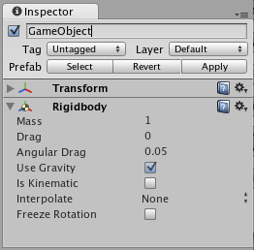

*An empty GameObject with a Rigidbody Component attached* 一个空白的GameObject与一个刚体组件连接

You can attach any number or combination of Components to a single GameObject. Some Components work best in combination with others. For example, the Rigidbody works with any Collider. The Rigidbody controls the Transform through the **Ageia PhysX** physics engine, and the Collider allows the Rigidbody to collide and interact with other Colliders. A different example of Component combinations is a **Particle System**. They use a **Particle Emitter**, **Particle Animator**, and **Particle Renderer** to create a group of moving particles.

你可以连接任何数量或组件的集合到一个单一的GameObject。一些组件与其它组件结合在一起工作最好。例如，刚体与任意的碰撞器一起工作。刚体控制变换通过**Ageia PhysX**物理引擎，以及碰撞器运行刚体去碰撞和与其它碰撞器结合。一个组件集合的不同的例子是粒子系统。它们使用一个粒子发射器、粒子动画、以及粒子渲染去建立一个移动的粒子群。

If you want to know more about using a particular Component, you can read about any of them in the [Component Reference](http://unity3d.com/support/documentation/Components/Components.html). You can also access the reference page for a Component from Unity by clicking on the small **?** on the Component's header in the Inspector.

如果你想去知道更多关于使用一个详细组件，你可以阅读关于它们在组件参考里。

**Editing Components 编辑组件**

One of the great aspects of Components is flexibility. When you attach a Component to a GameObject, there are different values or **Properties** in the Component that can be adjusted in the editor while building a game, or by scripts when running the game. There are two main types of Properties: **Values** and **References**.

组件主要的特性之一是灵活性。当你连接一个组件到一个GameObject（游戏物体），有不同的值或属性在组件里，在建造一个游戏的过程中可以在编辑器里调整，或在游戏运行时通过脚本进行处理。有两种主要的属性类型：值和引用。

Look at the image below. It is an empty GameObject with an **Audio Source** Component. All the values of the **Audio Source** in the Inspector are the default values.

查看下面的图片，这个一个空白的GameObject带有一个音频源组件。在检视器里的音频源组件的所有值是默认值。

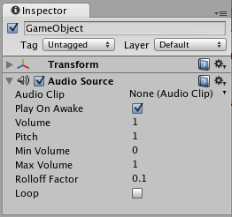

This Component contains a single Reference property, and seven Value properties. **Audio Clip** is the Reference property. When this Audio Source begins playing, it will attempt to play the audio file that is referenced in the **Audio Clip** property. If no reference is made, an error will occur because there is no audio to be played. You must reference the file within the Inspector. This is as easy as dragging an audio file from the Project View onto the Reference Property.

这个组件含有一个简单引用属性，已经七个值属性。音频剪辑是引用属性。当这个音频源开始播放时，它将连接到播放音频文件，它是在音频剪辑属性里被引用。如果没有引用被设置，一个错误将出现因为没有音频去播放。你必须在检视器里引用一个文件。这非常简单，从项目视图（面板）里拖动一个音频文件到引用属性上即可。

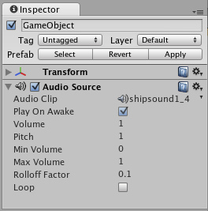

*Now a sound effect file is referenced in the* ***Audio Clip*** *property* 现在一个声音效果文件被引用在音频剪辑属性里。

Components can include references to any other type of Component, file, or GameObject. For any of these, you just need to drag & drop the appropriate reference to the property. This type of referencing is very quick and powerful, especially when using scripting. To learn more about using scripts and properties, please view the Scripting Tutorial on the [Tutorials](http://unity3d.com/support/documentation/Manual/Tutorials.html) page.

组件可以包括引用任何其它类型的组件、文件、或GameObject。对于这些，你仅需要拖放合适的引用到这个属性。引用类型是非常块和强大的，特别在使用脚本时。学习更多关于使用脚本和属性，请查看脚本教程在教程页。

The seven remaining properties on the Audio Clip are all Value properties. These can all be adjusted simply by clicking on them and pressing the Enter key. You can then enter any value you like using the keyboard, and press Enter to save the value.

在音频剪辑上剩余的七个属性被称为值属性。这些可以被调整仅仅通过在它们上面点击或按回车键。你可以输入任何你希望的值使用键盘，然后按回车键保存值。

You can also option- or right-click and drag on numeric properties to scroll values quickly

你也可以选择，或右键单击并在数值属性上面拖动去快速滚动值。（注意：在windows上左键单击）

The Value properties on the Audio Clip are all numeric, but some properties can be strings as well. For example, the **Text Mesh** Component contains a **Text** property, which accepts alphanumeric characters.

在音频剪辑上的值属性是数字，但一些属性可以也可是字符串。例如，文字网格组件包含一个文字属性，它接受字母数字字符。

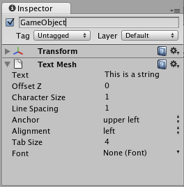

*Some values can contain text, like the* ***Text*** *property in the Text Mesh Component某些值可以包含文字，如在文本的Text属性网格组件*

**Testing out Properties 测试属性**

While your game is in **Play Mode**, you are free to change properties in any GameObject's Inspector. For example, you might want to experiment with different heights of jumping. If you create a **Jump Height** property in a script, you can enter Play Mode, change the value, and press the jump button to see what happens. Then without exiting Play Mode you can change it again and see the results within seconds. When you exit Play Mode, your properties will revert to their pre-Play Mode values, so you don't lose any work. This workflow gives you incredible power to experiment, adjust, and refine your gameplay without investing a lot of time in iteration cycles. Try it out with any property in Play Mode. We think you'll be impressed.

当你的游戏是播放模式时，在任意GameObject的检视器里自由的修改属性。例如，你也许想去实验不同的高度跳跃。如果你创建一个**Jump Heigh属性**在脚本里，你可以进入播放模式，修改此值，然后按跳跃键去看发生了什么。不用退出播放模式，你可以再次修改它并看结果在几秒钟内。当你退出播放模式，你的属性将恢复它们播放前的值，因此你就不会丢失任何工作。工作流给你难以置信的能力去实验、调整和完善你的游戏可玩性不用投入大量的时间反复循环操作。在播放模式利用任意属性实验它。我们认为你将会留下深刻印象。

**Removing Components 删除组件**

If you want to remove a Component, option- or right-click on its header in the Inspector, and choose **Remove Component**. Or you can left-click the options icon next to the **?** on the Component header. All the property values will be lost and this cannot be undone, so be completely sure you want to remove the Component before you do.

如果你想删除一个组件，在它的头上点鼠标右键单击在检视器里然后选择**Remove Component，**或者，你可以在？号旁边的选项图标上点鼠标左键在组件头上。所有属性值将被丢失，此项操作不能恢复（回退），因此，在你做之前，要十分确定你想删除组件。

**The Component-Script Relationship 组件-脚本关系**

Although **Scripts** seem very different from Components at first, the truth is that a script is a type of Component. Basically, it is a Component that you are creating yourself. You will define its members to be exposed in the Inspector, and it will execute whatever functionality you've written.

首先尽管脚本与组件看起来非常不同，事实上脚本是一宗组件类型。基本上，它是需要你自己创建的一个组件。你将定义它的成员在检视器里暴露，以及它将执行你写的什么功能。

**Scripting Components 脚本组件**

There are many Components that can be directly accessed in any script. For example, if you want to access the **Translate** function of the Transform component, you can just write **transform.Translate()** or **gameObject.transform.Translate()**. This works because all scripts are attached to a GameObject. So when you write **transform** you are implicitly accessing the Transform Component of the GameObject that is being scripted. To be explicit, you write **gameObject.transform**. There is no advantage in one method over the other, it's all a matter of preference for the scripter.

有许多组件可以被直接在任何脚本里访问。例如，如果你想去访问Transform **组件的Translate函数，**你可以仅书写**transform.Translate()或gameObject.transform.Translate()。这样写**因为所有的脚本是连接到一个GameObject。因此，当你写**transform时，**你是暗地里连接存在的脚本GameObject 的Transform组件。明确的表达式，你写**gameObject.transform。**有没有一个比其它更好的方法，这一些都是脚本偏好问题。

To see a list of all the Components you can access implicitly, take a look at the [GameObject](http://unity3d.com/support/documentation/ScriptReference/GameObject.html) page in the [Scripting Reference](http://unity3d.com/support/documentation/ScriptReference/index.html).

查看所有你可以暗地里访问组件的列表， 在脚本引用里查看[GameObject](http://unity3d.com/support/documentation/ScriptReference/GameObject.html)页。

**Using GetComponent() 使用GetComponent()**

There are many Components which are not enabled as members of the **GameObject** class. So you cannot access them implicitly, you have to access them explicitly. You do this by calling the **GetComponent("component name")** and storing a reference to the result. This is most common when you want to make a reference to another script attached to the GameObject.

有一些组件不作为**GameObject类的成员。**因此，你不能暗地里访问它们，你必须明确的访问它们。你可以通过调用**GetComponent("component name")**并存储一个引用返回值。这是最常见的当你想进行一个引用其它脚本去连接GameObject时。

Pretend you are writing *Script B* and you want to make a reference to *Script A*, which is attached to the same GameObject. You would have to use **GetComponent()** to make this reference. In Script B, you would simply write: **scriptA = GetComponent("ScriptA");**

假定你正在编写*Script B，*你想要进行一个引用*Script A*，它是连接同样的GameObject。你应当必须使用**GetComponent()去**进行这个引用。在Script B里，你应当简单书写：**scriptA = GetComponent("ScriptA");**

Then you would be able access any of the Script A variables by writing **scriptA.variableName** within Script B. For more help with using **GetComponent()**, take a look at the [GetComponent() Script Reference page](http://unity3d.com/support/documentation/ScriptReference/GameObject.GetComponent.html).

然后你将能访问任何Script A的变量，通过书写**scriptA.variableName 在**Script B里。更过使用**GetComponent()帮组，查看**[GetComponent() 脚本引用页。](http://unity3d.com/support/documentation/ScriptReference/GameObject.GetComponent.html)

**Prefabs 预制品**

[Unity Manual](http://unity3d.com/support/documentation/Manual/index.html) > [User Guide](http://unity3d.com/support/documentation/Manual/User%20Guide.html) > [Building Scenes](http://unity3d.com/support/documentation/Manual/Building%20Scenes.html) > [Prefabs](http://unity3d.com/support/documentation/Manual/Prefabs.html)

用户手册->用户指南->建立场景->预制品

A **Prefab** is a type of asset -- a reusable **GameObject** stored in **Project View**. Prefabs can be inserted into any number of scenes, multiple times per scene. When you add a Prefab to a scene, you create an **instance** of it. All Prefab instances are linked to the original Prefab and are essentially clones of it. No matter how many instances exist in your project, when you make any changes to the Prefab you will see the change applied to all instances.

预制品是一个资产的类型—一个**存储在**项目视图（面板）里可以重复使用的**GameObject（游戏物体）。**预制品可以被插入任何数量的场景、每个场景多次。当你添加以讹预制品到一个场景，你创建一个预制品的实例。所有的预制品实例被连接到原始的预制品，本质上是它自己的复制品（克隆）。不管如何许多实例存在于你的项目里，当你做任何更改到预制品你将看到更改被应用于所有的实例。

**Creating Prefabs 创建预制品**

In order to create a Prefab, you must make a new blank Prefab using the menu. This blank Prefab contains no GameObjects, and you cannot create an instance of it. Think of a new Prefab as an empty container, waiting to be filled with GameObject data.

为了创建一个预制品，你必须使用菜单件建一个新的空白预制品。这个空的预制品不包含GameObject（游戏物体），你也不能创建一个它的实例。把一个新的预制品作想象为一个空的容器，等待被用GameObject数据填充。

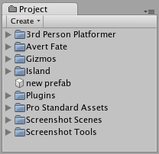

*A new, empty Prefab. It cannot be instanced until you fill it with a GameObject.*

*一个新的空预制品，它不能被实例化直到你用一个GameObject填充它*

To fill the Prefab, you use a GameObject that you've created in the scene.

去填充这个预制品，你使用一个你已经在场景里创建的GameObject。

1. Choose **Assets->Create->Prefab** from the menu bar and name your new Prefab.

从菜单条选择**Assets->Create->Prefab**并命名你新的预制品。

1. In **Hierarchy View**, select the GameObject you wish to make into a Prefab.

在层次视图（面板）里，选取你希望去制成一个预制品的GameObject

1. Drag & drop the GameObject from the Hierarchy onto the new Prefab in Project View.

从层次拖放这个GameObject 到在项目视图里的那个新的预制品上。

After you have performed these steps, the GameObject and all its children have been copied into the Prefab data. The Prefab can now be re-used in multiple instances. The original GameObject in the Hierarchy has now become an instance of the Prefab.

你处理完这些步骤之后，GameObject以及所有它的子已经被复制到预制品的数据里。预制品现在可以被重复使用在多个实例里。在层次里的原始GameObject现在已经变成预制品的一个实例。

**Prefab Instances 预制品实例**

To create a Prefab instance in the current scene, drag the Prefab from the Project View into the **Scene** or Hierarchy View. This instance is **linked** to the Prefab, as displayed by the blue text used for their name in the Project View.

在当前场景创建一个预制品实例，从项目视图里拖动预制品到场景里或层次视图里。这个实例被连接到预制品，在项目视图里它们的名称用蓝色文本显示。

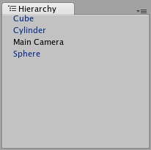

*Three of these GameObjects are linked to Prefabs. One of them is not. GameObjects中的*三个*连接到预制品，有一个没有连接。*

* If you have selected a Prefab instance, and want to make a change that affects all instances, you can click the **Select** button in the Inspector to select the source Prefab.
* 如果你已经选取了一个预制品实例，并想对更改一个而影响所有的实例，你可以在检视器里点击**Select按钮**去选取源预制品。
* Information about instantiating prefabs from scripts is in the [Instantiating Prefabs](http://unity3d.com/support/documentation/Manual/Instantiating%20Prefabs.html) page.
* 关于从脚本实例化预制品的信息在安装预制品页。

**Inheritance 继承**

Inheritance means that whenever the source Prefab changes, those changes are applied to all linked GameObjects. For example, if you add a new script to a Prefab, all of the linked GameObjects will instantly contain the script as well. However, it is possible to change the properties of a single instance while keeping the link intact. Simply change any property of a prefab instance, and watch as the variable name becomes bold. The variable is now overridden. All overridden properties will not be affected by changes in the source Prefab.

集成意味着只要源预制品改变，这些改变都适用于所有连接的GameObject。例如，如果你添加一个新的脚本到预制品，所有连接的GameObject将也立即包含脚本。然而，它是有可能改变一个单一实例的属性，同时保持原有的连接。简单改变任意的一个预制品实例的属性，变量名称变为粗体显示。这个变量现在是覆盖。所有覆盖的变量将不受更改影响在源预制品里。

This allows you to modify Prefab instances to make them unique from their source Prefabs without breaking the Prefab link.

允许你修改预制品实例使它们独立从它们源预制品，没有打破预制品连接。

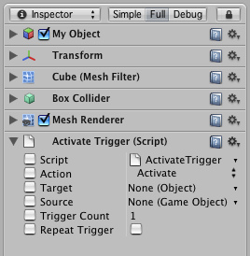

*A linked GameObject with no overrides enabled.* 一个没有覆盖*GameObject连接启用*

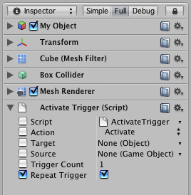

*A linked GameObject with one override enabled.* 一个有覆盖*GameObject的连接启用*

If you want to update the source Prefab and all instances with the new overridden values, you can click the **Apply** button in the Inspector.

如果你想更新源预制品以及所有的实例用新覆盖值，你可以点击**Apply（应用）按钮**在检视器里。

If you want to discard all overrides on a particular instance, you can click the **Revert** button.

如果你想放弃所有的覆盖在一个特殊的实例上，你可以点击**Revert（还原）按钮**

**Breaking and Restoring Prefab Links 断开与恢复预制品连接**

There are certain actions which will break the link between a single instance and its source prefab, but the link can always be restored. Actions that will break the link:

有确定的操作将断开一个单一实例与它们源预制品之间的连接，但连接可以总被恢复。端开连接的方法：

* Adding or removing a Component 添加或移除一个组件
* Adding or removing a child GameObject 添加或移除一个子GameObject

These actions will prompt a warning/confirmation message about breaking the link. Confirming the action will break the link so changes to the source Prefab will no longer affect the broken instance. To restore the link, you can click either the **Reconnect** or **Apply** buttons in the Inspector of the instance.

这些操作将提示一个警告/确认断开连接消息框。确定操作将断开连接使改变源预制品将不在影响端口的实例。恢复连接，你可以点击任一的**Reconnect（重新连接）或Apply（应用）按钮**在实例的检视器里。

* **Reconnect** will discard all differences from the source Prefab. **Reconnect（重新连接）将**放弃从源预制品的所有差异。
* **Apply** will copy all differences into the source Prefab (and therefore, all other Prefab instances)
* **Apply（应用）**将复制所有差异到源预制品（因此，含有所有其它预制品实例）

**Imported Prefabs 引入预制品**

When you place a mesh asset into your Assets folder, Unity automatically imports the file and generates something that looks similar to a Prefab out of the mesh. This is not actually a Prefab, it is simply the asset file itself. Instancing and working with assets introduces some limitations that are not present when working with normal Prefabs.

当你放置一个网格资产到你的资产文件夹，Unity自动的引入文件和生成一些类似于一个用网格制成的预制品。这不是一个实际的预制品，仅仅是一个资产文件本身。实例和资产的工作引入了一些限制，当与正常预制品一起工作时不存在。

*Notice the asset icon is a bit different from the Prefab icons 注意资产图标是异于预制品图标。*

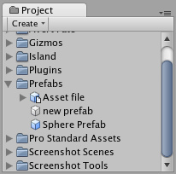

The asset is instantiated in the scene as a GameObject, linked to the source asset instead of a normal Prefab. Components can be added and removed from this GameObject as normal. However, you cannot apply any changes to the asset itself since this would add data to the asset file itself! If you're creating something you want to re-use, you should make the asset instance into a Prefab following the steps listed above under "Creating Prefabs".

资产是在场景里作为一个GameObject实例，连接到源资产而不是一个正常的预制品。组件可以正常的从一个GameObject被添加和移除。然而，你不能应用任何改变到资产它本身因为这将添加数据到资产文件本身。如果要创建的东西想重复使用，你应该使资成为一个预制品，跟随在“创建预制品”栏目下列出的步骤。

* When you have selected an instance of an asset, the **Apply** button in the Inspector is replaced with an **Edit** button. Clicking this button will launch the editing application for your asset (e.g. Maya or Max).

当以已经选取了一个资产实例，在检视器里的**Apply（应用）**按钮被替换为一个**Edit（编辑）**按钮。点击这个按钮将启动你的资产编辑应用程序（例如 Maya 或MAX）。

**Lights 光源**

[Unity Manual](http://unity3d.com/support/documentation/Manual/index.html) > [User Guide](http://unity3d.com/support/documentation/Manual/User%20Guide.html) > [Building Scenes](http://unity3d.com/support/documentation/Manual/Building%20Scenes.html) > [Lights](http://unity3d.com/support/documentation/Manual/Lights.html)

Unity手册->用户指南->建立场景->光源

**Lights** are an essential part of every scene. While meshes and textures define the shape and look of a scene, lights define the color and mood of your 3D environment. You'll likely work with more than one light in each scene. Making them work together requires a little practice but the results can be quite amazing.

光源是每个场景的基本部分。当网格和纹理定义场景的外观和形状的时候，光源定义你的3D环境的颜色和状态。你或许希望在每个场景里使用多个光源工作。使它们一起工作需要稍加练习但结果可能是非常惊人的。

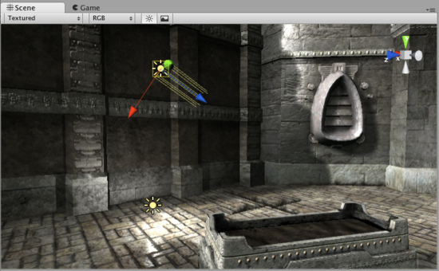

*A simple, two-light setup* 一个简单的，两个光源设置。

Lights can be added to your scene from the **GameObject->Create Other** menu. There are three types of lights which we'll discuss in a moment. Once a light has been added, you can manipulate it like any other GameObject. Additionally, you can add a Light Component to any selected GameObject by using **Component->Rendering->Light**.

光源可以从**GameObject->Create Other**被添加到你场景。有三种类型的光源，我们将在组件里讨论它们。一旦一个光源被添加，你可以操纵它像操纵其它的任何GameObject一样。另外，通过使用**Component->Rendering->Light**你可以添加一个光源到任何一个选取的GameObject。

There are many different options within the Light Component in the **Inspector**.

在检视器里光源组件有许多不同的选项。

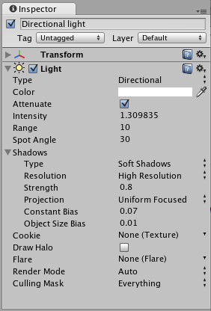

*Light Component properties in the Inspector* 在检视器里的光源组件属性。

By simply changing the **Color** of a light, you can give a whole different mood to the scene.

通过简单修改光源的颜色，你可以给场景完全不同的状态。

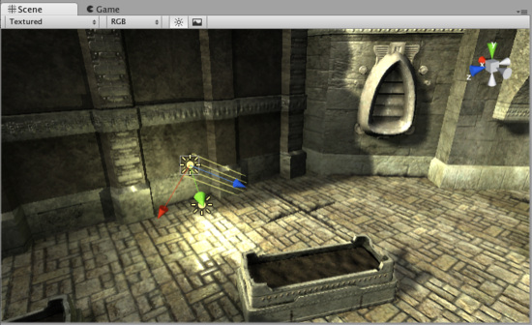

*Bright, sunny lights* 明亮，阳光光源

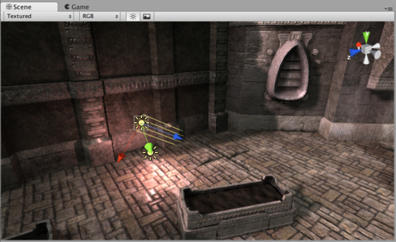

*Dark, medieval lights* 黑暗，中世纪光源

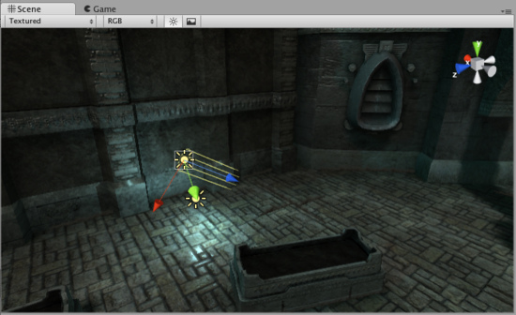

*Spooky night lights* 幽灵夜间光源

**More information 更多信息**

For more information about using Lights, check the [Lights page](http://unity3d.com/support/documentation/Components/class-Light.html) in the [Reference Manual](http://unity3d.com/support/documentation/Components/index.html).

关于使用光源的更多信息，产看在参考手册里的光源页。

**Cameras 摄像机**

[Unity Manual](http://unity3d.com/support/documentation/Manual/index.html) > [User Guide](http://unity3d.com/support/documentation/Manual/User%20Guide.html) > [Building Scenes](http://unity3d.com/support/documentation/Manual/Building%20Scenes.html) > [Cameras](http://unity3d.com/support/documentation/Manual/Cameras.html)

Unity手册->用户指南->创建场景->摄像机

Just as cameras are used in films to display the story to the audience, **Cameras** in Unity are used to display the game world to the player. You will always have at least one camera in a scene, but you can have more than one. Multiple cameras can give you a two-player splitscreen or create advanced custom effects. You can animate cameras, or control them with physics. Practically anything you can imagine is possible with cameras, and you can use typical or unique cameras to fit your game's style.

正如摄像机用于电影显示故事给观众，在Unity里摄像机用于显示游戏世界给玩家。在一个场景里，你总是拥有至少一个摄像机，但你可以拥有超过一个的摄像机。多个摄像机可以给你两个玩家分屏或建立高级的客户效果。你可以动画摄像机，或物理控制它们。你可以设想几乎任何事情是摄像机发生的已经你可以使用典型的或独特的摄像机以适合你的游戏的风格。

The remaining text is from the [Camera Component reference](http://unity3d.com/support/documentation/Components/class-Camera.html) page.

剩余的文本来自于摄像机组件引用页。

**Camera 摄像机**

**Cameras** are the devices that capture and display the world to the player. By customizing and manipulating cameras, you can make the presentation of your game truly unique. You can have an unlimited number of cameras in a scene. They can be set to render in any order, at any place on the screen, or only certain parts of the screen.

摄像机是捕获和展示世界该玩家的设备。通过定制和操纵摄像机，你可以使你的游戏真正独一无二的展示。在场景里你可以拥有不限数量的摄像机。它们可以被设置为任何顺序渲染、在屏幕的任何地方或仅是屏幕的以部分。

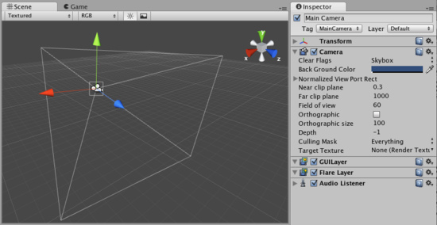

*Unity's flexible Camera object Unity的灵活的设计摄像机对象。*

**Properties 属性**

|  |  |
| --- | --- |
| **Clear Flags**  **清除标志** | Determines which parts of the screen will be cleared. This is handy when using multiple Cameras to draw different game elements.  确定屏幕的哪些部分将被清除。这是方便的当使用多个摄像机去绘制不同游戏元素时。 |
| **Background color**  **背景颜色** | Color applied to the remaining screen after all elements in view have been drawn and there is no skybox.  颜色应用于在所有在视图里的元素已经被绘制和没有天空盒之后的屏幕的剩余部分。 |
| **Normalized View Port Rect**  **标准视口矩形** | Four values that indicate where on the screen this camera view will be drawn, in Screen Coordinates (values 0-1).  四个值在屏幕上指定哪里，摄像机视图将被绘制，在场景里相配（值 0-1） |
| **X** | The beginning horizontal position that the camera view will be drawn.  摄像机视图开始的水平位置将被会绘制。 |
| **Y** | The beginning vertical position that the camera view will be drawn.  摄像机视图开始的垂直位置将被会绘制。 |
| **Width 宽度** | Width of the camera output on the screen.摄像机输出到屏幕上的宽度 |
| **Height 高度** | Height of the camera output on the screen.摄像机输出到屏幕上高度 |
| **Near clip plane近剪辑平面** | The closest point relative to the camera that drawing will occur.  相对于摄像机的最近点绘制将出现。 |
| **Far clip plane 远剪辑平面** | The furthest point relative to the camera that drawing will occur.  相对于摄像机的最远点绘制将出现。 |
| **Field of view 视界** | Width of the Camera's view angle, measured in degrees along the local Y axis.摄像机视角的宽度，沿本地y轴度量。 |
| **Orthographic 正交投影** | Toggles the camera's capability to simulate perspective.切换摄像机的性能去模拟远景 |
| **Orthographic size 正交投影大小** | The viewport size of the Camera when it is Orthographic.  当它是正交投影时，摄像机的视口大小。 |
| **Depth 深度** | The camera's position in the draw order. Cameras with a higher depth will be drawn on top of cameras with a lower depth value.  在绘制顺序里的摄像机的位置。拥有一个高深度的摄像机将紧接着所有低深度值的摄像机被绘制。 |
| **Culling Mask 剔除面具** | Include or omit layers of objects to be rendered by the Camera. Assign layers to your objects in the Inspector.  通过摄像机渲染包含或剔除对象的层。 在检视器里指定层到你的对象。 |
| **Render Target** (Unity Pro only) 渲染目标（Unity专业版仅有） | Reference to a [Render Texture](http://unity3d.com/support/documentation/Components/class-RenderTexture.html) that will contain the output of the Camera view. Making this reference will disable this Camera's capability to render to the screen.  引用一个包含摄像机视图输出的渲染纹理。使这个纹理将停用这个摄像机的性能去渲染屏幕。 |

**Details 详细资料**

Cameras are essential for displaying your game to the player. They can be customized, scripted, or parented to achieve just about any kind of effect imaginable. For a puzzle game, you might keep the Camera static for a full view of the puzzle. For a first-person shooter, you would parent the Camera to the player character, and place it at the character's eye level. For a racing game, you'd likely want to have the Camera follow your player's vehicle.

给玩家显示你的游戏摄像机是必需的。它们可以被定制、脚本或父类化取得恰当的任何可想象效果类型。对于一个益智游戏，你也许保持益智游戏全景视图的静态摄像机。对于一个第一人称射击，你将父类化摄像机给玩家角色以代替角色的视觉水平。对于赛车游戏，你可能希望有摄像机根须你的玩家的汽车。

You can create multiple Cameras and assign each one to a different **Depth**. Cameras are drawn from low **Depth** to high **Depth**. In other words, a Camera with a **Depth** of 2 will be drawn on top of a Camera with a depth of 1. You can adjust the values of the **Normalized View Port Rectangle** property to resize and position the Camera's view onscreen. This can create multiple mini-views like missile cams, map views, rear-view mirrors, etc.

你可以创建多个摄像机并指定每个摄像机不同的深度。摄像机从低深度到高深度绘制。换句话说，一个拥有深度2的将紧接着深度为1的被绘制。你可以调整水平视口矩形属性的值去调整大小和摄像机的视图在屏幕上的位置。这可以创建多个小视图就像发射物齿轮、地图窗口，后视镜等等。

**Clear Flags 清除标志**

Each Camera stores color and depth information when it renders its view. The portions of the screen that are not drawn in are empty, and will display the skybox by default. When you are using multiple Cameras, each one stores its own color and depth information in buffers, accumulating more data as each Camera renders. As any particular Camera in your scene renders its view, you can set the **Clear Flags** to clear different collections of the buffer information. This is done by choosing one of the four options:

当摄像机渲染它的视图时，每个摄像机存储颜色和深度信息。 屏幕的一部分是不绘制是空的，将默认被显示为天空。当你使用多个摄像机，每个摄像机存储它自己颜色和深度信息在缓存里、积累多的数据做个每个摄像机渲染。做为任一特殊的摄像机在你的场景里渲染它自己的视图，你可以设置清除标志去清除不同缓存信息的集合。这样做通过四个选项之一：

**Skybox 天空盒**

This is the default setting. Any empty portions of the screen will display the current Camera's skybox. If the current Camera has no skybox set, it will default to the skybox chosen in the [Render Settings](http://unity3d.com/support/documentation/Components/class-RenderSettings.html) (found in **Edit->Render Settings**). It will then fall back to the **Background Color**.

这是默认设置。任何场景的空白部分将先显示当前摄像机的天空盒。如果当前摄像机没有天空盒设置，它将默认为在渲染设置里（在**Edit->Render Settings里找到**）选择的天空盒。此后，它将回退到背景颜色。

**Solid Color 纯色**

Any empty portions of the screen will display the current Camera's **Background Color**.

屏幕的任何空白部分将显示当前摄像机的背景颜色。

**Depth Only 独立深度**

If you wanted to draw a player's gun without letting it get clipped inside the environment, you would set one Camera at **Depth** 0 to draw the environment, and another Camera at **Depth** 1 to draw the weapon alone. The weapon Camera's **Clear Flags** should be set to to **depth only**. This will keep the graphical display of the environment on the screen, but discard all information about where each object exists in 3-D space. When the gun is drawn, the opaque parts will completely cover anything drawn, regardless of how close the gun is to the wall.

如果你想去绘制一个玩家的枪 没有让它获得环境内侧剪辑，你应该设置摄像机在深度0绘制环境，其它摄相象在深度1绘制独立武器。武器摄像机的清除标志应该被设置为唯一深度。这将保持屏幕上环境图片显示，但是丢弃所有有关的每个对象存在于3D空间的地点信息。当枪被绘制时，不透明部分将完全覆盖任何事物绘制，不管抢是如何接近墙。

*The gun is drawn last, after clearing the depth buffer of the cameras before it*

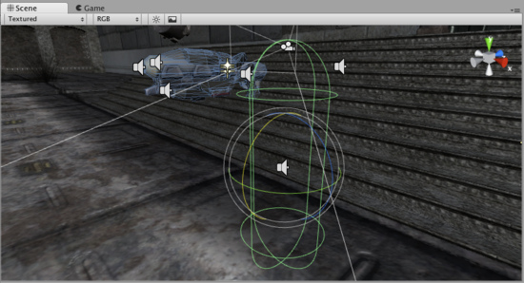

*抢被最后一次绘制，在摄像机的深度缓存清除前后。*

**Don't Clear 不清除**

This mode does not clear either the color or the depth buffer. The result is that each frame is drawn over the next, resulting in a smear-looking effect. This isn't typically used in games, and would likely be best used with a custom shader.

这个模式不清除任一的颜色或深度缓存。其结果是每帧被绘制在下一个之上，造成在一抹黑里的效果。在游戏里这不经常使用，有可能最好使用一个定制的阴影。

**Clip Planes 剪辑平面**

The **Near** and **Far Clip Plane** properties determine where the Camera's view begins and ends. The planes are laid out perpendicular to the Camera's direction and are measured from the its position. The **Near plane** is the closest location that will be rendered, and the **Far plane** is the furthest.

近处和远处剪辑面属性决定摄像机视图开始与结束的地方。平面是垂直布局于摄像机的方向并从它自己的位置来衡量。近处剪辑是接近渲染的本地，远处剪辑是最远的。

The clipping planes also determine how depth buffer precision is distributed over the scene. In general, to get better precision you should move the **Near plane** as far as possible.

剪辑的平面同样确认缓存精度如何分布在场景上。一般而言，去获得较好的精度你应该移动近处剪辑尽可能的远。

**Culling Mask 剔除面具**

The **Culling Mask** is used for selectively rendering groups of objects using Layers. More information on using layers can be found [here](http://unity3d.com/support/documentation/Components/Layers.html).

剔除面具被用于选择性的渲染对象组使用的层。使用层的更多信息在这里。

Commonly, it is good practice to put your User Interface on a different layer, then render it by itself with a separate Camera set to render the UI layer by itself.

一般地，一个良好的做法是把你的用户界面放置一个不同的层，然后渲染它它，利用各自摄像机设渲染它自己的UI层。

In order for the UI to display on top of the other Camera views, you'll also need to set the **Clear Flags** to **Depth only** and make sure that the UI Camera's **Depth** is higher than the other Cameras.

为了用户界面（UI）显示在其它摄像机的上面，你应该同样需要设置清除标志为单独深度并确定UI摄像机的深度是比其它摄像机高的高度。

**Normalized Viewport Rectangle 标准视口矩形**

**Normalized Viewport Rectangles** are specifically for defining a certain portion of the screen that the current camera view will be drawn upon. You can put a map view in the lower-right hand corner of the screen, or a missile-tip view in the upper-left corner. With a bit of design work, you can use **Viewport Rectangle** to create some unique behaviors.

**标准视口矩形**是特定定义一个屏幕的某一部分，当前摄像机视图将被绘制在上面。你可以放置一个地图视图在屏幕右手下角落里，或一个导弹提示视图在左上角。就设计工作的一点，你可以使用视口矩形去创建一些独特的行为。

It's easy to create a two-player split screen effect using **Normalized Viewport Rectangle**. After you have created your two cameras, change player one's Ymin value to 0.5, and player two's Ymax: value to 0.5. This will make player one's camera display from halfway up the screen to the top, and player two's camera will start at the bottom and stop halfway up the screen.

使用标准视口矩形很容易创建两个玩家分屏效果。在你已经建立两个摄像机之后，更改两个玩家之一的Ymin（y最小值）值为0.5，已经两个玩家的Ymax（y最大值）为0.5。这将使玩家之一的摄像机从屏幕的中部向上到顶部显示，以及第二个玩家的摄像机将开始在底部及停止在屏幕的中部。

*Two-player display created with* ***Normalized Viewport Rectangle 两个玩家显示利用标准视口矩形创建的。***

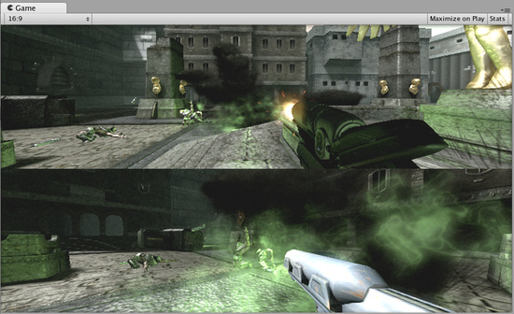

**Orthographic 正交投影**

Marking a Camera as **Orthographic** removes all perspective from the Camera's view. This is mostly useful for making isometric or 2D games.

使一个摄像机作为正交投影从摄像机的视图里删除所有透视。这是通常用于做等角（正交）或2D游戏。

*Perspective camera 透视摄像机.*

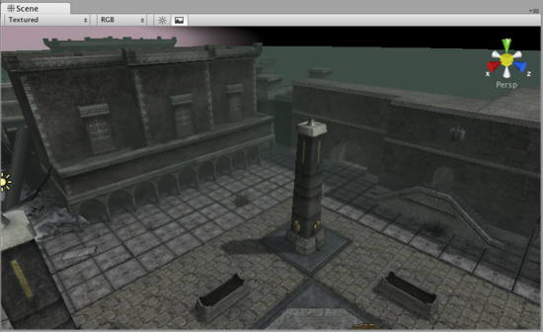

*Orthographic camera. Objects do not get smaller with distance here! 正交摄像机，对象不再获得小的位距这里！*

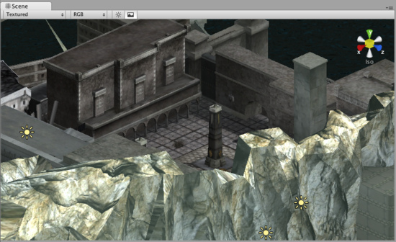

**Render Texture 渲染纹理**

This feature is only available for Unity Pro licenses (not applicable to any version of Unity iPhone). It will place the camera's view onto a [Texture](http://unity3d.com/support/documentation/Components/class-RenderTexture.html) that can then be applied to another object. This makes it easy to create sports arena video monitors, surveillance cameras, reflections etc.

这个特性仅是Unity 专业版本据有的许可（不适用于Unity iPhone的任何版本）。它将放置摄像机视图在一个纹理上，然后可以被用于其它对象。这很容易的去创建体育场检视器，检视摄像机，反射等。

*A Render Texture used to create a live arena-cam 一个渲染纹理被用于创建一个实况转播体育场*

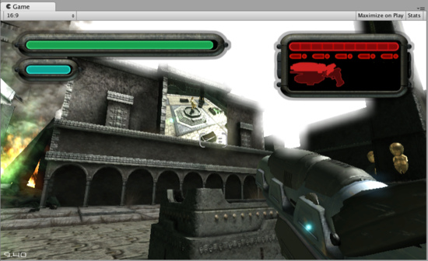

**Hints 提示**

Cameras can be instantiated, parented, and scripted just like any other GameObject.

摄像机可以被实例化、父类化、以及脚本化就像任何其它GameObject（游戏物体）。

To increase the sense of speed in a racing game, use a high **Field of View**.

为增加场景的速度感在一个赛车游戏里，使用高可视区。

Cameras can be used in physics simulation if you add a **Rigidbody** Component.

摄像机可以被用于物理仿真里如果你添加一个刚体组件。

There is no limit to the number of Cameras you can have in your scenes.

没有限制你拥有的摄像机的数量在你的场景里。

Orthographic cameras are great for making 3D user interfaces

正交投影摄像机可以制作3D用户界面。

If you are experiencing depth artifacts (surfaces close to each other flickering), try setting **Near Plane** to as large as possible.

如果你遇到史前古物深度技巧（表面接近的彼此闪烁），尝试设置近处平面尽可能的大。

Cameras cannot render to the Game Screen and a Render Texture at the same time, only one or the other.

摄像机不能渲染游戏场景和一个渲染纹理在同一时间，统一时间只能一个。

Pro license holders have the option of rendering a Camera's view to a texture, called Render-to-Texture, for even more unique effects.

专业版许可者拥有渲染的一个摄像机视图的渲染选项对一个纹理，称为渲染到纹理，为了更独特的效果。

Unity comes with pre-installed Camera scripts, found in **Components->Camera Control**. Experiment with them to get a taste of what's possible.

Unity配置了预安装摄像机脚本，在**Components->Camera Control**里找到。实验它们去获得可能发生的什么体验。

# [Unity Manual](http://unity3d.com/support/documentation/Manual/index.html) —> [User Guide](http://unity3d.com/support/documentation/Manual/User%20Guide.html) > [Building Scenes](http://unity3d.com/support/documentation/Manual/Building%20Scenes.html) > [Particle Systems](http://unity3d.com/support/documentation/Manual/Particle%20Systems.html)

# Unity手册—>用户手册—>建立场景—>粒子系统

# Particle Systems

# 粒子系统

Particles are essentially 2D images rendered in 3D space. They are primarily used for effects such as smoke, fire, water droplets, or leaves. A Particle System is made up of three separate Components: Particle Emitter, Particle Animator, and a Particle Renderer. You can use a Particle Emitter and Renderer together if you want static particles. The Particle Animator will move particles in different directions and change colors. You also have access to each individual particle in a particle system via scripting, so you can create your own unique behaviors that way if you choose.

粒子本质上是2D图象在3D空间的渲染。它们主要用于诸如烟，火，水飞沫，或树叶的装饰。一个 粒子系统由三个独立的组件组成： 粒子发射器， 粒子动画，以及 粒子渲染。如果你想建一个静态粒子，你可以使用一个粒子发射器和渲染结合处理。动画的粒子会移动不同的方向的粒子和改变颜色的粒子。你还可以在粒子系统中通过脚本访问每个粒子，因此，你可以选择创建自己独特的行为方式。

Please view the Particle Scripting Reference here.

粒子脚本参考 请查看[这里](http://unity3d.com/support/documentation/ScriptReference/ParticleEmitter.html)。

The remainder of this page's text is from the Particle Component Reference pages.

此网页的文本的其余部分是来之 [粒子组件参考](http://unity3d.com/support/documentation/Components/comp-ParticlesGroup.html) 页。

# Particle Components

# 粒子组件

## Particle Systems 粒子系统

Particle Systems in Unity are used to make clouds of smoke, steam, fire and other atmospheric effects. Particle Systems work by using one or two Textures & drawing them many times, creating a chaotic effect.

在Unity中，粒子系统通常用来制造烟雾，蒸气，火及其他大气的效果。粒子系统通过使用一个或两个纹理的多次绘制的操作，建立一个混乱的效果。

A Particle System included in the Standard Assets 标准资产包含的一个粒子系统

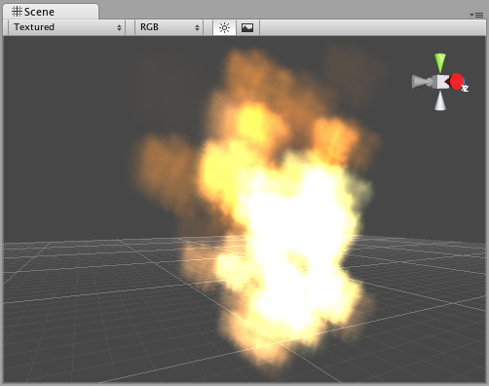

A typical Particle System in Unity is an object that contains a Particle Emitter, a Particle Animator and a Particle Renderer. The Particle Emitter generates the particles, the Particle Animator moves them over time, and the Particle Renderer draws them on the screen.

在Unity中，一个典型的粒子系统是一个对象，它包含一个粒子发射器、一个粒子动画和一个粒子渲染。粒子发射器产生所有的粒子，粒子动画随着时间移动它们，粒子渲染在屏幕上绘制它们。

If you want your particles to interact with the world, add a Particle Collider Component to the **GameObject**.

如果你希望你的粒子与游戏结合，添加一个[粒子对撞机](http://unity3d.com/support/documentation/Components/class-WorldParticleCollider.html)组件到一个**GameObject**。（游戏对象）

# Ellipsoid Particle Emitter 椭圆体的粒子发射器

The Ellipsoid Particle Emitter spawns particles inside a sphere. Use the Ellipsoid property below to scale & stretch the sphere.

椭圆体的粒子发射器在一个球面范围内产生粒子。使用椭圆体的伸展刻度属性在球面范围内进行伸展（放大或缩小）。

The Ellipsoid Particle Emitter *Inspector 椭圆体粒子发射器检视板*

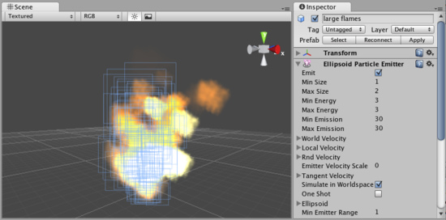

## Properties 属性

## Properties

|  |  |
| --- | --- |
| Emit  发射 | If enabled, the emitter will emit particles.  如勾选，发射器发射粒子 |
| Min Size  最小尺寸 | The minimum size each particle can be at the time when it is spawned.  产生粒子时的每个粒子的最小尺寸 |
| Max Size  最大尺寸 | The maximum size each particle can be at the time when it is spawned.  产生粒子时的每个粒子的最大尺寸 |
| Min Energy  最小能量 | The minimum lifetime of each particle, measured in seconds.  以秒计算，每个粒子最小生存期 |
| Max Energy  最大能量 | The maximum lifetime of each particle, measured in seconds.  以秒计算，每个粒子最大生存期 |
| Min Emission  最小发射 | The minimum number of particles that will be spawned every second.  每秒钟产生粒子的最小数量 |
| Max Emission  最大发射 | The maximum number of particles that will be spawned every second.  每秒钟产生粒子的最大数量 |
| World Velocity  全局速度 | The starting speed of particles in world space, along X, Y, and Z.  沿x,y,z轴粒子在全局空间的开始速度 |
| Local Velocity  本地速度 | The starting speed of particles along X, Y, and Z, measured in the object's orientation.  以物体的方向沿x，y，z轴的粒子开始速度 |
| Rnd Velocity  随即速度 | A random speed along X, Y, and Z that is added to the velocity.  沿x，y，z轴增量的随即速度 |
| Emitter Velocity Scale  发射速度缩放 | The amount of the emitter's speed that the particles inherit.  这个发射器速度数量继承至这些粒子（这个翻译的不明白） |
| Tangent Velocity  切线速度 | The starting speed of particles along X, Y, and Z, across the Emitter's surface.  交叉发射器的表面，沿x，y，z轴的粒子开始速度 |
| Simulate In World Space  在全局空间模拟 | If enabled, the particles don't move when the emitter moves. If false, when you move the emitter, the particles follow it around.  如勾选，当发射器移动时，粒子不移动。如不勾选，当移动发射器时，粒子跟随移动。 |
| One Shot  一次射击 | If enabled, the particle numbers specified by min & max emission is spawned all at once. If disabled, the particles are generated in a long stream.  如勾选，根据指定的粒子最小与最大数立即全部产生。如不勾选，粒子生成一个长的流。 |
| Ellipsoid  椭圆体 | Scale of the sphere along X, Y, and Z that the particles are spawned inside.  粒子产生在沿x，y，z轴伸缩球体的内部。 |
| **Min Emitter Range**  最小发射器范围 | Determines an empty area in the center of the sphere - use this to make particles appear on the edge of the sphere.  在球体中心确定一个空的区域，这个区域做为粒子出现的球体边界 |

## Details 详细说明

Ellipsoid Particle Emitters (EPEs) are the basic emitter, and are included when you choose to add a Particle System to your scene from Components->Particles->Particle System. You can define the boundaries for the particles to be spawned, and give the particles an initial velocity. From here, use the Particle Animator to manipulate how your particles will change over time to achieve interesting effects.

椭圆体粒子发射器（EPEs）是基本发射器，当你从Components->Particles->Particle System菜单选择增加一个粒子系统到你的场景时已经包含在其中。

Particle Emitters work in conjunction with Particle Animators and Particle Renderers to create, manipulate, and display Particle Systems. All three Components must be present on an object before the particles will behave correctly. When particles are being emitted, all different velocities are added together to create the final velocity.

粒子发射器与 [粒子动画师](http://unity3d.com/support/documentation/Components/class-ParticleAnimator.html)、[粒子渲染](http://unity3d.com/support/documentation/Components/class-ParticleRenderer.html)协同去创建，处理和显示粒子系统。在粒子正常运转之前，这三个组件必须存在于一个对象上。当粒子被发射，所有不同的速度相加形成粒子最终的速度。

### Spawning Properties （粒子）产生属性

Spawning properties like Size, Energy, Emission, and Velocity will give your particle system distinct personality when trying to achieve different effects. Having a small Size could simulate fireflies or stars in the sky. A large Size could simulate dust clouds in a musky old building.

当努力达到不同的效果时，产生粒子的属性，像大小、能量、发射和速度将给你的粒子系统独特的特性。一个小的尺寸可以模拟萤火虫或天空中的星星。一个大的尺寸可以模拟古色古香旧建筑物的尘埃。

Energy and Emission will control how long your particles remain onscreen and how many particles can appear at any one time. For example, a rocket might have high Emission to simulate density of smoke, and high Energy to simulate the slow dispersion of smoke into the air.

能量和发射将控制你的粒子在任何时间、任意数量的粒子在屏幕上显示多长的时间。例如：一个火箭有高的发射模拟烟雾，和高的能量模拟烟雾在空气中缓慢分散。

Velocity will control how your particles move. You might want to change your Velocity in scripting to achieve interesting effects, or if you want to simulate a constant effect like wind, set your X and Z Velocity to make your particles blow away.

速度将控制你的粒子如何移动。你或许想在脚本中更改速度实现有趣的效果，或则，你想模拟像风一样的恒定效果，设置你的X和Z轴的速度吹走你的粒子

### Simulate in World Space全局空间模拟

If this is disabled, the position of each individual particle will always translate relative to the Position of the emitter. When the emitter moves, the particles will move along with it. If you have Simulate in World Space enabled, particles will not be affected by the translation of the emitter. For example, if you have a fireball that is spurting flames that rise, the flames will be spawned and float up in space as the fireball gets further away. If Simulate in World Space is disabled, those same flames will move across the screen along with the fireball.

如这项是禁用的，每个个体粒子的坐标（位置）总转化为相对与该发射器的相对坐标。当发射器移动，粒子将随着该发射器移动。若Simulate in World Space选项是启用的，粒子将不受到发射器变换的影响。例如，你有一个火焰溅射上升的火球，作为火球的火焰将分散并悬浮在空间更远。若Simulate in World Space项是禁用的，这些相同火焰将随着火球在屏幕上一起移动。

### Emitter Velocity Scale 发射器速度缩放

This property will only apply if Simulate in World Space is enabled.

这个属性仅适用于Simulate in World Space选项已启动。

If this property is set to 1, the particles will inherit the exact translation of the emitter at the time they are spawned. If it is set to 2, the particles will inherit double the emitter's translation when they are spawned. 3 is triple the translation, etc.

若该属性设置为1，这些粒子将在它们产生时原样继承发射器的变化。若设置为2，这些粒子将在它们产生时两倍继承发射器的变化。若设置为2，这些粒子将在它们产生时三倍继承发射器的变化，等等。

### One Shot 一次射击

One Shot emitters will create all particles within the Emission property all at once, and cease to emit particles over time. Here are some examples of different particle system uses with One Shot Enabled or Disabled:

在发射属性内部，一次射击发射将立即建立全部粒子、时间过后发射粒子停止。这里有一些One Shot Enabled 启用 或Disabled禁止的不同粒子系统的例子：

Enabled: 启用

* Explosion 爆炸
* Water splash 水溅
* Magic spell 魔法

Disabled: 禁用

* Gun barrel smoke 枪管烟
* Wind effect 风效果
* Waterfall 瀑布

### Min Emitter Range 最小发射范围

The Min Emitter Range determines the depth within the ellipsoid that particles can be spawned. Setting it to 0 will allow particles to spawn anywhere from the center core of the ellipsoid to the outer-most range. Setting it to 1 will restrict spawn locations to the outer-most range of the ellipsoid.

这个最小发射范围确定粒子产生在椭圆体内的深度。设置为0，将允许粒子在从球体的外部边缘到中心的范围内

任何地方产生 ，设置为1，将限制在球体的边缘范围位置产生粒子。

*Min Emitter Range* of 0 最小范围为0

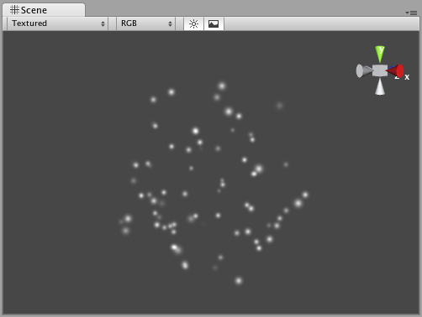

*Min Emitter Range* of 1最小范围为1

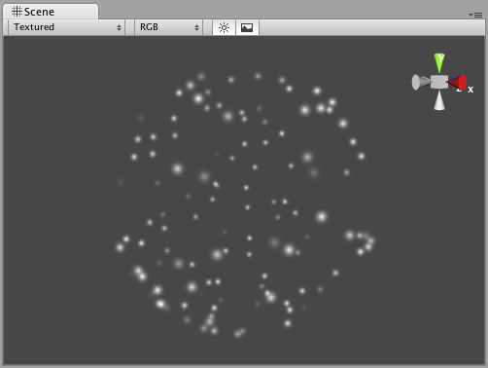

## Hints 提示

* Be careful of using many large particles. This can seriously hinder performance on low-level machines. Always try to use the minimum number of particles to attain an effect.
* 小心使用多的大粒子。这可能会严重妨碍低级别机器的性能。 总是试着用最小粒子数目达到效果
* The Emit property works in conjunction with the **AutoDestruct** property of the Particle Animator. Through scripting, you can cease the emitter from emitting, and then **AutoDestruct** will automatically destroy the Particle System and the GameObject it is attached to.
* 发射属性总是与粒子动画的自动毁坏属性一起工作。通过脚本，你可以停止发射器发射，然后自动毁坏属性将自动销毁粒子系统和它所附加游戏对象。

# Mesh Particle Emitter 网格粒子发射器

The Mesh Particle Emitter emits particles around a mesh. Particles are spawned from the surface of the mesh, which can be necessary when you want to make your particles interact in a complex way with objects.

网格粒子发射器发射网格状的粒子。当你想让你的粒子与物体一起相互影响时是必要的从网格的表面产生粒子。

The Mesh Particle Emitter *Inspector 网格粒子发射器检视面板*

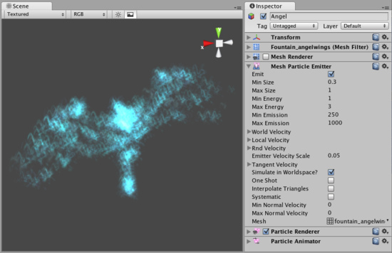

## Properties 属性

|  |  |
| --- | --- |
| Emit  发射 | If enabled, the emitter will emit particles.  若启用，发射器将发射粒子 |
| Min Size  最小尺寸 | The minimum size each particle can be at the time when it is spawned.  每个粒子在产生时的最小尺寸 |
| Max Size  最大尺寸 | The maximum size each particle can be at the time when it is spawned.  每个粒子在产生时的最大尺寸 |
| Min Energy  最小能量 | The minimum lifetime of each particle, measured in seconds.  以每秒钟计，每个粒子最小生存周期 |
| Max Energy  最大能量 | The maximum lifetime of each particle, measured in seconds.  以每秒钟计，每个粒子最大生存周期 |
| Min Emission  最小发射 | The minimum number of particles that will be spawned every second.  每秒钟将产生粒子的最小数量 |
| Max Emission  最大发射 | The maximum number of particles that will be spawned every second.  每秒钟将产生粒子的最大数量 |
| World Velocity  全局速度 | The starting speed of particles in world space, along X, Y, and Z.  沿X,Y,Z轴在全局空间的开始速度 |
| Local Velocity  局部速度 | The starting speed of particles along X, Y, and Z, measured in the object's orientation.  以物体的方向，沿X,Y,Z轴粒子的开始速度 |
| Rnd Velocity  随即速度 | A random speed along X, Y, and Z that is added to the velocity.  沿X,Y,Z轴随即增加的速度 |
| Emitter Velocity Scale  发射器速度伸缩 | The amount of the emitter's speed that the particles inherit.  从粒子继承的发射器的速度数量 |
| Tangent Velocity  切线速度 | The starting speed of particles along X, Y, and Z, across the Emitter's surface.  交叉通过发射器的表面沿X,Y,Z轴的粒子开始速度 |
| Simulate In World Space  空间模拟 | If enabled, the particles don't move when the emitter moves. If false, when you move the emitter, the particles follow it around.  若启用，当发射器移动，粒子不移动。若禁用，等发射器移动，粒子随着一起移动 |
| One Shot  一次射击 | If enabled, the particle numbers specified by min & max emission is spawned all at once. If disabled, the particles are generated in a long stream.  若启用，根据最小与最大属性指定的粒子数量立即产生粒子。若禁用，则产生一个粒子流 |
| Interpolate Triangles  插入三角形 | If enabled, particles are spawned all over the mesh's surface. If disabled, particles are only spawned from the mesh's vertrices.  若启用，粒子从网格表面的产生，若禁用，则只从网格的顶部产生 |
| Systematic  系统性 | If enabled, particles are spawned in the order of the vertices defined in the mesh. Although you seldom have direct control over vertex order in meshes, most 3D modelling applications have a very systematic setup when using primitives. It is important that the mesh contains no faces in order for this to work.  若启用，粒子在网管的顶部定义顺序产生，尽管你很少直接在网格顶部控制，多数的3D模型程序在使用一个系统的建立元素。重要的是这些网格包括不表面的顺序工作 |
| Min Normal Velocity  最小正常速度 | Minimum amount that particles are thrown away from the mesh.  粒子远离网格的最小数量 |
| Max Normal Velocity 最大正常速度 | Maximum amount that particles are thrown away from the mesh.  粒子远离网格的最大数量 |

## Details 详细说明

Mesh Particle Emitters (MPEs) are used when you want more precise control over the spawn position & directions than the simpler Ellipsoid Particle Emitter gives you. They can be used for making advanced effects.

当你想在更精确控制粒子产生位置与流向而简单的Ellipsoid Particle Emitte 不能提供时，使用网格粒子发射器（MPEs）。它们能够创造高级的效果。

MPEs work by emitting particles at the vertices of the attached mesh. Therefore, the areas of your mesh that are more dense with polygons will be more dense with particle emission.

MPEs发射粒子工作在所附网格的顶部。因此，你的网格区域是更密集的与多边的密集粒子发射区域。

Particle Emitters work in conjunction with Particle Animators and Particle Renderers to create, manipulate, and display Particle Systems. All three Components must be present on an object before the particles will behave correctly. When particles are being emitted, all different velocities are added together to create the final velocity.

粒子发射器与粒子动画、粒子渲染协同工作去创建、处理和显示粒子系统。在粒子正常运转前，三个组件必须一同存在于一个物体上。当粒子开始发射，所有不同的速度相加形成最终的速度。

### Spawning Properties （与上面的含义相同）

Spawning properties like Size, Energy, Emission, and Velocity will give your particle system distinct personality when trying to achieve different effects. Having a small Size could simulate fireflies or stars in the sky. A large Size could simulate dust clouds in a musky old building.

Energy and Emission will control how long your particles remain onscreen and how many particles can appear at any one time. For example, a rocket might have high Emission to simulate density of smoke, and high Energy to simulate the slow dispersion of smoke into the air.

Velocity will control how your particles move. You might want to change your Velocity in scripting to achieve interesting effects, or if you want to simulate a constant effect like wind, set your X and Z Velocity to make your particles blow away.

### Simulate in World Space （与上面的含义相同）

If this is disabled, the position of each individual particle will always translate relative to the Position of the emitter. When the emitter moves, the particles will move along with it. If you have Simulate in World Space enabled, particles will not be affected by the translation of the emitter. For example, if you have a fireball that is spurting flames that rise, the flames will be spawned and float up in space as the fireball gets further away. If Simulate in World Space is disabled, those same flames will move across the screen along with the fireball.

### Emitter Velocity Scale （与上面的含义相同）

This property will only apply if Simulate in World Space is enabled.

If this property is set to 1, the particles will inherit the exact translation of the emitter at the time they are spawned. If it is set to 2, the particles will inherit double the emitter's translation when they are spawned. 3 is triple the translation, etc.

### One Shot （与上面的含义相同）

One Shot emitters will create all particles within the Emission property all at once, and cease to emit particles over time. Here are some examples of different particle system uses with One Shot Enabled or Disabled:

Enabled:

* Explosion
* Water splash
* Magic spell

Disabled:

* Gun barrel smoke
* Wind effect
* Waterfall

## Interpolate Triangles 插入三角形

Enabling your emitter to Interpolate Triangles will allow particles to be spawned between the mesh's vertices. This option is off by default, so particles will only be spawned at the vertices.

启动你的发射器的插入三角形将允许粒子在网格顶部产生。这个选项默认是关闭的。因此，粒子只在在顶部产生。

A sphere with *Interpolate Triangles* off (the default) 一个带插入三角形关闭的球体（默认）

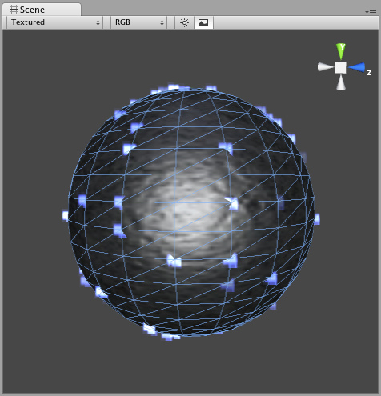

Enabling this option will spawn particles on and in-between vertices, essentially all over the mesh's surface (seen below).

启动该选项，将在网格表面顶部产生粒子。（看下面）

A sphere with *Interpolate Triangles* on 一个带打开插入三角形的球体

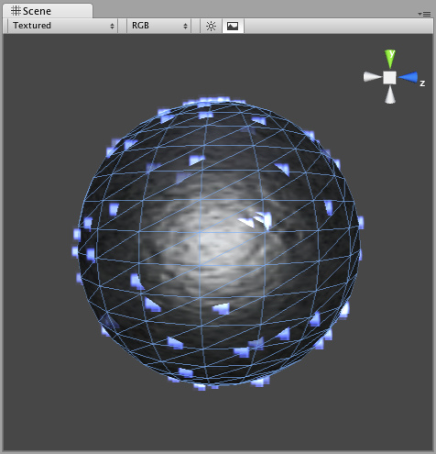

It bears repeating that even with Interpolate Triangles enabled, particles will still be denser in areas of your mesh that are more dense with polygons.

值得重申的是，即使插入三角形启动，粒子仍然在你的网格区域密集多边型。

## Systematic

系统性

Enabling Systematic will cause your particles to be spawned in your mesh's vertex order. The vertex order is set by your 3D modeling application.

开启系统性，将导致你的粒子在你的网格顶点顺序产生。顶点顺序的设置有你的3D模型程序设置。

An MPE attached to a sphere with *Systematic* enabled 一个MPE附在一个开启系统性的球体上

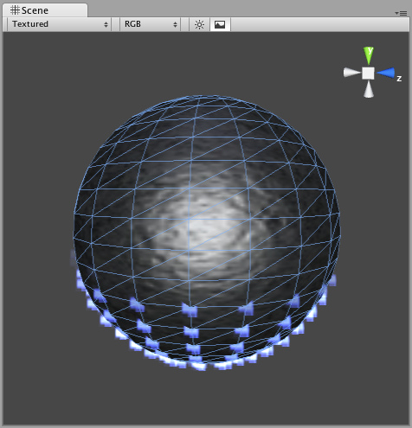

## Normal Velocity 正常速度

Normal Velocity controls the speed at which particles are emitted along the normal from where they are spawned.

正常速度控制哪个粒子从它们产生的地方沿正常发射速度来到。

For example, create a Mesh Particle System, use a cube mesh as the emitter, enable Interpolate Triangles, and set Normal Velocity Min and Max to 1. You will now see the particles emit from the faces of the cube in a straight line.

例如，建立一个网格粒子系统，使用一个立方体的网格作为发射器，启用插入三角形，设置正常最小速度与最大速度为1.你将看到粒子从立方体表面成一个直线发射。

## See Also 参阅

* How to make a Mesh Particle Emitter
* 如何构造一个网格发射器

## Hints （与上面相同）

* Be careful of using many large particles. This can seriously hinder performance on low-level machines. Always try to use the minimum number of particles to attain an effect.
* The Emit property works in conjunction with the **AutoDestruct** property of the Particle Animator. Through scripting, you can cease the emitter from emitting, and then **AutoDestruct** will automatically destroy the Particle System and the GameObject it is attached to.
* MPEs can also be used to make glow from a lot of lamps placed in a scene. Simply make a mesh with one vertex in the center of each lamp, and build an MPE from that with a halo material. Great for evil sci-fi worlds.

# Particle Animator 粒子动画

Particle Animators move your particles over time, you use them to apply wind, drag & color cycling to your particle systems.

粒子动画随着时间移动你的粒子，你使用它们引用到风上，拖动你的颜色板到你的粒子系统。

The Particle Animator *Inspector 粒子动画检视面板*

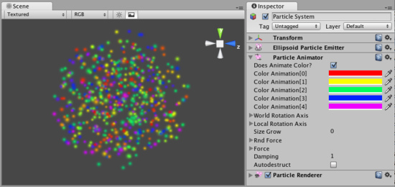

## Properties 属性

|  |  |
| --- | --- |
| Does Animate Color  做动画颜色 | If enabled, particles cycle their color over their lifetime.  若启用，粒子循环它们的颜色超过它们的生命周期 |
| Color Animation  颜色动画 | The 5 colors particles go through. All particles cycle over this - if some have a shorter life span than others, they will animate faster.  5种颜色粒子通过。所有粒子循环- 若有一些粒子生命比其它的短，它们的动画更快。 |
| World Rotation Axis  全局旋转轴 | An optional world-space axis the particles rotate around. Use this to make advanced spell effects or give caustic bubbles some life.  粒子围绕一个可选的全局空间轴旋转。使用这个可以制造高级的魅力效果或给予一个腐蚀性的生命气泡。 |
| Local Rotation Axis  本地旋转轴 | An optional local-space axis the particles rotate around. Use this to make advanced spell effects or give caustic bubbles some life.  粒子围绕一个可选的本地空间轴旋转。使用这个可以制造高级的魅力效果或给予一个腐蚀性的生命气泡。 |
| Size Grow  尺寸增长 | Use this to make particles grow in size over their lifetime. As randomized forces will spread your particles out, it is often nice to make them grow in size so they don't fall apart. Use this to make smoke rise upwards, to simulate wind, etc.  使用这个制造粒子增长大小超过它们的生命周期。作为随即力量将向外伸展你的粒子，通常使它们很好的增长尺寸不至于使它们下落崩溃。应用这个处理烟幕的上升，模拟风 等等。 |
| Rnd Force  随即强制 | A random force added to particles every frame. Use this to make smoke become more alive.  一个随即强制增加粒子每个帧。使用它处理烟雾更生动。 |
| Force  强制 | The force being applied every frame to the particles, measure relative to the world.  相对于全局的数量，强制对粒子每帧起作用 |
| Damping  衰减 | How much particles are slowed every frame. A value of 1 gives no damping, while less makes them slow down.  许多的粒子每帧变慢。在它们放慢过程中衰减值没有设为1 |
| Auto destruct  自动销毁 | If enabled, the GameObject attached to the Particle Animator will be destroyed when all particles disappear.  若启动，当所有的粒子消失时附加在动画粒子的游戏物体将销毁 |

## Details 详细信息

Particle Animators allow your particle systems to be dynamic. They allow you to change the color of your particles, apply forces and rotation, and choose to destroy them when they are finished emitting. For more information about Particle Systems, reference Mesh Particle Emitters, Ellipsoid Particle Emitters, and Particle Renderers.

粒子动画允许你的粒子系统是动态的。它们允许你更改你的粒子的颜色，应用强制和旋转，和选择当它们发射完毕销毁它们。更多的关于粒子系统的信息，参见 [网格粒子发射器](http://unity3d.com/support/documentation/Components/class-MeshParticleEmitter.html)，[椭球粒子发射器](http://unity3d.com/support/documentation/Components/class-EllipsoidParticleEmitter.html)和 [粒子渲染](http://unity3d.com/support/documentation/Components/class-ParticleRenderer.html)。

### Animating Color 动画颜色

If you would like your particles to change colors or fade in/out, enable them to Animate Color and specify the colors for the cycle. Any particle system that animates color will cycle through the 5 colors you choose. The speed at which they cycle will be determined by the Emitter's Energy value.

若你希望你的粒子更改颜色或渐显/淡出，启用它们的Animate Color 并指定颜色的循环周期。任何的粒子系统使用你所选择的5种颜色进行动画颜色的循环。它们的循环速度由发射器的Energy值决定。

If you want your particles to fade in rather than instantly appear, set your first or last color to have a low Alpha value.

若你想你的粒子渐显而不理解显示，设置你的第一或最后一个颜色为Alpha值

An *Animating Color* Particle System 一个动画颜色粒子系统

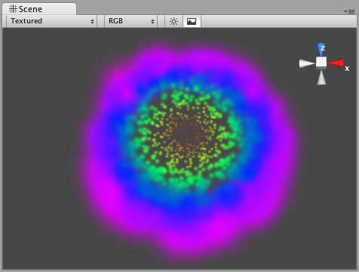

### Rotation Axes 旋转轴（坐标）

Setting values in either the Local or World Rotation Axes will cause all spawned particles to rotate around the indicated axis (with the Transform's position as the center). The greater the value is entered on one of these axes, the faster the rotation will be.

无论设置本地或全局旋转坐标将导致所有产生粒子围绕坐标旋转（以Transform的中心坐标）值越大进入这些坐标的粒子旋转越快。

Setting values in the Local Axes will cause the rotating particles to adjust their rotation as the Transform's rotation changes, to match its local axes.

设置本地值将导致旋转粒子以Transform的旋转改变排列一适应本地的坐标。

Setting values in the World Axes will cause the particles' rotation to be consistent, regardless of the Transform's rotation.

设置全局值将导致粒子的旋转的一致，不管以Transform的旋转。

### Forces & Damping 强制与衰减

You use force to make particles accelerate in the direction specified by the force.

你使用强制去处理粒子加速由强制指定的方向。

Damping can be used to decelerate or accelerate without changing their direction:

衰减用于处理加速或减速而不改变它们的方向

* A value of 1 means no Damping is applied, the particles will not slow down or accelerate.
* 值为1表示无衰减使用，这些粒子将不会减慢或加速
* A value of 0 means particles will stop immediately.
* 设为0表示粒子将立即停止
* A value of 2 means particles will double their speed every second.
* 设为2表示粒子将在每秒钟获得两倍的速度

### Destroying GameObjects attached to Particles

销毁附加粒子的游戏物体

You can destroy the Particle System and any attached **GameObject** by enabling the **AutoDestruct** property. For example, if you have an oil drum, you can attach a Particle System that has Emit disabled and **AutoDestruct** enabled. On collision, you enable the Particle Emitter. The explosion will occur and after it is over, the Particle System and the oil drum will be destroyed and removed from the scene.

你可以销毁通过启用**AutoDestruct属性的**粒子系统和任何附加的游戏物体。例如，若你有一个油桶，你可以附加一个发射禁止和自动销毁启用的粒子系统。在碰撞时，你启动粒子发射器。当爆炸发生结束后，粒子系统和油桶将销毁并从场景中移除。

。Note that automatic destruction takes effect only after some particles have been emitted. The precise rules for when the object is destroyed when **AutoDestruct** is on:

注意当一些粒子发射后自动销毁的效果就生效。这个精确规则为：当**AutoDestruct 开启，**物体就销毁

If there have been some particles emitted already, but all of them are dead now, or

If the emitter did have Emit on at some point, but now Emit is off.

如有一些粒子已经发射，但它们现在都死了或这个发射器在一些其它位置在发射，就关闭现在的发射。

## Hints 提示

* Use the Color Animation to make your particles fade in & out over their lifetime - otherwise, you will get nasty-looking pops.
* 使用颜色动画让你的粒子进行渐显和对它们的生命周期处理，否则，你将持久性的污染投影
* Use the **Rotation Axes** to make whirlpool-like swirly motions.
* 使用旋转坐标去处理旋窝般的动作。

# Particle Collider 粒子碰撞

The World Particle Collider is used to collide particles against other Colliders in the scene.

全局粒子碰撞通常用于在场景中与其它粒子碰撞。

A *Particle System* colliding with a *Mesh Collider 一个粒子系统碰撞的网格碰撞*

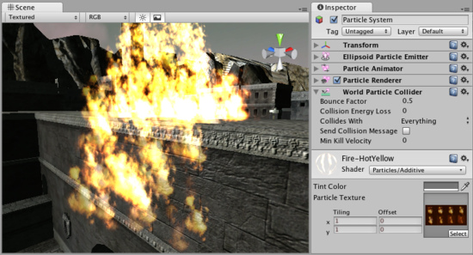

## Properties 属性

|  |  |
| --- | --- |
| Bounce Factor  弹跳因子 | Particles can be accelerated or slowed down when they collide against other objects. This factor is similar to the Particle Animator's Damping property.  当它们与其它物体碰撞时，这些粒子可以加速或放慢速度。这一因素与 Particle Animator's Damping 属性相似 |
| Collision Energy Loss  碰撞能量损失 | Amount of energy (in seconds) a particle should lose when colliding. If the energy goes below 0, the particle is killed.  当碰撞是，这些碰撞的粒子应失去能量（以秒计），若能力低于0的粒子就被杀死 |
| Min Kill Velocity  最小杀死速度 | If a particle's Velocity drops below Min Kill Velocity because of a collision, it will be eliminated.  若一个粒子的速度减低到最小杀死速度，因碰撞的原因，它将被淘汰 |
| Collides with  与碰撞 | Which Layers the particle will collide against.  每个阶层的俩字会相互碰撞 |
| Send Collision Message  发送碰撞消息 | If enabled, every particle sends out a collision message that you can catch through scripting.  若启用，每个粒子向外发送一个碰撞消息，你可以通过脚本抓取 |

## Details 详细资料

To create a Particle System with Particle Collider:

建立一个粒子碰撞系统：

1. Create a Particle System using **GameObject**->Create Other->Particle System

建立一个粒子系统，使用菜单 游戏物体—>建立其它 —>粒子系统

1. Add the Particle Collider using Component->Particles->World Particle Collider

添加碰撞粒子，使用菜单 组件—>粒子 —>全局粒子碰撞

### Messaging 消息

If Send Collision Message is enabled, any particles that are in a collision will send the message **OnParticleCollision**() to both the particle's **GameObject** and the GameObject the particle collided with.

若发送碰撞消息以启用，任何粒子碰撞都将发送消息，**OnParticleCollision**() 无论对于粒子的游戏物体还是游戏物体粒子碰撞。

## Hints 提示

Send Collision Message can be used to simulate bullets and apply damage on impact.

* 发送碰撞消息可以使用模拟子弹和应用损坏击打
* Particle Collision Detection is slow when used with a lot of particles. Use Particle Collision Detection wisely.
* 当使用大量的粒子粒子碰撞检测变慢。使用单个粒子碰撞检测明智
* Message sending introduces a large overhead and shouldn't be used for normal Particle Systems.
* 消息发送是一个大的开销，使用应不影响正常粒子系统

# Particle Renderer 粒子渲染

The Particle Renderer renders the Particle System on screen.

粒子渲染渲染粒子系统屏幕显示

The Particle Renderer *Inspector 粒子渲染检视面板*

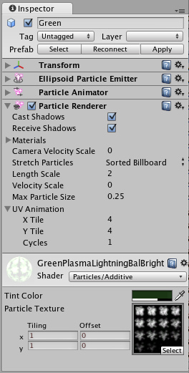

## Properties 属性

|  |  |
| --- | --- |
| Materials  材料 | Reference to a list of Materials that will be displayed in the position of each individual particle.  参考材料列表，每一个粒子的位置将显示 |
| Camera Velocity Scale  摄像机速度伸展 | The amount of stretching that is applied to the Particles based on Camera movement.  在摄像机移动基础上应用于粒子的伸展数量 |
| Stretch Particles  伸展粒子 | Determines how the particles are rendered.  确定如何渲染粒子 |
| Billboard  揭示栏 | The particles are rendered as if facing the camera.  面对摄像机粒子渲染 |
| Stretched  伸展 | The particles are facing the direction they are moving.  面对方向移动粒子渲染 |
| **Sorted Billboard**  排序揭示栏 | The particles are sorted by depth. Use this when using a blending material.  粒子深度排序。当使用混合材料时使用它 |
| **Vertical Billboard**  **垂直揭示栏** | All particles are aligned flat along the X/Z axes.  所有粒子以X/Z轴平面排列 |
| **Horizontal Billboard**  **垂直揭示栏** | All particles are aligned flat along the X/Y axes.  所有粒子以X/Y轴平面排列 |
| Length Scale  长度拉伸 | If Stretch Particles is set to Stretched, this value determines how long the particles are in their direction of motion.  若粒子拉伸设置为拉伸，则个值确定粒子在此方向上多长 |
| Velocity Scale  速度拉伸 | If Stretch Particles is set to Stretched, this value determines the rate at which particles will be stretched, based on their movement speed.  若粒子拉伸设置为拉伸，该值确定在粒子拉伸速度，以它们移动速度为基础 |
| UV Animation  紫外线动画 | If either of these are set, the UV coordinates of the particles will be generated for use with a tile animated texture. See the section on Animated Textures below.  如任一的或这些设置，紫外线与之相配的粒子将使用与动画材质一致并列产生。见下一结动画材质 |
| X Tile  X 排列 | Number of frames located across the X axis.  通过X轴定位帧的数量 |
| Y Tile  Y 排列 | Number of frames located across the Y axis.  通过Y轴定位帧的数量 |
| Cycles  循环 | How many times to loop the animation sequence.  多次循环动画序列 |

## Details 详细信息

Particle Renderers are required for any Particle Systems to be displayed on the screen.

粒子渲染所需要任何粒子系统将展现在屏幕上

A Particle Renderer makes the Gunship's engine exhaust appear on the screen

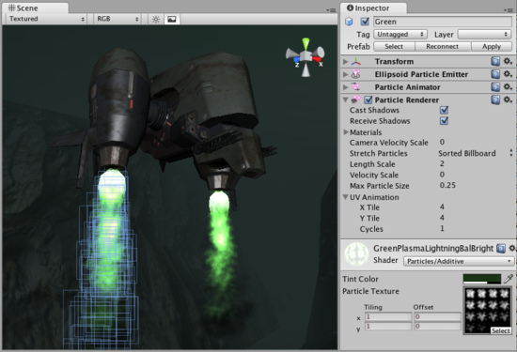

粒子渲染使得炮艇的发动机排气出现在屏幕上

### Choosing a Material 选择材料

When setting up a Particle Renderer it is very important to use an appropriate material and shader. Most of the time you want to use a Material with one of the built-in Particle Shaders. There are some premade materials in the Standard Assets->Particles->Sources folder.

当建立一个粒子渲染器非常重要的是使用适当的材料与着色。多数的时候，你想使用一个内置的材料对粒子着色。它们在Standard Assets->Particles->Sources文件夹中

Creating a new material is easy:

建立一个新的材料非常简单：

1. Select Assets->Create Other->Material from the menu bar.
2. 从菜单中选择 Assets->Create Other->Materia
3. The Material has a shader popup, choose one of the shaders in the Particles group. Eg. Particles->Multiply.
4. 材料着色弹出，在粒子群中选择一个着色，然后使用 Particles->Multiply.
5. Now assign a Texture. The different shaders use the alpha channel of the textures slightly differently, but most of the time a value of black will make it invisible and white in the alpha channel will display it on screen.
6. 现在分配一个纹理。同的着色器使用alpha通道的纹理略有不同，但大部分时间是将不可见的黑色和白色的alpha通道作将显示在屏幕上的值。

### Distorting particles 扭曲粒子

By default particles are rendered billboarded. That is simple square sprites. This is good for smoke and explosions and most other particle effects.

默认情况下，粒子billboarded用渲染，这是简单的平方单色画面。对烟雾和爆炸以及其它粒子是好的效果。

Particles can be made to either stretch with the velocity. This is useful for sparks, lightning or laser beams. Length Scale and Velocity Scale affects how long the stretched particle will be.

粒子可以与速度一起拉伸。通常用于火花、闪电或激光束。长度和速度拉伸影响粒子延伸的长度。

Sorted Billboard can be used to make all particles sort by depth. Sometimes this is necessary, mostly when using Alpha Blended particle shaders. This can be expensive and should only be used if it really makes a quality difference when rendering.

排序揭示栏可以用于所有粒子深度排序。有时这是必须的。主要当使用Alpha Blended混合粒子着色。这可能是昂贵的，当真的作出质量方面的差别时渲染使用。

### Animated textures 动画纹理

Particle Systems can be rendered with an animated tile texture. To use this feature, make the texture out of a grid of images. As the particles go through their life cycle, they will cycle through the images. This is good for adding more life to your particles, or making small rotating debris pieces.

粒子系统可以与动画材质一起渲染。使用此功能，使用网格图像纹理处理。作为通过粒子生命周期循环，它们将通过图片循环。这是一个好的增加你的粒子生命，或处理小的部分残骸的旋转。

## Hints 提示

* Use Particle Shaders with the Particle Renderer.

使用粒子着色与粒子渲染

[**Unity Manual**](http://unity3d.com/support/documentation/Manual/index.html) **—>** [**User Guide**](http://unity3d.com/support/documentation/Manual/User%20Guide.html)**—>** [**Building Scenes**](http://unity3d.com/support/documentation/Manual/Building%20Scenes.html) **—>** [**Terrains**](http://unity3d.com/support/documentation/Manual/Terrains.html)

**Unity手册—>用户指南—>建立场景—>地形**

# Terrain Engine Guide 地形引擎指南

This section will explain how to use the **Terrain Engine**. It will cover creation, technical details, and other considerations. It is broken into the following sections:

本节将讲述如何使用**地形引擎。**It will cover creation, technical details, and other considerations.这将包括创建，技术细节，和其他因素。 It is broken into the following sections:它分为以下部分：

## （1）Using Terrains 使用地形

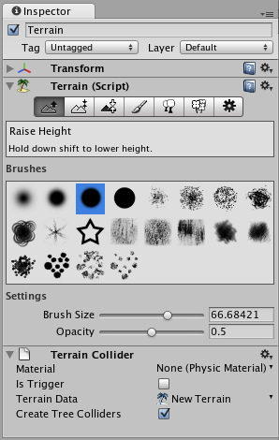

This section covers the most basic information about using Terrains. This includes creating Terrains and how to use the new Terrain tools & brushes.

本节包括有关使用地形最基本的资料。这包括建立地形，以及如何使用新的地形工具和刷子。

## （2）Height 高度

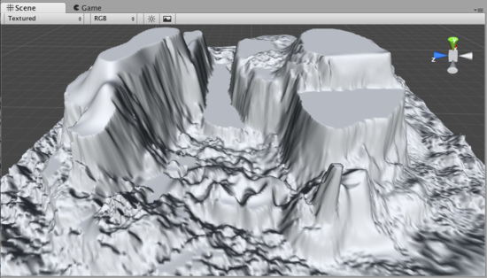

This section explains how to use the different tools and brushes that alter the Height of the Terrain.

本节讲解如何使用不同的工具和笔刷，改变地形高度。

## （3）Terrain Textures 地形纹理

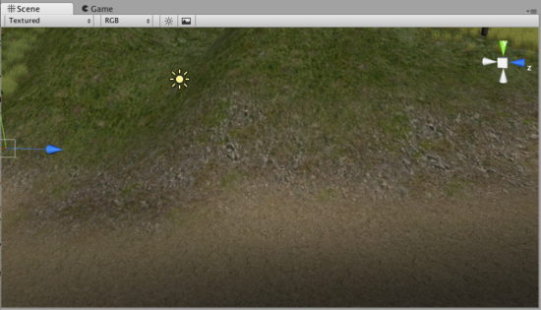

This section explains how to add, paint and blend Terrain Textures using different brushes.

本节讲解如何添加、描绘和地形纹理混合使用不同的刷子

## （4）Trees 树

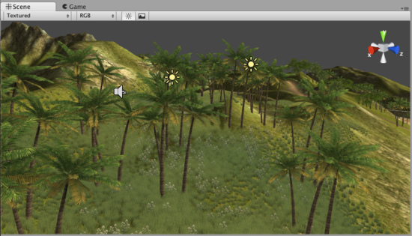

This section contains important information for creating your own tree assets. It also covers adding and painting trees on your Terrain.

本节包含用于创建你自己树资产的重要信息。它包括增加和绘画树木在你的地形上。

## （5）Grass 草

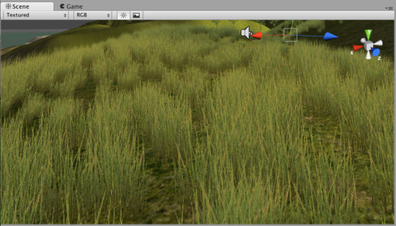

This section explains how grass works, and how to use it.

本节讲解草如何工作，以及如何使用它。

## （6）Detail Meshes元件网格

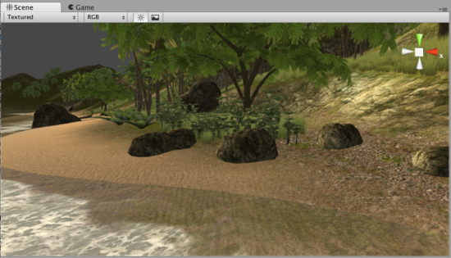

This section explains practical usage for detail meshes like rocks, haystacks, vegetation, etc.

本节讲解元件网格的实际应用，像岩石、草堆、植被等等。

## （7）Lightmaps光照映射

***（解释：光照映射****(****lightmaps****)把预先计算好的纹理混合在基本纹理上方，用于模拟真实的光影效果，在目前的3D游戏中对画质影响非常大。）*

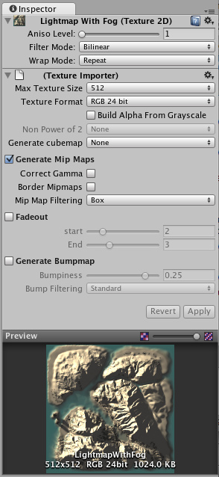

This section explains the advantages of using Lightmaps, how to create them, and technical information.

本节讲解使用光照映射的优势，如何建立它们以及它们的技术信息

## （8）Other Settings 其它设置

This section covers all the other settings associated with Terrains.

本节涵盖了所有与地形有关的其他设置。

# 1）Using Terrains 使用地形

[Reference Manual](http://unity3d.com/support/documentation/Components/index.html) > [Terrain Engine Guide](http://unity3d.com/support/documentation/Components/script-Terrain.html) > [Using Terrains](http://unity3d.com/support/documentation/Components/terrain-UsingTerrains.html)

参考手册—>地形引擎指南—>使用地形

## Creating a new Terrain 建立一个新的地形

A new **Terrain** can be created from **Terrain->Create Terrain**. This will add a Terrain to your **Project** and **Hierarchy Views**.

从菜单 **Terrain->Create Terrain** 建立一个新的地形。这将添加一个地形到你的项目中以及在层次面板中显示。

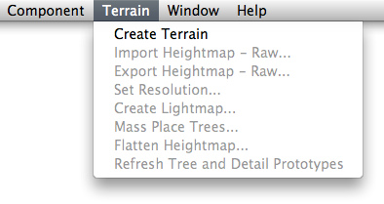

Your new Terrain will look like this in the **Scene View**:

你的新地形在场景中看起来向这个样子：

*A new Terrain in Scene View 一个新地形在场景视图中。*

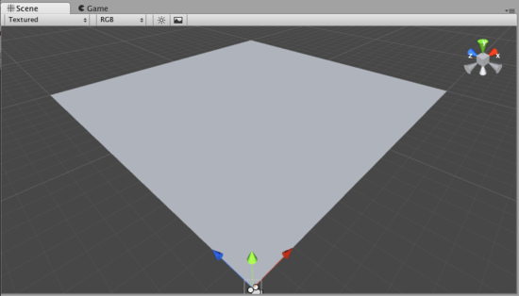

If you would like a differently sized Terrain, choose **Terrain->Set Resolution** from the menu bar. There are a number of settings that related to Terrain size which you can change from this dialog.

如果你项一个大小不同的地形，从菜单栏选择**Terrain->Set Resolution**。在该对话框中，有很多有关地形大小的设置，在此可以设置地形的数据。

## Navigating the Terrain 地形导航（定位地形）

Terrains work a bit differently than other GameObjects. Most notably, there is no Transform Gizmo that allows you to position the Terrain. Instead, you use **Brushes** to paint and manipulate your Terrain. If you do want to reposition a Terrain, you can modify its **Transform Position** values in the **Inspector**. This allows you to move your Terrain around, but you cannot rotate or scale it.

地形操作与其它游戏物体有一个不同点。特别显著的是它没有变换的辅助工具（Gizmo）允许你定位地形。相反，你使用画刷去画和操作你的地形。如果你想重新定位你的地形，你可以在检视面板（**Inspector**）修改它的 **Transform Position** 值。这允许你移动你的地形，但你不能旋转或缩放它。

While your Terrain is selected in the Hierarchy, you can gracefully navigate the terrain with the F (focus) key. When you press F, wherever your mouse is positioned will be moved to the center of the Scene View. This allows you to touch up an area, and quickly zoom over to a different area and change something else. If your mouse is not hovering over an area of the Terrain when you press the F key, the entire Terrain will be centered in your Scene View.

当你在层次面板（Hierarchy）中选择你的地形，你可以使用F键导航（定位）你的地形。当你按F键，无论你的鼠标位置在何处，它将移动到场景的中心。（提示，前提是你的鼠标在场景视图中）。这允许你到一个区域，并快速变焦到不同区域以及改变一些其它的东西。若你的鼠标位置没有停在地形中一个区域上面，当你按F键时，整个地形将显示在场景视图的中心。（提示，当地形有多个区域时，按F键可以测试一下结果）

## Editing the Terrain 编辑地形

With the Terrain selected, you can look at the **Inspector** to see some incredible new Terrain editing tools.

选择地形，你可以在检视面板看到一些难以置信新的地形编辑工具。（这句话好像是对老的Unity用户说的）

*Terrain Editing Tools appear in the Inspector 地形编辑工具显示在检视面板中。*

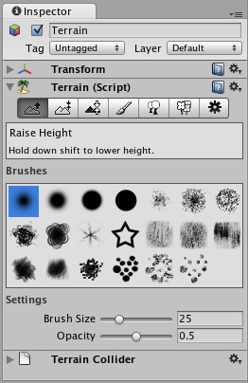

Each rectangular button is a different Terrain tool. There are tools to change the height, paint splat maps, or attach details like trees or rocks. To use a specific tool, click on it. You will then see a short description of the tool appear in text below the tool buttons.

每一个长方形按钮就是一个不同的地形工具。有些工具是改变高度、画长条木板地图，或则是类似对树、岩石附加细节工具。使用此特定工具，就点击它。你将看到这个工具一个小的描述文本显示在该功能工具按钮的下面。

Most of the tools make use of a brush. Many different brushes are displayed for any tool that uses a brush. To select a brush, just click on it.

大多数的工具利用一个刷子。多数不同的刷子显示为任何工具使用一个刷子。选择一个刷子，只要点击一下它。（这句话的意识是使用一把刷子，根据选择不同类型变成不同的刷子使用）

You will use all of these brushes in the **Scene View** to paint directly onto your Terrain. Simply choose the tool and brush you want, then click & drag on the Terrain to alter it in real-time. To paint height, textures, or decorations, you must have the Terrain selected in the **Hierarchy View**.

你将使用所有的这些刷子在**Scene View（**场景视图）中直接画你的地形。简单的选择你想还要的工具和刷子，然后在地形上点击和拖拽就能实时改变。你必须在层次视图**Hierarchy View**中选择地形，去画高、纹理或修饰。

**Note:** When you have a brush selected, move your mouse over the Terrain in the Scene View and press **F**. This will center the Scene View over the mouse pointer position and automatically zoom in to the **Brush Size** distance. This is the quickest & easiest way to navigate around your Terrain while creating it.

注意：当你有一个选择的刷子，在场景的地形上移动你的鼠标和按F键，这将把鼠标指针位置显示在场景中心和自动放大画刷大小距离。在创建地形时，这是最快与最简单的方法去浏览你的地形。

# 2）Height 高度

[Reference Manual](http://unity3d.com/support/documentation/Components/index.html) > [Terrain Engine Guide](http://unity3d.com/support/documentation/Components/script-Terrain.html) > [Height](http://unity3d.com/support/documentation/Components/terrain-Height.html)

参考手册—>地形引擎指南—>高度

Using any of the Terrain editing tools is very simple. You will literally paint the Terrain from within the Scene View. For the height tools and all others, you just have to select the tool, and click the Terrain in Scene View to manipulate it in real-time.

使用任何地形编辑工具是非常简单的。从场景视图内部你将照字面意义画地形。对于高度工具和其它的工具，你只要选择工具，然后在场景视图中的地形里点击就可以实时操作生成。

## Raising & Lowering Height 升高和降低高度

The first tool on the left is the Raise Height tool .



左边第一个工具是提高高度工具。

With this tool, you paint brush strokes that will raise the height of the Terrain. Clicking the mouse once will increment the height. Keeping the mouse button depressed and moving the mouse will continually raise the height until the maximum height is reached.

用这个工具，你的笔触将提高地形的高度。点击鼠标一次将增高高度。保持按住鼠标左键，移动鼠标将不断提高高度，直到达到最大高度。

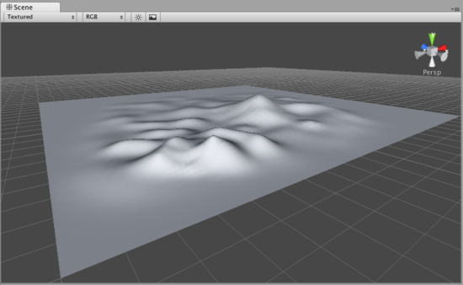

You can use any of the brushes to achieve different results 你可以使用任何刷子取得不同的结果。

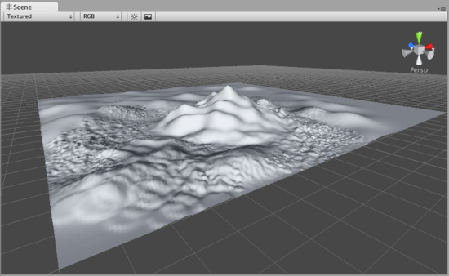

If you want to lower the height when you click, hold the Shift key. 如果你想降低高度，按住Shift键点击。

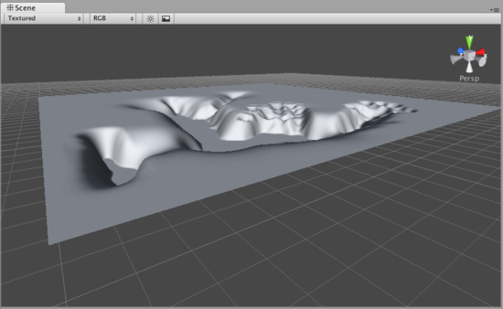

**Note:**When you have a brush selected, move your mouse over the Terrain in the Scene View and press F. This will center the Scene View over the mouse pointer position and automatically zoom in to the Brush Size distance. This is the quickest & easiest way to navigate around your Terrain while creating it.

注意：当你有一个选择的刷子，在场景视图的地形上移动你的鼠标并按**F**键。This will center the Scene View over the mouse pointer position and automatically zoom in to the Brush Size distance.这将把鼠标指针的位置移动到场景中心显示，并自动放大的画笔大小的距离。 在创建地形时，This is the quickest & easiest way to navigate around your Terrain while creating it.这是最快和最简单的方法来浏览你的地形。

### Paint Height 画高度

The second tool from the left is the Paint Height tool .



左边第二个工具是画高工具。

This tool allows you to specify a target height, and move any part of the terrain toward that height. Once the terrain reaches the target height, it will stop moving and rest at that height.

这个工具允许你指定目标高度，地形的任何一部分向这个高度移动。一旦这个地形达到目标高度，它将停止移动并在停那个高度。

To specify the target height, hold Shift and click on the terrain at the height you desire. You can also manually adjust the Height slider in the Inspector.

指定目标高度，按住Shift键，然后在地形上点击你希望高度的地方。在检视面板中你也可以手工调整高度滑块。



Now you've specified the target height, and any clicks you make on the terrain will move the terrain up or down to reach that height.

现在，你已经指定了目标高度，然后在地形上任意点击将移动地形上涨或下跌达到那个指定的高度。

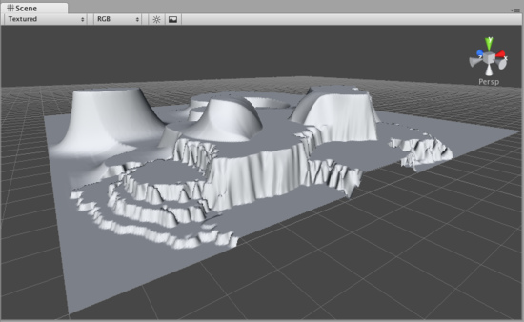

### Smoothing Height 平滑高度

The third tool from the left is the Smoothing Height tool .



左边第三个工具是平滑高度工具。

This tool allows you to soften any height differences within the area you're painting. Like the other brushes, paint the areas you want to smooth in the Scene View.

这个工具允许你在你画的区域内软化任意高度差。像其它画刷，在场景视图中画你想平滑的区域。

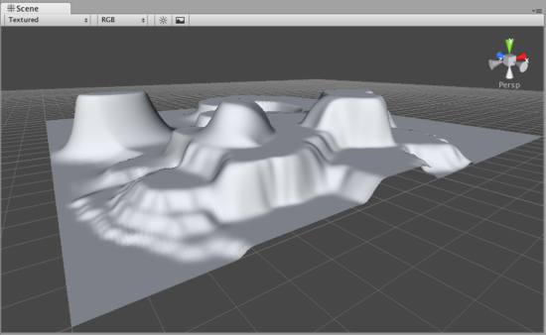

## Working with Heightmaps 与高度图合作

If you like, you can import a greyscale Heightmap created in Photoshop, or from real-world geography data and apply it to your Terrain. To do this, choose Terrain->Import Heightmap - Raw..., then select the desired RAW file. You'll then see some import settings. These will be set for you, but you have the option of changing the size of your Terrain from this dialog if you like. When you're ready, click the Import button. Once the Heightmap has been applied to the Terrain, you can edit it normally with all the Tools described above. Note that the Unity Heightmap importer can only import grayscale raw files. Thus you can't create a raw heightmap using RGB channels, you must use grayscale.

如果你愿意，你可以导入在Photoshop中建立的灰度高度图，或从真实世界地理数据应用到你的地形。要做到这一点，选择 Terrain->Import Heightmap - Raw...（地形>“导入高度图-原始...），然后选择所需的RAW文件。 You'll then see some import settings.然后，你将会看到一些导入设置。 These will be set for you, but you have the option of changing the size of your Terrain from this dialog if you like.这些将为你设置，但是你必须从这个对话框改变选项至你喜欢的地形的大小。 When you're ready, click the Import button.当你准备好，点击Import（导入）按钮。 Once the Heightmap has been applied to the Terrain, you can edit it normally with all the Tools described above. Note that the Unity Heightmap importer can only import grayscale raw files.一旦高度图已应用于地形，你可以使用上面描述的所有功能工具正常的编辑它。注意，Unity引入的高度图只能引入灰度原始文件。 Thus you can't create a raw heightmap using RGB channels, you must use grayscale.因此，你不能创建一个使用RGB通道的原始高度图，你必须使用灰度。

Unity works with RAW files which make use of full 16-bit resolution. Any other heightmap editing application like Bryce, Terragen, or Photoshop can work with a Unity Heightmap at full resolution.

Unity与RAW文件一起利用完整的16位分辨率的使用。 任何其它的Any other heightmap editing application like Bryce, Terragen, or Photoshop can work with a Unity Heightmap at full resolution.高度图编辑程序如Bryce，Terragen，或Photoshop都可以与Unity的高度图的全分辨率一起使用。

You also have the option of exporting your Heightmap to RAW format. Choose Terrain-> Export Heightmap - Raw... and you'll see a export settings dialog. Make any changes you like, and click Export to save your new Heightmap.

你同样有个选项把你的高度图导出到RAW格式。Choose Terrain->Import Heightmap - Raw... and you'll see a export settings dialog.选择 Terrain-> Export Heightmap - Raw...（地形>“导出高度图-原始...），你会看到一个导出设置对话框。 Make any changes you like, and click Export to save your new Heightmap.做你喜欢的任意更改，然后点击导出按钮，保存你的新高度图。

Unity also provides an easy way to flatten your terrain. Choose Terrain->Flatten.... This lets you flatten your terrain to a height you specify in the wizard.

Unity还提供了一个简单的方法来平坦你的地形。 选择Choose **Terrain->Flatten...（** .**地形**-> **平坦...）。** This lets you flatten your terrain to a height you specify in the wizard.这使你平坦你的地形到你在向导中指定的高度。

# 3）Textures 纹理

[Reference Manual](http://unity3d.com/support/documentation/Components/index.html) > [Terrain Engine Guide](http://unity3d.com/support/documentation/Components/script-Terrain.html) > [Textures](http://unity3d.com/support/documentation/Components/terrain-Textures.html)

参考手册—>地形引擎指南—>纹理

Decorate the landscape of your terrain by tiling **Terrain Textures** across the entire terrain. You can blend and combine Terrain Textures to make smooth transitions from one map to another, or to keep the surroundings varied.

在整个地形上平铺**Terrain Textures（**地形纹理）来美化你的地形。你可以混合并结合地形纹理去平滑变化从一个映射到另一个映射，或保持各种各样的环境。

Terrain Textures are also called splat maps. What this means is you can define several repeating high resolution textures and blend between them arbitrarily, using alpha maps which you paint directly onto the Terrain. Because the textures are not large compared to the size of the terrain, the distribution size of the Textures is very small.

地形纹理也称为长条木板地图。 What this means is you can define several repeating high resolution textures and blend between them arbitrarily, using alpha maps which you paint directly onto the Terrain.这意味着你可以定义多个重复的高分辨率纹理和它们之间的任意混合，使用alpha（阿尔法）地图直接在你的地形上画图。 Because the textures are not large compared to the size of the terrain, the distribution size of the Textures is very small.由于纹理与地形的大小相比不大，分布的纹理尺寸非常小。

**Note:** Using an amount of textures in a multiple of four provides the greatest benefit for performance and storage of the Terrain alpha maps.

注意：最好的有益处理和存储地阿尔法地图地形是使用四个提供在一个管道多数量的纹理。

To being working with textures, click on the **Paint Textures** button in the Inspector.



处理纹理，在检视面板中点击**Paint Textures（绘制纹理）**按钮。

**Adding a Terrain Texture 添加一个地形纹理**

Before you can begin painting Terrain Textures, you will add at least one to the Terrain from your Project folder. Click the **Options Button->Add Texture...**.

在你开始绘制地形纹理之前，你至少应添加加一个地形从你的项目文件夹中。点击 **Options Button->Add Texture...**.（**选项按钮->添加纹理...**）

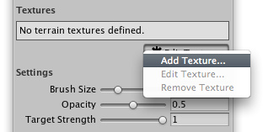

This will bring up the Add Terrain Texture dialog. 这将弹出一个添加纹理的对话框

*The Add Terrain Texture dialog 添加地形纹理对话框*

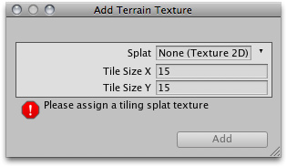

From here, select a tileable texture in the **Splat** property. You can either drag a texture to the property from the Project View, or choose one from the drop-down.

从这里，在长条木板属性中选择一个平铺的纹理，你也可以从项目面板视图中拖拽一个纹理到该属性中，或从下来单中选择一个。

Now, set the **Tile Size X** and **Tile Size Y** properties. The larger the number, the larger each "tile" of the texture will be scaled. Textures with large **Tile Sizes** will be repeated fewer times across the entire Terrain. Smaller numbers will repeat the texture more often with smaller tiles.

现在，设置平铺X和平铺Y的属性。数字越大，每个平铺的纹理就对应的按比例放大。大的平铺尺寸的纹理将在整个地形中重复少的次数。通常少数的平铺尺寸小的纹理将重复纹理多次。

Click the **Add** Button and you'll see your first Terrain Texture tile across the entire Terrain.

点击 增加 按钮，你将看到第一个地形纹理平铺到整个地形。

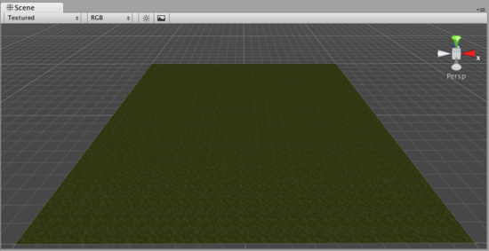

Repeat this process for as many Terrain Textures as you like. 多地形纹理的重复处理直到你满意为止。

**Painting Terrain Textures 绘制地形纹理**

Once you've added at least two Terrain Textures, you can blend them together in various ways. This part gets really fun, so let's jump right to the good stuff.

一旦你至少增加了两个地形纹理，你可以以不同的方式把它们混合在一起。这部分很有趣，让我们马上进入主题。

Select the Terrain Texture you want to use. The currently selected Terrain Texture will be highlighted in blue.

选择你想用的地形纹理。当前选择的地形纹理将以蓝框线高亮显示。

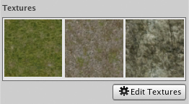

Select the Brush you want to use. The currently selected Brush will be highlighted in blue.

选择你想用的画刷。当前选择的画刷将以蓝框线高亮显示。

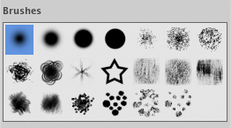

Select the Brush **Size**, **Opacity**, and **Target Strength**.

选择画刷的大小，不透明度，和目标强度

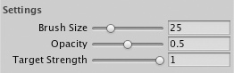

Click and drag on the terrain to draw the Terrain Texture.

在地形上点击和拖动去绘制地形纹理

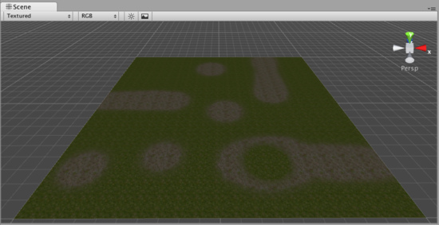

Use a variety of Textures, Brushes, Sizes, and Opacities to create a great variety of blended styles.

使用多种的纹理，画刷，大小和不透明度去建立一个多种有趣的混合风格。

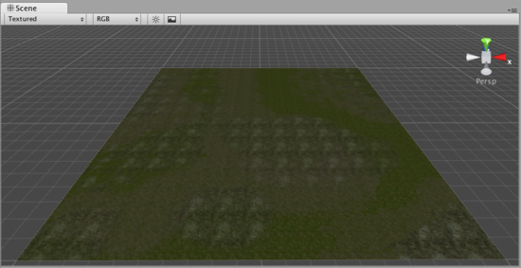

**Note:**When you have a brush selected, move your mouse over the Terrain in the Scene View and press **F**. This will center the Scene View over the mouse pointer position and automatically zoom in to the **Brush Size** distance. This is the quickest & easiest way to navigate around your Terrain while creating it.

注意：当你有一个选择的画刷，在场景视图中的地形上移动你的鼠标并按F键。这将把鼠标指针的位置移动到场景中心显示，并自动放大的画刷大小的距离。 在创建地形时，这是最快和最简单的方法来浏览你的地形。

# 4）Trees 树

[Reference Manual](http://unity3d.com/support/documentation/Components/index.html) > [Terrain Engine Guide](http://unity3d.com/support/documentation/Components/script-Terrain.html) > [Trees](http://unity3d.com/support/documentation/Components/terrain-Trees.html)

参考手册—>地形引擎指南—>树

Unity's Terrain Engine has special support for Trees. You can put thousands of trees onto a Terrain, and render them in-game with a practical frame rate. This works by rendering trees near the camera in full 3D, and transitioning far-away trees to 2D billboards. Billboards in the distance will automatically update to orient themselves correctly as they are viewed from different angles. This transition system makes a detailed tree environment very simple for performance. You have complete control over tweaking the parameters of the mesh-to-billboard transition so you can get the best performance you need.

Unity的地形引擎有特别为树的支持。You can put thousands of trees onto a Terrain, and render them in-game with a practical frame rate.你可以在一个地形上放置数千棵树，并用一个实际的帧速渲染它们。在一个全3D的摄像机附近进行树的重绘工作，并且把远的树变换成2D揭示牌。在远处的揭示牌它们自己将自动更正到恰当的方向以符合它们从不同的角度展示。这个变换系统处理一个元件树环境是非常简单特性。 你可以完全控制网格的参数到揭示牌的转换，以便你达到你需要的最佳性能。

You can easily paint lots of trees for beautiful environments like this 你可以轻松的绘制出像这个美丽的多树环境。

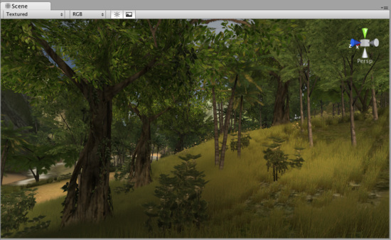

## Adding Trees 添加树

Select the Place Trees button in the Inspector.



在检视面板选择Place Trees（种树）按钮

Before you can place trees on your terrain, you have to add them to the library of available trees. To do this, click the Edit Trees button->Add Tree. You'll see the Add Tree dialog appear.

在你的地形上种树之前，你必须添加它们到可以使用的树木库。为此，点击 Edit Trees button->Add Tree（编辑树木按钮->添加树）。你将看到添加树木的对话框显示。

The Add Tree dialog 添加树木对话框

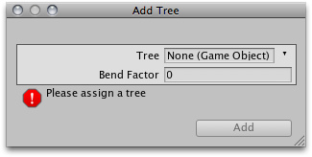

Select the tree from your Project View and drag it to the Tree variable. You can also edit the Bend Factor if you want to add an additional bit of animated "bending in the wind" effect to the trees. When you're ready, click Add. The tree will now appear selected in the Inspector.

从你的项目面板视图中选择树木，然后拖拽它到这个树变量。如果你想增加额外的“风中的弯曲效应”效果动画给这些树木，你可以编辑**Bend Factor（弯曲因子）。**当你准备好，点击 添加 按钮，这个选定的树木将在检视面板中显示。

The newly added tree appears selected in the Inspector 在检视面板中显示新添加选择的树木

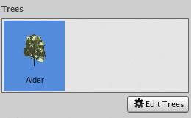

You can add as many trees as you like. Each one will be selectable in the Inspector for you to place on your Terrain.

你可以添加许多你喜欢的树木。检视面板里被选择的每一个树木可以种在你的地形上。

The currently selected tree will always be highlighted in blue 当前选定的树总是以蓝色突出显示

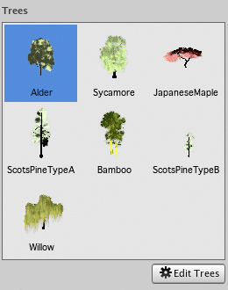

## Painting Trees 画树

While still using the Place Trees tool, click anywhere on the Terrain to place your trees. To erase trees, hold the Shift button and click on the Terrain.

仍旧使用种树工具，在地形上任意地点栽种你的树木。清除树木，按住Shift键，然后在地形上点击。

Painting trees is as easy as using a paintbrush tool 绘制树木与使用画刷工具一样容易

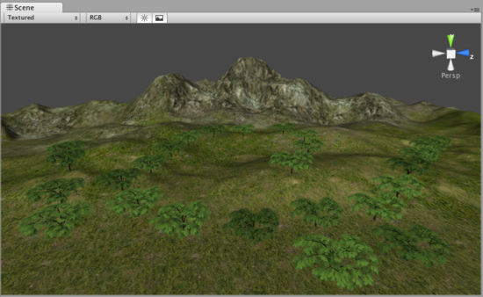

There are a number of options at your disposal when placing trees.

当种植树木是，这有几个选项由你支配。

|  |  |
| --- | --- |
| Brush Size  画刷大小 | Radius in meters of the tree placing brush.  树木刷子的米半径 |
| Tree Spacing  树间距 | Percentage of tree width between trees.  树木之间间距宽度的百分比 |
| Color Variation  颜色变化 | Allowed amount of color difference between each tree.  每棵树之间的颜色差异的允许量 |
| Tree Height  树高 | Height adjustment of each tree compared to the asset.  每棵树的高度调整相比于其它资产 |
| Height Variation  高度差 | Allowed amount of difference in height between each tree.  每一个树的高度差的允许量 |
| Tree Width  树宽 | Width adjustment of each tree compared to the asset.  每棵树的宽度调整相比于其它资产 |
| Width Variation  宽度变化 | Allowed amount of difference in width between each tree.  每一个树宽度差的允许量 |

### Tree Painting Tips 树绘制技巧

Different Brush sizes cover different area sizes 不同的画刷大小覆盖不同区域的大小

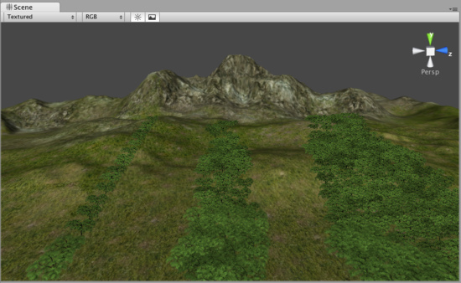

Adjust *Tree Spacing* to change the density of the trees you're painting 在你绘制时，调整树间距改变树木的密度

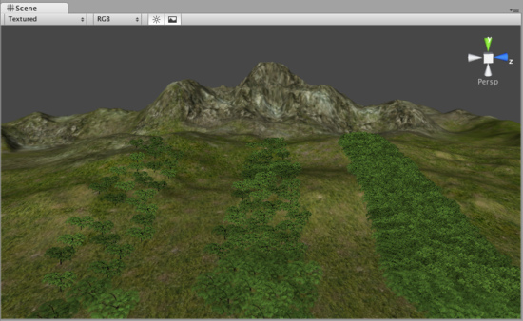

## Editing Trees 编辑树

To change any import parameters for an added tree, select the detail and choose Edit Trees button->Edit Detail. Or double-click the tree you want to edit. You will then see the Edit Tree dialog, and you can change any of the settings.

为添加树木更改任何重要的参数，选取元件并选择Edit Trees button->Edit Detail.（编辑树木按钮 ->编辑元件）。或双击你想要编辑的树。你将看到编辑树对话框，然后，你可以任意更改设置。

## Mass Placement 大规模种植

If you don't want to paint your trees and you just want a whole forest created, you can use Terrain->Mass Place Trees. Here, you will see the Mass Place Trees dialog. You can set the number of trees you want placed, and they'll be instantly positioned. All the trees added to your Terrain will be used in this mass placement.

如果你不想画你的树木有想快速的建立整个森林，你可以使用Terrain->Mass Place Trees（地形->大规模种树）.

这里，你将看到大规模种树对话框，你可以设置你想种植树的数，然后，它们将立即栽种。所有树木将被用于整体布置添加到你的地形。

10,000 Trees placed at once 10000棵树木立即种植

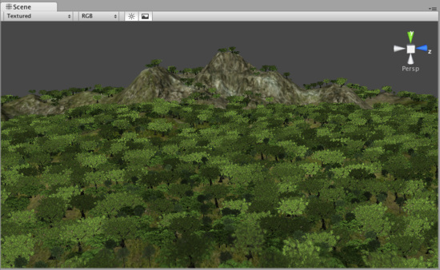

## Refreshing Source Assets 更新源资产

If you make any updates to your tree asset source file, it must be manually re-imported into the Terrain. To do this, use Terrain->Refresh Tree and Detail Prototypes. This is done after you've changed your source asset and saved it, and will refresh the trees in your Terrain immediately.

如果你进行任意更改你的树木资产源文件，它必须要手工重新引入到地形。要做到这一点，使用Terrain->Refresh Tree and Detail Prototypes（地形->刷新树和元件原型）。这样做完后，你已经更新了你的源资产并保持它，而且，将立即刷新在你地形里的树。

## Creating Trees 创建树

Every tree should consist of a single mesh with two Materials. One for the trunk and one for the leaves. For performance reasons, triangle count should be kept below 2000 for an average tree. The fewer triangles the better. The pivot point of the tree mesh must be exactly at the root of the tree, that is at the point where the tree should meet the surface it is placed on. This makes it the easiest to import into Unity and other modelling applications.

每个树应当由一个简单的网格和两个材料组成。一个树干和一个树叶。由于性能的原因，三角形应保持低于2000的一个平均树。三角形越少越好，树网格的支点坐标必须正确的在树的根部，这是个坐标在那个地方遇到表面，它才能栽种上。这使它成为最容易导入到Uinty中和其它模型的应用。

Trees must use the Nature/Soft Occlusion Leaves and Nature/Soft Occlusion Bark shader. In order to use those shaders you also have to place the tree in a special folder that contains the name "Ambient-Occlusion". When you place a model in that folder and reimport it, Unity will calculate soft ambient occlusion specialized for trees. The "Nature/Soft Occlusion" shaders need this information. If you don't follow the naming conventions the tree will look weird with completely black parts.

树必须使用**自然/软闭塞树叶**和**自然/软闭塞树皮着色。**为使用这些着色器，你也必须同样在一个指定的文件夹名称中含"Ambient-Occlusion"的文件夹中放置树。当你放置一个模型在那个文件夹中并重新引入它，Unity将计算软环境闭塞专有的树木，这个"Nature/Soft Occlusion"（自然/软闭塞）着色器需要这个信息。如果你不遵循这个命名约定，这个树看起来是完全怪异的黑色。

Unity also ships with several high quality trees in the "Terrain Demo.unitypackage". You can use those trees readily in your game. Even if you don't want to use the builtin trees, we strongly recommend that you take a look at those trees as an example on how to model trees.

Unity也附带了几个高品质的树木在"Terrain Demo.unitypackage"中。你可以在你的游戏里容易的使用这些树。即使你不想使用内置的树，但我们强烈的建议你把这些树作为模型例子看看。

## Using Low Poly Trees 使用低聚树

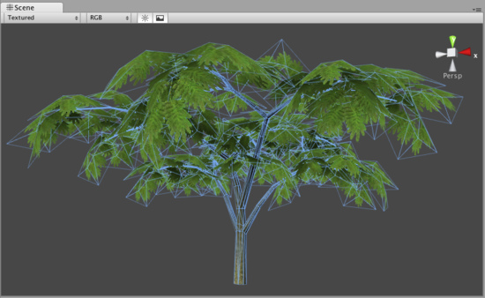

One branch with leaves is done with only six triangles and shows quite a bit of curvature. You can add more triangles for even more curvature. But the main point is: When making trees, work with triangles not with quads. If you use quads you basically need twice as many triangles to get the same curvature on branches.

一个叶分支，完成只有6个三角形和显示相当多的曲率。你可以为每个曲率添加更多的三角形。但是主要问题是：当处理树木时，三角形不能与四方形联合使用。如果你使用四方形，你基本上需要一样多三角形两次来取得分支同样的曲率。

The tree itself wastes a lot of fillrate by having large polygons but almost everything is invisible due to the alpha. This should be avoided for performance reasons and of course because the goal is to make dense trees. This is one of the things that makes Oblivion's trees look great. They are so dense you cant even see through the leaves.

树本身损耗庞大的供应速率由巨大的无形阿尔法大量填充率的多边形提供。这应该是性能避免的原因，当然，目标为茂密树林也是其原因。This should be avoided for performance reasons and of course because the goal is to make dense trees. This is one of the things that makes Oblivion's trees look great.这是湮没的树木更好看事物的其中之一。 它们They are so dense you cant even see through the leaves.它们它们它们是如此密集，甚至你看穿叶子。

## Setting up Tree Collisions Setting up Tree Collisions设置树碰撞

If you'd like your trees to make use of colliders, it's very easy. When you've imported your Tree asset file, all you need to do is instantiate it in the Scene View, add a Capsule Collider and tweak it, and make the GameObject into a new Prefab. Then when you're adding trees to your Terrain, you add the tree Prefab with the Capsule Collider attached. You can only use Capsule Colliders when adding collisions with trees.

如果你希望你的树木使用碰撞器，这很容易。当你引入你的树资产文件，所有你需要做的是场景视图中实例化它们，添加一个Capsule Collider和调整它，使它成为一个新的预制游戏物体。然后，当你添加树木到你的地形时，你添加带有附着Capsule Collider预制的树。你也可以在添加带有碰撞的树时单独使用Capsule Colliders。

# 5）Grass 草

[Reference Manual](http://unity3d.com/support/documentation/Components/index.html) > [Terrain Engine Guide](http://unity3d.com/support/documentation/Components/script-Terrain.html) > [Grass](http://unity3d.com/support/documentation/Components/terrain-Grass.html)

参考手册—>地形引擎指南—>草

The **Paint Foliage** button allows you to paint grass, rocks, or other decorations around the Terrain. To paint grass, choose **Edit Details button->Add Grass Texture**. You don't need to create a mesh for grass, just a texture.



画枝叶按钮允许你在地形上绘制草、岩石或其它装饰。绘制草，选择**Edit Details button->Add Grass Texture（编辑元件按钮->添加草纹理）**.你不需要为草建立网格，仅是一个纹理。

*The Add Grass Texture dialog 添加草纹理对话框*

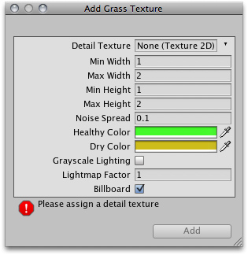

At this dialog, you can fine-tune the appearance of the grass with the following options:

在这个对话框中，你可以根据下面的选项调整草的外观：

|  |  |
| --- | --- |
| **Detail Texture 细节纹理** | The texture to be used for the grass. 纹理用来做草 |
| **Min Width 最小宽度** | Minimum width of each grass section in meters. 在米的每个草区域内最小宽度 |
| **Max Width 最大宽度** | Maximum width of each grass section in meters.在米的每个草区域内最大宽度 |
| **Min Height 最小高度** | Minimum height of each grass section in meters. 在米的每个草区域内最小高度 |
| **Max Height 最大高度** | Maximum height of each grass section in meters. 在米的每个草区域内最大高度 |
| **Noise Spread**  噪声传播 | The size of noise-generated clusters of grass. Lower numbers mean less noise.  草丛产生的噪音大小。低数字意味着少的噪音 |
| **Healthy Color**  健康颜色 | Color of healthy grass, prominent in the center of **Noise Spread** clusters.  健康草的颜色，突出在噪音传播群的中心 |
| **Dry Color**  **干草颜色** | Color of dry grass, prominent on the outer edges of **Noise Spread** clusters.  干草的颜色，突出在噪音传播群的边缘 |
| **Grayscale Lighting**  **灰度灯光** | If enabled, grass textures will not be tinted by any colored light shining on the Terrain.  如果启动，在地形上草纹理不会受到任何彩色光的照射色彩。 |
| **Lightmap Factor**  **光照映射因子** | How much the grass will be influenced by the Lightmap.  许多的草将被光映射影响 |
| **Billboard**  **揭示牌** | If checked, this grass will always rotate to face the main **Camera**.  如选择，这个草将总是面对主摄像机旋转 |

After you've clicked the **Add** button, you'll see the grass appear selectable in the **Inspector**.

在你已经点击添加按钮之后，你将在检视面板中看到选择的草出现。

*The added grass appears in the Inspector 添加的草出现在检视面板中*

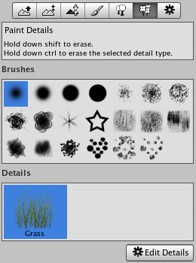

**Painting Grass 画草**

Painting grass works the same as painting textures or trees. Select the grass you want to paint, and paint right onto the Terrain in the **Scene View**

绘制草的工作与绘制纹理或树木相同。选择你想绘制的草，在场景视图里的地形上正确绘制。

*Painting grass is easy as pie 绘制草饼是容易的*

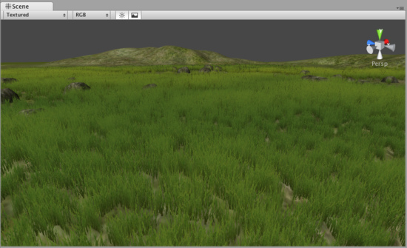

**Note:**When you have a brush selected, move your mouse over the Terrain in the Scene View and press **F**. This will center the Scene View over the mouse pointer position and automatically zoom in to the **Brush Size** distance. This is the quickest & easiest way to navigate around your Terrain while creating it.

注意：当你有一个选择的画刷，在场景视图中的地形上移动你的鼠标并按F键。这将把鼠标指针的位置移动到场景中心显示，并自动放大的**画刷大小**的距离。 在创建地形时，This is the quickest & easiest way to navigate around your Terrain while creating it.这是最快和最简单的方法来浏览你的地形。

**Editing Grass 编辑草**

To change any import parameters for a particular Grass Texture, select it choose **Edit Details button->Edit**. You can also double-click it. You will then see the **Edit Grass** dialog appear, and be able to adjust the parameters described above.

更改特定草纹理任意重要参数，选取它，选择**Edit Details button->Edit**.（**编辑元件按钮->编辑）**，你也可以双击它，你将看到编辑草的对话框出现，然后调整上述的参数。

You'll find that changing a few parameters can make a world of difference. Even changing the **Max/Min Width** and **Height** parameters can vastly change the way the grass looks, even with the same number of grass objects painted on the Terrain.

你会发现，改变一些参数可以实现天差之别。甚至更改高度和宽度的最大/最小参数可以广大改变草的外观，甚至是绘制在地形上的相同数量草的对象。

*Grass created with the default parameters 以默认参数建立的草*

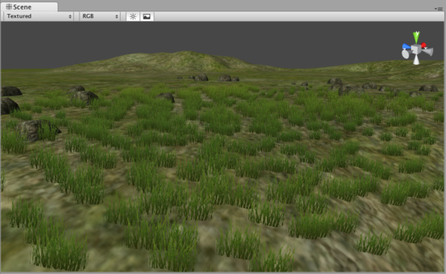

*The same number of painted grass objects, now wider and taller 相同数量绘制的草对象，现在宽和高相同。*

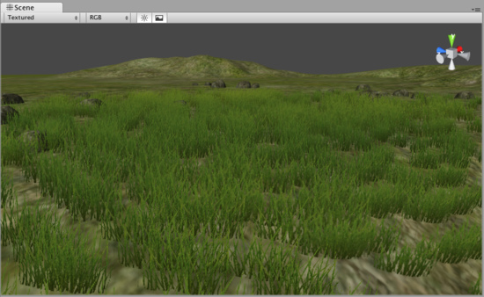

# 6）Detail Meshes 元件网格

[Reference Manual](http://unity3d.com/support/documentation/Components/index.html) > [Terrain Engine Guide](http://unity3d.com/support/documentation/Components/script-Terrain.html) > [Detail Meshes](http://unity3d.com/support/documentation/Components/terrain-DetailMeshes.html)

参考手册—>地形引擎指南—>元件网格

Any Terrain decoration that is not trees or grass should be created as a **Detail Mesh**. This is perfect for things like rocks, 3D shrubbery, or other static items. To add these, use the **Paint Foliage** button

任何没有树或草的地形装饰被作为一个元件网格创建。这是理想的事情，像岩石，三维灌木丛，或其它静态的东西。要添加这些，使用**Paint Foliage（画树叶按钮）**

. Then choose **Edit Details button->Add Detail Mesh**. You will see the **Add Detail Mesh** dialog appear.



然后选择**Edit Details button->Add Detail Mesh（编辑元件按钮->添加元件网格）**。你将看到添加元件网格对话框出现。

*The Add Detail Mesh dialog 添加元件网格对话框*

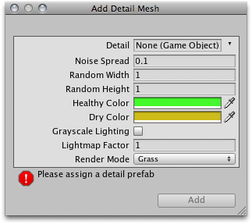

|  |  |
| --- | --- |
| **Detail 原件** | The mesh to be used for the detail. 网格被用于元件 |
| **Noise Spread**  **噪音传播** | The size of noise-generated clusters of the **Detail**. Lower numbers mean less noise.  元件群产生噪音的大小。低数字意味着少的噪音 |
| **Random Width 随机宽度** | Limit for the amount of width variance between all detail objects. 限制所有元件对象之间宽度数值的差异 |
| **Random Height随机高度** | Limit for the amount of height variance between all detail objects.限制所有元件对象之间高度数值的差异 |
| **Healthy Color健康颜色** | Color of healthy detail objects, prominent in the center of **Noise Spread** clusters.  元件对象的健康颜色，突出在噪音传播群中心 |
| **Dry Color干颜色** | Color of dry detail objects, prominent on the outer edges of **Noise Spread** clusters.  元件对象的干颜色，突出在噪音传播群的边缘 |
| **Grayscale Lighting灰度灯光** | If enabled, detail objects will not be tinted by any colored light shining on the Terrain  如果启动，在地形上元件对象不会受到任何彩色光的照射色彩。. |
| **Lightmap Factor**光照映射因子 | How much the detail objects will be influenced by the Lightmap.许多元件对象将被灯光映射影响 |
| **Render Mode 渲染模式** | Select whether this type of detail object will be lit using Grass lighting or normal Vertex lighting. Detail objects like rocks should use Vertex lighting. 是否选取这个类型将决定被使用草灯光或正常顶点等光。向岩石的元件对象应使用顶点灯光。 |

After you've clicked the **Add** button, you'll see the Detail mesh appear in the **Inspector**. Detail meshes and grass will appear next to each other.

在你已经点击添加按钮之后，你将看到元件网格显示在检视面板里。元件网格和草将互相显示在一起。

*The added Detail mesh appears in the Inspector, beside any Grass objects 添加的元件网格显示在检视面板，在其它的草对象旁边。*

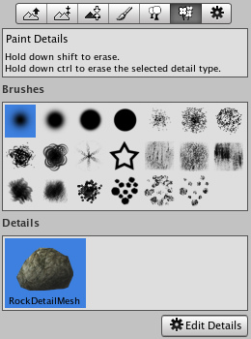

**Painting Detail Meshes 画元件网格**

Painting a Detail mesh works the same as painting textures, trees, or grass. Select the Detail you want to paint, and paint right onto the Terrain in the Scene View.

绘制一个元件网格的工作与绘制纹理、树木、或草一样。选取你想要绘制的元件，在场景视图中的地形上正确绘制。

*Painting Detail meshes is very simple 绘制元件网格非常容易*

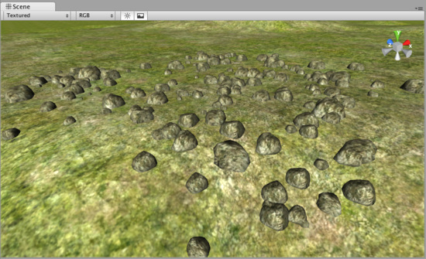

**Note:** When you have a brush selected, move your mouse over the Terrain in the Scene View and press **F**. This will center the Scene View over the mouse pointer position and automatically zoom in to the **Brush Size** distance. This is the quickest & easiest way to navigate around your Terrain while creating it.

注意：当你有一个选择的画刷，在场景视图中的地形上移动你的鼠标并按F键。这将把鼠标指针的位置移动到场景中心显示，并自动放大的**画刷大小**的距离。 在创建地形时，This is the quickest & easiest way to navigate around your Terrain while creating it.这是最快和最简单的方法来浏览你的地形。

**Editing Details 编辑元件**

To change any import parameters for a Detail Mesh, select it and choose **Edit Details button->Edit**. You will then see the **Edit Detail Mesh** dialog appear, and be able to adjust the parameters described above.

更改一个元件任意重要参数，选取它，选择**Edit Details button->Edit**.（**编辑元件按钮->编辑）**，你将看到编辑草的对话框出现，然后调整上述的参数。

**Refreshing Source Assets 更新源资产**

If you make any updates to your Detail Mesh asset source file, it must be manually re-imported into the Terrain. To do this, use **Terrain->Refresh Tree and Detail Prototypes**. This is done after you've changed your source asset and saved it, and will refresh the Detail Meshes in your Terrain immediately.

如果你进行更新任何你的元件网格资产源文件，它必须手动重新引入到地形里。要做到这一点，使用**Terrain->Refresh Tree and Detail Prototypes（**地形**->更新树和元件原型）。**做完这一点后，你已经更改了你的源资产并保存了它，它将立即在你的地形中刷新元件网格。

# 7）Lightmaps 光照映射

[Reference Manual](http://unity3d.com/support/documentation/Components/index.html) > [Terrain Engine Guide](http://unity3d.com/support/documentation/Components/script-Terrain.html) > [Lightmaps](http://unity3d.com/support/documentation/Components/terrain-Lightmaps.html)

参考手册—>地形引擎指南—>光照映射

You can create and use a **Lightmap**, based on the **Lights** in your **Scene**. You should almost always use Lightmaps. A Lightmapped terrain looks substantially better than Vertex lit. On top of that a Lightmapped terrain also runs faster than a Vertex lit terrain!

在你的场景灯光的基础上，你可以创建和使用光照映射。你应该总是使用光照映射。一个光照映射地形看起来大大好过顶点照射。另外一个光照映射地形运行速度也比顶点照射地形快。

*A mountain view without a Lightmap 没有光照映射的山脉视图*

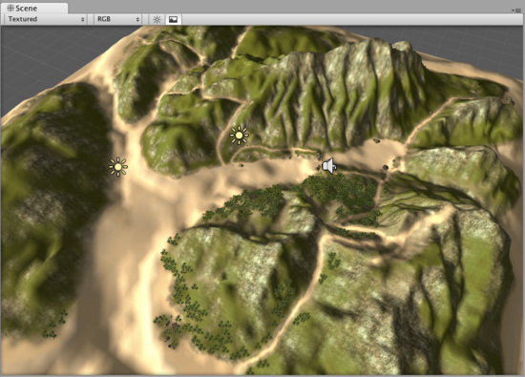

*The same mountain, now using a Lightmap. Much better! 同样的山脉，使用光照映射，好多了！*

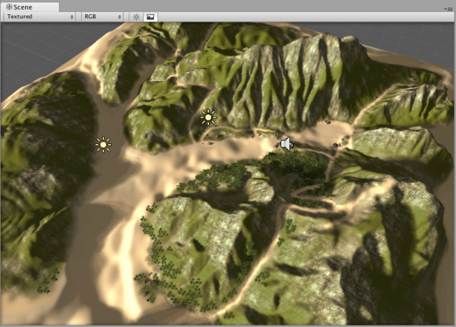

**Creating a Lightmap 建立一个光照映射**

To create a Lightmap, make sure you have at least one **Directional Light** in your scene. Then choose **Terrain->Create Lightmap** from the menu. Here you can set various options like the **Resolution** of the Lightmap, choose the Lights used in the Lightmap, **Shadows**, and **Shadow Sampling**.

创建一个光照映射，在你的场景中确认至少已经有一个方向光（**Directional Light**）。然后，从菜单选择**Terrain->Create Lightmap（地形->建立光照映射）。**这里你可以设置不同的选项，如光照映射分斌率、选择光照映射使用的灯光，阴影和阴影取样。

**Toggling Lightmap 切换光照映射**

To enable or disable the active Lightmap, select your Terrain and click the [Terrain Settings](http://unity3d.com/support/documentation/Components/terrain-OtherSettings.html) tab. In **Lighting** popup, choose **Lightmap** or **Pixel** lighting mode.   
启动或禁止激活光照映射，选取你的地形并点击地形设置选项卡，在照明弹出里，选择光照映射或像素照射模式。

Note: You must use a **Directional Light** to create the lightmap. **Point** and **Spot Lights** will not be taken into account when creating the lightmap.

注意：你必须使用一个方向光去建立一个光照映射。当建立光照映射，点光源和聚光灯将不被考虑。

# 8）Other Settings

[Reference Manual](http://unity3d.com/support/documentation/Components/index.html) > [Terrain Engine Guide](http://unity3d.com/support/documentation/Components/script-Terrain.html) > [Other Settings](http://unity3d.com/support/documentation/Components/terrain-OtherSettings.html)

参考手册—>地形引擎指南—>其它设置

There are a number of options under the **Terrain Settings** button in the Terrain Inspector.



检视面板中的地形设置按钮里有许多的选项。

*All additional Terrain Settings 所有附加的地形设置*

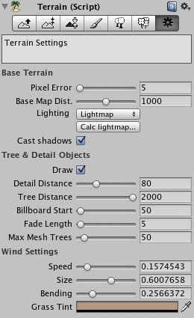

**Base Terrain** 基本地形

|  |  |
| --- | --- |
| **Pixel Error**  **像素差错** | Amount of allowable errors in the display of Terrain Geometry. This is essentially a LOD setting.  地形几何显示允许的错误数。它本质上是一个LOD设置 |
| **Base Map Dist.**  **基本映射距离** | The distance that Terrain Textures will be displayed in high-resolution.  地形纹理距离被用于高分辨率显示 |
| **Lighting 灯光** | Terrain lighting mode: 地形灯光模式 |
| **Vertex 顶点** | Terrain is lit by lights in vertex lit mode. 地形被顶点灯光模式照亮 |
| **Lightmap 光照映射** | Terrain uses lightmap and is not affected by lights. 地形使用光照映射并不被灯光影响 |
| **Pixel 像素** | Terrain is lit by pixel & vertex lights up close, and fades out to lightmap in the distance. Close by it can also receive shadows.  地形被像素或关闭顶点灯光照亮，并在远处淡出到灯光映射。关闭它能够获得阴影。 |
| **Cast Shadows 阴影造型** | Should terrain cast shadows? 地形是否设置阴影？ |

**Tree & Detail Settings** 树木和元件设置

|  |  |
| --- | --- |
| **Draw 绘制** | If enabled, all trees, grass, and detail meshes will be drawn.  如果开始，所有的树木、草、和元件网格将被绘制 |
| **Detail Distance**  **元件距离** | Distance from the camera that details will stop being displayed.  那些距离摄像机远的元件将被停止显示。 |
| **Tree Distance**  **树木距离** | Distance from the camera that trees will stop being displayed. The higher this is, the further-distance trees can be seen.  那些距离摄像机远的树木将被停止显示。这是指较高的树木，更远距离的树木可以被看见。 |
| **Billboard Start**  **揭示牌开始** | Distance from the camera that trees will start appearing as Billboards instead of Meshes.  那些距离摄像机距离远的树木将被网格揭示牌代替开始显示 |
| **Fade Length**  淡出长度 | Total distance delta that trees will use to transition from Billboard orientation to Mesh orientation.  那些全距离元件树木将从揭示牌方向转换到网格方向 |
| **Max Mesh Trees**  **最大网格树木** | Total number of allowed mesh trees to be capped in the Terrain.  在地形里，网格树木允许数量被并行处理 |

**Wind Settings** 风设置

|  |  |
| --- | --- |
| **Speed 速度** | The speed that wind blows through grass. 风吹过草的速度 |
| **Size 大小** | The areas of grass that are affected by wind all at once. 立即被风影响的草的区域 |
| **Bending 弯曲** | Amount that grass will bend due to wind. 由于风，草的弯曲数值 |
| **Grass Tint 草色** | Overall tint amount for all Grass and Detail Meshes.所有草和元件网格整体色彩数值 |

**Working with Assets 与资产合作**

[**Unity Manual**](http://unity3d.com/support/documentation/Manual/index.html) > [**User Guide**](http://unity3d.com/support/documentation/Manual/User%20Guide.html) > [**Working with Assets**](http://unity3d.com/support/documentation/Manual/Working%20with%20Assets.html)

Unity手册->用户指南->与资产合作

A large part of making a game is utilizing your asset source files in your **GameObjects**. This goes for textures, models, sound effects and behaviour scripts. Using the **Project View** inside Unity, you have quick access to all the files that make up your game:

制作一个游戏的一个巨大部分是在你的**GameObject**中利用你的资产源文件**。**努力获取纹理、模型、音效以及行为脚本。在Unity里利用项目视图，你可以快速访问建造你的游戏的所有文件。

*The Project View displays all source files and created* ***Prefabs*** *项目视图显示所有的源文件和已经建立的预制品*



This view shows the organization of files in your project's Assets folder. Whenever you update one of your asset files, the changes are immediately reflected in your game!

这个视图显示在你的项目资产文件夹里的文件结构。无论何时你更新你的资产文件中的一个，更改立即反射到你的游戏里。

To import an asset file into your project, move the file into **(your Project folder)->Assets** in the Finder, and it will automatically be imported into Unity. To apply your assets, simply drag the asset file from the Project View window into the **Hierarchy** or **Scene View**. If the asset is meant to be applied to another object, drag the asset over the object.

引入一个资产文件到你的项目里，在程序定位器里（在windows里资源管理器里）移动文件到（你的项目文件夹）资产里，然后它将自动的被引入到Unity里。要应用你的资产，简单拖动资产文件从项目视图窗口到层次或场景视图里。如果资产是打算被应用于其它对象，拖动资产到那个对象上。

**Hints 提示**

When backing up a project folder **always** back up both *Library* and *Assets* folders. The Library folder contains all meta data and all the connections between objects, thus if the Library folder gets lost, you will lose references from scenes to assets. Easiest is just to back up the whole project folder containing both the Assets and Library folder.

当备份一个项目文件夹总是备份*Library*和 *Assets*两个文件夹。Library文件夹包含所有元数据和所有对象之间的连接，一旦Library文件夹丢失，你将丢失场景里引用的资产。最简单的备份是整个项目文件夹同时包Assets 和 Library文件夹

Rename and move files to your heart's content inside Project View; nothing will break.

在项目视图里尽兴的重新命名和移动文件，什么也没有断开。

**Never** rename or move anything from the Finder or another program; everything will break. In short, Unity stores lots of metadata for each asset (things like import settings, cached versions of compressed textures, etc.) and if you move a file externally, Unity can no longer associate metadata with the moved file.

**决不**重命名或一移动任何东西从程序定位器里（在windows里资源管理器里）或其它程序里，（如果这样做了）每件东西将被断开。简而言之，Unity存储许多元数据为每个资产（诸如此类导入设置，压缩纹理的缓冲版本等等），如果你移动一个外部文件，Unity不再和移动的文件连接元数据。

Continue reading for more information: 继续阅读更多信息：

* [Importing Assets](http://unity3d.com/support/documentation/Manual/Importing%20Assets.html) 引入资产
* [Meshes](http://unity3d.com/support/documentation/Manual/Meshes.html) 网格
* [Materials and Shaders](http://unity3d.com/support/documentation/Manual/Materials.html) 材料与阴影
* [Texture 2D](http://unity3d.com/support/documentation/Manual/Textures.html) 纹理2D
* [Movie Texture](http://unity3d.com/support/documentation/Manual/Video%20Files.html) 电影纹理
* [Audio Files](http://unity3d.com/support/documentation/Manual/Audio%20Files.html) 音频文件
* [Using Scripts](http://unity3d.com/support/documentation/Manual/Scripting.html) 使用脚本
* [Asset Server Guide](http://unity3d.com/support/documentation/Manual/Asset%20Server.html) 资产服务器指南
* [Behind the Scenes](http://unity3d.com/support/documentation/Manual/Behind%20the%20Scenes.html) 场景幕后

**Importing Assets 引入资产**

[**Unity Manual**](http://unity3d.com/support/documentation/Manual/index.html) > [**User Guide**](http://unity3d.com/support/documentation/Manual/User%20Guide.html) > [**Working with Assets**](http://unity3d.com/support/documentation/Manual/Working%20with%20Assets.html) > [**Importing Assets**](http://unity3d.com/support/documentation/Manual/Importing%20Assets.html)

Unity手册-> 用户指南->与资产合作->引入资产

Unity will automatically detect files as they are added to your Project folder's **Assets** folder. When you put any asset into your Assets folder, you will see the asset appear in your **Project View**.

Unity将自动检测文件当它们被添加到你的项目文件的资产文件夹。当你放置任何资产到你的资产文件里时，你将看到资产显示在你项目视图里。

*The Project View is your window into the Assets folder, normally accessible from the file manager*



*项目视图是你的进入资产文件夹、从文件管理器里正常可存取的窗口*

When you are organizing your Project View, there is one very important thing to remember:

当你组织你的项目视图，有一个很重要的事情要记住：

**Never move any assets or organize this folder from the Explorer (Windows) or Finder (OS X). Always use the Project View!**

**决不移动决不移动移动的任何资产或组织这个文件夹从资源管理器（Windows）或程序文件定位器（OS X）。 始终使用项目视图！**

There is a lot of meta data stored about relationships between asset files within Unity. This data is all dependent on where Unity expects to find these assets. If you move an asset from within the Project View, these relationships are maintained. If you move them outside of Unity, these relationships are broken. You'll then have to manually re-link lots of dependencies, which is something you probably don't want to do.

So just remember to only save assets to the Assets folder from other applications, and never rename or move files outside of Unity. Always use Project View. You can safely open files for editing from anywhere, of course.

有大量的元数据存储关于在Unity内部资产文件之间的关系。此数据是在Unity期望找到这些资产的依赖。如果你从项目视图内部移动资产，这些关系得以维持。 如果你在Unity外部移动它们，这些关系断开。.然后你就必须手动重新连接许多的依存关系，这是你可能不希望做的事。

因此，只要记住从其他应用程序仅保存资产到资产文件夹，决不重命名或移动文件在Unity之外。始终使用项目视图，当然，你可以安全地从任何地方打开编辑文件。

**Creating and Updating Assets 创建和更新资产**

When you are building a game and you want to add a new asset of any type, all you have to do is create the asset and save it somewhere in the Assets folder. When you return to Unity or launch it, the added file(s) will be detected and imported.

当你建立一个游戏机你要添加任何类型的新的资产时，所有你需要做的就是创建资产并将其保存在某个资产文件夹中。当你返回到Unity或启动它，添加的文件被发现和引入。

Additionally, as you update and save your assets, the changes will be detected and the asset will be re-imported in Unity. This allows you to focus on refining your assets without struggling to make them compatible with Unity. Updating and saving your assets normally from its native application provides optimum, hassle-free workflow that feels natural.

.此外，当你更新和保存你的资产，在Unity中这些变化将被发现和资产将被重引入。这使你可以专注于完善你的资产不用努力使其与Unity兼容。更新和保存你的资产正常的从它的原生程序提供提供最佳的、无障碍的感觉自然的工作流。

**Asset Types 资产类型**

There are a handful of basic asset types that will go into your game. The types are:

有一些基本的少数几个资产类型将进入的你的游戏里。类型是：

* Mesh Files & Animations 网格文件和动画
* Texture Files Texture Files纹理文件
* Sound Files 声音文件

We'll discuss the details of importing each of these file types and how they are used.

我们将讨论这些每个引入文件类型的详细资料，以及如何使用它们。

**Meshes & Animations**网格和动画

Whichever 3D package you are using, Unity will import the meshes and animations from each file. For a list of applications that are supported by Unity, please see [this page](http://unity3d.com/support/documentation/Manual/HOWTO-importObject.html).

你使用的是任何一个的3D程序包，Unity将引入的每个文件的网格和动画。对于这种由Unity支持的应用程序列表，请参阅[此网页](http://translate.googleusercontent.com/translate_c?hl=zh-CN&tl=zh-CN&u=http://unity3d.com/support/documentation/Manual/HOWTO-importObject.html&rurl=translate.google.com&usg=ALkJrhgOwn9zJqK_Fkt1N7TuLdvoSVdUQQ)

Your mesh file does not need to have an animation to be imported. If you do use animations, you have your choice of importing all animations from a single file, or importing separate files, each with one animation. For more information about importing animations, please see [this page](http://unity3d.com/support/documentation/Manual/Character-Animation.html).

你的网格文件不需要有一个动画引入。如果你使用动画，你有你的引入所有动画的选择，从单个文件，或引入分散的文件，各自与各自的动画。 有关导入动画信息，请参阅[此网页](http://translate.googleusercontent.com/translate_c?hl=zh-CN&tl=zh-CN&u=http://unity3d.com/support/documentation/Manual/Character-Animation.html&rurl=translate.google.com&usg=ALkJrhiFdW0L40nuhXc8rhaYqcl4z152Xg) 。 Your mesh file does not need to have an animation to be imported.

Once your mesh is imported into Unity, you can drag it to the **Scene** or **Hierarchy** to create an instance of it. You can also add **Components** to the instance, which will not be attached to mesh file itself.

一旦你的网格引入到Unity里，你可以拖动到场景或层次里来创建它的一个实例。 你还可以添加组件的实例，它不会被附加到网格文件本身。

Meshes will be imported with UVs and a number of default **Materials** (one material per UV). You can then assign the appropriate texture files to the materials and complete the look of your mesh in Unity's game engine.

网格将被引入UV和预设材料 （每个UV的物质）的数量。 然后，你可以分配适当的纹理文件给材料并完成你的网格外表，在Unity的游戏引擎里。

**Textures 纹理**

Unity supports all image formats. Even when working with layered Photoshop files, they are imported without disturbing the Photoshop format. This allows you to work with a single texture file for a very care-free and streamlined experience.

Unity支持所有的图像格式。 甚至工作于分层的Photoshop文件，他们被引入并不扰乱Photoshop格式。 这使允许你与一个简单纹理文件一起工作为了非常无忧无虑和改进的经验。

You should make your textures in dimensions that are to the power of two (e.g. 32x32, 64x64, 128x128, 256x256, etc.) Simply placing them in your project's Assets folder is sufficient, and they will appear in the Project View.

你应该使你的纹理在像素里的两个能力（如到32x32，64x64，128x128，256x256等），只需放置它们在你的项目的资产文件里就足够了，它们将出现在项目视图。

Once your texture has been imported, you should assign it to a [Material](http://unity3d.com/support/documentation/Components/class-Material.html). The material can then be applied to a mesh, **Particle System**, or **GUI Texture**. Using the **Import Settings**, it can also be converted to a **Cubemap** or **Bumpmap** for different types of applications in the game. For more information about importing textures, please read the [Texture Component page](http://unity3d.com/support/documentation/Components/class-Texture2D.html).

一旦你的纹理已经导入，你应该把它分配给一个材料 。 这种材料可以应用到网格， 粒子系统 ， 或 GUI 纹理 。 使用导入设置 ，也可以转换为凸起映射或凹陷映射为应用的不同类型在游戏里。 有关导入纹理信息，请阅读纹理组件页 。

**Sounds 声音**

Unity features support for two types of audio: **Uncompressed Audio** or **Ogg Vorbis**. Any type of audio file you import into your project will be converted to one of these formats.

Unity特性支持两种类型的音频： 压缩音频或 Ogg Vorbis。 任何类型的音频文件引入到你的项目将被转换为这些格式之一。

**File Type Conversion文件类型转换**

|  |  |
| --- | --- |
| **.AIFF** | Converted to uncompressed audio on import, best for short sound effects.  在引入时转换为压缩音频，在短期声音效果最好的。 |
| **.WAV** | Converted to uncompressed audio on import, best for short sound effects.  在引入时转换为压缩音频，在短期声音效果最好的。 |
| **.MP3** | Converted to Ogg Vorbis on import, best for longer music tracks.  在引入时转换为Ogg Vorbis，更长的音乐曲目最好的 |
| **.OGG** | Compressed audio format, best for longer music tracks.  压缩音频格式，更长的音乐曲目最好的 |

**Import Settings 引入设置**

If you are importing a file that is not already compressed as Ogg Vorbis, you have a number of options in the **Import Settings** of the Audio Clip. Select the Audio Clip in the **Project View** and edit the options in the Import Setting section of the **Inspector**. Here, you can compress the Clip into Ogg Vorbis format, force it into Mono or Stereo playback, and tweak other options. There are positives and negatives for both Ogg Vorbis and uncompressed audio. Each has its own ideal usage scenarios, and you generally should not use either one exclusively.

如果你要导入一个尚未为Ogg Vorbis的压缩文件，你有一些在音频剪辑的导入设置选项。在项目视图里选择音频剪辑和在检视器面板里的导入设置节里编辑选项。 在这里，你可以压缩成Ogg Vorbis格式的剪辑，强迫单声道或立体声播放它，调整其它选项。 都有正反两个Ogg Vorbis的和未压缩音频底片。 每一个都有自己的理想的使用方案，你一般不使用任何一个专用。

Read more about using Ogg Vorbis or Uncompressed audio on the [Audio Clip Component Reference page](http://unity3d.com/support/documentation/Components/class-AudioClip.html).

了解更多有关使用Ogg Vorbis或未压缩音频在音频组件参考页面。

Once sound files are imported, they can be attached to any **GameObject**. The Audio file will create an [Audio Source Component](http://unity3d.com/support/documentation/Components/class-AudioSource.html) automatically when you drag it onto a GameObject.

一旦声音文件都是引入的，它们可以连接到任何GameObject。 音频文件将创建一个音频源组件，当自动拖动它到GameObject。

**Meshes 网格**

[**Unity Manual**](http://unity3d.com/support/documentation/Manual/index.html) > [**User Guide**](http://unity3d.com/support/documentation/Manual/User%20Guide.html) > [**Working with Assets**](http://unity3d.com/support/documentation/Manual/Working%20with%20Assets.html) > [**Meshes**](http://unity3d.com/support/documentation/Manual/Meshes.html)

Unity手册> 用户指南> 与资产合作> 网格

At the core of any 3D game are **Meshes** - objects consisting of triangles, with textures applied.

在任何3D游戏的核心是网格-三角形组成的、纹理与应用的物体。

Meshes in Unity are rendered with **renderer** components. Although there may be many variations, a [**Mesh Renderer**](http://unity3d.com/support/documentation/Components/class-MeshRenderer.html) is the most commonly used.

在Unity里的网格是渲染器组件的渲染。虽然可能有许多变量，一个网格生成器是最常用的。

* The renderer displays the mesh at the **GameObject**'s position.
* 一个渲染器显示网格在**GameObject**的位置上。
* The appearance of the mesh is controlled through the renderer's [**Materials**](http://unity3d.com/support/documentation/Manual/Materials.html).
* 网格的外貌是通过渲染器的材料控制的。

*A* [*Mesh Filter*](http://unity3d.com/support/documentation/Components/class-MeshFilter.html) *together with* [*Mesh Renderer*](http://unity3d.com/support/documentation/Components/class-MeshRenderer.html) *makes the model appear on screen.*

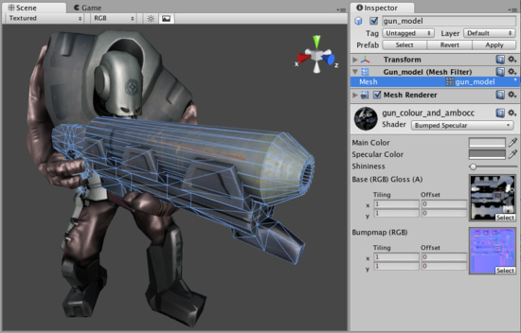

一个网格过滤器连同网格渲染器使得模型显示在屏幕上

**Meshes 网格**

**Meshes** make up a large part of your 3D worlds. You don't build your meshes in Unity, but in another application.

网格组成的3D世界的很大一部分。 你不建立你的网格在Unity里，但在另一个应用程序里。

In Unity, we have done everything in our power to make this process as simple as possible. There are a lot of details, but the following pages should address all specificities of the common 3D art packages:

在Unity里，我们在我们的能力以内所做的一切，使这一过程尽可能简单。 有很多细节，但下面的网页，所有常见的3D艺术包：

* [Maya](http://unity3d.com/support/documentation/Manual/HOWTO-ImportObjectMaya.html)
* [Cinema 4D](http://unity3d.com/support/documentation/Manual/HOWTO-ImportObjectCinema4D.html)
* [3ds Max](http://unity3d.com/support/documentation/Manual/HOWTO-ImportObjectMax.html)
* [Cheetah3D](http://unity3d.com/support/documentation/Manual/HOWTO-ImportObjectCheetah3D.html)
* [Modo](http://unity3d.com/support/documentation/Manual/HOWTO-ImportObjectModo.html)
* [Lightwave](http://unity3d.com/support/documentation/Manual/HOWTO-importObjectLightwave.html)
* [Blender](http://unity3d.com/support/documentation/Manual/HOWTO-ImportObjectBlender.html)

**Other applications 其它应用程序**

Unity can read **.FBX**, **.dae** (Collada), **.3DS**, **.dxf** and **.obj** files, so if your program can export to this format you're home free. FBX exporters for popular 3D packages can be found [here](http://autodesk.com/fbx). Many packages also have a Collada exporter available.

Unity可以阅读.FBX、.dae （Collada）、.3DS、.dxf及.obj文件，因此，如果你的程序可以自由的导出到这种格式。 流行的三维软件包的FBX导出可以在这里找到。 许多软件包也有一个COLLADA导出可用 。

**Textures 纹理**

Unity will attempt to hook up materials to your imported scenes automatically. To take advantage of this, place your textures in a folder called "Textures" next to the scene file, or in any folder above it.

Unity将尝试钩住材料的自动引入到场景。 要利用这一优势，放置你纹理在一个称为“Textures”的文件夹里紧邻着场景文件，或在任何它上面的文件夹。

*Place your textures in a* ***Textures*** *folder at or above the asset's level*

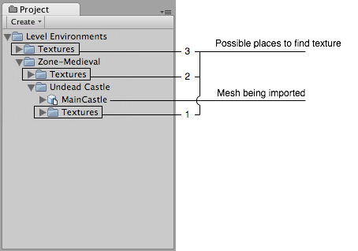

*放置你的纹理在一个纹理文件夹里或在资产的层上。*

**Import settings. 引入设置**

To access the **Import Settings** for a 3D mesh file, select it and the relevant options will appear in the **Inspector**.

要访问的3D网格文件导入设置，选取它，相关的选项将显示在检视器里。

*The Mesh Import Settings dialog网格导入设置对话框*

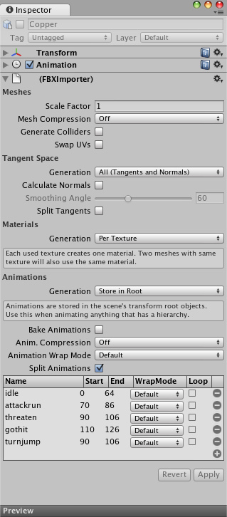

|  |  |
| --- | --- |
| **Meshes** | 网格 |
| **Scale Factor**  比例因子 | Unity's physics system expects 1 meter in the game world to be 1 unit in the imported file. If you like to model at a different scale, this is the place to fix it.  Unity的物理系统预计在1米的游戏世界将在1个单位导入的文件。 如果你希望不同的伸缩模式，这是修改它的地方。 |
| **Mesh Compression网格压缩** | Turning this up will reduce the size of the mesh, but might introduce irregularities. It's best to turn it up as high as possible without the mesh looking too different from the uncompressed version. This is useful for [optimizing game size](http://unity3d.com/support/documentation/Manual/Reducing%20File%20size.html).  开启将减少的网格尺寸，但可能引起不规则行为。 最好开启它作为尽可能高，看起来与不同的网格压缩版本没有太多不同。 这通常用于优化游戏的大小 。 |
| **Generate Colliders**  生成对撞机 | If this is enabled, your meshes will be imported with Mesh Colliders automatically attached. This is recommended for background geometry, but never for geometry you move about. For more info see [Colliders](http://unity3d.com/support/documentation/Manual/Meshes.html#colliders#colliders) below.  如果启用，你的网格会自动附加到网格对撞机。这是建议的背景几何架构，但从来没有几何架构关于你移动。 欲了解更多信息见下文对撞机 。 |
| **Swap UVs交换UV** | Use this if Lightmapped shaders pick up wrong UV channels. This will swap your primary and secondary uv channel.  使用这个，如果Lightmapped阴影加速错误UV通道。 这将交换你的最初的和辅组UV通道 |
| **Tangent Space** | 切换空间 |
| **Generation**  生成 | Determine some specific parts of vertex data to be generated or not. This is useful for [optimizing game size](http://unity3d.com/support/documentation/Manual/Reducing%20File%20size.html).  确定一些顶点数据部分产生与否。 这用于优化游戏的大小 |
| **All (Tangents and Normals)** **全部（切线和法线）** | Enable Normals and Tangents.  启用法线和切线。 |
| **Normals Only**  **法线唯一** | Enable Normals only. The mesh will have no Tangents, so won't work with bump-mapped shaders.  启用法线唯一。这意味着将没有切线，因此将没有凸块映射工作。 |
| **None**  **无** | Disable tangents and normals. Use this option if the mesh is neither bumpmapped nor affected by realtime lighting.  停用切线和法线。使用此选项，如果既不是bumpmapped网也不是实时灯光的影响。 |
| **Calculate Normals**  计算法线 | Enable this to recalculate normals for the imported geometry. If enabled, the **Smoothing Angle** also becomes enabled.  启用此重新计算的导入的几何法线。 如果启用，平滑角也变为启用。 |
| **Smoothing Angle**  平滑角 | Sets how sharp an edge has to be to be treated as a hard edge. It is also used to split normal map tangents.  设置陡沿必须被作为硬边如何处理。 它也可以用来分裂正常地图切线 |
| **Split Tangents**  **分离切线** | Enable this if bumpmap lighting is broken by seams on your mesh. This usually only applies to characters.  如果启用，如果bumpmap照明是被断开通过裂缝在你的网格上。 这通常只适用于字符。 |
| **Materials** | 材料 |
| **Generation 生成** | Controls how materials are generated: 控制材料如何生成 |
| **Off 关闭** | This will not generate materials at all. 这根本不会产生材料。 |
| **Per Texture**  每纹理 | Enable this to generate material files near the found texture files. When enabled, different scenes will share the same material settings when they use the same textures. For the precise rules, see Material Generation below.  启用，在找到的纹理文件附近生成材料文件。 当启用时，不同的场景将共享相同的材料设置，当它们使用相同的纹理时。 对于精确的规则，请参见下面的材料生成。 |
| **Per Material**  每材料 | This will generate materials per scene, so only this scene uses them.  这将生成每个场景的材料，所以只有这个场景使用它们 |
| **Animations** | 动画 |
| **Generation 生成** | Controls how animations are imported: 控制动画如何被导入 |
| **Don't Import 不导入** | No animation or skinning is imported. 无动画或皮肤被导入 |
| **Store in Original Roots**  **存储在原始根目录里** | Animations are stored in root objects of your animation package (these might be different from root objects in Unity).  动画存储在你的动画包的项目的跟目录里（这些可以不同于根对象在Unity里） |
| **Store in Nodes**  **存储在节点里** | Animations are stored together with the objects they animate. Use this when you have a complex animation setup and want full scripting control.  动画是与它们的动画对象一起存储的。 使用此当你有一个复杂的动画设置并希望充分脚本控制。 |
| **Store in Root**  **存储在根里** | Animations are stored in the scene's transform root objects. Use this when animating anything that has a hierarchy.  动画存储在场景的变换根对象里。 使用此当任何动画有一个层时。 |
| **Bake Animations**  烘烤动画 | When using IK or simulation in your animation package, enable this. Unity will convert to FK on import.  当使用IK或模拟在你动画包里时，启用此。 Unity将转换为FK在导入上。 |
| **Animation Compression**  动画压缩 | What type of compression will be applied to this mesh's animation(s)  什么样的压缩类型将被应用到该网格的动画 |
| **Animation Wrap mode**  动画环绕模式 | The default **Wrap Mode** for the animation in the mesh being imported  默认环绕模式为在网格里动画被导入。 |
| **Split Animations**  分裂动画 | If you have multiple animations in a single file, here you can split it into multiple clips.  如果在一个文件里有多个动画，在这里你可以分割成多个剪辑了。 |
| **Name 名称** | Name of the split animation clip分割动画剪辑的名称 |
| **Start 开始** | First frame of this clip in the model file 在模式文件里剪辑的第一帧 |
| **End 结束** | Last frame of this clip in the model file在模式文件里剪辑的最后帧 |
| **WrapMode 换行模式** | What the split clip does when the end of the animation is reached  分割剪辑做什么，当动画结束达到结束时 |
| **Loop 循环** | Depending on how the animation was created, one extra frame of animation may be required for the split clip to loop properly. If your looping animation doesn't look correct, try enabling this option.  依靠动画是如何创建，一个多帧的动画可能需要分割剪辑循环属性。 如果你的循环动画看起来不正确，尝试启用此选项。 |

**Material Generation 材料生成**

Materials are found based on the following rules:

材料基于以下规则

* Unity gets the name of the main diffuse material bound to the objects in the scene.
* Unity获得主要绑定到对象的弥漫材料的名称在场景里。
* Unity looks for a material with this name in a Folder called **Materials** next to the scene.
* Unity寻找带有这个名称的材料在一个称为**Materials文件夹里在场景附近。**
* Unity goes up the project folders, looking for the Material in each **Materials** folder along the way.
* Unity到项目文件夹，寻找材料在每个材料文件夹沿着这个路。

If Unity can't find the Material, it tries to create one from the texture:

如果Unity不能发现材料，它将尝试从纹理建立一个：

Unity checks for a texture with the correct name in the same folder as the scene.

Unity检查一个正确名称的纹理在同样的文件夹里为一个场景。

Unity checks for a texture with the correct name in a folder called **Textures** next to the scene.

Unity检查一个带有正确名称的纹理在文件夹里称为**Textures紧邻着场景。**

Unity goes up the project folders, looking for the correct texture in each **Textures** folder along the way.

Unity到项目文件夹里，查找正确纹理在每个**Textures的文件夹沿路线。**

If Unity finds the texture, it creates a **Materials** folder next to it and creates a material in there.

如果Untiy找到纹理，它建立一个材料文件夹紧邻着它并在那里建立一个材料。

**Colliders 碰撞器**

Unity features two primary types of colliders: **Mesh Colliders** and **Primitive Colliders**. Mesh colliders are imported together with your geometry and are used for background objects. When you enable **Generate Colliders** in the Import Settings, a Mesh collider is automatically added when the mesh is added to the Scene. It has become solid as far as the physics system is concerned.

Unity配备两个主要类型碰撞器： 网格碰撞器和原始碰撞器 。 网格碰撞器被连同你的几何和为背景的对象一起被导入。 当启用生成碰撞器在导入设置时，一个网格碰撞器自动添加网格添加在网格添加到场景时 。 它已成为固体作为长久物理系统是关联的。

If you are moving the object around (a car for example), you can not use Mesh colliders. Instead, you will have to use Primitive colliders. In this case you should disable the **Generate Colliders** setting.

如果你是四处移动（例如汽车）的对象，你不能使用网格碰撞器。 相反，你将必须使用原始碰撞器。 在这种情况下你应该关闭生成碰撞器的设置。

**Animations 动画**

Animations are automatically imported from the scene. For more details about animation import options see [Character Animation](http://unity3d.com/support/documentation/Manual/Character-Animation.html) chapter.

从场景里，动画会自动导入。 有关动画导入选项的更多细节见角色动画的篇章。

**Normal mapping and characters 法线映射和角色**

If you have a character with a normal map that was generated from a high-polygon version of the model, you should import the game-quality version with a **Smoothing angle** of 180 degrees. This will prevent odd-looking seams in lighting due to tangent splitting. If the seams are still present with these settings, enable **Split tangents across UV seams**.

如果你有一个角色拥有法线映射，是由高面多边形模型版本生成的，你要引入一个拥有的平滑的180度角的游戏品质版本。 这将防止长相照明由于切线分裂接缝。 如果接缝仍 呈现这些设置，启用分割切线交叉UV裂缝。

If you are converting a greyscale image into a bumpmap, you don't need to worry about this.

如果你是转换成灰度图像到一个凸起映射（bumpmap）里，你不必为此担心。

**Hints 提示**

Merge your meshes together as much as possible. Make them share materials and textures. This has a huge performance benefit.

尽可能的归并你的网格在一起。 使它们共享的材料和纹理。 这是一个巨大的性能优势。

If you need to set up your objects further in Unity (adding physics, scripts or other coolness), save yourself a world of pain and name your objects properly in your 3D application. Working with lots of *pCube17* or *Box42*-like objects is not fun.

如果你需要进一步设置你的对象在Unity里（添加加物理，脚本或其它冷色），保存你自己努力的世界和命名你的项目属性在你的3D应用程序中里。大量的pCube17或Box42类是对象工作不是开玩笑。

Make your meshes be centered on the world origin in your 3D app. This will make them easier to place in Unity.

让你的网格在 世界里中心原点对齐在你的3D应用里。 这将使它们更容易地放置在Unity里。

**See Also参见**

* [Modeling Optimized Characters](http://unity3d.com/support/documentation/Manual/Modeling%20Optimized%20Characters.html) 角色优化模型
* [How do I use bump maps?](http://unity3d.com/support/documentation/Manual/HOWTO-bumpmap.html) 如何使用撞击地图？
* [How do I fix the rotation of an imported model?](http://unity3d.com/support/documentation/Manual/HOWTO-FixZAxisIsUp.html) 如何解决一个引入模式的旋转？

**Materials and Shaders 材料与阴影**

[**Unity Manual**](http://unity3d.com/support/documentation/Manual/index.html) > [**User Guide**](http://unity3d.com/support/documentation/Manual/User%20Guide.html) > [**Working with Assets**](http://unity3d.com/support/documentation/Manual/Working%20with%20Assets.html) > [**Materials and Shaders**](http://unity3d.com/support/documentation/Manual/Materials.html)

Unity 手册-> 用户指南-> 与资产合作-> 材料与阴影

There is a close relationship between **Materials** and **Shaders** in Unity. Shaders contain code that defines what kind of properties and assets to use. Materials allow you to adjust properties and assign assets.

在Unity里，材料与阴影之间有一个紧密的关系。阴影包含定义什么类型的属性和资产去使用的代码。材料允许你去调整属性及分配资产。

*A Shader is implemented through a Material 阴影通过材料实现*

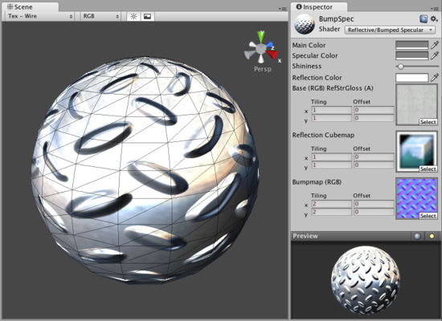

To create a new Material, use **Assets->Create->Material** from the main menu or the **Project View** context menu. Once the Material has been created, you can apply it to an object and tweak all of its properties in the **Inspector**. To apply it to an object, just drag it from the **Project View** to any object in the **Scene** or **Hierarchy**.

创建一个新材料，从主菜单条使用**Assets->Create->Material 或Project View（项目视图）环境菜单。**一旦材料已经被创建，你可以应用它到一个对象并在检视器面板里修改它的所有属性。应用到一个对象，从**Project View**（项目视图）里仅拖拽它到在场景或层次里的任何对象上即可。

**Setting Material Properties 设置材料属性**

You can select which Shader you want any particular Material to use. Simply expand the **Shader** drop-down in the Inspector, and choose your new Shader. The Shader you choose will dictate the available properties to change. The properties can be colors, sliders, textures, numbers, or vectors. If you have applied the Material to an active object in the **Scene**, you will see your property changes applied to the object in real-time.

你可以选取你希望任何特别的材料阴影去使用。在检视器里简单展开阴影下拉，选择你的新阴影。你选择的阴影将按指定可用的属性改变。属性可以是颜色、滑动块、纹理、数量或向量。如何在场景里你已经应用材料去激活属性，你将实时看到你的属性改变应用到对象。

There are two ways to apply a **Texture** to a property.

有两种方法去应用纹理到属性。

1. Drag it from the Project View on top of the Texture square 从项目视图里拖拽它到纹理方块上
2. Click the **Select** button, and choose the texture from the drop-down list that appears 点击**Select按钮，**从下拉框显示的列表里选择纹理。

Two placement options are available for each **Texture**: 两个布局选项对每个纹理是可用到的：

|  |  |
| --- | --- |
| **Tiling贴瓷** | Scales the texture along the different. 沿不同缩放纹理 |
| **Offset 偏移** | Slides the texture around. 环绕纹理滑动 |

**Built-in Shaders 内置阴影**

There is a library of [built-in Shaders](http://unity3d.com/support/documentation/Components/Built-in%20Shader%20Guide.html) that come standard with every installation of Unity. There are over 30 of these [built-in Shaders](http://unity3d.com/support/documentation/Components/Built-in%20Shader%20Guide.html), and six basic families.

有一个内置阴影库，Unity的标准版本带有全部的预安装。有超过30的内置阴影以及6个基本系列：

* [Normal](http://unity3d.com/support/documentation/Components/shader-NormalFamily.html): For opaque textured objects.
* 标准：适合于不透明纹理对象
* [Transparent](http://unity3d.com/support/documentation/Components/shader-TransparentFamily.html): For partly transparent objects. The texture's alpha channel defines the level of transparency.
* 透明：适合于部分透明对象。纹理的alpha通道定义透明性的等级。
* [TransparentCutOut](http://unity3d.com/support/documentation/Components/shader-TransparentCutoutFamily.html): For objects that have only fully opaque and fully transparent areas, like fences.
* 透明切除外观：适用于仅全部白底和全部透明区域的对象，像栅栏。
* [Self-Illuminated](http://unity3d.com/support/documentation/Components/shader-SelfIllumFamily.html): For objects that have light emitting parts.
* 自身照明：适用于有光放射部分的对象。
* [Reflective](http://unity3d.com/support/documentation/Components/shader-ReflectiveFamily.html): For opaque textured objects that reflect an environment **Cubemap**.
* 反射：适用于反射环境立方体映射的不透明纹理对象。
* [Lightmapped](http://unity3d.com/support/documentation/Components/shader-LightmapFamily.html): For objects that have an additional **Lightmap** texture and corresponding texture UV channel.
* 光波映射：适用于拥有附加的光波映射纹理机交叉纹理UV通道的对象。

In each group, built-in shaders range by complexity, from the simple **VertexLit** to the complex **Parallax Bumped with Specular**. For more information about performance of Shaders, please read the built-in Shader [performance page](http://unity3d.com/support/documentation/Components/shader-Performance.html)

在每个分组里，内置阴影复杂的范围从简单顶点到镜面凸起视差集合。更多关于阴影的特性信息，请阅读内置阴影特性页。

This grid displays a thumbnail of all built-in Shaders: 这个表格显示的所有的内置阴影缩微图：

*The builtin Unity shaders matrix Unity内置的阴影矩阵*

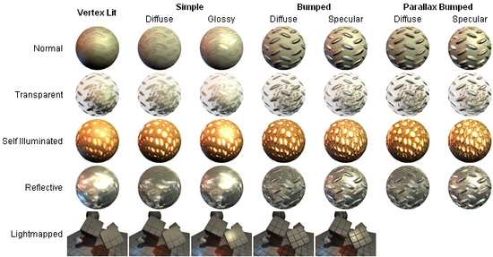

**Shader technical details 阴影技术详细资料**

Unity has an extensive Shader system, allowing you to tweak the look of all in-game graphics. It works like this:

Unity有一个广泛的阴影系统，允许你调整所有在游戏里的图形外观，它的工作像这样地：

A Shader basically defines a formula for how the in-game shading should look. Within any given Shader is a number of properties (typically textures). Shaders are implemented through **Materials**, which are attached directly to individual **GameObjects**. Within a Material, you will choose a Shader, then define the properties (usually textures and colors, but properties can vary) that are used by the Shader.

一个阴影主要定义一个公式在游戏里的阴影看起来如何。任何给定的阴影的内部是一个属性数据（特色的纹理）。阴影是以材料为工具直接附加在专用的**GameObject**上。一个材料内部，你将选择一个阴影，然后定义属性（通常是纹理与颜色，但属性可以变更）通过阴影来使用。

This is rather complex, so let's look at a workflow diagram: 这更适合集合，因此让我们观察一个工作流图表：

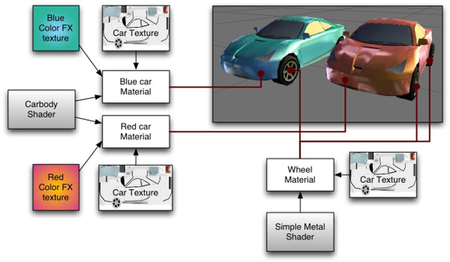

On the left side of the graph is the **Carbody Shader**. 2 different Materials are created from this: **Blue car Material** and **Red car Material**. Each of these Materials have 2 textures assigned; the **Car Texture** defines the main texture of the car, and a **Color FX texture**. These properties are used by the shader to make the car finish look like 2-tone paint. This can be seen on the front of the red car: it is yellow where it faces the camera and then fades towards purple as the angle increases. The car materials are attached to the 2 cars. The car wheels, lights and windows don't have the color change effect, and must hence use a different Material. At the bottom of the graph there is a **Simple Metal Shader**. The **Wheel Material** is using this Shader. Note that even though the same **Car Texture** is reused here, the end result is quite different from the car body, as the Shader used in the Material is different.

在图形的左边是轿车体阴影。2个不同材料被创建从这里：蓝色轿车材料和红色轿车材料。这些材料的每一个有2个纹理附加；轿车额外那里定义了这个轿车的主纹理，以及一个FX纹理颜色。这些属性被阴影使用构成轿车涂层看起来像2色调绘画。这可以在红色轿车的前面观看：它面对摄像机然后当角落增大时向前衰减成紫色的地方它是黄色。轿车材料是附加到2个轿车。一个轿车轮子、灯光和窗口不能有颜色更改效果，以及必须从此使用一个不同的材料。在图形的底部有一个简单金属阴影。轮子材料被应用这个阴影。注意，那个即使同样的轿车纹理在这里重复使用，最终结果是完全不同与轿车体，作为阴影使用的材料是不同的。

To be more specific, a Shader defines: 一个阴影不同的更多细节：

* The method to render an object. This includes using different methods depending on the graphics card of the end user.

渲染对象的方法。包含使用不同方法依靠在最终用户的图形卡上。

* Any vertex and fragment programs used to render. 任意顶点与分段程序被用于渲染。
* Some texture properties that are assignable within Materials. 一些纹理属在材料内部是可指定的。
* Color and number settings that are assignable within Materials. 颜色与数量设置在材料内部是可指定的。

A Material defines: 材料定义:

* Which textures to use for rendering. 哪个纹理用于渲染。
* Which colors to use for rendering. 哪个颜色用于渲染。
* Any other assets, such as a Cubemap that is required by the shader for rendering.
* 任何其它资产，诸如一个立方体映射是需要通过阴影渲染的。

Shaders are meant to be written by graphics programmers. They are created using the **ShaderLab** language, which is quite simple. However, getting a shader to work well on a variety graphics cards is an involved job and requires a fairly comprehensive knowledge of how graphics cards work.

阴影是意味着被编写通过图形开发员。它们使用**ShaderLab语言创建**，是十分简单的。然而，获得一个阴影去在多样的图形卡上良好的工作是棘手的事情并需图形卡如何工作的相当的综合知识。

A number of shaders are built into Unity directly, and some more come in the [Standard Assets](http://unity3d.com/support/documentation/Manual/HOWTO-InstallStandardAssets.html) Library. If you like, there is plenty more shader information in the [Built-in Shader Guide](http://unity3d.com/support/documentation/Components/Built-in%20Shader%20Guide.html).

阴影的数据是直接编译到Unity里，以及一些在标准资产库里。如果你喜欢，还有更多的阴影信息在内置阴影指南里。

**Texture 2D 纹理2D**

[**Unity Manual**](http://unity3d.com/support/documentation/Manual/index.html) > [**User Guide**](http://unity3d.com/support/documentation/Manual/User%20Guide.html) > [**Working with Assets**](http://unity3d.com/support/documentation/Manual/Working%20with%20Assets.html) > [**Texture 2D**](http://unity3d.com/support/documentation/Manual/Textures.html)

Unity 手册->用户指南->与资产合作->纹理2D

**Textures** bring your **Meshes**, **Particles**, and interfaces to life! They are image or movie files that you lay over or wrap around your objects. As they are so important, they have a lot of properties. If reading this for the first time, jump down to [Details](http://unity3d.com/support/documentation/Manual/Textures.html#details#details), and return to the actual settings when you need a reference.

纹理带给你的网格、粒子及界面生命力。它们是图像或电影你覆盖或环绕你的对象。当它们引入时，它们有许多属性。如果在第一时间渲染，跳至[Details](http://unity3d.com/support/documentation/Manual/Textures.html#details#details)（详细资料处），并返回动作设置在你需要一个引用时。

The shaders you use for your objects put specific requirements on which textures you need, but the basic principle is that you can put any image file inside your project. If it meets the size requirements (specified below), it will get imported and optimized for game use. This extends to multi-layer Photoshop or TIFF files - they are flattened on import, so there is no size penalty for your game.

为你的对象使用阴影放置指定的需求在你需要的纹理上，但是基本原则是你可以放置任何图像文件在你的项目里。如果它满足需求大小（在下面指定），它将获得引入并为游戏使用组织。这个扩展到多层Photoshop或TIFF文件它们是在引入上变平，因此没有大小损失你的游戏。

**Properties 属性**

The **Texture Inspector** looks a bit different from most others: 纹理检视器面板看起来与其它大多数的有点不同

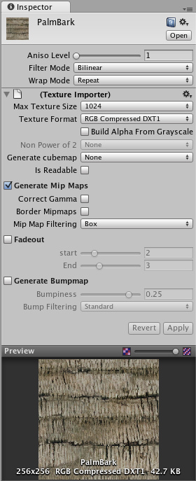

The top section contains a few settings, and the bottom part contains import settings and a texture preview.

顶部部分包含几个设置，底部部分包含引入设置和纹理预览

|  |  |
| --- | --- |
| **Aniso Level**  **不同级别** | Increases texture quality when viewing the texture at a steep angle. Good for floor and ground textures, see [below](http://unity3d.com/support/documentation/Manual/Textures.html#anisotropy#anisotropy).  当子一个陡峭角度观看纹理时，增长纹理质量。能担当地板与地面纹理，见下面。 |
| **Filter Mode**  **过滤模式** | Selects how the Texture is filtered when it gets stretched by 3D transformations:  选取当纹理通过3D转换获得伸展时纹理如何被过滤 |
| **No Filtering**  **无过滤** | The Texture becomes blocky up close  纹理变为斑驳向上接近 |
| **Bilinear**  **双线性** | The Texture becomes blurry up close  纹理变为模糊向上接近 |
| **Trilinear**  **三线** | Like Bilinear, but the Texture also blurs between the different mip levels  像双线性，但纹理也在不同人工处理级别之间模糊 |
| **Wrap Mode**  缠绕模式 | Selects how the Texture behaves when tiled:  选取当纹理平铺时，纹理如何运转 |
| **Repeat**  **重复** | The Texture repeats (tiles) itself  纹理它自己重复 |
| **Clamp**  **钳住** | The Texture's edges get stretched  纹理的边缘获得伸展 |

**Import Settings 引入设置**

Textures all come from image files in your **Project Folder**. How they are imported is specified by the texture's **Import Settings**. You change these by selecting the file texture in the **Project View** and modifying the **Import Settings** in the **Inspector**.

纹理全部来自图象文件在你的项目文件夹里。它们如何被引入是通过纹理的引入设置指定的。你更改它们通过选择纹理文件在项目视图里并修改引入设置在检视器面板。

*The Texture Import Settings dialog 纹理引入设置对话框*

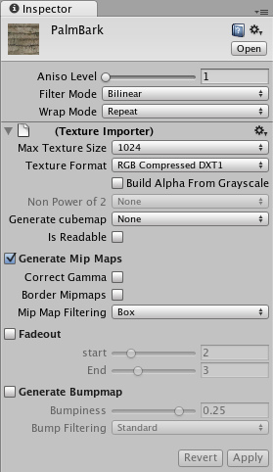

|  |  |
| --- | --- |
| **Max Texture Size**  **最大纹理大小** | The maximum imported texture size. A lot of artists prefer to work with huge textures - scale the texture down to a suitable size with this.  最大值引入纹理大小。许多艺术家更愿意与巨大纹理一起工作—伸展纹理到合适的大小 |
| **Texture Format**  **纹理格式** | What internal representation is used for the texture. This is a tradeoff between size and quality. In the examples below we show the final size of a in-game texture of 256 by 256 pixels:什么内部表示应用与纹理。这是大小与质量之间的折衷。在下面的例子里，我们显示最终规模由256像素的游戏内部纹理： |
| **RGB Compressed**  **DXT1**  **RGB压缩DXT1** | Compressed RGB texture. This is the most common format for diffuse textures. 4 bits per pixel (32 KB for a 256x256 texture).  压缩RGB纹理。这是常见的漫射纹理格式。4位每像素（32KB的256*256纹理） |
| **RGBA Compressed**  **DXT5**  **RGBA 压缩DXT5** | Compressed RGBA texture. This is the main format used for diffuse & specular control textures. 1 byte/pixel (64 KB for a 256x256 texture).  压缩RGB纹理。这是主要的漫射与反射控制纹应用的主要理格式。每像素1位（64KB的256*256纹理） |
| **RGB 16 bit**  **16位的RGB** | 65 thousand colors with no alpha. Compressed DXT formats use less memory and usually look better. 128 KB for a 256x256 texture.  65000没有alpha的颜色。压缩DXT格式用于减少内存以及通常好看。128K的256*256纹理。 |
| **RGB 24 bit**  **24位的RGB** | Truecolor but without alpha. 192 KB for a 256x256 texture. 没有alpha的真彩。192K的256*256纹理 |
| **Alpha 8 bit**  **8位的Alpha** | High quality alpha channel but without any color. 64 KB for a 256x256 texture.  无任何颜色的高质量alpha通道。64K的256*256纹理。 |
| **RGBA 16 bit**  **16位的RGBA** | Low-quality truecolor. Has 16 levels of red, green, blue and alpha. Compressed DXT5 format use less memory and usually look better. 128 KB for a 256x256 texture.  低质量真彩。有16位级别的红、绿、蓝以及alpha。压缩DXT5格式的使用少的内存并通产好看。128k的256*256纹理。 |
| **RGBA 32 bit**  **32位的RGBA** | Truecolor with alpha - this is the highest quality. At 256 KB for a 256x256 texture, this one is expensive. Most of the time, **DXT5** offers sufficient quality at a much smaller size. The main place this is used is for bump maps, as DXT compression there often carries a visible quality loss.  有alpha的真彩—这是最高的质量。在256K的256*256纹理，据此之一是昂贵的。在多数情况下，DXT5提供了一个更小的大小足够的质量。主要地方是用于凹凸图，DXT压缩经常带有明显的质量损失。 |
| **Build Alpha From Grayscale**  **从灰度级建立Alpha** | If enabled, an alpha transparency channel will be generated by the image's existing values of light & dark.  如果启用，一个alpha透明性通道将通过图象的存在明暗的值产生 |
| **Non Power of 2 sizes**  非2的幂的大小 | If texture has non-power-of-two size, this will define a scaling behavior at import time (for more info see [Texture Sizes](http://unity3d.com/support/documentation/Manual/Textures.html#texturesizes#texturesizes) section below):  如果纹理有两个幂的大小，这将定义一个在引入时的伸展行为（更多信息看下面的纹理大小节）。 |
| **Keep original**  **保持原件** | Texture will be padded to the larger power-of-two size for use with GUITexture component.  纹理将填补大的两个幂的大小与GUI纹理组件一起使用。 |
| **Scale to nearest**  **最近的规模** | Texture will be scaled to the nearest power-of-two size at import time. For instance 257x511 texture will become 256x512. Note that PVRTC formats require textures to be square (width equal to height), therefore final size will be upscaled to 512x512.  在引入时，纹理将被伸缩到最近两个幂的大小。对于257*511纹理实例将变为256*512.注意PVRTC格式需要纹理是正方形（宽高相等），因此最终规模将扩大到512*512. |
| **Scale to larger**  **规模变大** | Texture will be scaled to the larger power-of-two size at import time. For instance 257x511 texture will become 512x512.  在引入时，纹理将缩放到大的两个幂尺寸。对于257*511纹理实例将变为512*512. |
| **Scale to smaller**  **规模变小** | Texture will be scaled to the smaller power-of-two size at import time. For instance 257x511 texture will become 256x256.  在引入时，纹理将缩放到小的两个幂尺寸。对于257*511纹理实例将变为256*256. |
| **Generate Cube Map**  **产生立方体映射** | Generates a cubemap from the texture using different generation methods.  产生一个立方体映射从纹理使用不同方式产生。 |
| **Is Readable**  **是可读** | Select this to enable access to the texture data from the scripts (GetPixels, SetPixels and other [Texture2D](http://unity3d.com/support/documentation/ScriptReference/Texture2D.html) functions). Note however that a copy of the texture data will be made doubling the amount of memory required for texture asset. Use only if absolutely necessary. Disabled by default.  选取它启用访问纹理数据从脚本（GetPixels, SetPixels以及其它纹理2D函数）。不过注意，纹理数据的副本将使用双倍内存需要的纹理资产。使用只读绝对必要。默认禁用。 |
| **Generate Mip Maps**  **产生Mip映射** | Select this to enable mip-map generation. Mip maps are smaller versions of the texture that gets used when the texture is very small on screen. For more info, see [Mip Maps](http://unity3d.com/support/documentation/Manual/Textures.html#mipmaps#mipmaps) below.  选取启用mip映射生成。Mip映射是当纹理非常小的显示在屏幕上时获得使用的小的纹理版本。更多信息，查看下面的mip映射 |
| **Correct Gamma**  **纠正Gamma** | Select this to enable per-mip-level gamma correction.  选取启用每mip级别纠正 |
| **Border Mip Maps**  **边界Mip映射** | Select this to avoid colors seeping out to the edge of the lower Mip levels. Used for light cookies (see below).  选取是为了避免颜色渗漏到低mip级别边缘外部。光波烹调使用（看下面） |
| **Mip Map Filtering**  **Mip映射过滤** | Two ways of mip map filtering is available to optimize image quality:  Mip映射过滤的两种方法是可用的优化图形质量。 |
| **Box**  **盒子** | The simplest way to fade out the mipmaps - the mip levels become smoother and smoother as they go down in size.  简单的方法淡出mip映射—mip级别变为平滑及平滑作为它们下降的尺寸。 |
| **Kaiser** | A sharpening Kaiser algorithm is run on the mip maps as they go down in size. If your textures are too blurry in the distance, try this option. Kaiser钝化算法是运行在mip映射上作为它们下降的尺寸。如果你的纹理是在远处太模糊，尝试这个选项。 |
| **Fade Out Mips**  **淡出Mips** | Enable this to make the mipmaps fade to gray the mip levels progress. This is used for detail maps.启用它使mip映射淡出到灰色mip级别处理。这被用于详细映射。 |
| **Fade Out start**  **淡出开始** | The first mip level to begin fading out at.  第一mip级别开始淡出。 |
| **Fade Out End**  **淡出结束** | The mip level where the texture is completely grayed out.  纹理完成的灰色输出那里的mip级别。 |
| **Generate Bump Map**  **产生凹凸映射** | Enable this to turn the color channels into a format suitable for real-time bumpmapping. For more info, see [Bump Maps](http://unity3d.com/support/documentation/Manual/Textures.html#bumpmaps#bumpmaps), below.  启用它去更改颜色通道对到一个适合格式的实时凹凸。更多信息，查看凹凸映射，在下面。 |
| **Bumpiness崎岖不平** | Control the amount of bumpiness. 控制崎岖不平的数量 |
| **Filtering 过滤** | Determine how the bumpiness is calculated: 确认崎岖不平如何计算的。 |
| **Standard 标准** | This generates normal maps that are quite smooth. 这样生成的正常映射十分平滑。 |
| **Sobel 索贝尔** | The Sobel filter generates normal maps that are sharper than Standard.  **Sobel**过滤器产生比正常标准清晰的映射。 |

**Details 详细资料**

**Supported Formats 支持格式**

Unity can read the following file formats: PSD, TIFF, JPG, TGA, PNG, GIF, BMP, IFF, PICT. It should be noted that Unity can import multi-layer PSD & TIFF files just fine. They are flattened automatically on import but the layers are maintained in the assets themselves, so you don't lose any of your work when using these file types natively. This is important as it allows you to just have one copy of your textures that you can use from Photoshop, through your 3D modelling app and into Unity.

Unity可以读取如下的格式：PSD、TIFF、JPG、TGA、PNG、GIF、BMP、IFF、PICT。应该注意的是Unity可以引入充分精细的多层的PSD与TIFF文件。在引入时，它们是自动变平但阶层是保留它们自己的资产，因此你不能丢失任何你的工作当使用它们的原生类型文件时。这是重要的因为它允许你仅有一个你的纹理副本可以使用从Photoshop里，通过你的3D模型应用程度进入到Unity里。

**Texture Sizes 纹理大小**

Ideally texture sizes should be powers of two on the sides. These sizes are as follows: 2, 4, 8, 16, 32, 64, 128, 256, 512, 1024 or 2048 pixels. The textures do not have to be square, i.e. width can be different from height.

完美的纹理大小应是作为2的幂。这些尺寸如下：2，4，8，16，32，64，128，256，512，1024或2048像素。纹理不必是方形即宽度与高度可以不同。

It is possible to use other (non power of two) texture sizes with Unity. Non power of two texture sizes work best when used on [GUI Textures](http://unity3d.com/support/documentation/Components/class-GuiTexture.html), however if used on anything else they will be converted to an uncompressed RGBA 32 bit format. That means they will take up more video memory (compared to DXT compressed textures) and will be slightly slower to load. In general you'll use non power of two sizes only for making GUI.

它可能使用其它（非2的幂）纹理尺寸与Unity。非2的幂的纹理尺寸工作更好当在GUI纹理上使用时。然而如果在其它事物上使用它们将转换成非压缩的RGBA 32位格式。那意味着它们将花费更多显存（）以及将装载变慢。在一般情况下，你将仅使用非2的幂大小处理GUI。

Non power of two texture assets can be scaled up at import time using **Non Power of 2 sizes** option in the import settings. Then Unity will scale texture contents as requested, and in the game they will behave just like any other texture. So they can still be compressed and very fast to load.

非2的幂的纹理资产可以在引入时被伸缩，在引入设置里使用**Non Power of 2 sizes**选项。然后Unity将伸缩纹理内容依照要求，在游戏里它们将表现像任何其它纹理。所有它们仍旧可以被压缩及非常快速的装载。

**UV Mapping 紫外线映射**

When mapping a 2D texture on to a 3D model, some sort of wrapping is done. This is called **UV mapping** and is done in your 3D modelling app. Inside Unity, you can scale and move the texture using [Materials](http://unity3d.com/support/documentation/Components/class-Material.html). Scaling bump & detail maps is especially useful.

当映射一个2D纹理到一个3D模型时，一些环绕顺序已经完成。这被称为UV映射并完成在你的3D模型应用程序里。在Unity里，你可以伸缩并移动纹理使用原料。伸缩凹凸详细资料映射是特别有用的。

**Mip Maps Mip映射**

Mip Maps are a list of progressively smaller versions of an image, used to optimise performance on real-time 3D engines. Objects that are far away from the camera use the smaller texture versions. Using mip maps uses 33% more memory, but not using them can be a huge performance loss. You should always you mipmaps for in-game textures; the only exceptions are textures that will never be minified (e.g. GUI textures).

Mip映射是一个图象小版本的形象列表，用于优化性能在实时3D引擎上。对象是远离摄像机使用的小的纹理版本。使用Mip映射利用33%更多内存，但不使用它们就有巨大的性能损失。你应该总是mip映射在游戏里的纹理；唯一的例外是纹理将永远不缩小（例如 GUI纹理）。

**Bump Maps 凹凸映射**

Bump maps are used by bump map shaders to make low-polygon models look as if they contain more detail. Unity uses normal maps encoded as RGB images. You also have the option to generate a normal map from a grayscale height map image.

凹凸映射是通过凹凸映射阴影使用去做低多边形模块外表如果它们包含更多详细资料。Unity使用正常映射编码作为RGB图形。你同样有产生正常映射的选项从一个灰度的高映射图形。

**Detail Maps 详细映射**

If you want to do a terrain, you normally use your main texture to show where there are grass, rocks sand, etc... If your terrain has a decent size, you will end up with a very blurry terrain. [Detail textures](http://unity3d.com/support/documentation/Manual/HOWTO-UseDetailTexture.html) hide this fact by fading in small details as your main texture get up close.

如果你想要做一个地形，你通常使用的主要纹理显示在有草，石头沙子等. 如果你的地形有一个体面的大小，你将以一个非常模糊地形结束。 详细纹理隐藏真相，通过衰减小的详细资料作为你的主要纹理获得近距离。

When drawing detail textures, a neutral gray is invisible, white makes the main texture twice as bright and black makes the main texture completely black.

当绘制详细纹理时，一个中立灰色不可见，白色使主要纹理两次作为明和暗使主要纹理完成黑色。

**Cube Maps 立方体映射**

If you want to use texture for reflection maps (e.g. use the **Reflective** builtin shaders), you need to use [Cubemap Textures](http://unity3d.com/support/documentation/Components/class-Cubemap.html).

.如果你想使用反射贴图纹理（如使用反射内建阴影），你需要使用Cubemap纹理 。

**Anisotropic filtering 非均匀性过滤**

Anisotropic filtering increases texture quality when viewed from a grazing angle, at some expense of rendering cost (the cost is entirely on the graphics card). Increasing anisotropy level is usually a good idea for ground and floor textures. In [Quality Settings](http://unity3d.com/support/documentation/Components/class-QualitySettings.html) anisotropic filtering can be forced for all textures or disabled completely.

非均匀性过滤增加纹理质量当从入射余角观看时，花费一些选人代价（该代价取决于图形卡）。增加的非均匀性级别是通常好的想法对于地面和地板纹理。在[Quality 设置非均匀性过滤可被强制处理所有纹理或完全禁用。](http://unity3d.com/support/documentation/Components/class-QualitySettings.html)

*No anisotropy used on the ground texture 没有非均匀性使用在地面纹理上*

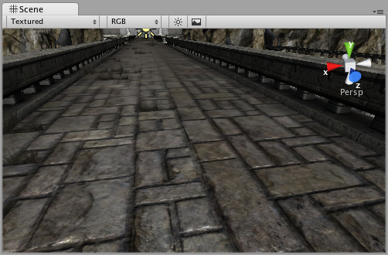

*Maximum anisotropy used on the ground texture 最大值非均匀性使用在地面纹理上*

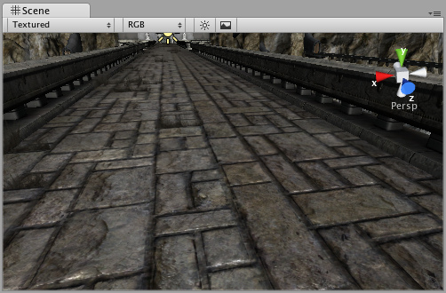

**Light Cookies 光波Cookies**

An interesting way to add a lot of visual detail to your scenes is to use **Cookies** - greyscale textures you use to control the precise look of in-game lighting. This is fantastic for making moving clouds and giving an impression of dense foilage. The [Light](http://unity3d.com/support/documentation/Components/class-Light.html) page has more info on all this, but the main thing is that for textures to be usable for cookies, the following properties need to be set:

一个有趣的方法去添加许多可视详细资料到你的场景是使用Cookis—灰度级纹理你应用控制精确外观在游戏里的光波。这是奇异的制造移动的云和给予密集的foilage印象。光波页有许多这方面的信息，但主要的事情是为纹理可用的Cookies，接下来的属性需要去设置：

For **Spotlight** Cookies, use the following settings: 对于**Spotlight（聚光灯）**Cookies，使用下面的设置：

|  |  |
| --- | --- |
| **Texture Format**  **纹理格式** | Any setting that has an alpha channel: **Alpha 8 bit** (recommended), ` **DXT5 RGBA**, **RGBA 16 bit** or **RGBA 32 bit**.  任何设置拥有一个alpha通道：8位**Alpha（推荐的）**、**DXT5 RGBA、16位的RGBA或32位的RGBA** |
| **Build Alpha from RGB Grayscale**  **从RGB灰度级创建Alpha** | Enabled  启用 |
| **Generate Mip Maps**  **产生 Mip映射** | Enabled  启用 |
| **Border Mip Maps**  **边界Mip映射** | Enabled  启用 |

You should keep the edges of you cookie texture solid black in order to get the proper effect. In the Texture Inspector, set the Edge Mode to **Clamp**.

你应保持你的边缘cookie的质地纯黑色以得到适当的效果。在纹理检视器里，设置边缘模式为**Clamp**（钳住）。

For **Directional Lights**, use the following settings: 对于**Directional Lights（方向灯）**

|  |  |
| --- | --- |
| **Texture Format**  **纹理格式** | Any setting that has an alpha channel: **Alpha 8 bit** (recommended), **DXT5 RGBA**, **RGBA 16 bit** or **RGBA 32 bit**.  任何设置拥有一个alpha通道：8位**Alpha（推荐的）**、**DXT5 RGBA、16位的RGBA或32位的RGBA** |
| **Build Alpha from RGB Grayscale**  **从RGB灰度级创建Alpha** | Enabled  启用 |
| **Generate Mip Maps**  **产生 Mip映射** | Enabled  启用 |
| **Border Mip Maps**  **边界Mip映射** | Disabled  启用 |

This texture will tile, so in the texture inspector, you must set the Edge Mode to **Repeat**.

纹理将平铺显示，因此在纹理检视器里，你必须设置边界模式为Repeat。

For **Point Lights**, you need to use **Cube Maps**. To generate one, either make six textures and assign them as described in [Cubemap Textures](http://unity3d.com/support/documentation/Components/class-Cubemap.html) or generate one with the following settings:

对于点光源，你需要使用**Cube Maps（立方体映射）.**生成一个，任一个：使用6纹理并附加它们作为描述在立方体映射里或以下面的设置生成一个：

|  |  |
| --- | --- |
| **Texture Format**  **纹理格式** | Any setting that has an alpha channel: **Alpha 8 bit** (recommended), **DXT5 RGBA**, **RGBA 16 bit** or **RGBA 32 bit**.  任何设置拥有一个alpha通道：8位**Alpha（推荐的）**、**DXT5 RGBA、16位的RGBA或32位的RGBA** |
| **Generate Cube Map**  **生成立方体映射** | Any other setting than **None**.  无任何其它设置 |
| **Build Alpha from RGB Grayscale**  **从RGB灰度级创建Alpha** | Enabled启用 |
| **Generate Mip Maps**  **生成Mip映射** | Enabled启用 |
| **Border Mip Maps**  **边界Mip映射** | Disabled启用 |

**Movie Texture 电影纹理**

[**Unity Manual**](http://unity3d.com/support/documentation/Manual/index.html) > [**User Guide**](http://unity3d.com/support/documentation/Manual/User%20Guide.html) > [**Working with Assets**](http://unity3d.com/support/documentation/Manual/Working%20with%20Assets.html) > [**Movie Texture**](http://unity3d.com/support/documentation/Manual/Video%20Files.html)

**Movie Textures** are animated **Textures** that are created from a video file. By placing a video file in your project's **Assets Folder**, you can import the video to be used exactly as you would use a regular [Texture](http://unity3d.com/support/documentation/Components/class-Texture2D.html).

电影纹理是动画纹理是从视频文件里创建的。通过在你的项目的Assets文件夹放置一个视频文件，你可以引入视频被正确使用作为你将看到使用一个正常的纹理。

Video files are imported via Apple QuickTime. Supported file types are what your QuickTime installation can play (usually **.mov**, **.mpg**, **.mpeg**, **.mp4**, **.avi**, **.asf**). On Windows movie importing requires Quicktime to be installed ([download here](http://www.apple.com/quicktime/download/)).

视频文件被引入经由苹果公司的数字多媒体技术。支持文件的类型是你的多媒体技术安装的可播放的什么类型。（通常是 .mov, .mpg, .mpeg, .mp4, .avi, .asf）。在windows上的电影引入需要数字多媒体技术的安装（在这里下载）。

**Properties 属性**

The Movie Texture **Inspector** is very similar to the regular [Texture](http://unity3d.com/support/documentation/Components/class-Texture2D.html) Inspector.

电影纹理检视器面板与正常纹理的检视器面板是非常相似的。

*Video files are Movie Textures in Unity 在Unity里的视频文件是电影纹理。*

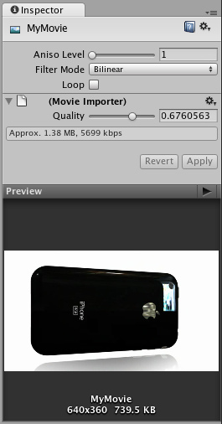

|  |  |
| --- | --- |
| **Aniso Level**  **Aniso 级别** | Increases Texture quality when viewing the texture at a steep angle. Good for floor and ground textures  当在陡峭角落查看纹理时增加纹理质量。地板和地面良好的纹理。 |
| **Filtering Mode**  **过滤模式** | Selects how the Texture is filtered when it gets stretched by 3D transformations  选取纹理如何过滤当它通过3D转换获得伸展时 |
| **Loop**  **循环** | If enabled, the movie will loop when it finishes playing  如果启用，电影将循环当它在文成播放时。 |
| **Quality**  **品质** | Compression of the Ogg Theora video file. A higher value means higher quality, but larger file size  Ogg Theora格式的压缩的视频文件。高数值意味着高品质，但文件尺寸巨大。 |

**Details 详细资料**

When a video file is added to your Project, it will automatically be imported and converted to **Ogg Theora** format. Once your Movie Texture has been imported, you can attach it to any **GameObject** or **Material**, just like a regular Texture.

当一个视频文件被加入到你的项目，它将自动的被引入并转换成Ogg Theora格式。一旦你的电影纹理已经被引入，你可以附加它到任何 **GameObject 或材料上，**就像一个正常的纹理。

**Playing the Movie 播放电影**

Your Movie Texture will not play automatically when the game begins running. You must use a short script to tell it when to play.

你的电影纹理将不自动播放当游戏开始运行时。你必须使用一个小的脚本去告诉它当播放时。

// this line of code will make the Movie Texture begin playing 这行代码将使电影纹理开始播放

renderer.material.mainTexture.Play();

Attach the following script to toggle Movie playback when the space bar is pressed:

当空白键被按下时，附加下面的脚本到电影回放切换开关上。

function Update () {

if (Input.GetButtonDown ("Jump")) {

if (renderer.material.mainTexture.isPlaying) {

renderer.material.mainTexture.Pause();

}

else {

renderer.material.mainTexture.Play();

}

}

}

For more information about playing Movie Textures, see the [Movie Texture Script Reference](http://unity3d.com/support/documentation/ScriptReference/MovieTexture.html) page

更多关于播放电影纹理的信息，查看 [Movie Texture Script Reference](http://unity3d.com/support/documentation/ScriptReference/MovieTexture.html) 页。

**Movie Audio 电影音频**

When a Movie Texture is imported, the audio track accompanying the visuals are imported as well. This audio appears as an **AudioClip** child of the Movie Texture.

当一个电影纹理被引入时，音频曲目伴随图象也被引入。音频作为电影纹理的子音频剪辑显示。

*The video's audio track appears as a child of the Movie Texture in the* ***Project View***

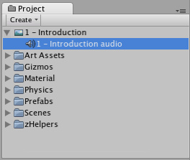

***视频的音频曲目作为电影纹理的子显示在项目视图里。***

To play this audio, the Audio Clip must be attached to a GameObject, like any other Audio Clip. Drag the Audio Clip from the Project View onto any GameObject in the Scene or Hierarchy View. Usually, this will be the same GameObject that is showing the Movie. Then use [audio.Play()](http://unity3d.com/support/documentation/ScriptReference/%20GameObject-audio.html) to make the the movie's audio track play along with its video.

去播放这个音频，音频剪辑必须附加到一个GameObject，像任意其它音频剪辑。从项目视图里拖动音频剪辑到在场景里或层次里的任意的GameObject。通常，这将同样的GameObject放映电影。然后使用[audio.Play()](http://unity3d.com/support/documentation/ScriptReference/%20GameObject-audio.html)去使电影音频曲目随这视频一起播放。

**Audio Files 音频文件**

[**Unity Manual**](http://unity3d.com/support/documentation/Manual/index.html) > [**User Guide**](http://unity3d.com/support/documentation/Manual/User%20Guide.html) > [**Working with Assets**](http://unity3d.com/support/documentation/Manual/Working%20with%20Assets.html) > [**Audio Files**](http://unity3d.com/support/documentation/Manual/Audio%20Files.html)

Unity手册-> 用户指南 ->与资产合作-> 音频文件

Just like when using Meshes or Textures, the workflow for **Audio File** assets is designed to make things work for you quickly and easily. You can make your Audio Files with any format you like, and Unity can import them and play them back, but there's some specific information you should know for working with Audio Files.

就像当使用网格或纹理时，工作流程 **音频文件** 资产的目的是有计划的使事情为你快速及轻松地工作。你可以用你喜欢的任何格式的音频文件，Unity可以导入和播放发挥它们，但是有一些具体的信息，你应该知道与音频文件工作。

The supported audio formats for Unity executables are **Ogg Vorbis** and uncompressed audio. You can choose to convert any Audio File to Ogg Vorbis from inside the **Editor**. You can create your audio files in any format you like, and Unity will automatically convert them to Ogg Vorbis. If you don't, then your audio files will remain uncompressed, and will be much larger in size. Having uncompressed audio is okay for short sounds, like up to several seconds. Longer sounds and especially music will have huge file sizes when uncompressed, and will increase the overall size of the executable.

Unity支持的可执行音频格式是 Ogg Vorbis的 和未压缩音频。你可以选择从编辑器内部转换任何音频文件为Ogg Vorbis格式。你可以创建你喜欢的任何格式音频文件，Unity将自动将其转换成Ogg Vorbis。如果你没有，那么你的音频文件将保留未压缩，而大小将非常巨大。经压缩的音频是好的短的声音，像几秒钟。特别是较长的声音和音乐有很大的文件当未压缩时，并会增加可执行文件的总体规模。

With this in mind, the general rules of thumb are: 考虑到这一点，一般的经验规则是：

* Convert music and long sounds to Ogg Vorbis from inside the Editor. The audio data will be small, but will cost CPU cycles to decode at play time. For best sound quality supply your own Ogg Vorbis files, or use uncompressed audio files (converting an MP3 file to Ogg loses some quality).

在编辑器内部转换的音乐和长期的声音到Ogg Vorbis。音频数据将变小，但将花费CPU周期去解码在播放时。为了达到最佳的声音质量提供自己的Ogg Vorbis文件，或使用压缩的音频文件（转换 MP3文件为Ogg失去一些质量）。

* Use uncompressed audio for short sound effects. The audio data will be larger, but sounds won't need to be decoded at play time.
* 短声音效果使用未压缩音频。音频数据将变大，但声音不会需要在播放时解码。

Any Audio File imported into Unity is called as an **Audio Clip**. Audio Clips work in conjunction with **Audio Sources** and an **Audio Listener**. Think of Clips as audio data only. When you attach your Clip to an object in the game, it becomes an Audio Source and it now has **Volume**, **Pitch**, and other properties like **Loop**. While a Source is playing, an Audio Listener can "hear" all Sources that are close enough, and those are the sounds you will hear through your speakers. There can be only one Audio Listener in your scene, and this is usually attached to the **Main Camera**. In most cases you will work with Audio Sources more than Clips or Listeners.

任何音频文件引入到Unity里被称作为**音频剪辑**。音频剪辑工作与**音频源** 和 **音频监听**协作。考虑剪辑仅作为音频数据，当你将你的剪辑附加到一个游戏中的对象时，它成为一个音频源，并拥有一个音量，**间距**及其它属性像循环。当一个源正在播放时，一个音频监听器可以“听”到足够接近所有来源的，这些都是你会听到声音通过扬声器。只能有一个音频监听在你的场景中，这通常是附加到 **主相机**。在大多数情况下，你将与音频源一起工作，超过剪辑或监听程序。

See the [Sound chapter](http://unity3d.com/support/documentation/Manual/Sound.html) in the [Creating Gameplay](http://unity3d.com/support/documentation/Manual/Creating%20Gameplay.html) section of this manual for more information on using sound in Unity.

在本手册的[创建游戏](http://unity3d.com/support/documentation/Manual/Creating%20Gameplay.html)里看[声音章](http://unity3d.com/support/documentation/Manual/Sound.html)，获得更多使用声音信息在Unity里。

**Audio Clip 音频剪辑**

**Audio Clips** are used by [Audio Sources](http://unity3d.com/support/documentation/Components/class-AudioSource.html) to represent the audio asset imported into Unity. Unity supports both Mono and Stereo audio assets. Unity supports importing the following audio file formats: **.aif**, **.wav**, **.mp3**, and **.ogg**.

音频剪辑 通过音频源的使用表现音频资产引入到Unity里。Unity同时支持单声道和立体声音频资产。Unity支持导入以下音频文件格式：**.aif**, **.wav**, **.mp3**, 及 **.ogg**。

*The Audio Clip* ***Inspector 音频剪辑在检视器里***

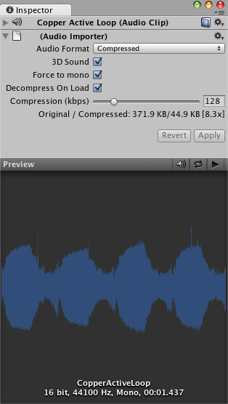

**Properties 属性**

|  |  |
| --- | --- |
| **Audio Format**  音频格式 | The specific format that will be used for the sound at runtime.  具体格式将声音在运行时使用。 |
| **Native**  **原态** | Larger file size, higher quality. Best for very short sound effects.  较大的文件大小，质量更高。最好用于很短的音响效果。 |
| **Compressed**  **压缩的** | Smaller file size, lower/variable quality. Best for medium length sound effects and music.  较小的文件尺寸，降低/可变质量。最好用于中等长度的音效和音乐的媒体。 |
| **3D Sound**  **3D声音** | If enabled, the sound will play back in 3D space. In Unity 2.6, both Mono and Stereo sounds can be played in 3D  如果启用，声音将播放在三维空间中。在Unity2.6里，单声道和立体声都可以被播放  在3D里 |
| **Force to mono**  **强制单声道** | If enabled, the stereo audio clip will be condensed to a single channel mono sound.  如果启用，立体声音频剪辑将简化为单一通道单声道。 |
| **Decompress On Load 解压装载** | If enabled, this clip will be loaded into memory as soon as the scene containing it is loaded. It is suggested that you leave this on, otherwise your game may have reduced performance as the sound is decompressed real-time at runtime.  如果启用，该剪辑将被加载到内存中当现场包含它同时被加载。建议你保留这个启用，否则，你的游戏可能减少性能当声音是在运行时解压缩实。 |
| **Compression**  **压缩** | Amount of Compression to be applied to a **Compressed** clip. Statistics about file size can be seen beneath the slider. It is suggested to drag the slider to a place that leaves the playback "good enough" but still at a small enough size to meet your file size/distribution needs.  压缩量将适用于压缩 剪辑。统计有关文件的大小可以看到下面的滑块。它建议拖动滑块到一个地方，离开播放“足够好”，但仍在一个足够小的尺寸以满足你的文件大小/分配的需要。 |

**Importing Audio Assets 导入音频资产**

Unity supports both Compressed and Uncompressed Audio. Any type of file except .mp3 will be initially imported as Uncompressed. MP3 and Compressed audio files must be decompressed by the CPU while the game is running, but are smaller in file size. Native formats have the benefit of being higher fidelity without increasing CPU taxation, but create much larger files.

Unity同时支持压缩和非压缩音频。任何类型文件除了MP3将首先为未压缩引入，MP3和压缩音频文件必须由CPU解压缩在游戏运行时，但它们是小的文件尺寸。原生格式有益于高保真而没有增加CPU的课税，但是建立更大的文件。

As a general rule of thumb, Compressed audio is best for long files like background music or dialog, and uncompressed is better for short sound effects that are under two seconds. However...

作为一般原则，压缩音频是最好用于长文件像背景音乐或对话，未压缩的是最好用于短音效果少于两秒钟。然而...

**If you are creating a web player game, you should Compress as much of your audio as possible.** This will help you attain the smallest file size for webplayer downloads. If you tweak the amount of Compression, the difference in sound quality won't be noticeable.

**如果您要创建一个web玩家游戏，你应该压缩尽可能多的你的音频。** 这将帮助你实现最小的webplayer下载文件的大小。如果你修改的压缩量，在音质的差异不会明显。

## Using 3D Audio 使用3D音频

If an audio clip is marked as a **3D Sound** then it will be played back to simulate its position in the game world's 3D space. 3D sounds simulate distance and location of sounds by fading volume and panning across speakers. Unity supports 3D audio, and any stereo or mono clip can be played back in 3D space. However, mono 3D sounds are the most common.

如果音频剪辑被标记为一个**3D音效** 然后将播放模拟其在游戏世界的三维空间位置。三维模拟的声音衰减量和跨者平移距离和声音的位置。Unity支持3D音效，任何剪辑立体声或单声道，可在三维空间中播放。不过，单声道立体声音是最常见的。

**Loading Compressed Audio**载入压缩音频

Compressed audio files have an option to choose when the Clip will be decompressed. The option is set in the Import Settings:

压缩音频文件的选项，选择剪辑时会解压缩。该选项设置在导入设置：

|  |  |
| --- | --- |
| **Decompress On Load** enabled  解压缩在装载 启用 | Decompress and load the Clip into RAM when the player is loading.  解压缩并加载剪辑到RAM里当播放器装载时。 |
| **Decompress On Load** disabled (Live decompression)  解压缩在装载禁止（实时解压） | Decompress and play the Clip real-time when the Clip is triggered to start.  当剪辑被触发时启动实时的解压缩和播放剪辑。 |

Decompressing on load is the most commonly used option, and shouldn't really be disabled unless you have a special case. It means that the levels containing the Clip will take longer to load initially, and it will use up more of the end-user's RAM. Live decompression does not load the Clip data into RAM at level load. Instead, it requires the CPU to decompress the sound real-time. This means it is more CPU intensive rather than RAM intensive.

在装载时解压缩是最常用的选项，实在不应被禁用，除非你有特殊情况。这意味着，各级包含剪辑将需要更长的时间来加载最初的，它会使用更多的最终用户的内存。实时解压不加载到内存在装载时。相反，它需要CPU来实时解压缩声音。这意味着它是更多的CPU加强而非内存加强。

To summarize, enable decompression on load as much as possible, and definitely for all short Clips. Pick live decompression for longer Clips like music tracks. All Ogg Vorbis Clips using live decompression will increase CPU usage. It can use a substantial amount of CPU to live decompress multiple Clips at once, so you should avoid playing more than 2 live decompression Clips at once.

总之，在加载时尽可能启用解压缩，并明确所有短的剪辑。挑选实时解压的长的剪辑像音乐曲目。 所有的Ogg Vorbis剪辑使用实时解压会增加CPU使用率。它可以使用大量的CPU数量一次解压缩多个剪辑，所以你应该避免在播放超过2个立即实时解压剪辑。

**Using Scripts 使用脚本**

[**Unity Manual**](http://unity3d.com/support/documentation/Manual/index.html) > [**User Guide**](http://unity3d.com/support/documentation/Manual/User%20Guide.html) > [**Working with Assets**](http://unity3d.com/support/documentation/Manual/Working%20with%20Assets.html) > [**Using Scripts**](http://unity3d.com/support/documentation/Manual/Scripting.html)

Unity手册-> 用户指南 ->与资产合作->使用脚本

This is a short introduction on how to create and utilize scripts in a project. For detailed information about the Scripting API, please view the [Scripting Reference](http://unity3d.com/support/documentation/ScriptReference/index.html). For detailed information about creating game play through scripting, please view the [Creating Gameplay](http://unity3d.com/support/documentation/Manual/Creating%20Gameplay.html) page of this manual.

这是一个小的介绍如何在一个项目里建立和使用脚本。关于脚本API的详细信息，请查看脚本引用。关于通过脚本建立游戏玩家的详细信息，请查看本手册的建立游戏玩家页。

Scripting inside Unity is done by writing simple behaviour scripts in **JavaScript**, **Boo** or **C#**. You can use one or all scripting languages in a single project, there is no penalty for using more than one. Unless stated otherwise, all the scripting examples are in JavaScript.

在Unity里的脚本的完成通过编写简单行为脚本在**JavaScript**, **Boo** 或 **C#之内**。你可以使用一个或所有简本语言在一个独立的项目中，使用多于一个没有损失。除非另有说明，所有的脚本例子是JavaScript的。

**Creating new scripts 建立新脚本**

Unlike other assets like Meshes or Textures, Script files can be created from within Unity. To create a new script, open the **Assets->Create->JavaScript** (or **Assets->Create->C Sharp Script** or **Assets->Create->Boo Script**) from the main menu. This will create a new script called **NewBehaviourScript** and place it in the selected folder in **Project View**. If no folder is selected in Project View, the script will be created at the root level.

和其它资产不同，像网格或纹理，脚本文件可以Unity内部被建立。建立一个新的脚本，从主菜单打开**Assets->Create->JavaScript（或Assets->Create->C Sharp Scrip 或Assets->Create->Boo Script）**。这将建立一个新脚本称为**NewBehaviourScript**并放置它在项目视图里选择的文件夹里。如果在项目视图里没有文件夹选取，脚本将被建立在根层次。

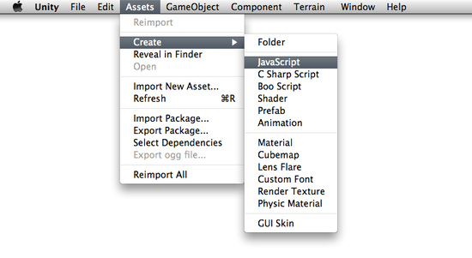

You can edit the script by double-clicking on it in the Project View. This will launch **Unitron**, the script editor for Unity. You do all your scripting in an external text editor like Unitron, and not in Unity directly. To set the default script editor, change the drop-down item in **Unity->Preferences->External Script editor**.

你可以在项目视图里通过在脚本上双击编辑它。这将启动**Unitron，**Unity的脚本编辑器。在外部文本编辑器里你处理所有你脚本像Unitron一样，但不如在Unity里直接。设置默认的脚本编辑器，在**Unity->Preferences->External Script editor里（在windows上是 Eidt->Preferences->External Script editor）**更改下拉框的项目

These are the contents of a new, empty behaviour script: 这些是新的内容，空白行为脚本：

function Update () {

}

A new, empty script does not do a lot on its own, so let's add some functionality. Change the script to read the following: 一个新的，空白脚本不做它自身的任何事情，因此让我们添加一些功能。修改脚本阅读如下：

function Update () {

print("Hello World");

}

When executed, this code will print "Hello World" to the console. But there is nothing that causes the code to be executed yet. We have to attach the script to an active **GameObject** in the **Scene** before it will be executed.

当执行，这个代码将打印"Hello World"到控制台里。但什么也没有导致代码的执行。在它执行之前，在场景里，我们必须附加脚本到一个活动的GameObject。

**Attaching scripts to objects 附加脚本到对象**

Save the above script and create a new object in the Scene by selecting **GameObject->Create Other->Cube**. This will create a new GameObject called "Cube" in the current Scene.

保存上面的脚本并建立一个新的对象在场景里通过选取**GameObject->Create Other->Cube。**这将建立一个新的游戏物体称为"Cube”在当前场景里。

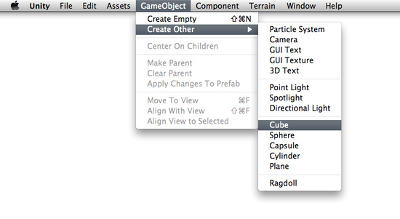

Now drag the script from the Project View to the Cube (in the Scene or **Hierarchy View**, it doesn't matter). You can also select the Cube and choose **Component->Scripts->New Behaviour Script**. Either of these methods will attach the script to the Cube. Every script you create will appear in the **Component->Scripts** menu. If you have changed the name of your script, you will that name instead.

现在从项目视图里拖拽脚本到这个立方体（Cube）（在场景里或层次视图里，这无关紧要）。你也可以选取这这个Cube并选择**Component->Scripts->New Behaviour Script。**这些方法的编辑器将附加这个脚本到Cube。你建立的每个脚本将显示在**Component->Scripts菜单里。**如果你已经修改了你的脚本的名称，你将代替那个名称。

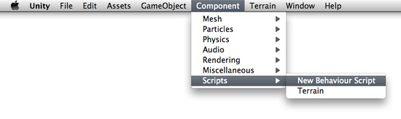

If you select the Cube and look at the **Inspector**, you will see that the script is now visible. This means it has been attached.

如果你选取里Cube并查看检视器，你将看到脚本是现在可见。这意味着它已经被附加了。

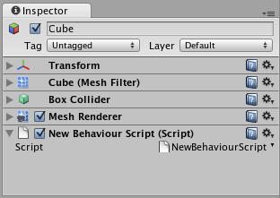

Press **Play** to test your creation. You should see the text "Hello World" appear beside the Play/Pause/Step buttons. Exit play mode when you see it.

按播放按钮去测试你的创造。你应该看到"Hello World"文本显示Play/Pause/Step按钮旁边 （在2.5的windows 版的里，显示在底部状态栏）。当你看到它退出播放模式。



**Manipulating the object 操作对象**

A **print()** statement can be very handy when debugging your script, but it does not manipulate the GameObject it is attached to. Let's change the script to add some functionality:

一个**print()语句**可以非常便利的当调试你的脚本时，但它不能操作被附属于的GameObject（游戏物体）。让我们修改脚本添加一些功能：

function Update () {

transform.Rotate(0, 5*Time.deltaTime, 0);

}

If you're new to scripting, it's okay if this looks confusing. These are the important concepts to understand:

如果你是新的脚本，它看起来有些凌乱。这些是重要的概念理解：

1. **function Update () {}** is a container for code that Unity executes multiple times per second (once per frame). **function Update () {}**是Unity多个时间每秒钟执行代码的容器（一次每帧）。
2. **transform** is a reference to the GameObject's [Transform Component](http://unity3d.com/support/documentation/Components/class-Transform.html). **Transform**是一个对象物体的变换组件的引用。
3. **Rotate()** is a function contained in the Transform **Component**. **Rotate()是**在变换组件里的功能容器。
4. The numbers in-between the commas represent the degrees of rotation around each axis of 3D space: X, Y, and Z. 在逗号之间的数字表示环绕每个3D空间空间轴：x，y和z 的旋转的角度。
5. **Time.deltaTime** is a member of the Time class that evens out movement over one second, so the cube will rotate at the same speed no matter how many frames per second your machine is rendering. Therefore, **5 * Time.deltaTime** means 5 degrees per second.

**Time.deltaTime是**Time类的一个成员，使每秒移动平坦，因此这个Cube将以同样的速度旋转而不管你机器的每秒的多少帧被绘制。所以，**5 * Time.deltaTime意味着每秒5度。**

With all this in mind, we can read this code as "every frame, rotate this GameObject's Transform component a small amount so that it will equal five degrees around the Y axis each second."

所有在这一点，我们可以阅读这个代码作为“每一个帧，旋转这个GameObject的变换组件一个小的数量因此它将等于5度环绕Y轴每秒”

You can access lots of different Components the same way as we accessed **transform** already. You have to add Components to the GameObject using the **Component** menu. All the Components you can easily access are listed under **Variables** on the [GameObject Scripting Reference Page](http://unity3d.com/support/documentation/ScriptReference/GameObject.html).

同样的方法你可以访问许多不同组件是与我们已经访问了**transform的一样方法。**你必须添加组件到GameObject使用组件菜单。所有组件你可以容易访问被在GameObject脚本引用页的变量下列出。

For more information about the relationship between GameObjects, Scripts, and Components, please jump ahead to the [GameObjects](http://unity3d.com/support/documentation/Manual/GameObjects.html) page or [Using Components](http://unity3d.com/support/documentation/Manual/Using%20Components.html) page of this manual.

关于GameObjects, Scripts和Components间的关系的更多信息，请跳到前面的GameObjects页或本手册的[Using Components](http://unity3d.com/support/documentation/Manual/Using%20Components.html)页。

**The Power of Variables 变量的功能**

Our script so far will always rotate the Cube 5 degrees each second. We might want it to rotate a different number of degrees per second. We could change the number and save, but then we have to wait for the script to be recompiled and we have to enter Play mode before we see the results. There is a much faster way to do it. We can experiment with the speed of rotation in real-time during Play mode, and it's easy to do.

我们的脚本到目前为止将总每秒选择Cube 5度。我们也许想要它每秒选择不同数量的角度。我们可以改变数据并保存它，但我们必须等待脚本被从新编译以及我们必须进入播放模式在我们看到结果之前。有一个非常快速的方法去做它。在实时播放模式过程中，我们可以利用旋转速度实验，而且它是容易去做到。

Instead of typing **5** into the **Rotate()** function, we will declare a **speed** variable and use that in the function. Change the script to the following code and save it:

替代在**Rotate()函数输入5**，我们将定义一个speed 变量并在函数里使用它。修改脚本到如下的代码并保存它。

var speed = 5.0;

function Update () {

transform.Rotate(0, speed*Time.deltaTime, 0);

}

Now select the Cube and look at the Inspector. Notice how our **speed** variable appears.

现在，选取这个Cube并在检视器里查看。注意我们的speed变量如何显示。

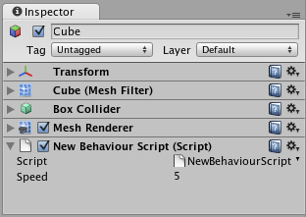

This variable can now be modified directly in the Inspector, just like renaming a file in the file explorer. Select it, press **Return** and change the value. You can also right- or option-click on the value and drag the mouse up or down. You can change the variable at any time, even while the game is running.

在检视器里的这个变量现在可以被直接修改，就像在文件资源管理器里重命名一个文件一样。选取它，按回车键并修改它的值。你也可以恰当的点击选项并左右拖动鼠标（修改值）。你可以在任何时间更改变量，甚至当游戏在运行的过程中。

Hit Play and try modifying the **speed** value. The Cube's rotation speed will change instantly. When you exit Play mode, you'll see that your changes are reverted back to their value before entering Play mode. This way you can play, adjust, and experiment to find the best value, then apply that value permanently.

击播放按钮并尝试修改speed变量的值。这个Cube的旋转速度将立即改变。等你退出播放模式时，你将看到你的更改回复到进入播放模式之前的它们值。这个方法你可以播放、调整以及实验去找打最优的值，然后应用不变的引用那个值。

Using this method of changing a variable's value in the Inspector means that you can re-use one script on many objects, each with a different variable value. If you attach the script to multiple Cubes, and change the **speed** of each cube, they will all rotate at different speeds even though they use the same script.

在检视器里使用这个方法修改变量的值意味着你可以重复使用一个脚本在多个对象上，每次用一个不同的变量值。如果你附加这个脚本到多个Cube，并更改每个Cube的speed，它们将全部用不同的速度旋转甚至是它们使用同样的脚本。

**Where to go from here 从这里走到哪里**

This was just a short introduction on how to use scripts inside the Editor. For more examples, check out the [Tutorials](http://unity3d.com/support/documentation/Manual/Tutorials.html) that come with Unity. You should also read through [Scripting Overview](http://unity3d.com/support/documentation/ScriptReference/index.html) inside the Script Reference, which contains a more thorough introduction into scripting with Unity plus pointers into the reference itself for in-depth information. If you're really stuck, be sure to visit the [Unity Forums](http://forum.unity3d.com) and ask questions there. Someone is always willing to help.

这仅是一个短小的介绍如何使用脚本在编辑器里。更多的例子，检查Unity带来的手册。你也应该通过阅读脚本概述在脚本引用里，它包含了一个脚本到自己的参考指针与Unity加更详细的介绍深入的信息。如果你真的坚持，一定要访问Unity论坛并要求咨询，有人总是愿意提供帮助。

**Asset Server Guide 资产服务指南（管理游戏的源代码，目前windows服务器不支持，因此翻译省略。）**

[**Unity Manual**](http://unity3d.com/support/documentation/Manual/index.html) > [**User Guide**](http://unity3d.com/support/documentation/Manual/User%20Guide.html) > [**Working with Assets**](http://unity3d.com/support/documentation/Manual/Working%20with%20Assets.html) > [**Asset Server Guide**](http://unity3d.com/support/documentation/Manual/Asset%20Server.html)

Unity手册-> 用户指南 ->与资产合作->资产服务指南

**Unity Asset Server Overview Unity资产服务综述**

The **Unity Asset Server** is an asset and version control system with a graphical user interface integrated into Unity. It is meant to be used by team members working together on a project on different computers either in-person or remotely. The Asset Server is highly optimized for handling large binary assets in order to cope with large multi gigabyte project folders. When uploading assets, **Import Settings** and other meta data about each asset is uploaded to the asset server as well. Renaming and moving files is at the core of the system and well supported.

Unity资产服务器是一个资产与版本控制系统具有图形用户界面的集成到Unity里。它是意味着被团队成员一起工作使用在一个项目上的 不同计算机，无论成员个人或远程使用。资产服务器是高度组织的操作二进制资产为了处理巨大的多倍GB项目的文件夹。当上载资产，导入设置及其它媒体数据时关于每个资产也同样被上载到资产服务器。重命名与移动文件是在系统系统核心和好的支持。

It is available only for Unity Pro, and is an additional license per client. To purchase an Asset Server Client License, please visit the Unity store at <http://unity3d.com/store>

它仅是Unity专业版本支持，以及可以添加每个客户许可。购买一个资产服务器客户许可，请访问Unity商场在<http://unity3d.com/store>上。

**New to Source Control?**

If you have never used Source Control before, it can be a little unfriendly to get started with any versioning system. Source Control works by storing an entire collection of all your assets - meshes, textures, materials, scripts, and everything else - in a database on some kind of server. That server might be your home computer, the same one that you use to run Unity. It might be a different computer in your local network. It might be a remote machine colocated in a different part of the world. It could even be a virtual machine. There are a lot of options, but the location of the server doesn't matter at all. The important thing is that you can access it somehow over your network, and that it stores your game data.

In a way, the Asset Server functions as a backup of your Project Folder. You do not directly manipulate the contents of the Asset Server while you are developing. You make changes to your Project locally, then when you are done, you **Commit Changes** to the Project on the Server. This makes your local Project and the Asset Server Project identical.

Now, when your fellow developers make a change, the Asset Server is identical to their Project, but not yours. To synchronize your local Project, you request to **Update from Server**. Now, whatever changes your team members have made will be downloaded from the server to your local Project.

This is the basic workflow for using the Asset Server. In addition to this basic functionality, the Asset Server allows for rollback to previous versions of assets, detailed file comparison, merging two different scripts, resolving conflicts, and recovering deleted assets.

**Setting up the Asset Server**

The Asset Server requires a one time server setup and a client configuration for each user. You can read about how to do that in the [Asset Server Setup page](http://unity3d.com/support/documentation/Components/assetserver-Setup.html).

The rest of this guide explains how to deploy, administrate, and regularly use the Asset Server.

**Daily use of the Asset Server**

This section explains the common tasks, workflow and best practices for using the Asset Server on a day-to-day basis.

**Getting Started**

If you are joining a team that has a lot of work stored on the Asset Server already, this is the quickest way to get up and running correctly. If you are starting your own project from scratch, you can skip down to the [Workflow Fundamentals](http://unity3d.com/support/documentation/Manual/Asset%20Server.html#Fundamentals#Fundamentals) section.

1. Create a new empty Project with no packages imported
2. From the menubar, select **Window->Asset Server**
3. Click the **Connection** button
4. Enter your user name and password (provided by your Asset Server administrator)
5. Click **Show Projects** and select the desired project
6. Click **Connect**
7. Click the **Update** tab
8. Click the **Update** button
9. If a conflict occurs, discard all local versions
10. Wait for the update to complete
11. You are ready to go

Continue reading for detailed information on how to use the Asset Server effectively every day.

**Workflow Fundamentals**

When using the Asset Server with a multi-person team, it is generally good practice to Update all changed assets from the server when you begin working, and Commit your changes at the end of the day, or whenever you're done working. You should also commit changes when you have made significant progress on something, even if it is in the middle of the day. Committing your changes regularly and frequently is recommended.

**Understanding the Server View**

The **Server View** is your window into the Asset Server you're connected to. You can open the Server View by selecting **"Window->Asset Server"** .

*The* ***Overview*** *tab*

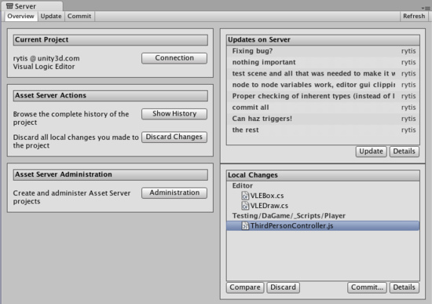

The Server View is broken into tabs: **Overview** **Update**, and **Commit**. **Overview** will show you any differences between your local project and the latest version on the server with options to quickly commit local changes or download the latest updates. **Update** will show you the latest remote changes on the server and allow you to download them to your local project. **Commit** allows you to create a **Changeset** and commit it to the server for others to download.

**Connecting to the server**

Before you can use the asset server, you must connect to it. To do this you click the **Connection** button, which takes you to the connection screen:

*The Asset Server connection screen*

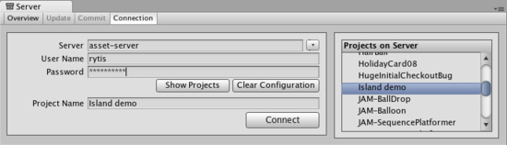

Here you need to fill in:

1. Server address
2. Username
3. Password

By clicking **Show projects** you can now see the available projects on the asset server, and choose which one to connect to by clicking **Connect**. Note that the username and password you use can be obtain from your system administrator. Your system administrator created accounts when they installed Asset Server.

**Updating from the Server**

To download all updates from the server, select the **Update** tab from the Overview tab and you will see a list of the latest committed Changesets. By selecting one of these you can see what was changed in the project as well as the provided commit message. Click **Update** and you will begin downloading all Changeset updates.

*The* ***Update*** *Tab*

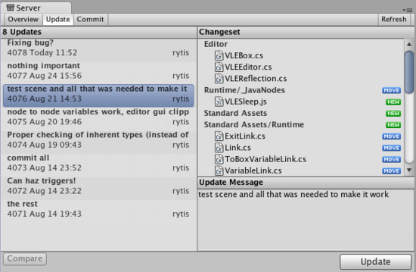

**Committing Changes to the Server**

When you have made a change to your local project and you want to store those changes on the server, you use the top **Commit** tab .

*The* ***Commit*** *tab*

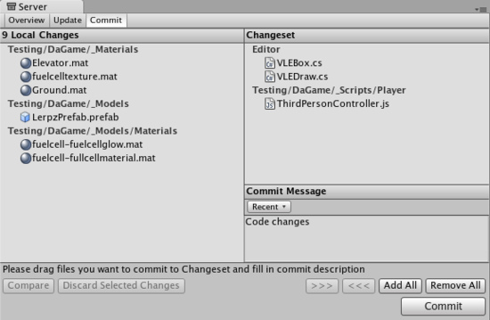

Now you will be able to see all the local changes made to the project since your last update, and will be able to select which changes you wish to upload to the server. You can add changes to the changeset either by manually dragging them into the changeset field, or by using the buttons placed below the commit message field. Remember to type in a commit message which will help you when you compare versions or revert to an earlier version later on, both of which are discussed below.

**Resolving conflicts**

With multiple people working on the same collection of data, conflicts will inevitably arise. Remember, there is no need to panic! If a conflict exists, you will be presented with the **Conflict Resolution** dialog when updating your project .

*The* ***Conflict Resolution*** *screen*

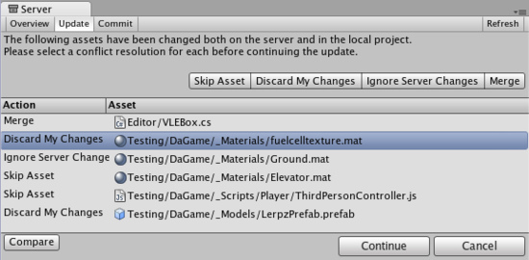

Here, you will be informed of each individual conflict, and be presented with different options to resolve each individual conflict. For any single conflict, you can select **Skip Asset** (which will not download that asset from the server), **Discard My Changes** (which will completely overwrite your local version of the asset) or **Ignore Server Changes** (which will ignore the changes others made to the asset and after this update you will be able to commit your local changes over server ones) for each individual conflict. Additionally, you can select **Merge** for text assets like scripts to merge the server version with the local version.

If you run into a conflict while you are committing your local changes, Unity will refuse to commit your changes and inform you that a conflict exists. To resolve the conflicts, select **Update**. Your local changes will not automatically be overwritten. At this point you will see the **Conflict Resolution** dialog, and can follow the instructions in the above paragraph.

**Browsing revision history and reverting assets**

The Asset Server retains all uploaded versions of an asset in its database, so you can revert your local version to an earlier version at any time. You can either select to restore the entire project or single files. To revert to an older version of an asset or a project, select the Overview tab then click **Show History** listed under Asset Server Actions. You will now see a list of all commits and be able to select and restore any file or all project to an older version.

*The* ***History*** *dialog*

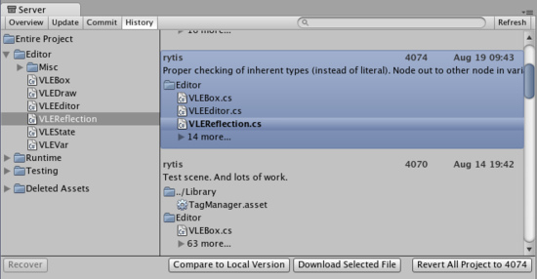

Here, you can see the version number and added comments with each version of the asset or project. This is one reason why descriptive comments are helpful. Select any asset to see its history or **Entire Project** for all changes made in project. Find revision you need. You can either select whole revision or particular asset in revision. Then click **Download Selected File** to get your local asset replaced with a copy of the selected revision. **Revert All Project** will revert entire project to selected revision.

Prior to reverting, if there are any differences between your local version and the selected server version, those changes will be lost when the local version is reverted.

If you only want to abandon the changes made to the local copy, you don't have to revert. You can discard those local modifications by selecting **Discard Changes** in the main asset server window. This will immediately download the current version of the project from the server to your local Project.

**Comparing asset versions**

If you're curious to see the differences between two particular versions you can explicitly compare them. To do this, open **History** window, select revision and asset you want to compare and press **Compare to Local Version**. If you need to compare two different revisions of an asset - right click on it, in the context menu select **Compare to Another Revision** then find revision you want to compare to and select it.

*Note*: this feature requires that you have one of supported file diff/merge tools installed. Supported tools are:

* On Windows:
  + TortoiseMerge: part of [TortoiseSVN](http://tortoisesvn.net/) or a separate download from the [project site](http://sourceforge.net/project/showfiles.php?group_id=138498).
  + [WinMerge](http://winmerge.org/).
  + [SourceGear Diff/Merge](http://www.sourcegear.com/diffmerge/).
  + [Perforce Merge (p4merge)](http://www.perforce.com/perforce/products/merge.html): part of Perforce's visual client suite (P4V).
  + [TkDiff](http://sourceforge.net/projects/tkdiff/).
* On Mac OS X:
  + [SourceGear Diff/Merge](http://www.sourcegear.com/diffmerge/).
  + FileMerge: part of Apple's [XCode development tools](http://developer.apple.com).
  + [TkDiff](http://sourceforge.net/projects/tkdiff/).
  + [Perforce Merge (p4merge)](http://www.perforce.com/perforce/products/merge.html): part of Perforce's visual client suite (P4V).

**Recovering deleted assets**

Deleting a local asset and committing the delete to the server will in fact not delete an asset permanently. Just as any previous version of an asset can be restored through **History** window from the Overview tab.

*The* ***History*** *dialog*

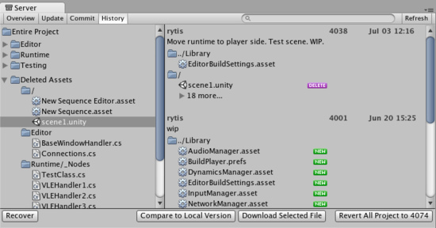

Expand **Deleted Assets** item, find and select assets from the list and hit **Recover**, the selected assets will be downloaded and re-added to the local project. If the folder that the asset was located in before the deletion still exists, the asset will be restored to the original location, otherwise it will be added to the root of the Assets folder in the local project.

**Asset Server training complete**

You should now be equipped with the knowledge you need to start using the Asset Server effectively. Get to it, and don't forget the good workflow fundamentals. Commit changes often, and don't be afraid of losing anything.

# Behind the Scenes 场景幕后

# [Unity Manual](http://unity3d.com/support/documentation/Manual/index.html) > [User Guide](http://unity3d.com/support/documentation/Manual/User%20Guide.html) > [Working with Assets](http://unity3d.com/support/documentation/Manual/Working%20with%20Assets.html) > [Behind the Scenes](http://unity3d.com/support/documentation/Manual/Behind%20the%20Scenes.html)

# Unity手册-> 用户指南 ->与资产合作->场景幕后

Unity automatically imports assets for you and manages all kinds of metadata for you. How does this all work?

Unity为你自动的导入资产并为你管理所有类型的元数据。这些是如何工作的？

When you place an Asset like a texture in the Assets folder, Unity will first detect that a new file it doesn't know about has been added. A new unique identifier will be given to the asset and Unity will then start importing it. Unity processes every imported asset. When you see a texture in the Project View, this is already a processed asset.

当你放置一个资产像一个纹理在资产文件夹里，Unity将首先到检测一个新文件，它不知道已经被添加。一个新的唯一标识将提供给资产及Unity将开始导入它。Unity处理每个导入的资产。当你在项目视图里看到一个纹理，这是已经被处理过的资产。

This way you can attach a lot of metadata to an imported asset. For example in the texture's import settings you can tell the texture to use mip maps. Photoshop of course doesn't support mip maps, thus the need for metadata. All metadata for each asset is stored in the Library folder. As as user, you should never have to manually alter the Library folder.

这种方式你可以附加许多的元数据去导入资产。例如，在纹理导入设置里你可以告诉所有的纹理使用mip映射。Photoshop当然不支持mip映射，然而，需要元数据。每个资产的所有元数据被存储在Library文件夹里。作为一个用户，你应该从不手工修改Library文件夹。

In Unity you can organize and move Assets around however you like from the Project View. Unity automatically tracks all movements of files and references to other assets. You **must** move the files inside of Unity. You can easily do this via drag & drop in Project View. But if you move an object in the Explorer (Windows) or Finder (OS X), Unity will not detect the move. It will treat it like as if new asset was created and another one deleted. Thus if you move an asset in the OS file manager, connections to the asset will be lost.

在Unit里，你可以组织和四处移动资产，然而你要从项目视图里。Unity自动的跟踪所有的文件移动和引用其它的资产。你必须在Unity内部移动文件。你可以容易的做这个经由拖放子项目视图里。但是如果你在资源管理器里（windwos）或程序定位器里（OS x）一哦那个一个对象，Unity将不能检测到移动。它将协商就像新的资产被建立或另外一个被删除。因而，如果你移动一个资产在系统文件管理器里，连接到的资产将丢失。

The Library folder is critical to your project. Unity manages the Library folder for you automatically. Thus you should never move files around in it or touch it. But still it is critical to your project. If you delete it, all your connections to assets will be lost.

Library（库）文件夹是对于你的项目是关键的。Unity为你自动管理库文件夹。因而你应该从不四处移动文件在库文件夹里或触动它。但是，它仍旧是对你的项目是关键的。如果你删除了它，所有你的连接到的资产将全部丢失。

When backing up a project, **always** back up the project folder-level, containing both the Assets and Library folders!

当备份一个项目，总是要备份项目文件夹级别，同时包含Assets（资产） 和Library（库）文件夹！

**Creating Gameplay 创建可玩性游戏**

[**Unity Manual**](http://unity3d.com/support/documentation/Manual/index.html) > [**User Guide**](http://unity3d.com/support/documentation/Manual/User%20Guide.html) > [**Creating Gameplay**](http://unity3d.com/support/documentation/Manual/Creating%20Gameplay.html)

Unity 手册->用户指南->创建可玩性游戏

Unity empowers game designers to make games. What's really special about Unity is that you don't need years of experience with code or a degree in art to make fun games. There are a handful of basic workflow concepts needed to learn Unity. Once understood, you will find yourself making games in no time. With the time you will save getting your games up and running, you will have that much more time to refine, balance, and tweak your game to perfection.

Unity 授权游戏设计师去创建游戏。Unity真正的特别之处什么，是你不需要多年的代码经验或某种程度的艺术就能做出一些有趣的游戏。有少数的基本流程的概念需要去学习Unity。一旦明白,你会发现自己做游戏在很短的时间内。你可以节省时间和游戏的运行,你娘会有更多的时间来提炼、平衡、调整你的游戏。，

This section will explain the core concepts you need to know for creating unique, amazing, and fun gameplay. The majority of these concepts require you to write **Scripts**. For an overview of creating and working with Scripts, please read the [Scripting](http://unity3d.com/support/documentation/Manual/Scripting.html) page.

本节将解释其核心概念,你需要知道,创造出独特新奇的、有趣的游戏。大部分的这些概念要求你去编写脚本。创建和利用脚本工作的概述,请读脚本页。

* [Instantiating Prefabs at runtime](http://unity3d.com/support/documentation/Manual/Instantiating%20Prefabs.html) 在运行时初始化预制品
* [Input](http://unity3d.com/support/documentation/Manual/Input.html) 输入
* [Transforms](http://unity3d.com/support/documentation/Manual/Transforms.html) 变换
* [Physics](http://unity3d.com/support/documentation/Manual/Physics.html) 物理
* [Animation](http://unity3d.com/support/documentation/Manual/Animation.html) 动画
* [Character Animation](http://unity3d.com/support/documentation/Manual/Character-Animation.html) 角色动画
* [Sound](http://unity3d.com/support/documentation/Manual/Sound.html) 声音
* [Game Interface Elements](http://unity3d.com/support/documentation/Manual/Game%20Interface%20Elements.html) 游戏接口元素
* [Networked Multiplayer](http://unity3d.com/support/documentation/Manual/Networked%20Multiplayer.html) 网络多玩家

**Instantiating Prefabs at runtime 在运行时初始化预制品**

[**Unity Manual**](http://unity3d.com/support/documentation/Manual/index.html) > [**User Guide**](http://unity3d.com/support/documentation/Manual/User%20Guide.html) > [**Creating Gameplay**](http://unity3d.com/support/documentation/Manual/Creating%20Gameplay.html) > [**Instantiating Prefabs at runtime**](http://unity3d.com/support/documentation/Manual/Instantiating%20Prefabs.html)

Unity手册->用户指南->创建可玩性游戏->在运行时初始化预制品

By this point you should understand the concept of **Prefabs** at a fundamental level. They are a collection of predefined **GameObjects** & **Components** that are re-usable throughout your game. If you don't know what a Prefab is, we recommend you read the [Prefabs](http://unity3d.com/support/documentation/Manual/Prefabs.html) page prior to this one.

这一点,你应该在一个基本的水平理解Prefabs概念。他们是一个预定义的GameObjects及组件的集合，可在你的游戏重复使用。如果你不知道什么是预制品,我们建议你在这一页之前阅读Prefabs。

Prefabs come in very handy when you want to instantiate complicated GameObjects at runtime. The alternative to instantiating Prefabs is to create GameObjects from scratch using code. Instantiating Prefabs has many advantages over the alternative approach:

Prefabs派上用场,当你要想在运行的时候完成GameObjects初始化。可供选择的初始化Prefabs是从头开始使用的代码创建GameObjects。初始化Prefabs有很多优点方法：

* You can instantiate a Prefab from one line of code, with complete functionality. Creating equivalent GameObjects from code takes an average of five lines of code, but likely more.
* 你可以用一行代码初始化，利用完成的功能。从代码可以创造同等GameObjects需要平均5行代码,但可能更多。
* You can set up, test, and modify the Prefab quickly and easily in the Scene and Inspector.
* 你可以在场景里及检视器里迅速并容易的设置，测试及修改预制品。
* You can change the Prefab being instanced without changing the code that instantiates it. A simple rocket might be altered into a super-charged rocket, and no code changes are required.
* 你可以修改预制品在初始化时不需要修改代码而初始化它。一个简单的火箭可能会改变成超级火箭,并没有代码需要改变。

**Common Scenarios 常见方案**

To illustrate the strength of Prefabs, let's consider some basic situations where they would come in handy:

为了说明预制品的强大，让我们考虑一些基本情况，它们将在哪里派上用场：

1. Building a wall out of a single "brick" Prefab by creating it several times in different positions.

在不同的位置创建几个独立的“brick”（砖）预制品的墙

1. A rocket launcher instantiates a flying rocket Prefab when fired. The Prefab contains a Mesh, **Rigidbody**, **Collider**, and a child GameObject with its own trail **Particle System**.

当火箭筒发射时，一个火箭筒实例飞行预制品。预制品包含一个网格，刚体、碰撞器以及一个拥有它自己的痕迹的粒子系统的子Gameobject。

1. A robot exploding to many pieces. The complete, operational robot is destroyed and replaced with a wrecked robot Prefab. This Prefab would consist of the robot split into many parts, all set up with Rigidbodies and Particle Systems of their own. This technique allows you to blow up a robot into many pieces, with just one line of code, replacing one object with a Prefab.

一个机器人爆炸成多个分片。完整的业务机器人被摧毁和一个破坏机器人预制品所取代。这预制将由分裂的机器人组成许多部分，所有设置利用它们自己的Rigidbodies（刚体）和颗粒系统。这种技术允许你炸毁一个机器人成多块，仅有一行代码，利用一个预制品替代一个对象。

**Building a wall 创建一个墙**

This explanation will illustrate the advantages of using a Prefab vs creating objects from code.

这将说明使用一个预制品的优点与从代码创建对象的对比。

First, lets build a brick wall from code: 首先，让我们从代码创建一个砖头墙：

function Start () {

for (var y = 0; y < 5; y++) {

for (var x = 0; x < 5; x++) {

var cube = GameObject.CreatePrimitive(PrimitiveType.Cube);

cube.AddComponent(Rigidbody);

cube.transform.position = Vector3 (x, y, 0);

}

}

}

* To use the above script we simply save the script and drag it onto an empty GameObject.
* Create an empty GameObject with **GameObject->Create Empty**.
* 使用上面的脚本我们单独保存这个脚本并拖拽它到一个空白的GameObject上。建立一个空白的脚本利用**GameObject->Create Empty。**

If you execute that code, you will see an entire brick wall is created when you enter **Play Mode**. There are two lines relevant to the functionality of each individual brick: the **CreatePrimitive()** line, and the **AddComponent()** line. Not so bad right now, but each of our bricks is un-textured. Every additional action to want to perform on the brick, like changing the texture, the friction, or the Rigidbody **mass**, is an extra line.

如果你执行那个代码，你将看到完整砖墙被创建当你进入播放模式时。有两条线关联的每个个个的功能函数：**CreatePrimitive() 线和AddComponent() 线**。没那么糟糕，每个动作都要执行的砖,如改变纹理、摩擦、或刚体质量,是一个额外的线。

If you create a Prefab and perform all your setup before-hand, you use one line of code to perform the creation and setup of each brick. This relieves you from maintaining and changing a lot of code when you decide you want to make changes. With a Prefab, you just make your changes and Play. No code alterations required.

如果你创建一个预制品和完成所有你的预先配置，使用运输一行代码来进行创建和配置每块砖。当你决定你要做出一些改变时，这减轻你维护和改变很多代码。用预制,你可以改变和播放。没有代码的修改。

If you're using a Prefab for each individual brick, this is the code you need to create the wall.

如果你使用个别砖的预制品,这是你需要建立墙的代码。

var cube : Transform;

function Start () {

for (var y = 0; y < 5; y++) {

for (var x = 0; x < 5; x++) {

var cube = Instantiate(cube, Vector3 (x, y, 0), Quaternion.identity);

}

}

}

This is not only very clean but also very reusable. There is nothing saying we are instantiating a cube or that it must contain a rigidbody. All of this is defined in the Prefab and can be quickly created in the Editor.

这不仅是很原始而且真正的重复使用。没有说我们实例化一个立方体或它必须包含刚体。所有这一切都定义在预制品里，可迅速在编辑器中创建。

Now we only need to create the Prefab, which we do in the Editor. Here's how:

现在我们仅需要创建预制品，在编辑器里做，方法如下：

1. Choose **GameObject->Create Other->Cube** 选择**GameObject->Create Other->Cube**
2. Choose **Component->Physics->Rigidbody** 选择**Component->Physics->Rigidbody**
3. Choose **Assets->Create Prefab** 选择 **Assets->Create Prefab**
4. In the **Project View**, change the name of your new Prefab to "Brick"

在项目视图了，修改你的新的预制品的名字为“Brick”

1. Drag the cube you created in the **Hierarchy** onto the "Brick" Prefab in the **Project View**

在层次里拖动你创建的立方体到项目视图里的“Brick”上

1. With the Prefab created, you can safely delete the Cube from the Hierarchy (**Delete** on Windows, **Command-Backspace** on Mac) 利用已创建的预制品，你可以安全的删除这个立方体从层次里（在windows上按 Delete键，在Mac上 按Command-Backspace 键）

We've created our Brick Prefab, so now we have to attach it to the **cube** variable in our script. Select the empty GameObject that contains the script. Notice that a new variable has appeared in the Inspector, called "cube".

我们已经创造了我们砖的预制品，所以现在我们必须附加它到我们的脚本里的**cube**的变量上。选择包含脚本的空GameObject。注意到一个新的变量已经出现在检视器里，称为“cube”。

*This variable can accept any GameObject or Prefab这个变量可以接受任何GameObject或预制品*

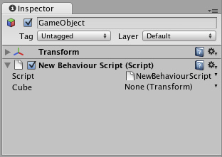

Now drag the "Brick" Prefab from the Project View onto the cube variable in the Inspector. Press Play and you'll see the wall built using the Prefab. 现在从项目视图里拖拽"Brick"预制品到检视器里的cube变量上。按播放键你就会看到墙上使用预制品。

This is a workflow pattern that can be used over and over again in Unity. In the beginning you might wonder why this is so much better, because the script creating the cube from code is only 2 lines longer.

这是一个工作流模式，在Unity里可反复使用。在一开始，你可能惊讶，为什么会是这样好，因为该脚本创建立方体的代码只有2行长。

But because you are using a Prefab now, you can adjust the Prefab in seconds. Want to change the mass of all those instances? Adjust the Rigidbody in the Prefab only once. Want to use a different **Material** for all the instances? Drag the Material onto the Prefab only once. Want to change friction? Use a different **Physic Material** in the Prefab's collider. Want to add a Particle System to all those boxes? Add a child to the Prefab only once.

但是，因为现在你使用的是预制品，你可以在几秒钟内调整预制品。想要改变的那些例子吗?在预制品里调整刚体仅一次。想要使用一种不同的材料对所有的例子吗?拖拽物质到预制品上仅一次。想要改变摩擦吗?使用不同的物理资料在预制品的碰撞器里。要添加一个粒子系统给所有那些方框吗?添加一个子预制品仅一次。

**Instantiating rockets & explosions**火箭和爆炸的初始化

Here's how Prefabs fit into this scenario: 现在是预制品如何融入到这个场景里：

1. A rocket launcher instantiates a rocket Prefab when the user presses fire. The Prefab contains a mesh, Rigidbody, Collider, and a child GameObject that contains a trail particle system.

一个火箭发射实例化一个火箭预制品当用户按发射键时。预制品包含一个网格、刚体、碰撞器以及一个含有痕迹粒子系统的子GameObject。

1. The rocket impacts and instantiates an explosion Prefab. The explosion Prefab contains a Particle System, a light that fades out over time, and a script that applies damage to surrounding GameObjects.

火箭影响和一个爆炸预制品的实例。爆炸预制包含一个粒子系统、随着时间的推移淡出光以及脚本应用损害周围的GameObjects。

While it would be possible to build a rocket GameObject completely from code, adding Components manually and setting properties, it is far easier to instantiate a Prefab. You can instantiate the rocket in just one line of code, no matter how complex the rocket's Prefab is. After instantiating the Prefab you can also modify any properties of the instantiated object (e.g. you can set the velocity of the rocket's Rigidbody).

虽然有可能从代码完成构建一个火箭的GameObject，完全手动添加组件并设置属性，容易得多去实例化一个预制品。你可以在仅有一行代码里实例化火箭，无论多么复杂，火箭是预制的。实例化预制品后，你还可以修改实例化对象的任何属性（例如，可以设置的火箭刚体速度）。

Aside from being easier to use, you can update the prefab later on. So if you are building a rocket, you don't immediately have to add a Particle trail to it. You can do that later. As soon as you add the trail as a child GameObject to the Prefab, all your instantiated rockets will have particle trails. And lastly, you can quickly tweak the properties of the rocket Prefab in the Inspector, making it far easier to fine-tune your game.

除了更容易的使用，稍后你可以更新预制。因此，如果你要构建一个火箭，你不立即需要添加一个粒子痕迹给它。以后你能做到这一点。只要你添加一个子GameObject到预制品，所有实例化的火箭将有粒子痕迹。最后，你可以快速调整火箭的性能预制在检视器里，使微调你的游戏容易得多。

This script shows how to launch a rocket using the **Instantiate()** function.

此脚本显示了如何使用发射火箭的**Instantiate()**函数。

// Require the rocket to be a rigidbody.

// This way we the user can not assign a prefab without rigidbody

var rocket : Rigidbody;

var speed = 10.0;

function FireRocket () {

var rocketClone : Rigidbody = Instantiate(rocket, transform.position, transform.rotation);

rocketClone.velocity = transform.forward * speed;

// You can also acccess other components / scripts of the clone

rocketClone.GetComponent(MyRocketScript).DoSomething();

}

// Calls the fire method when holding down ctrl or mouse

function Update () {

if (Input.GetButtonDown("Fire1")) {

FireRocket();

}

}

**Replacing a character with a ragdoll or wreck 取代一个拥有破碎的或损坏的飞船**

Let's say you have a fully rigged enemy character and he dies. You could simply play a death animation on the character and disable all scripts that usually handle the enemy logic. You probably have to take care of removing several scripts, adding some custom logic to make sure that no one will continue attacking the dead enemy anymore, and other cleanup tasks.

假设你有一个完全操纵敌人的角色和它死亡。你可以简单地处理一个死亡的动画和禁用所有通常敌人的逻辑处理脚本。你可能要消除几个脚本，加入一些自定义的逻辑，以确保没有人会继续攻击死亡的敌人，以及其它清理工作。

A far better approach is to immediately delete the entire character and replace it with an instantiated wrecked prefab. This gives you a lot of flexibility. You could use a different material for the dead character, attach completely different scripts, spawn a Prefab containing the object broken into many pieces to simulate a shattered enemy, or simply instantiate a Prefab containing a version of the character.

一个更好的办法是立即删除整个角色并替换它为一个破坏的预制品实例。这使你具有很大的灵活性。你可以使用死亡角色的不同的材料，附加完全不同的脚本，产生一个含有模拟一个支离破碎的敌人的预制品，或者仅仅是实例化一个含有小块的角色的预制品。

Any of these options can be achieved with a single call to **Instantiate()**, you just have to hook it up to the right prefab and you're set!

任何这些问题可以通过一个调用Instantiate()取得，你只要把它挂到右侧预制品上和你设定的选项上！

The important part to remember is that the wreck which you **Instantiate()** can be made of completely different objects than the original. For example, if you have an airplane, you would model two versions. One where the plane consists of a single GameObject with **Mesh Renderer** and scripts for airplane physics. By keeping the model in just one GameObject, your game will run faster since you will be able to make the model with less triangles and since it consists of fewer objects it will render faster than using many small parts. Also while your plane is happily flying around there is no reason to have it in separate parts.

最重要的部分要记住的是那个你Instantiate()由完全不同的对象组成的失事的飞船。例如，如果你有一架飞机，你会创建两个版本。那架飞机的一个组成一个网渲染的独立GameObject的飞机及一个物理脚本飞机。通过保持在只有一个GameObject的模式，因为你将会能够制造与较少的三角形的模型而且自从它之后它将会描绘的较少的物件，你的游戏将会运行得快速，超过使用许多小的部份。也当你的飞机在附近快乐飞的时候，没有理由要在分开的部份中有它。

To build a wrecked airplane Prefab, the typical steps are:

建立一架被破坏的飞机的预制品，典型的步骤是：

1. Model your airplane with lots of different parts in your favorite modeler 在你喜欢的模型里，利用不同的部分模拟的你飞机。
2. Create an empty Scene 建立一个空白场景
3. Drag the model into the empty Scene 拖动模型到这个空白场景
4. Add Rigidbodies to all parts, by selecting all the parts and choosing **Component->Physics->Rigidbody**

添加刚体到所有部分，通过选取所有部分和选择**Component->Physics->Rigidbody**

1. Add Box Colliders to all parts by selecting all the parts and choosing **Component->Physics->Box Collider**

添加碰撞器盒到所有选取的部分和选择**Component->Physics->Box Collider**

1. For an extra special effect, add a smoke-like Particle System as a child GameObject to each of the parts 对于一个额外的效果，添加一个烟雾模拟粒子系统作为子GameObject到每个部分。
2. Now you have an airplane with multiple exploded parts, they fall to the ground by physics and will create a Particle trail due to the attached particle system. Hit Play to preview how your model reacts and do any necessary tweaks.

现在你拥有了一个含有多个爆破部分的飞机，它们堕落物理的地上而且附加的粒子系统将产生一个粒子痕迹。

1. Choose **Assets->Create Prefab** 选择**Assets->Create Prefab**
2. Drag the root GameObject containing all the airplane parts into the Prefab

拖动包含所有飞机部件根的GameObject到预制品里。

var wreck : GameObject;

// As an example, we turn the game object into a wreck after 3 seconds automatically

function Start () {

yield WaitForSeconds(3);

KillSelf();

}

// Calls the fire method when holding down ctrl or mouse

function KillSelf () {

// Instantiate the wreck game object at the same position we are at

var wreckClone = Instantiate(wreck, transform.position, transform.rotation);

// Sometimes we need to carry over some variables from this object

// to the wreck

wreckClone.GetComponent(MyScript).someVariable = GetComponent(MyScript).someVariable;

// Kill ourselves

Destroy(gameObject);

}

The First Person Shooter tutorial explains how to replace a character with a ragdoll version and also synchronize limbs with the last state of the animation. You can find that tutorial on the [Tutorials](http://unity3d.com/support/documentation/Manual/Tutorials.html) page.

第一人称射击指南讲解如何去替代一个角色利用一个布娃娃版本和同步四肢最后状态的动画。你以在指南页发现那个指南。

**Placing a bunch of objects in a specific pattern**把一束对象放一个特定的图案中

Lets say you want to place a bunch of objects in a grid or circle pattern. Traditionally this would be done by either:

对你来说想要把一束物件放一个方格里或圆周图案中。传统地会采用下列之一做：

1. Building an object completely from code. This is tedious! Entering values from a script is both slow, unintuitive and not worth the hassle. 完全的从代码创建一个对象。这是乏味的！从一个脚本输入值是两倍的慢，直觉的不值得麻烦。
2. Make the fully rigged object, duplicate it and place it multiple times in the scene. This is tedious, and placing objects accurately in a grid is hard.

在场景里，制造完全装配的对象，复制它并放置它多次。这是沉闷的，而且正确放置对象在网格里是困难的。

So use **Instantiate()** with a Prefab instead! We think you get the idea of why Prefabs are so useful in these scenarios. Here's the code necessary for these scenarios:

因此使用**Instantiate()与**一个预制品替代。我们认为你获得一个想法：在这些场景里为什么预制品是如此有用。这些场景所需的代码在这里：

// Instantiates a prefab in a circle

var prefab : GameObject;

var numberOfObjects = 20;

var radius = 5;

function Start () {

for (var i = 0; i < numberOfObjects; i++) {

var angle = i * Mathf.PI * 2 / numberOfObjects;

var pos = Vector3 (Mathf.Cos(angle), 0, Mathf.Sin(angle)) * radius;

Instantiate(prefab, pos, Quaternion.identity);

}

}

// Instantiates a prefab in a grid

var prefab : GameObject;

var gridX = 5;

var gridY = 5;

var spacing = 2.0;

function Start () {

for (var y = 0; y < gridY; y++) {

for (var x=0;x<gridX;x++) {

var pos = Vector3 (x, 0, y) * spacing;

Instantiate(prefab, pos, Quaternion.identity);

}

}

}

**Input 输入**

[**Unity Manual**](http://unity3d.com/support/documentation/Manual/index.html) > [**User Guide**](http://unity3d.com/support/documentation/Manual/User%20Guide.html) > [**Creating Gameplay**](http://unity3d.com/support/documentation/Manual/Creating%20Gameplay.html) > [**Input**](http://unity3d.com/support/documentation/Manual/Input.html)

Unity手册->用户指南->建立可玩性游戏->输入

Unity supports Keyboard, Joystick and Gamepad input. Unity支持键盘、操纵杆及游戏键盘输入。

Virtual axes and buttons can be created in the **Input Manager** and end users can configure Keyboard input in a nice screen configuration dialog. 虚拟坐标轴和按钮可以在输入管理里被创建以及最终用户可以在一个美好的屏幕配置对话框里配置键盘输入。

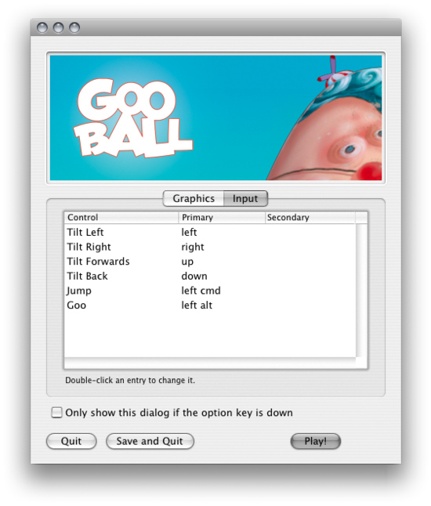

You can setup Joysticks, Gamepads, Keyboard, and Mouse, then access them all through one simple scripting interface. 你可以配置操纵杆、小键盘、键盘和鼠标，然后通过一个简单的脚本界面访问它们。

From scripts, all virtual axes are accessed by their name. 从脚本里，所有虚拟轴是通过它们的名称访问的。

Every project has the following default input axes when it's created: 每个项目拥有下面默认的输入轴当它们被创建时：

* **Horizontal** and **Vertical** are mapped to w, a, s, d and the arrow keys.
* 水平和垂直被映射到w、a、s、d以及方向键。
* **Fire1**, **Fire2**, **Fire3** are mapped to Control, Option (Alt), and Command, respectively.
* **开火1、开火2、开火3**被映射到Control、Option（Alt）以及各个的指令。
* **Mouse X** and **Mouse Y** are mapped to the delta of mouse movement.
* **所标的左和右键被映射**鼠标移动的增量。
* **Window Shake X** and **Window Shake Y** is mapped to the movement of the window.
* **窗口摇动X和Y被映射窗口的移动。**

**Adding new Input Axes添加新的输入坐标轴**

If you want to add new virtual axes go to the **Edit->Project Settings->Input** menu. Here you can also change the settings of each axis.

如果你想添加新的虚拟轴就到**Edit->Project Settings->Inpu**菜单。这里你也可以更改每个轴的设置。

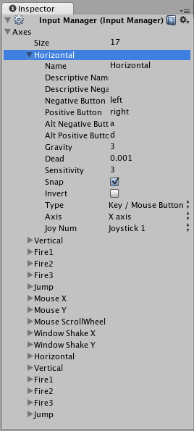

You map each Axis to two buttons either on a Joystick, Mouse, or Keyboard keys.

你映射每个轴到两个按钮其中一个是操纵杆或键盘的键。

|  |  |
| --- | --- |
| **Name**  **名称** | The name of the string used to check this Axis from a script.  字符串名称被用于确认轴从脚本里 |
| **Descriptive Name**  **描述名称** | Positive value name displayed in the Input tab of the Configuration dialog for standalone builds.  正向值的名称显示在输入配置对话框为独立建立。 |
| **Descriptive Negative Name**  描述反向名称 | Negative value name displayed in the Input tab of the Configuration dialog for standalone builds.  反向值的名称显示在输入配置对话框为独立建立 |
| **Negative Button**  反向按钮 | The button used to push the Axis in the negative direction.  本按钮被用于推动轴在反向的方向上 |
| **Positive Button**  **正向按钮** | The button used to push the Axis in the positive direction.  本按钮用于推动轴在正向方向上 |
| **Alt Negative Button**  Alt反向按钮 | Alternative button used to push the Axis in the negative direction.  交错按钮被用于推动轴在反向的方向上。 |
| **Alt Positive Button**  **Alt 正向按钮** | Alternative button used to push the Axis in the positive direction.  交错按钮被用于推动轴在正向方向上。 |
| **Gravity**  **重力** | Speed in units per second that the Axis falls toward neutral when no buttons are pressed.  每秒单位内的速度轴线下落到中轴当没有按钮被按下时。 |
| **Dead**  **停用** | Size of the analog dead zone. All analog device values within this range result map to neutral.  模拟停用区域的大小。所有的模拟设备值在这个范围内的结果映射到中枢。 |
| **Sensitivity**  **灵敏度** | Speed in units per second that the the Axis will move toward the target value. This is for digital devices only.  每秒单位内的速度，轴将向前移动到目标的值。这是仅为数字设备。 |
| **Snap**  **捕获** | If enabled, the Axis value will reset to zero when pressing a button of the opposite direction.  如果启用，轴值将重设为零当按下相对位置按钮时。 |
| **Invert**  **反转** | If enabled, the Negative Buttons provide a positive value, and vice-versa.  如果启用，反向按钮提供一个正向值，反之依然。 |
| **Type**  **类型** | The type of inputs that will control this Axis.  输入类型，控制这个轴的 |
| **Axis**  **轴** | The axis of a connected device that will control this Axis.  连接设备的轴控制这个轴 |
| **Joy Num**  **操纵杆编号** | The connected Joystick that will control this Axis.  连接操纵杆控制的轴。 |

Use these settings to fine tune the look and feel of input. They are all documented with tooltips in the Editor as well. 使用这些设置去细微调整外观和输入的感觉。它们所有在编辑器里的提示文本也将说明。

**Using Input Axes from Scripts 从脚本使用输入轴**

You can query the current state from a script like this:

你可以查询当前状态从一个脚本里，像这样：

value = Input.GetAxis ("Horizontal");

An axis has a value between -1 and 1. The neutral position is 0. This is the case for Joystick input and Keyboard input.

一个轴拥有一个在-1到1之间的值。中间位置是0。这是一个选择为操纵杆输入和键盘输入。

However, Mouse delta and Window Shake delta are how much the mouse or window moved during the last frame. This means it can be larger than 1 or smaller than -1 when the user moves the mouse quickly.

然而，鼠标增量和窗口摇动增量是在最近的帧期间内鼠标或窗口移动多少。

It is possible to create multiple Axes with the same name. When getting the input axis, the axis with the largest absolute value will be returned. This makes it possible to assign more than one input device to one Axis name. For example, create one axis for keyboard input and one axis for joystick input with the same name. If the user is using the joystick, input will come from the joystick, otherwise input will come from the keyboard. This way you don't have to think at all about from where the input comes when writing scripts.

它可以创建具有相同名称的多个轴。当输入轴获取，拥有最大绝对值的轴线将返回。这使得分配多个输入设备，以一轴的名称。例如，创建一个键盘输入和一个摇杆具有相同名称的输入轴轴。如果用户正在使用操纵杆，输入来自操纵杆，否则将来自输入键盘。这样，你就不必为在所有关于从那里输入正值编写脚本。

**Button names 按钮名称**

To map a key to an axis, you have to enter the key's name in the **Positive Button** or **Negative Button** property in the **Inspector**.

映射到一个轴键，在检视器属性里，你必须在正向按钮或负向按钮里输入键的名称。

The names of keys follow this convention: 键的名称符合下面的约定：

* Normal keys: "a", "b", "c" ... 正常键 a，b，c…
* Number keys: "1", "2", "3", ... 数字键 1，2，3，
* Arrow keys: "up", "down", "left", "right" 方向键 "up", "down", "left", "right"
* Keypad keys: "[1]", "[2]", "[3]", "[+]", "[equals]" 小键盘键"[1]", "[2]", "[3]", "[+]", "[equals]"
* Modifier keys: "right shift", "left shift", "right ctrl", "left ctrl", "right alt", "left alt", "right cmd", "left cmd"
* 修改键"right shift", "left shift", "right ctrl", "left ctrl", "right alt", "left alt", "right cmd", "left cmd"
* Mouse Buttons: "mouse 0", "mouse 1", "mouse 2", ... 鼠标键"mouse 0", "mouse 1", "mouse 2", ...
* Joystick Buttons (from any joystick): "joystick button 0", "joystick button 1", "joystick button 2", ...
* 操纵杆键（任何操纵杆）："joystick button 0", "joystick button 1", "joystick button 2", ...
* Joystick Buttons (from a specific joystick): "joystick 0 button 0", "joystick 0 button 1", "joystick 1 button 0", ...
* 操纵杆键（指定操纵杆）："joystick 0 button 0", "joystick 0 button 1", "joystick 1 button 0", ...
* Special keys: "backspace", "tab", "return", "escape", "space", "delete", "enter", "insert", "home", "end", "page up", "page down"
* 专用键backspace", "tab", "return", "escape", "space", "delete", "enter", "insert", "home", "end", "page up", "page down"
* Function keys: "f1", "f2", "f3", ... 功能键 "f1", "f2", "f3", ...

The names used to identify the keys are the same in the scripting interface and the Inspector.

名称用来识别键是相同的在脚本接口里和在检视器里。

value = Input.GetKey ("a");

**Transforms 变换**

[**Unity Manual**](http://unity3d.com/support/documentation/Manual/index.html) > [**User Guide**](http://unity3d.com/support/documentation/Manual/User%20Guide.html) > [**Creating Gameplay**](http://unity3d.com/support/documentation/Manual/Creating%20Gameplay.html) > [**Transforms**](http://unity3d.com/support/documentation/Manual/Transforms.html)

Unity手册->用户指南->建立可玩性游戏->变化

**Transforms** are a key **Component** in every **GameObject**. They dictate where the GameObject is positioned, how it is rotated, and its scale. It is impossible to have a GameObject without a Transform. You can adjust the Transform of any GameObject from the **Scene View**, the **Inspector**, or through Scripting.

**Transforms**是一个关键组件在每个GameObject里。它们指定GameObject的位置是哪里，如何旋转，以及如何缩放。一个没有Transform的GameObject是可能的。从场景视图里、检视器里户或通过脚本你可以调整任何GaomeObject的Transform。

The remainder of this page's text is from the [Transform Component Reference](http://unity3d.com/support/documentation/Components/class-Transform.html) page.

本页剩余部分的文本是来自Transform 组件引用页。

**Transform 变换**

The **Transform** **Component** determines the actual **Position**, **Rotation**, and **Scale** of all objects in the scene. Every object has a Transform.

在场景里，Transform组件确定所有对象的实际的位置、旋转和缩放。每个对象有一个Transform。

*The Transform Component is viewable and editable in the* ***Inspector***

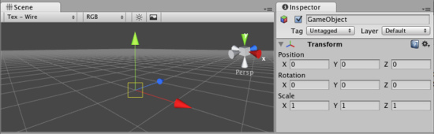

***在检视器里，****Transform组件是可视与可编辑的。*

**Properties 属性**

|  |  |
| --- | --- |
| **Position**  **位置** | Position of the Transform in X, Y, and Z coordinates.  与x，y，z相配配的Transform的位置 |
| **Rotation**  **旋转** | Rotation of the Transform around the X, Y, and Z axes, measured in degrees.  Transform围绕x，y，z轴旋转，使用角度规则。 |
| **Scale**  **缩放** | Scale of the Transform along X, Y, and Z axes. Value "1" is the original size (size at which the object was imported).沿x，y，z轴变换伸缩。值为1是原始大小（在该对象导入时的大小） |

All properties of a Transform are measured relative to the Transform's parent. If the Transform has no parent, the properties are measured relative to World Space.

所有变换组件的属性的测量是相对于变换组件的父。若这个变换组件没有父，这些属性的测量相对于整个空间。

**Using Transforms 使用变换组件**

Transforms are always manipulated in 3D space using X, Y, and Z axes. In Unity, these axes are represented by the colors red, green, and blue respectively. Remember: XYZ = RGB.

变换组件总是在3D空间使用x，y，z轴生成。在Unity里，这些轴通过红、绿、蓝三种颜色分别展现。记住：XYZ=RGB.

*Color-coded relationship between 3 axes and Transform properties 色标3个轴与变换组件之间的关系。*

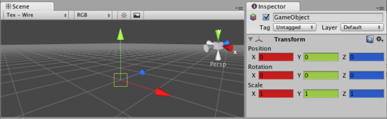

Transform Components can be directly manipulated using the **Scene View** or the Inspector. The Inspector will list the properties stated above for easy editing. You can also modify Transforms in your Scene by interacting with them, using the Move, Rotate, and Scale tools. These tools are located in the upper left-hand corner of the Unity Editor.

Transform（变换）组件可以直接操作使用场景视图或检视器面板。检视器面板将列出容易编辑的属性状态。你也可以在你的场景里通过使用移动、旋转和伸缩互动修改变化组件。这些工具定位在Unity编辑器的左手上角。

*The View, Translate, Rotate, and Scale tools 查看，变换，旋转机伸缩工具。*



The tools will be usable on any object in your scene. Click on the object, and you will see the tool gizmo appear around it. Depending on the current tool, the gizmo will look slightly different. Clicking the object will also cause the Transform component to become visible in the Inspector. If the Inspector does not display the Transform component or its properties, then you do not have an object highlighted in the Scene View.

在你的场景里，这个工具可用在任何对象上。在对象上点击，然后你将看到小发明（gizmo翻译成装置/辅助？）工具显示在对象的周围。利用当前工具，小发明将看起来稍微不同。点击对象也将导致变换组件在检视器面板了变为可见。如果检视器面板里没有显示变换组件或它的属性，在场景视图里你不能拥有一个高亮显示的对象。

平移工具-快捷键 W 旋转工具-快捷键 E 缩放工具-快捷键 R



All three Gizmos can be directly edited in Scene View. 所有三个小发明可以直接在场景视图里编辑。

To manipulate the Transform, click and drag on one of the 3 gizmo axes, you'll notice its color changes. As you drag the mouse, you will see the object translate, rotate, or scale along the axis. When you release the mouse button, you'll notice that the axis remains selected. You can click the middle mouse button and drag the mouse to manipulate the Transform along the selected axis. To access all 3 axes at once click and drag the center point of all 3 gizmos.

操作变换，在小发明3个轴的一个轴上点击并拖动，你将注意到它的颜色改变。在你拖动鼠标，你将看到对象平移、旋转、或沿轴伸缩。当你释放鼠标按钮，你将注意到这个轴仍然被选取。你可以点击鼠标的中间键并拖动鼠标去操作变换沿选取的轴。一起访问所有的3个轴，点击并拖动3个小发明的中心。

*Any individual axis will become selected when you click on it 任何个体的轴将变为选取状态当你在它上面点击时。*

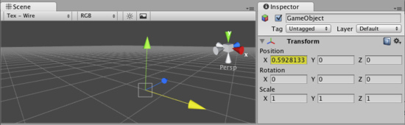

**Parenting 父类化**

Parenting is one of the most important concepts to understand when using Unity. When a GameObject is a **Parent** of another GameObject, the **Child** GameObject will move, rotate, and scale exactly as its Parent does. Just like your arms are attached to your body, when you turn your body, your arms move because they're attached. Any object can have multiple children, but only one parent.

当使用Unity时，理解父类化是一个非常重要的概念。当一个GameObject（游戏物体）是另外一个GameObject的一个父时，子GameObject将移动、旋转和正确的伸缩当它的父在做这些改变时。就像你的胳膊被附加到你的身体，当你转动你的身体时，你的胳膊因为它们被附加而移动。任何对象可以拥有多个子，但是只有一个父。

You can create a Parent by dragging any GameObject in the **Hierarchy View** onto another. This will create a Parent-Child relationship between the two GameObjects.

你可以在层次视图里通过拖动任何对象到其它对象上创建一个父。这将在两个GameObject之间建立一个父-子关系。

*A real-world example of a Parent-Child hierarchy. All the GameObjects with arrows to the left are Parents.*

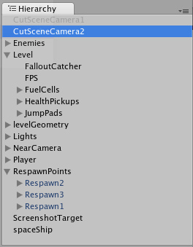

*父-子层次的一个真实世界的例子。所有的GameObject利用箭头指向左边的父。*

In the above example, we say that the arms are parented to the body, and the hands are parented to the arms. The scenes you make in Unity will contain collections of these **Transform hierarchies**. The topmost parent object is called the **Root object**. When you move, scale, or rotate a parent, all the changes in its Transform are applied to its children as well.

在上面的例子里，我们说胳膊是身体的父，以及手是胳膊的父。在Unity里你创造的场景将包含这些变换层次的集合。最顶层父对象被称为根对象。当你移动，伸缩或旋转一个父对象，所有的改变在它的变化里也被应用于它的子孙。

It is worth pointing out that the Transform values in the Inspector of any Child GameObject are displayed relative to the Parent's Transform values. These are also called the **Local Coordinates**. Through scripting, you can access the **Global Coordinates** as well as the Local Coordinates.

值得指出的是在检视器里的任何子GameObject的变化值是相对于父的变化值显示。这些也被称为局部坐标。通过脚本，你可以访问全局坐标与局部坐标。

You can build compound objects by parenting multiple separate objects together, like the skeletal structure of a human ragdoll. You can also create small yet effective objects with single parents. For example, if you have a horror game that takes place at night, you can create an effective atmosphere with a flashlight. To create this object, you would parent a spotlight Transform to the flashlight Transform. Then, any alteration of the flashlight Transform will affect the spotlight, creating a convincing flashlight effect.

通过父类化多重的对象结合在一起，你可以创建复合对象，像一个人的骨骼结构。你也可以建立单亲的小有效对象。例如，如果你一个发生在夜间的恐怖游戏，你可以创建一个手电筒的有效气氛。创建这个对象，你将父类一个聚光灯变换组件到一个手电筒变换组件。然后，任何手电筒变换组件的改变会影响关注的焦点，创造一个有说服力的闪光效果。

**Importance of Scale 缩放的重要性**

The scale of the Transform determines the difference between the size of your mesh in your modeling application, and the size of your mesh in Unity. The mesh's size in Unity (and therefore the Transform's scale) is **very** important, especially during physics simulation. There are 3 factors that can determine the Scale of your object:

转换的伸缩确定你的模型程序里的网格大小与Unity里的网格大小之间的不同。在Unity里的网格大小（因此变换组件的伸缩）是非常重要的，尤其在物理模式时。有3种因素可以确定你的对象伸缩：

* The size of your mesh in your 3D modeling application. 在你的3D模型程序里你的网格大小
* The **Mesh Scale Factor** setting in the object's **Import Settings**. 网格伸缩比率设置在对象导入设置里。
* The **Scale** values of your Transform Component. 你变换组件的伸缩值。

Ideally, you should not adjust the **Scale** of your object in the Transform Component. The best option is to create your models at real-life scale, so you won't have to change your Transform's scale. The second-best option is to adjust the scale at which your mesh is imported in the **Import Settings** for your individual mesh. Certain optimizations occur based on the import size, and instantiating an object that has an adjusted scale value can decrease performance. For more information, read through the [Rigidbody](http://unity3d.com/support/documentation/Components/class-Rigidbody.html) component's section on optimizing scale.

理想地，你不应该在变换组件中调整你的对象的伸缩。最好的选项是在现实的数值产生的你的模型，因此你将不必改变你的变换数值。第二个好的选项是调整伸缩在导入设定中设置你的个体网格的导入。特定的最佳化出现基于导入的大小，而且对象初始化有一个调整数值可以减少处理性能。更多的信息，通读刚体组件的优化伸缩部分。

**Hints 提示**

* When parenting Transforms, put the parent's location at 0,0,0 before applying the child. This will save you many headaches later.
* 当父类化变换时，设置父的位置为0，0，0在应用子之前。这将保存你以后许多头疼的事情。
* **Particle Systems** are not affected by the Transforms **Scale**. In order to scale a Particle System, you need to modify the properties in the System's Particle Emitter, Animator and Renderer.
* **粒子系统**不受变化伸缩的影响。为了伸缩一个粒子系统，你需要修改属性在粒子系统的发射器里，动画以及渲染器里。
* If you are using **Rigidbodies** for physics simulation, there is some important information about the Scale property to be read on the [Rigidbody](http://unity3d.com/support/documentation/Components/class-Rigidbody.html) page.
* 如果你使用刚体为物理模拟，在刚体页，有一些重要的关于伸缩属性的信息阅读。
* You can change the colors of the Transform axes (and other UI elements) from the **Unity Menu->Preferences->Colors & keys**.
* 你可以更改 变化轴的演示（其它UI元素）从Unity **Menu->Preferences->Colors & keys（在windows上是 Edit Preferences->Colors & keys）**
* If you can avoid scaling, do so. Try to have the scales of your object finalized in your 3D modeling application, or in the **Import Settings** of your mesh.
* 如果你能避免伸缩，如此做。尝试在你的3D模型应用程序中确定你最终的对象伸缩，或在你的网格导入设置里设置。

**Physics 物理**

[**Unity Manual**](http://unity3d.com/support/documentation/Manual/index.html) > [**User Guide**](http://unity3d.com/support/documentation/Manual/User%20Guide.html) > [**Creating Gameplay**](http://unity3d.com/support/documentation/Manual/Creating%20Gameplay.html) > [**Physics**](http://unity3d.com/support/documentation/Manual/Physics.html)

Unity手册->用户指南->创建可玩性游戏->物理

Unity has the next-generation Ageia PhysX physics engine built-in. This allows for unique emergent behaviour and is generally very cool.

Unity已经内置了下一代Ageia PhysX物理引擎。这将允许独特的紧急行为，而且通常是非常酷。

**Basics 基础**

To put an object under physics control, simply add a **Rigidbody** to it. When you do this, the object will be affected by gravity, and can collide with other objects in the world.

去放置对象在物理控制下，仅需添加一个刚体给它。当你这样做时，该对象将受到重力的影响，并能与其他对象碰撞在游戏世界里。

**Rigidbodies 刚体**

You use [Rigidbodies](http://unity3d.com/support/documentation/Components/class-Rigidbody.html) for things that the player can push around, eg. crates or loose objects. You can also add [Joints](http://unity3d.com/support/documentation/Components/class-HingeJoint.html) to rigidbodies to make the behavior more complex. For example, you could make a physical door or a crane with a swinging chain.

玩家可以挤压你所使用刚体的物体。例如，创建或释放对象。你也可以添加连接到刚体去创建复杂的行为。比如，你可以创建一个物理的门或一个摆动链的起重机。

You also use Rigidbodies to bring vehicles to life, for example you can make cars using a Rigidbody, 4 [Wheel Colliders](http://unity3d.com/support/documentation/Components/class-WheelCollider.html) and a script applying wheel forces based on the user's [Input](http://unity3d.com/support/documentation/Components/class-InputManager.html).

你还可以使用刚体去体验车辆的生活，例如你可以使用刚体创建汽车，4轮碰撞器和应用脚本基本处理车轮在用户的输入上。

You can make airplanes by applying forces to the Rigidbody from a script. Or you can create special vehicles or robots by adding various Joints and applying forces via scripting.

你可以通过从脚本处理刚体制造飞机。或你可以通过添加变量连接和经由脚本处理建立一个指定的飞船或机器人。

Rigidbodies are most often used in combination with [primitive colliders](http://unity3d.com/support/documentation/Components/class-BoxCollider.html).

刚体通常与原始碰撞机一起使用。

**Kinematic Rigidbodies 动态刚体**

**Kinematic Rigidbodies** are not affected by forces, gravity or collisions. They are driven explicitly by setting the position and rotation of the transform or animating them, yet they can interact with other non-Kinematic Rigidbodies.

动态刚体不受强制、重力或碰撞的影响。它们是通过设置的位置和变换的旋转或动画被明确转动。但是它们可以与其它非动态的刚体相互配合。

Kinematic Rigidbodies are used for three purposes: 动态刚体被用于三个方面的目的：

1. Sometimes you want an object to be under physics control but in another situation to be controlled explicitly from a script or animation. For example you could make an animated character whose bones have Rigidbodies attached that are connected with joints for use as a Ragdoll. Most of the time the character is under animation control, thus you make the Rigidbody Kinematic. But when he gets hit you want him to turn into a Ragdoll and be affected by physics. To accomplish this, you simply disable the isKinematic property.

有时你想要对象在物理控制下，但在另一种情况是从脚本或动画进行明确控制。例如，你可以做一个动画人物的骨骼附加刚体作为一个布娃娃被连接。大多数情况下，角色在动画控制之下，从而使你刚体运动。但是，当它获取击打你想它变成一个布娃娃以及物理的影响。为实现这一目标，你仅需禁用isKinematic属性。

1. Kinematic Rigidbodies play better with other Rigidbodies. For example if you have an animated platform and you want to place some Rigidbody boxes on top, you should make the platform a Kinematic Rigidbody instead of just a **Collider** without a Rigidbody.

动态刚体与其他刚体配合更好。例如，如果你有一个动画平台和你想要放置一些刚体盒在上面，你应该使态刚体平台动替代一个没有刚体碰撞器。

1. You might want to have a Kinematic Rigidbody that is animated and have a real Rigidbody follow it using one of the available Joints.

你或许想要一个动态刚体就是拥有一个真正的刚体动画跟随它，使用一个可用的关联。

**Static Colliders 静态碰撞器**

**Static Colliders** are used for level geometry which does not move around much. You add a **Mesh Collider** to your already existing graphical meshes (even better use the **Import Settings** Generate Colliders check box). You can still move around Static Colliders, but if you move them around a lot, you might want to add a Kinematic Rigidbody. There are two reasons why you want to make a Static Collider into a Kinematic Rigidbody instead:

静态碰撞器用于水平几何不再移动。你添加一个网格碰撞器到你已经存在的图形网格（甚至更好地利用导入设置生成撞机复选框）。你仍可以移动静态碰撞器，但如果你移动了它们很多，你可能要添加动态刚体。有两个原因你想使之成为一个运动刚体，而不是一个静态碰撞器：

1. Kinematic Rigidbodies [wake up](http://unity3d.com/support/documentation/Components/RigidbodySleeping.html) other Rigidbodies when they collide with them.

动态刚体唤醒其它刚体当它们互相碰撞时。

1. Kinematic Rigidbodies apply friction to Rigidbodies placed on top of them

动态刚体允许摩擦放置在它们上面的刚体。

**Character Controllers 角色控制器**

You use [Character Controllers](http://unity3d.com/support/documentation/Components/class-CharacterController.html) if you want to make a humanoid character. This could be the main character in a third person platformer, FPS shooter or any enemy characters.

如果你想创建一个有人的特点的角色，你可以使用人物（角色）控制器。这可以是主角色在一个第三人称平台里，FPS（第一人称）射击或任何敌人角色。

These Controllers don't follow the rules of physics since it will not feel right (in Doom you run 90 miles per hour, come to halt in one frame and turn on a dime). Instead, a Character Controller performs collision detection to make sure your characters can slide along walls, walk up and down stairs, etc.

因为它将感觉不到正确，这些控制器不遵从物理学的规则。（判定你运行每小时 90 里，在一个帧里异常终止并且打开一个一角硬币）相反地，一个角色控制器执行撞击检测确定你的角色能沿着墙壁滑动，上下地走楼梯，等等。

Character Controllers are not affected by forces but they can push Rigidbodies by applying forces to them from a script. Usually, all humanoid characters are implemented using Character Controllers.

角色控制器不是强制的影响，但是它们从一个脚本的强制应用到推动刚体上 。通常，所有的像人角色使用人物控制器被实现。

Character Controllers are inherently unphysical, thus if you want to apply real physics - Swing on ropes, get pushed by big rocks - to your character you have to use a Rigidbody, this will let you use joints and forces on your character. But be aware that tuning a Rigidbody to feel right for a character is hard due to the unphysical way in which game characters are expected to behave.

角色控制器是固有的非物理性，如此如果你想要应用真正的物理－在栏索上摇摆，根据大岩石推动－对你的角色你必须使用刚体 ，这将会让你使用连接并强加到你的角色上。但是知道的调节一个刚体到正确地感觉为一个角色是很硬式非物理性的方法在游戏角色是非期望的动作。

TIPS 提示

* You should never have a parent and child rigidbody together你不应该有一个父和子刚体在一起。
* You should never scale the parent of a rigidbody 你应该从不伸缩一个刚体的父。

**Constant Force 常力**

**Constant Force** is a quick utility for adding constant forces to a **Rigidbody**. This works great for one shot objects like rockets, if you don't want it to start with a large velocity but instead accelerate.

常力是为刚体添加常力的一个快速实用工具。这个伟大的工程，像一个火箭发射对象一样，如果你不想让它启动一个大速度，而是加快。

*A rocket propelled forward by a Constant Force 常力推动火箭向前*

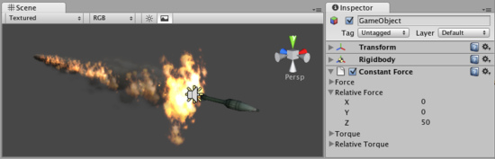

**Properties 属性**

|  |  |
| --- | --- |
| **Force**  **推力** | The vector of a force to be applied in world space.  一个推力的向量被应用于整个世界空间。 |
| **Relative Force**  **相对推力** | The vector of a force to be applied in the object's local space.  一个推力的向量被应用于对象的本地空间。 |
| **Torque**  **力矩** | The vector of a torque, applied in world space. The object will begin spinning *around* this vector. The longer the vector is, the faster the rotation.  一个力矩向量，被应用于整个世界空间。对象将围绕这个向量旋转。向量越大，旋转速度越快。 |
| **Relative Torque**  **相对力矩** | The vector of a torque, applied in local space. The object will begin spinning *around* this vector. The longer the vector is, the faster the rotation.  一个力矩向量，被应用于本地空间。对象将围绕这个向量旋转。向量越大，旋转速度越快。 |

**Details 详细资料**

To make a rocket that accelerates forward set the **Relative Force** to be along the positive z-axis. Then use the Rigidbody's **Drag** property to make it not exceed some maximum velocity (the higher the drag the lower the maximum velocity will be). In the Rigidbody, also make sure to turn off gravity so that the rocket will always stay on its path.

去创建一个加速向前的火箭，设置**Relative Force（相对推力）**沿着正向的z轴。然后使用刚体的**Drag（拖动）**属性去使它不超过其中的最大速度（将高速度拖动到低速度）。在刚体里，也可以明确关于重力致使火箭将总是停留砸它自己的路线上。

**Hints 提示**

* To make an object flow upwards, add a Constant Force with the **Force** property having a positive Y value. 使一个对象向上升，添加一个常力使用Force（强制）属性拥有的一个正向的Y值。
* To make an object fly forwards, add a Constant Force with the **Relative Force** property having a positive Z value. 使一个对象向前飞，添加一个常力使用**Relative Force**（相对推力）属性拥有的一个正向的Z值。

**Sphere Collider 球状碰撞器**

The **Sphere Collider** is a basic sphere-shaped collision primitive. 球体碰撞器是一个基本的球形的碰撞元素。

*A pile of Sphere Colliders 一堆球体碰撞器*

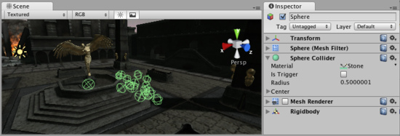

**Properties 属性**

|  |  |
| --- | --- |
| **Material**  **材料** | Reference to the [Physic Material](http://unity3d.com/support/documentation/Components/class-PhysicMaterial.html) that determines how this Collider interacts with others.  参考物理材料，确定这个碰撞器如何与其它物体碰撞。 |
| **Is Trigger**  **是触发器** | If enabled, this Collider is used for triggering events, and is ignored by the physics engine.  如果启用，这个碰撞器被用于触发事件， 并且被物理引擎忽略。 |
| **Radius**  **半径** | The size of the Collider.  碰撞器的大小。 |
| **Center**  **中心** | The position of the Collider in the object's local space.  碰撞器的位置在对象本地的空间里。 |

**Details 详细资料**

The Sphere Collider can be resized to uniform scale, but not along individual axes. It works great for falling boulders, ping pong balls, marbles, etc. 球体碰撞器可以调整大小去等份标尺，但不能沿个别的轴。它很好的工作于卵石，乒乓球、弹子求的滚动。

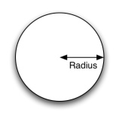

*A standard Sphere Collider* 一个标准的球体碰撞器

Colliders work with Rigidbodies to bring physics in Unity to life. Whereas Rigidbodies allow objects to be controlled by physics, Colliders allow objects to collide with each other. Colliders must be added to objects independently of Rigidbodies. A Collider does not necessarily need a Rigidbody attached, but a Rigidbody **must** be attached in order for the object to move as a result of collisions.

碰撞器与刚体一起工作引领在Unity里的物理生命。而刚体允许对象通过物理控制，碰撞器允许对象相互碰撞。碰撞器必须被添加到独立于刚体的对象上。一个碰撞器不一定需要连接刚体，但一个刚体必须按次序的附加，为对象移动作为碰撞的结果。

When a collision between two Colliders occurs and if at least one of them has a Rigidbody attached, [three](http://unity3d.com/support/documentation/ScriptReference/Collider.OnCollisionEnter.html) [collision](http://unity3d.com/support/documentation/ScriptReference/Collider.OnCollisionExit.html) [messages](http://unity3d.com/support/documentation/ScriptReference/Collider.OnCollisionStay.html) are sent out to the objects attached to them. These events can be handled in scripting, and allow you to create unique behaviors with or without making use of the built-in Ageia's physX engine.

当一个碰撞在两个碰撞器之间出现并且至少它们中的一个拥有一个刚体附加，三个碰撞消息被发出到附属于它们的对象。这些事件可以在脚本里处理，并允许你创建独特的行为或不利用内置的Ageia的PhysX物理引擎。

**Triggers 触发器**

An alternative way of using Colliders is to mark them as a **Trigger**, just check the IsTrigger property checkbox in the Inspector. Triggers are effectively ignored by the physics engine, and have a unique set of [three](http://unity3d.com/support/documentation/ScriptReference/Collider.OnTriggerEnter.html) [trigger](http://unity3d.com/support/documentation/ScriptReference/Collider.OnTriggerExit.html) [messages](http://unity3d.com/support/documentation/ScriptReference/Collider.OnTriggerStay.html) that are sent out when a collision with a Trigger occurs. Triggers are useful for triggering other events in your game, like cutscenes, automatic door opening, displaying tutorial messages, etc. Use your imagination!

使用碰撞器的一个可选择的方法是把它们标记为一个触发器，仅检验IsTrigger属性检验框在检视器里。触发器是通过物理引擎实际上忽略，并且有一个三个触发器消息的独特设置，当一个触发器碰撞出现时它们被发出。在你的游戏里触发器被用于触发其他事件，像剪切场景，自动开门，显示指导信息等，使用你的想像力！

Be aware that in order for two Triggers to send out trigger events when they collide, one of them must include a Rigidbody as well. For a Trigger to collide with a normal Collider, one of them must have a Rigidbody attached. For a detailed chart of different types of collisions, see the collision action matrix in the Advanced section below.

请注意，为了使两个触发器发出触发事件当它们碰撞时，它们中的一个必须也包含刚体。对于触发碰撞利用一个正常碰撞器，它们中的一个必须有一个刚体连接。如需不同类型的碰撞的详细图表，请参阅下面的高级部分碰撞行动矩阵。

**Friction and bouncyness摩擦和弹性**

Friction, bouncyness and softness are defined in the [Physic Material](http://unity3d.com/support/documentation/Components/class-PhysicMaterial.html). The [Standard Assets](http://unity3d.com/support/documentation/Manual/HOWTO-InstallStandardAssets.html) contain the most common physics materials. To use one of them click on the Physic Material drop-down and select one, eg. Ice. You can also [create](http://unity3d.com/support/documentation/Components/class-PhysicMaterial.html) your own physics materials and tweak all friction values.

摩擦、弹性和柔软是定义在物理材质里。标准资产包含了许多公共物理材质。使用它们中的一个，在物理材质下拉框上点击并选择一个，例如 冰。你也可以建立你自己的物理材质并调整所有的摩擦值。

**Compound Colliders 复合碰撞器**

Compound Colliders are combinations of primitive Colliders, collectively acting as a single Collider. They come in handy when you have a complex mesh to use in collisions but cannot use a **Mesh Collider**. To create a Compound Collider, create child objects of your colliding object, then add a primitive Collider to each child object. This allows you to position, rotate, and scale each Collider easily and independently of one another.

复合碰撞器是原始的碰撞器的组合，统称为一个单一的碰撞器。它们派上用场当你有一个复杂的网格冲突中使用时，但不能使用网碰撞器。要创建一个复合碰撞器，创建你的碰撞对象的子对象，然后添加原始碰撞器为每个子对象。这可以让你去定位，旋转，以及每个碰撞器的容易伸缩和相互独立。

*A real-world Compound Collider setup 一个真实世界的复合碰撞器的设置*

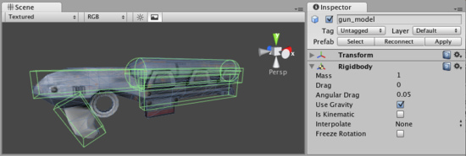

In the above picture, the environment has a Mesh Collider attached. Mesh Colliders work the best for terrain or environments made from irregular shapes. The **gun_model** GameObject has a Rigidbody attached, and multiple primitive Colliders as child GameObjects. When the Rigidbody parent is moved around by forces, the child Colliders move along with it. The primitive Colliders will collide with the environment's Mesh Collider, and the parent Rigidbody will alter the way it moves based on forces being applied to it and how its child Colliders interact with other Colliders in the Scene.

在上面的图像里，环境有一个网格碰撞器附加。网格碰撞器最好工作于地形或环境由不规则的形状组成。抢模型游戏对象有一个刚体，并且有多个原始碰撞器作为子游戏对象。当刚体的父被强制四处移动，子刚体也随着它一起移动。原始碰撞器将与环境的碰撞器碰撞，并且父刚体将改变方式，它移动的基本强度被应用到它并且子碰撞器与其它碰撞器如何配合在场景里。

Mesh Colliders can't normally collide with each other. If a Mesh Collider is marked as **Convex**, then it can collide with another Mesh Collider. The typical solution is to use primitive Colliders for any objects that move, and Mesh Colliders for static background objects.

网格碰撞器通常不能相互碰撞。如果一个网碰撞器被标记为凸，那么它可以碰撞其他网碰撞器。典型的解决方案是使用原始撞机上的任何对象的移动，和静态的背景对象的网格碰撞器。

**Hints 提示**

* To add multiple Colliders for an object, create child GameObjects and attach a Collider to each one. This allows each Collider to be manipulated independently.
* 要添加一个对象的多个撞机，创建子GameObjects，并附上碰撞器的每一个。这使得每个碰撞器是独立操作。
* You can look at the gizmos in the **Scene View** to see how the Collider is being calculated on your object.
* 在场景视图里你可以查看小发明，看碰撞器如何在你的对象上计算。
* Colliders do their best to match the scale of an object. If you have a non-uniform scale (a scale which is different in each direction), only the Mesh Collider can match completely.
* 碰撞器尽力匹配对象的伸缩。如果你有一个非统一的标准（其规模是每个方向不同），只有网格碰撞器可以完全匹配。
* If you are moving an object through its Transform component but you want to receive Collision/Trigger messages, you must attach a Rigidbody to the object that is moving.
* 如果你正在通过其变换组件的对象，但你要接收碰撞/触发邮件，你必须刚体附加的对象是移动。
* If you make an explosion, it can be very effective to add a rigidbody with lots of drag and a sphere collider to it in order to push it out a bit from the wall it hits.
* 如果你发生爆炸，它可以非常有效地添加带有很多的阻力和领域碰撞器刚体它为推动它从墙上点击一下。

**Advanced 高级**

**Collider combinations 碰撞器制品**

There are numerous different combinations of collisions that can happen in Unity. Each game is unique, and different combinations may work better for different types of games. If you're using physics in your game, it will be very helpful to understand the different basic Collider types, their common uses, and how they interact with other types of objects.

有许多不同的组合，可以碰撞发生在Unity里。每个游戏都是独一无二的，不同的组合可以更好地为不同类型的游戏。如果你使用物理在你的游戏里，这将非常有助于理解基本的碰撞器的不同类型，它们的共同使用，以及它们如何与其他类型的对象交互。

**Static Collider 静态碰撞器**

These are GameObjects that do **not** have a Rigidbody attached, but **do** have a Collider attached. These objects should remain still, or move very little. These work great for your environment geometry. They will not move if a Rigidbody collides with them.

这些GameObjects是没有刚体连接，但有一碰撞器重视。这些对象应仍旧保持，或移动很少。这些工作非常适合你环境的几何。他们将不会移动如果一个它们有一个刚体碰撞器。

**Rigidbody Collider 刚体碰撞器**

These GameObjects contain both a Rigidbody and a Collider. They are completely affected by the physics engine through scripted forces and collisions. They might collide with a GameObject that only contains a Collider. These will likely be your primary type of Collider in games that use physics.

这些GameObjects同时包含刚体和对撞机。他们完全受影响，通过强制脚本和碰撞的物理引擎。他们可能碰撞的GameObject只包含一对撞机。这些可能是你的对撞机的主要类型的游戏，利用物理学。

**Kinematic Rigidbody Collider 动态刚体碰撞器**

This GameObject contains a Collider and a Rigidbody which is marked **IsKinematic**. To move this GameObject, you modify its [Transform](http://unity3d.com/support/documentation/Components/class-Transform.html) Component, rather than applying forces. They're similar to Static Colliders but will work better when you want to move the Collider around frequently. There are some other specialized scenarios for using this GameObject.

这个GameObject包含一个碰撞器和一个刚体，被标记为**IsKinematic**。移动这个GameObject，你修改它的Transform组件，与其倒不如应用强制。它们是与静态碰撞器相似，但将工作更好，当你想频繁的围绕碰撞器移动时。有些其它特别的脚本为使用这个GamoObject。

This object can be used for circumstances in which you would normally want a Static Collider to send a trigger event. Since a Trigger must have a Rigidbody attached, you should add a Rigidbody, then enable **IsKinematic**. This will prevent your Object from moving from physics influence, and allow you to receive trigger events when you want to.

此对象可用于在哪些情况下你通常需要一个静态撞机发送一个触发事件。由于必须有一个触发刚体连接，你应该添加一个刚体，然后启用IsKinematic。这将阻止从物理学影响移动您的对象，并允许你想收到的触发事件当你想要时。

Kinematic Rigidbodies can easily be turned on and off. This is great for creating ragdolls, when you normally want a character to follow an animation, then turn into a ragdoll when a collision occurs, prompted by an explosion or anything else you choose. When this happens, simply turn all your Kinematic Rigidbodies into normal Rigidbodies through scripting.

动态刚体可以很容易地打开和关闭。这是愉快的去创建ragdolls，当你通常想要一个角色动画，然后变成一个布娃娃当发生碰撞时，由爆炸或任何其他你选择的提示。当发生这种情况，只要变成动态刚体进入正常的刚体里通脚本。

If you have Rigidbodies come to rest so they are not moving for some time, they will "fall asleep". That is, they will not be calculated during the physics update since they are not going anywhere. If you move a Kinematic Rigidbody out from underneath normal Rigidbodies that are at rest on top of it, the sleeping Rigidbodies will "wake up" and be correctly calculated again in the physics update. So if you have a lot of Static Colliders that you want to move around and have different object fall on them correctly, use Kinematic Rigidbody Colliders.

如果你有刚体停止移动，因此不在一段时间内移动，他们将“睡着”。也就是说，他们不会在更新的物理计算，因为他们不会去任何地方。如果你移动动态的刚体从在正常刚体下面，睡觉刚体会“唤醒”，并再次正确计算物理更新。因此，如果你有一些静态刚体，想要移动和对不同对象正确轮到它们，使用运动刚体碰撞器。

**Collision action matrix 碰撞操作矩阵**

Depending on the configurations of the two colliding Objects, a number of different actions can occur. The chart below outlines what you can expect from two colliding Objects, based on the components that are attached to them. Some of the combinations only cause one of the two Objects to be affected by the collision, so keep the standard rule in mind - physics will not be applied to objects that do not have Rigidbodies attached.

取决于二个碰撞对象的配置，一些不同的行为可能出现。下面的图表表示你能从两个碰撞对象得到会发生什么，基于附加于它们上面的组件。一些组合仅导致这二个物件之一的通过撞击的影响，因此在思想里保持标准的规则－物理将不被适用于没有刚体附加的对象。

|  |  |  |  |  |  |  |
| --- | --- | --- | --- | --- | --- | --- |
| **Collision detection occurs and messages are sent upon collision** | | | | | | |
|  | Static Collider  静态碰撞器 | Rigidbody Collider  刚体碰撞器 | Kinematic  Rigidbody Collider  动态刚体碰撞器 | Static  Trigger Collider  静态触发碰撞器 | Rigidbody  Trigger Collider  刚体触发碰撞器 | Kinematic Rigidbody  Trigger Collider  动态刚体触发碰撞器 |
| Static Collider  静态碰撞器 |  | Y |  |  |  |  |
| Rigidbody Collider  刚体碰撞器 | Y | Y | Y |  |  |  |
| Kinematic Rigidbody Collider  动态刚体碰撞器 |  | Y |  |  |  |  |
| Static Trigger Collider  静态触发碰撞器 |  |  |  |  |  |  |
| Rigidbody Trigger Collider  刚体触发碰撞器 |  |  |  |  |  |  |
| Kinematic Rigidbody Trigger Collider  动态刚体触发碰撞器 |  |  |  |  |  |  |

|  |  |  |  |  |  |  |
| --- | --- | --- | --- | --- | --- | --- |
| **Trigger messages are sent upon collision** | | | | | | |
|  | Static Collider | Rigidbody Collider | Kinematic  Rigidbody Collider | Static  Trigger Collider | Rigidbody  Trigger Collider | Kinematic Rigidbody  Trigger Collider |
| Static Collider |  |  |  |  | Y | Y |
| Rigidbody Collider |  |  |  | Y | Y | Y |
| Kinematic Rigidbody Collider |  |  |  | Y | Y | Y |
| Static Trigger Collider |  | Y | Y |  | Y | Y |
| Rigidbody Trigger Collider | Y | Y | Y | Y | Y | Y |
| Kinematic Rigidbody Trigger Collider | Y | Y | Y | Y | Y | Y |

**Box Collider 盒状碰撞器**

The **Box Collider** is a basic cube-shaped collision primitive. 盒状碰撞器是基本立方体原始碰撞。

*A pile of Box Colliders 一堆盒状碰撞器*

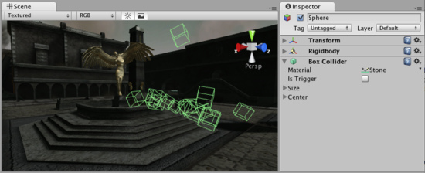

**Properties**

|  |  |
| --- | --- |
| **Material**  **材质** | Reference to the [Physic Material](http://unity3d.com/support/documentation/Components/class-PhysicMaterial.html) that determines how this Collider interacts with others.  参考物理材料，确定这个碰撞器如何与其它物体碰撞 |
| **Is Trigger**  **是否触发** | If enabled, this Collider is used for triggering events, and is ignored by the physics engine.  如果启用，这个碰撞器被用于触发事件， 并且被物理引擎忽略。 |
| **Size**  **大小** | The size of the Collider in the X, Y, Z directions.  碰撞器的大小。 |
| **Center**  **中心** | The position of the Collider in the object's local space.  碰撞器的位置在对象本地的空间里 |

**Details 详细资料**

The Box Collider can be resized into different shapes of rectangular prisms. It works great for doors, walls, platforms, etc. It is also effective as a human torso in a ragdoll or as a car hull in a vehicle. Of course, it works perfectly for just boxes and crates as well!

盒状碰撞器的大小可以改变成不同形状的长方形棱镜。它适用于门，墙壁，平台等，也可作为一个人体躯干或作为一辆汽车体。当然，它完美的适用于箱子，板条箱！

*A standard Box Collider 一个标准盒状碰撞器*

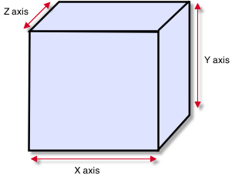

Colliders work with Rigidbodies to bring physics in Unity to life. Whereas Rigidbodies allow objects to be controlled by physics, Colliders allow objects to collide with each other. Colliders must be added to objects independently of Rigidbodies. A Collider does not necessarily need a Rigidbody attached, but a Rigidbody **must** be attached in order for the object to move as a result of collisions.

碰撞器与刚体一起工作引领在Unity里的物理生命。而刚体允许对象通过物理控制，碰撞器允许对象相互碰撞。碰撞器必须被添加到独立于刚体的对象上。一个碰撞器不一定需要连接刚体，但一个刚体必须按次序的附加，为对象移动作为碰撞的结果。

When a collision between two Colliders occurs and if at least one of them has a Rigidbody attached, [three](http://unity3d.com/support/documentation/ScriptReference/Collider.OnCollisionEnter.html) [collision](http://unity3d.com/support/documentation/ScriptReference/Collider.OnCollisionExit.html) [messages](http://unity3d.com/support/documentation/ScriptReference/Collider.OnCollisionStay.html) are sent out to the objects attached to them. These events can be handled in scripting, and allow you to create unique behaviors with or without making use of the built-in Ageia's physX engine.

当一个碰撞在两个碰撞器之间出现并且至少它们中的一个拥有一个刚体附加，三个碰撞消息被发出到附属于它们的对象。这些事件可以在脚本里处理，并允许你创建独特的行为或不利用内置的Ageia的PhysX物理引擎。

**Triggers**

An alternative way of using Colliders is to mark them as a **Trigger**, just check the IsTrigger property checkbox in the Inspector. Triggers are effectively ignored by the physics engine, and have a unique set of [three](http://unity3d.com/support/documentation/ScriptReference/Collider.OnTriggerEnter.html) [trigger](http://unity3d.com/support/documentation/ScriptReference/Collider.OnTriggerExit.html) [messages](http://unity3d.com/support/documentation/ScriptReference/Collider.OnTriggerStay.html) that are sent out when a collision with a Trigger occurs. Triggers are useful for triggering other events in your game, like cutscenes, automatic door opening, displaying tutorial messages, etc. Use your imagination!

使用碰撞器的一个可选择的方法是把它们标记为一个触发器，仅检验IsTrigger属性检验框在检视器里。触发器是通过物理引擎实际上忽略，并且有一个三个触发器消息的独特设置，当一个触发器碰撞出现时它们被发出。在你的游戏里触发器被用于触发其他事件，像剪切场景，自动开门，显示指导信息等，使用你的想像力！

Be aware that in order for two Triggers to send out trigger events when they collide, one of them must include a Rigidbody as well. For a Trigger to collide with a normal Collider, one of them must have a Rigidbody attached. For a detailed chart of different types of collisions, see the collision action matrix in the Advanced section below.

请注意，为了使两个触发器发出触发事件当它们碰撞时，它们中的一个必须也包含刚体。对于触发碰撞利用一个正常碰撞器，它们中的一个必须有一个刚体连接。如需不同类型的碰撞的详细图表，请参阅前面的高级部分碰撞行动矩阵。

**Friction and bouncyness**

Friction, bouncyness and softness are defined in the [Physic Material](http://unity3d.com/support/documentation/Components/class-PhysicMaterial.html). The [Standard Assets](http://unity3d.com/support/documentation/Manual/HOWTO-InstallStandardAssets.html) contain the most common physics materials. To use one of them click on the Physic Material drop-down and select one, eg. Ice. You can also [create](http://unity3d.com/support/documentation/Components/class-PhysicMaterial.html) your own physics materials and tweak all friction values.

摩擦、弹性和柔软是定义在物理材质里。标准资产包含了许多公共物理材质。使用它们中的一个，在物理材质下拉框上点击并选择一个，例如 冰。你也可以建立你自己的物理材质并调整所有的摩擦值。

**Mesh Collider 网格碰撞器**

The **Mesh Collider** takes a [Mesh Asset](http://unity3d.com/support/documentation/Components/class-Mesh.html) and builds its Collider based on that mesh. It is far more accurate for collision detection than using primitives for complicated meshes. Mesh Colliders that are marked as **Convex** can collide with other Mesh Colliders.

网格碰撞器携带一个网格资产并在其它网格的基础上建立它自己的碰撞器。它是更加精确的为碰撞检测比使用元素更为复杂的网格。网格碰撞器标记为凸起可与其它网格碰撞器碰撞。

*A Mesh Collider used on level geometry* 一个网格碰撞器应用在几何学上

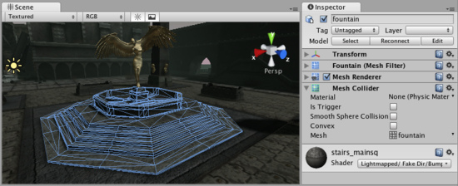

**Properties 属性**

|  |  |
| --- | --- |
| **Material**  **材质** | Reference to the [Physic Material](http://unity3d.com/support/documentation/Components/class-PhysicMaterial.html) that determines how this Collider interacts with others.  参考物理材料，确定这个碰撞器如何与其它物体碰撞 |
| **Is Trigger**  **是否触发** | If enabled, this Collider is used for triggering events, and is ignored by the physics engine.  如果启用，这个碰撞器被用于触发事件， 并且被物理引擎忽略。 |
| **Mesh**  **网格** | Reference to the Mesh to use for collisions.  引用网格作为碰撞使用 |
| **Smooth Sphere Collisions**  平滑球状碰撞器 | When this is enabled, collision mesh normals are smoothed. You should enable this on smooth surfaces eg. rolling terrain without hard edges to make sphere rolling smoother.  当这个启动时，网格碰撞通常是平滑的。你应该启用这个在表面平滑。例如没有铸件毛刺的起伏地区去使用卷动平滑。 |
| **Convex**  **凸面** | If enabled, this Mesh Collider will collide with other Mesh Colliders. Convex Mesh Colliders are limited to 255 triangles.  如果启用，这个网格碰撞器将与其它网格碰撞器碰撞。凸面网格碰撞器被限制在255个三角形。 |

**Details 详细资料**

The Mesh Collider builds its collision representation from the [Mesh](http://unity3d.com/support/documentation/Components/class-Mesh.html) attached to the GameObject, and reads the properties of the attached [Transform](http://unity3d.com/support/documentation/Components/class-Transform.html) to set its position and scale correctly.

网格碰撞器建立它自己的碰撞表现从GameObject附加的网格，并读取附加的Transform的属性去设置它的位置与正确的伸缩。

Collision meshes use backface culling. If an object collides with a mesh that will be backface culled graphically it will also not collide with it physically.

碰撞网格使用背面剔除。如果一个对象碰撞器利用一个网格将背面剔除图形，它也将不与它的体格上碰撞。

There are some limitations when using the Mesh Collider. Usually, two Mesh Colliders cannot collide with each other. All Mesh Colliders can collide with any primitive Collider. If your mesh is marked as **Convex**, then it can collide with other Mesh Colliders.

当商用网格碰撞器时有一些局限。通常，两个网格碰撞器不能互相碰撞。所有的网格碰可以与任何原始的碰撞器碰撞。如果你的网格是被标记为凸面，然后它能与其它碰撞器碰撞。

Colliders work with Rigidbodies to bring physics in Unity to life. Whereas Rigidbodies allow objects to be controlled by physics, Colliders allow objects to collide with each other. Colliders must be added to objects independently of Rigidbodies. A Collider does not necessarily need a Rigidbody attached, but a Rigidbody **must** be attached in order for the object to move as a result of collisions.

碰撞器与刚体一起工作引领在Unity里的物理生命。而刚体允许对象通过物理控制，碰撞器允许对象相互碰撞。碰撞器必须被添加到独立于刚体的对象上。一个碰撞器不一定需要连接刚体，但一个刚体必须按次序的附加，为对象移动作为碰撞的结果。

When a collision between two Colliders occurs and if at least one of them has a Rigidbody attached, [three](http://unity3d.com/support/documentation/ScriptReference/Collider.OnCollisionEnter.html) [collision](http://unity3d.com/support/documentation/ScriptReference/Collider.OnCollisionExit.html) [messages](http://unity3d.com/support/documentation/ScriptReference/Collider.OnCollisionStay.html) are sent out to the objects attached to them. These events can be handled in scripting, and allow you to create unique behaviors with or without making use of the built-in Ageia's physX engine.

当一个碰撞在两个碰撞器之间出现并且至少它们中的一个拥有一个刚体附加，三个碰撞消息被发出到附属于它们的对象。这些事件可以在脚本里处理，并允许你创建独特的行为或不利用内置的Ageia的PhysX物理引擎。

**Triggers 触发器**

An alternative way of using Colliders is to mark them as a **Trigger**, just check the IsTrigger property checkbox in the Inspector. Triggers are effectively ignored by the physics engine, and have a unique set of [three](http://unity3d.com/support/documentation/ScriptReference/Collider.OnTriggerEnter.html) [trigger](http://unity3d.com/support/documentation/ScriptReference/Collider.OnTriggerExit.html) [messages](http://unity3d.com/support/documentation/ScriptReference/Collider.OnTriggerStay.html) that are sent out when a collision with a Trigger occurs. Triggers are useful for triggering other events in your game, like cutscenes, automatic door opening, displaying tutorial messages, etc. Use your imagination!

使用碰撞器的一个可选择的方法是把它们标记为一个触发器，仅检验IsTrigger属性检验框在检视器里。触发器是通过物理引擎实际上忽略，并且有一个三个触发器消息的独特设置，当一个触发器碰撞出现时它们被发出。在你的游戏里触发器被用于触发其他事件，像剪切场景，自动开门，显示指导信息等，使用你的想像力！

Be aware that in order for two Triggers to send out trigger events when they collide, one of them must include a Rigidbody as well. For a Trigger to collide with a normal Collider, one of them must have a Rigidbody attached. For a detailed chart of different types of collisions, see the collision action matrix in the Advanced section below.

请注意，为了使两个触发器发出触发事件当它们碰撞时，它们中的一个必须也包含刚体。对于触发碰撞利用一个正常碰撞器，它们中的一个必须有一个刚体连接。如需不同类型的碰撞的详细图表，请参阅前面的高级部分碰撞行动矩阵。

**Friction and bouncyness**

Friction, bouncyness and softness are defined in the [Physic Material](http://unity3d.com/support/documentation/Components/class-PhysicMaterial.html). The [Standard Assets](http://unity3d.com/support/documentation/Manual/HOWTO-InstallStandardAssets.html) contain the most common physics materials. To use one of them click on the Physic Material drop-down and select one, eg. Ice. You can also [create](http://unity3d.com/support/documentation/Components/class-PhysicMaterial.html) your own physics materials and tweak all friction values.

摩擦、弹性和柔软是定义在物理材质里。标准资产包含了许多公共物理材质。使用它们中的一个，在物理材质下拉框上点击并选择一个，例如 冰。你也可以建立你自己的物理材质并调整所有的摩擦值。

**Hints 提示**

* Mesh Colliders **cannot** collide with each other unless they are marked as **Convex**. Therefore, they are most useful for background objects like environment geometry.
* 网格碰撞器不能与其它网格碰撞器碰撞除非它们被标记为凸面。因此，它们通常用于背景对象就像环境的几何结构。
* **Convex** Mesh Colliders must be fewer than 255 triangles. 凸面网格碰撞器必须小于255个三角形
* Primitive Colliders are less costly for objects under physics control. 原始碰撞器是较少的代价为物理控制下的对象。
* When you attach a Mesh Collider to a **GameObject**, its Mesh property will default to the mesh being rendered. You can change that by assigning a different Mesh. 当你附加一个网格碰撞器到一个GameObject时，它自己的网格属性将默认到网格被纳入。你可以更改通过分配不同的网格。
* To add multiple Colliders for an object, create child GameObjects and attach a Collider to each one. This allows each Collider to be manipulated independently. 添加多个碰撞器为一个对象，创建子GameObject并附加一个碰撞器到每一个上。这允许每个碰撞器去独立生成。
* You can look at the gizmos in the **Scene View** to see how the Collider is being calculated on your object. 你可以查看小发明在场景视图里，观看碰撞器是如何被运算在你的对象上。
* Colliders do their best to match the scale of an object. If you have a non-uniform scale (a scale which is different in each direction), only the Mesh Collider can match completely.
* 碰撞器做它们最好调和一个对象的伸缩。如果你有一个非等份的伸缩（在每个不同方向上伸缩），仅需要网格碰撞器完整的匹配。
* If you are moving an object through its Transform component but you want to receive Collision/Trigger messages, you must attach a Rigidbody to the object that is moving.
* 如果你移动对象通过它自己的Transform组件，但你想接收碰撞/触发消息，你必须附加一个刚体到对象上进行移动。

**Physic Material 网络材质**

The **Physic Material** is used to adjust friction and bouncing effects of colliding objects.

网络材质被用于调整摩擦和碰撞对象的跳动效果。

To create a Physic Material select **Assets->Create->Physic Material** from the menu bar. Then drag the Physic Material from the Project View onto a **Collider** in the scene.

建议一个网络材质，选取**Assets->Create->Physic Material** 从主菜单条。然后拖动物理材质从项目视图里到场景视图里的一个碰撞器上。

*The Physic Material* ***Inspector 物理材质的检视器***

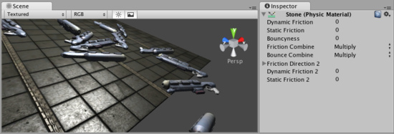

**Properties 属性**

|  |  |
| --- | --- |
| **Dynamic Friction**  **动态每次** | The friction used when already moving. Usually a value from 0 to 1. A value of zero feels like ice, a value of 1 will make it come to rest very quickly unless a lot of force or gravity pushes the object. 当移动时摩擦被应用。通常一个值从0到1之间。一个0值感觉像冰，一个1值将使它非常快的停止除非许多的强迫或重力推动这个对象。 |
| **Static Friction**  **静态摩擦** | The friction used when an object is laying still on a surface. Usually a value from 0 to 1. A value of zero feels like ice, a value of 1 will make it very hard to get the object moving.  当一个对象是停留在表面上时摩擦被应用。通常的值是在0至1之间。一个0值感觉像冰，一个1值将使一个对象很艰难的移动。 |
| **Bouncyness**  **弹性** | How bouncy is the surface? A value of 0 will not bounce. A value of 1 will bounce without any loss of energy. 表面是如何弹性的。一个0值将不弹起，一个1值将没有任何损失的弹起。 |
| **Friction Combine Mode**  摩擦组合模式 | How the friction of two colliding objects is combined.  两个碰撞对象如何摩擦组合。 |
| **Average 平均** | The two friction values are averaged. 两个摩擦值是平均的。 |
| **Min 最小** | The smallest of the two values is used. 两个值中的最小的值被使用。 |
| **Max 最大** | The largest of the two values is used. 两个值中的最大的值被使用 |
| **Multiply 多倍** | The friction values are multiplied with each other. 摩擦值是对互相多倍的 |
| **Bounce Combine**  弹性组合 | How the bouncyness of two colliding objects is combined. It has the same modes as Friction Combine Mode 两个碰撞对象的弹性是如何组合的。它拥有同样的模式作为摩擦组合模式。 |
| **Friction Direction 2**  摩擦方向2 | The direction of anisotropy. Anisotropic friction is enabled if this direction is not zero. Dynamic Friction 2 and Static Friction 2 will be applied along Friction Direction 2.  各向异向的方向。各向异向的摩擦是启用的，如果方向不是0。动态摩擦2 和静态摩擦 2将被应用于摩擦方向2。 |
| **Dynamic Friction 2**  **动态摩擦2** | If anisotropic friction is enabled, DynamicFriction2 will be applied along Friction Direction 2.  如果各向异向摩擦是启用的，动态摩擦2将被应用于摩擦方向2 |
| **Static Friction 2**  **静态摩擦2** | If anisotropic friction is enabled, StaticFriction2 will be applied along Friction Direction 2.  如果各向异向摩擦是启用的，静态摩擦2将被应用于摩擦方向2 |

**Details 详细资料**

Friction is the quantity which prevents surfaces from sliding off each other. This value is critical when trying to stack objects. Friction comes in two forms, dynamic and static. **Static friction** is used when the object is lying still. It will prevent the object from starting to move. If a large enough force is applied to the object it will start moving. At this point **Dynamic Friction** will come into play. **Dynamic Friction** will now attempt to slow down the object while in contact with another.

摩擦的数量可以防止表面互相滑动。此值是关键当试图堆积对象时。摩擦有两种形式，动态和静态的。静摩擦被应用当对象是停止不动时。它会阻止对象开始动移动。如果一个足够大的力量应用到该对象上，它将开始移动。在这一点上动态摩擦将开始发挥作用。动态摩擦现在将尝试减缓对象，同时与另一联系。

**Hints 提示**

* Don't try to use a standard physic material for the main character. Make a customized one and get it perfect. 不要为主角色尝试使用标准物理材质。做一个定制的并获得完善它。

**Hinge Joint 铰链组合**

The **Hinge Joint** groups together two [Rigidbodies](http://unity3d.com/support/documentation/Components/class-Rigidbody.html), constraining them to move like they are connected by a hinge. It is perfect for doors, but can also be used to model chains, pendulums, etc.

铰链组合在一起联合两个刚体，迫使它们移动像它们连接的通过一个铰链。这是完美的大门，但也可以用来模拟锁链，钟摆等。

*The Hinge Joint* ***Inspector 铰链的检视器***

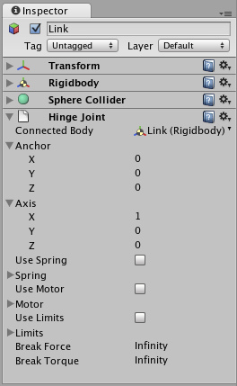

**Properties 属性**

|  |  |
| --- | --- |
| **Connected Body**  **连接躯体** | Optional reference to the Rigidbody that the joint is dependent upon. If not set, the joint connects to the world.  可选的刚体引用，连接依赖上面。如果不设置，连接接通世界。 |
| **Anchor 定位器** | The position of the axis around which the body swings. The position is defined in local space. 围绕轴身体波动的定位。该位置是指在局部空间 |
| **Axis 轴** | The direction of the axis around which the body swings. The direction is defined in local space.围绕轴的方向身体的摆动。方向是指在局部空间。 |
| **Use Spring 使用弹簧** | Spring makes the Rigidbody reach for a specific angle compared to its connected body.  弹簧使一个刚体接触到指定的角度去连接它自己的身体。 |
| **Spring 弹簧** | Properties of the Spring that are used if **Use Spring** is enabled.  弹簧的属性被使用如何Use Sping启用。 |
| **Spring弹簧** | The force the object asserts to move into the position.  强制的对象资产移动到位置里。 |
| **Damper 阻尼器** | The higher this value, the more the object will slow down.  这个值越高，越多对象将放缓。 |
| **Target Position**  目标位置 | Target angle of the spring. The spring pulls towards this angle measured in degrees.  弹簧的目标夹角。弹簧拉度朝着这个角度来衡量。 |
| **Use Motor 使用马达** | The motor makes the object spin around.马达使对象围绕自旋。 |
| **Motor 马达** | Properties of the Motor that are used if **Use Motor** is enabled.马达的属性被使用如何Use Motor启用 |
| **Target Velocity**  **目标速率** | The speed the object tries to attain. 对象的速度尝试实现。 |
| **Force 强制** | The force applied in order to attain the speed. 强制被应用为了实现速度。 |
| **Free Spin 自由转动** | If enabled, the motor is never used to brake the spinning, only accelerate it.  如果启用，马达从不使用去断开弹簧，仅增加它的速度 |
| **Use Limits 使用限制** | If enabled, the angle of the hinge will be restricted within the **Min** & **Max** values.  如果启用，铰链的角度被限制在Min与Max值之间。 |
| **Limits 限制** | Properties of the Limits that are used if **Use Limits** is enabled.  如果Use Limits启用，Limits的属性被应用。 |
| **Min 最小** | The lowest angle the rotation can go. 低角度旋转被使用 |
| **Max 最大** | The highest angle the rotation can go. 高角度旋转被使用 |
| **Min Bounce 最小弹回** | How much the object bounces when it hits the minimum stop.当它点击最小值停止时多少对象的弹回。 |
| **Max Bounce 最大弹回** | How much the object bounces when it hits the maximum stop.  多少对象弹回当图点击最大值停止时 |
| **Break Force 断开强制** | The force that needs to be applied for this joint to break.  强制需要被应用于这个连接去断开。 |
| **Break Torque 断开力矩** | The torque that needs to be applied for this joint to break.  力矩需要被应用于这个连接去断开。 |

**Details 详细资料**

A single Hinge Joint should be applied to a **GameObject**. The hinge will rotate at the point specified by the **Anchor** property, moving around the specified **Axis** property. You **do not** need to assign a GameObject to the joint's **Connected Body** property. You should only assign a GameObject to the **Connected Body** property if you want the joint's **Transform** to be dependent on the attached object's Transform.

一个单一的铰链联合应当适用于一GameObject。铰链将轮流在定位器属性所指定的位置，围绕指定的轴财产移动。你不需要指定一个GameObject去连接关连体的属性。你应该只分配一个GameObject的关连体的属性，如果你想联合的**Transform**将所附对象的变换而定。

Think about how the hinge of a door works. The **Axis** in this case is up, positive along the Y axis. The **Anchor** is placed somewhere at the intersection between door and wall. You would not need to assign the wall to the **Connected Body**, because the joint will be connected to the world by default. 想想铰链门如何工作。在这种情况下的轴是向上，正向沿着Y轴。定位器被放置在门和墙之间的交叉点。你不会需要分配墙的连接体，因为联合将默认连接到世界。

Now think about a doggy door hinge. The doggy door's **Axis** would be sideways, positive along the relative X axis. The main door should be assigned as the **Connected Body**, so the doggy door's hinge is dependent on the main door's Rigidbody. 现在想想一个狗门铰链。在狗门的轴将是斜向一边的，正沿着相对的X轴。大门应指定为连接体，因此，狗门的铰链是依赖于大门的刚体。

**Chains 链接**

Multiple Hinge Joints can also be strung together to create a chain. Add a joint to each link in the chain, and attach the next link as the **Connected Body**. 多关节铰链也可以串成创造链。添加一个联合中的每个环节，并附加的下一个环节连接机构。

**Hints 提示**

* You do not need to assign a **Connected Body** to your joint for it to work.
* 你不需要去指定一个连接体去为它的工作的你的连接。
* Use **Break Force** in order to make dynamic damage systems. This is really cool as it allows the player to break a door off its hinge by blasting it with a rocket launcher or running into it with a car.
* 使用强制断开以便进行动态破坏系统。这实在是很酷，因为它可以让玩家打破过的铰链门爆破用火箭发射器，或进利用汽车进入。
* The **Spring**, **Motor**, and **Limits** properties allow you to fine-tune your joint's behaviors.
* 弹簧、马达和限制属性允许你去调整你的连接行为。

**Animation 动画**

[**Unity Manual**](http://unity3d.com/support/documentation/Manual/index.html) > [**User Guide**](http://unity3d.com/support/documentation/Manual/User%20Guide.html) > [**Creating Gameplay**](http://unity3d.com/support/documentation/Manual/Creating%20Gameplay.html) > [**Animation**](http://unity3d.com/support/documentation/Manual/Animation.html)

Unity手册->用户指南->建立可玩性游戏->动画

**Animation View Guide 动画视图指南**

The **Animation View** in Unity 2.6 allows you create and modify **Animation Clips** directly inside Unity. It is meant to be a powerful and easy tool that can supplement external 3D animation programs or even be used instead. It is great for creating simple Animation Clips, and has the added benefits of being able to animate variables of materials and components, and add **Animation Events** to Animation Clips that can call script functions at specific points in time.

动画视图在Unity2.6里允许你创建和直接在Unity里修改动画剪辑。这就意味着功能强大和易用的工具可以填补外界的3D动画程序或甚至被替代使用。它是擅长于创建简单动画剪辑，以及拥有添加益处能够用来制作动画的材料和组件的变量，并添加动画的动画剪辑事件，可以调用脚本函数在指定的时间点。

For information about animating characters or importing animations see the [Character Animation section](http://unity3d.com/support/documentation/Manual/Character-Animation.html).

有关动画角色和导入动画的信息查看角色动画章节。

This Animation View Guide is broken up into different pages that focus on different areas of the Animation View itself. Please visit the following pages to build comprehensive knowledge about using the Animation View.

这个动画视图指南是分成不同的网页，重点对动画视图本身不同的领域。请访问以下网页去建立有关使用动画视图的综合知识。

[**Using the Animation View**](http://unity3d.com/support/documentation/Components/animeditor-UsingAnimationEditor.html) **使用动画视图**

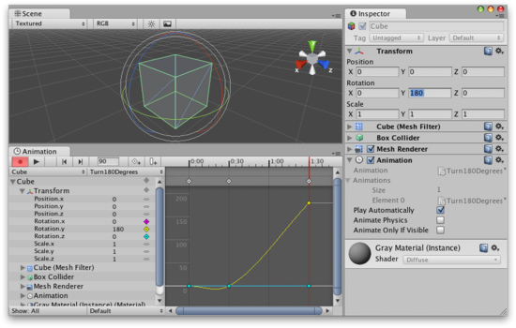

This section covers the most basic information about using the **Animation View**. This includes creating **Animations Clips** and how to edit them using the **Animation Mode**. 本节包括有关使用动画视图最基本的资料。这包括创建动画剪辑和编辑他们如何使用动画模式。

[**Editing Animation Curves**](http://unity3d.com/support/documentation/Components/animeditor-AnimationCurves.html) **编辑动画曲线**

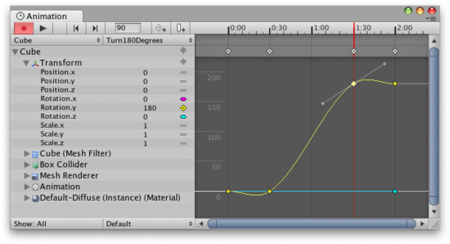

This section covers how to add and edit **Animation Curves** directly in the **Animation View**. This includes creating Animation Curves, creating and moving **keys** and **keyframes**, and editing **tangents** and tangent types.

这一节介绍如何添加和直接编辑动画曲线在动画视图里。这包括创建动画曲线，创建和移动键和关键帧，并编辑切线和切线类型。

[**Objects with Multiple Moving Parts**](http://unity3d.com/support/documentation/Components/animeditor-MultipleParts.html) **对象的多个移动部件**

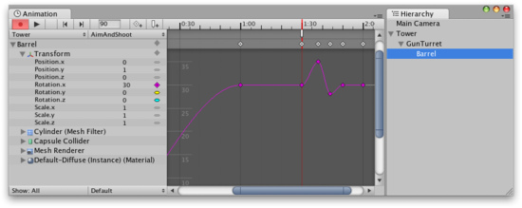

This section covers how to animate **Game Objects** with multiple moving parts and how to handle cases where there is more than one **Animation Component** that can control the selected **Game Object**. 本节介绍如何动画游戏对象的多个运动部件，以及在有一个以上的动画组件可以控制选定的游戏对象的情况下如何处理。

[**Using Animation Events**](http://unity3d.com/support/documentation/Components/animeditor-AnimationEvents.html) **使用动画事件**

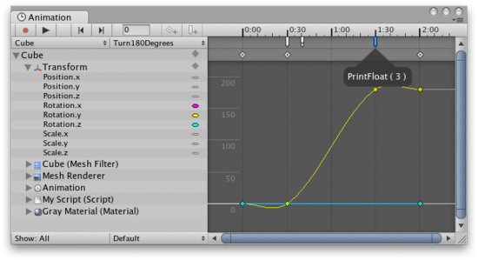

This section covers how to add **Animation Events** to an **Animation Clip**. Animation Events lets you call a script function similar to **SendMessage** as part of playing back an animation.

本节介绍如何添加一个动画事件到一个动画剪辑上。动画事件让你调用相似于SendMessage的脚本函数作为物理播放动画的一部分。

**Character Animation 角色动画**

[**Unity Manual**](http://unity3d.com/support/documentation/Manual/index.html) > [**User Guide**](http://unity3d.com/support/documentation/Manual/User%20Guide.html) > [**Creating Gameplay**](http://unity3d.com/support/documentation/Manual/Creating%20Gameplay.html) > [**Character Animation**](http://unity3d.com/support/documentation/Manual/Character-Animation.html)

Unity手册->用户指南->建立可玩性游戏->角色动画

Unity's Animation System allows you to create beautifully animated skinned characters. The Animation System supports animation blending, mixing, additive animations, walk cycle time synchronization, animation layers, control over all aspects of the animation playback (time, speed, blend-weights), mesh skinning with 1, 2 or 4 bones per vertex and finally physically based ragdolls.

Unity的动画系统允许你创建优美的动画皮肤的角色。动画系统支持动画混合，搅拌，附加的动画，步行周期时间同步，动画层，控制所有动画重放的影像（时间，速度，混合权重），1，2或4格每个顶点皮肤和骨骼最终基于物理布娃娃系统。

There are some best practices for creating a rigged character with optimal performance in Unity. It is recommended that you read about these techniques on the [Modeling Optimized Characters](http://unity3d.com/support/documentation/Manual/Modeling%20Optimized%20Characters.html) page.

在Unity里有一些最佳做法去创建一个装配最佳性能的角色。建议你阅读这些技术在[Modeling Optimized Characters](http://unity3d.com/support/documentation/Manual/Modeling%20Optimized%20Characters.html)（模型优化角色）页面。

Making an animated character involves two things; *moving* them through the world and *animating* them accordingly. 制作一个动画人物涉及两件事：在世界里移动它们并作出相应动画。

This page focuses on the animation. If you want to learn more about moving characters around (for a Super Mario Bros style game or a first-person shooter), take a look at the [Character Controller page](http://unity3d.com/support/documentation/Components/class-CharacterController.html). 本页关注于动画。如果你想了解更多有关角色的移动，（例如超级马里奥兄弟式的游戏或第一人称射击），关注Character Controller（角色控制）页面。

If you like, quickly jump to one of the topics covered on this page: 如果你喜欢，快速跳转到这个网页上所涉及的主题之一：

* [Importing Character Animations](http://unity3d.com/support/documentation/Manual/Character-Animation.html#ImportAnim#ImportAnim) 导入角色动画
  + [Animation Splitting](http://unity3d.com/support/documentation/Manual/Character-Animation.html#ImportSplit#ImportSplit) 动画分离
  + [Multiple Files](http://unity3d.com/support/documentation/Manual/Character-Animation.html#ImportFile#ImportFile) 多个文件
  + [Inverse Kinematics](http://unity3d.com/support/documentation/Manual/Character-Animation.html#ImportIK#ImportIK) 相反运动
* [Inserting Into a Unity Scene](http://unity3d.com/support/documentation/Manual/Character-Animation.html#IntoScene#IntoScene) 插入到Unity场景里
* [Animating the Character](http://unity3d.com/support/documentation/Manual/Character-Animation.html#Animate#Animate) 动画的角色
  + [Animation Blending](http://unity3d.com/support/documentation/Manual/Character-Animation.html#AnimBlend#AnimBlend) 动画混合
  + [Animation Layers](http://unity3d.com/support/documentation/Manual/Character-Animation.html#AnimLayers#AnimLayers) 动画层
  + [Additive Animation](http://unity3d.com/support/documentation/Manual/Character-Animation.html#LayerExample#LayerExample) 附加物动画

You can download an [example demo](http://www.unity3d.com/examples/index.html) showing pre-setup animated characters [here](http://www.unity3d.com/examples/index.html).

你可以下载实例演示放映每一步设置动画角色在这里。

**Importing The Animations 导入动画**

First of all we have to import the character. Unity natively imports Maya (.mb or .ma) files, Cinema 4D (.c4d) files, and fbx files which can be exported from most animation packages. Click here to learn how to [export from your modelling/animation package](http://unity3d.com/support/documentation/Manual/HOWTO-importObject.html). 第一步我们必须导入角色。Unity原始支持导入Maya（.mb 或 .ma）文件，Cinema 4D (.c4d)文件，以及fbx文件，可以被导出从许多动画包里。点击这里去学习如何导出从你的模型/动画包里。

**Importing Animations using Animation Splitting使用动画分离导入动画**

The most convenient way for animators to work is to have a single model containing all animations. When importing the animated model, you can define which frames make up each part of the animation. Unity will automatically split the animation into the individual parts, called **Animation Clips**.

对于动画师的工作，最方便的方法就是有一个单一的模式包含所有的动画。当导入动画模型，可以定义帧，构成每个动画的一部分。Unity将自动分割动画到各个部分里，称为动画剪辑。

For example: 例如：

* walk animation during frames 1 - 33 走动动画帧在1~33之间
* run animation during frames 41 - 57 跑动动画帧在41~57之间
* kick animation during frames 81 - 97 急冲动画帧在81~97之间

To import the animations you simply place the model in the **Assets** folder of your project. Unity will now automatically import it. Highlight it in the **Project View** and edit the **Import Settings** in the **Inspector**.

要导入动画你仅放置模型在你的项目里的Assets文件里。Unity现在将自动导入它。突出显示它在项目视图里，并编辑导入设置在检视器里。

*The Import Settings Dialog for a mesh 一个网格导入设置对话框*

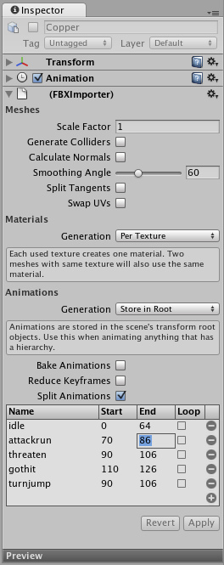

In the Import Settings, the **Split Animations** table is where you tell Unity which frames in your asset file make up which Animation Clip. The names you specify here are used to activate them in your game.

在导入设置里，拆分动画是你告诉在你的资产文件里组成Unity的框架的动画剪辑。你这里指定的名称是用来激活在你的游戏里。

|  |  |
| --- | --- |
| **Name**  **名称** | Defines the Animation Clip's name within Unity.  在Unity里定义动画剪辑的名称 |
| **first frame**  **第一帧** | The first frame of the animation. The frame number refers to the same frame as in the 3D program used to create the animation.动画的第一个帧。帧编号指引同样的帧作为在3D程序里用于创建动画。 |
| **last frame**  **最后一帧** | The last frame of the animation.动画的最后一帧。 |
| **loop frame**  **循环帧** | If enabled, an extra **loop frame** is inserted at the end of the animation. This frame matches the first frame in the clip. Use this if you want to make a looping animation and the first & last frames don't match up exactly.如果启用，附加的循环帧被被插入到动画的最后。这个帧相对于第一帧在剪辑里。使用这个如果你想去做一个循环的动画并且第一和最后帧正确的匹配。 |

**Importing Animations using multiple model files 使用多个模型文件导入动画**

The other way to import animations is to follow the @ animation naming scheme. You create separate model files and use this naming convention: 'model name'@'animation name'.fbx

另一种是导入动画方法是遵循@动画命名方案。你创建各自的模型文件，并使用这个命名约定：’模型名称’@’动画的名字’.fbx。

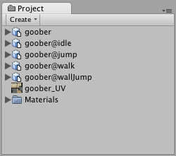

*An example of four animation files for an animated character* 四个动画文件例子为一个动画角色

Unity automatically imports all four files and collects all animations to the file without the @ sign in. In the example above, the goober.mb file will be set up to reference idle, jump, walk and wallJump automatically.

Unity自动导入所有的四个文件，收集所有动画到没有@符号注册的文件。在上面的例子里，goober.mb文件将被设置为基准空闲，跳，步行和自动的步跳。

**Importing Inverse Kinematics导入逆向运动**

When importing animated characters from Maya that are created using IK, you have to check the **Bake IK & simulation** box in the Import Settings. Otherwise, your character will not animate correctly.

当从玛雅导入动画角色被用于创建使用使用，你必须检查**Bake IK**和**simulation（**模拟）在导入设置框中。否则，你的角色不会正确动画。

**Bringing the character into the Scene 带入角色到场景里**

When you have imported your model you drag the object from the Project view into the **Scene View** or **Hierarchy**. 当你已经导入你的模型，你可以从项目视图里拖拽这个对象到场景里或层次里。

*The animated character is added by dragging it into the scene 动画角色通过拖拽添加到场景里。*

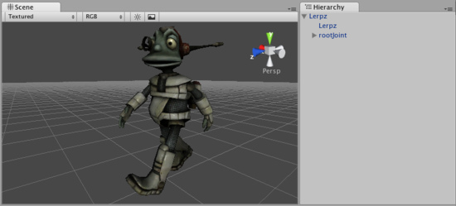

The character above has three animations in the animation list and no default animation. You can add more animations to the character by dragging animation clips from the Project View on to the character (in either the Hierarchy or Scene View). This will also set the default animation. When you hit Play, the default animation will be played. 上面角色有三个动画在动画列表中，并没有默认的动画。你可以添加更多的动画到角色，通过从项目视图动里拖动画剪辑到角色上（无论是在层次里和场景视图里）。这将设置默认动画。当你打游戏，默认的动画将播放。

TIP: You can use this to quickly test if your animation plays back correctly. Also use the **Wrap Mode** to view different behaviors of the animation, especially looping. 提示：你可以用它来快速测试，如果你的动画回放正确。还可以使用换行模式，以查看不同的行为动画的，特别是循环。

**Animating the Character 动画角色**

The actual animating of characters is done through Unity's scripting interface. 现实的角色动画是通过Unity的脚本界面完成。

**Animation Blending 动画混合**

In today's games, animation blending is an essential feature to ensure that characters have smooth animations. Animators create separate animations, e.g. a walk cycle, run cycle, idle animation or shoot animation. At any point in time in your game you need to be able to transition from the idle animation into the walk cycle and vice versa. Of course you don't want any sudden jumps in the motion, you want the animation to smoothly transition.

在今天的游戏里，动画融合是一个重要的功能，确保了平滑的动画人物。动画师创建单独的动画，例如：走动周期，跑动周期，空闲动画或射击动画。在你游戏里的任何时间点，你需要能够从空闲动画进入走动循环，反之亦然。当然，你不想在运动状态里任何突然的跳跃，你想动画平滑的过渡。

This is where animation blending comes in. In Unity you can have an arbitrary amount of animations playing on the same character. All animations are blended or added together to generate the final animation.

这是动画混合带来的。在Unity里，你可以有任意数量的动画在同样的角色上利用。所有的动画混合或相加去产生最后的动画。

Our first step will be to make a character smoothly blend between the idle and walk animations. In order to make our job simpler when scripting, we will first set the **Wrap Mode** of the animation to **Loop**. Then we will turn off **Play Automatically** to make sure our script is the only one playing animations.

我们的第一步，是要在一个角色在空闲与步行动画之间平滑混合。为了使我们的工作更简单当用脚本时，我们会首先设置动画的换行模式到循环模式。然后，我们将关闭自动播放，以确保我们的脚本是唯一的播放动画。

Our first script for animating the character is quite simple; we only need some way to detect how fast our character is moving, and then fade between walk and idle animation. For this simple test we use the pre-setup input axes. 我们对动画人物第一个脚本很简单，我们只需要一些方法来检测我们的角色如何快速移动，然后在步行与空闲动画之间逐渐衰减。对于这个简单的测试中，我们使用预先设置的输入轴。

function Update ()

{

if (Input.GetAxis("Vertical") > 0.2)

animation.CrossFade ("walk");

else

animation.CrossFade ("idle");

}

To get this script running: 获得脚本的运行：

1. Create a javascript using **Assets->Create Other->Javascript**. 建立一个Javascript 使用**Assets->Create Other->Javascript**
2. Copy & Paste the code into it 复制与粘贴代码到它里面。
3. Drag the script onto the character (It needs to be the same **GameObject** as the animation) 拖动脚本到角色里（它需要同样的GameObject作为动画）

When you hit the Play button, the character will start walking in place when you hold the up arrow key and return to the idle pose when you release it. 当你点击播放按钮，角色将开始在适当的位置行走当你按住向上键并且当你释放它时返回空闲姿态。

**Animation Layers 动画层**

Layers are an incredibly useful concept that allow you to group animations and prioritize weighting. 层是一个非常有用的概念，允许你组合动画和优化比重。

In Unity's animation system, you can blend between as many animation clips as you want. You can assign blend weights manually or simply use **animation.CrossFade()**, which will animate the weight automatically.

在Unity的动画系统里，你可以在你希望的与任意多的动画剪辑之间的混合。你可以手工指定混合比重或简单使用**animation.CrossFade()**，将自动的比重动画。

**Blend weights are always normalized before being applied混合权重总是规范化在应用之前**

Let's say you have a walk cycle and a run cycle, both have a weight of 1 (100%). When Unity generates the final animation it will normalize the weights, which means walk will contribute 50% to the animation, the run cycle will also contribute 50%. 假设你有一个步行周期和运行周期，都有一个比重为1（100％）。当Unity生成最终动画它将规范化比重，这意味着步行将贡献出50％的动画，运行周期也将贡献出50％。

This is all very nice, but often you want to prioritize which animation receives most weight when there are two animations playing. Surely you could just make sure that the weight sums up to 100% manually, but it is a lot easier to use layers for this purpose. 这是非常好的，但是往往你要优先考虑的动画得到最高比重，当有两个动画播放时。当然你可以只确保比重手工加权到100％，但它是一个更容易用于此目的层。

**Layering Example 层的例子**

As an example, you might have a shoot animation, an idle and a walk cycle. You will want to continously fade between the walk and idle animation based on the player's speed. But when the player shoots you want to only show the shoot animation. Thus the shoot animation essentially has a higher priority. 一个例子，你也许有一个射击动画，一个空闲和一个走动周期。你想不断的在行走和空闲动画之间的基础上逐渐衰减玩家的速度。但当玩家射击时，你只想显示射击动画。然而，射击动画实质上有一个高的优先。

The easiest way to do this is to simply keep playing the walk and idle animations while shooting. Then we need to make sure that the shoot animation is in a higher layer than idle and walk. This means the shoot animation will receive blend weights first. The walk and idle animation will receive weights only if the shoot animation doesn't use all of the 100% blend weights. So when CrossFading the shoot animation in, the weight will start out at zero and over a short period become 100%. In the beginning the walk and idle layer will still receive blend weights but when the shoot animation is completely faded in, they will receive no weights at all. This is exactly what we need! 最简单的方法实现这一点是简单地保持播放步行和闲置动画在射击过程中。然后，我们需要确保在射击动画比空闲和步行处于更高层。这意味着射击动画将获得混合权重第一。步行和空闲的动画将获得比重只有在射击动画不使用时的100％的混合权重。因此，当交叉衰减射击动画时，比重在开始时会在零和在短期内变成100％。在开始步行和空闲层仍然会收到混合比重，但在射击动画时完全增强时，它们将根本没有获得比重。这正是我们所需要的！

function Start ()

{

// Set all animations to loop

animation.wrapMode = WrapMode.Loop;

// except shooting

animation["shoot"].wrapMode = WrapMode.Once;

// Put idle and walk into lower layers (The default layer is always 0)

// This will do two things

// - Since shoot and idle/walk are in different layers they will not affect

// each other's playback when calling CrossFade.

// - Since shoot is in a higher layer, the animation will replace idle/walk

// animations when faded in.

animation["shoot"].layer = 1;

// Stop animations that are already playing

//(In case user forgot to disable play automatically)

animation.Stop();

}

function Update () {

// Based on the key that is pressed,

// play the walk animation or the idle animation

if (Mathf.Abs(Input.GetAxis("Vertical")) > 0.1)

animation.CrossFade("walk");

else

animation.CrossFade("idle");

// Shoot

if (Input.GetButtonDown ("Fire1"))

animation.CrossFade("shoot");

}

By default the **animation.Play()** and **animation.CrossFade()** will stop or fade out animations that are in the same layer. This is exactly what we want in most cases. In our shoot, idle, run example, playing idle and run will not affect the shoot animation and vice versa (you can change this behaviour with an optional parameter to animation.CrossFade if you like). 默认情况下，在同一层中animation.Play()和animation.CrossFade()将停止或淡出动画。这正是我们在大多数情况下希望。在我们的射击、空闲、运行的例子里，播放空闲和运行不会影响射击动画，反之亦然（如果你喜欢,你可以改变一个可选参数到animation.CrossFade()）。

**Additive Animations and Animation Mixing 附加物动画和动画混合**

Additive Animations and Animation mixing allow you to cut down on the number of animations you have to create for your game, and are important for creating facial animations. 附加物动画和混合动画让你减少你必须为你游戏创建的动画的编号，为创建面部动画是重要的。

Let's say you want to create a character that leans to the sides when running and turning. 假设你要创建一个角色，倾向于侧面当运行和转弯时。

You already made a walk and run cycle, now you could make individual walk-lean-left, walk-lean-right, run-lean-left, run-lean-right animations. 你已经作出了步行和运行周期，现在可以进行个别左右行走动画。

But that means you just quadrupled the amount of animation work! Creating a huge amount of animations is not feasiable. Additive animations and Mixing to the rescue! 但是，这意味着你四倍的动画作品数量！创建大量的动画不可行的。附加物动画和混合去挽救！

**Additive Animation Example 附加物动画例子**

Additive animations allow you to overlay the effects of animation on top of any others that may be playing. When making additive animations, Unity will calculate the difference between the first frame in the animation clip and the current frame. Then it will apply this difference on top of all other playing animations.

附加物动画让你覆盖的任何其他可能扮演的顶部动画效果。当创建附加物动画时，Unity将计算出的动画剪辑的第一帧与当前帧之间的差异，然后，将应用于这个不同在所有其它播放动画的上方。

Now you only have to make a lean-left and lean-right animation. Unity will then layer this animation on top of the walk, idle or run cycle. 现在你只需要作一个精简左和精益右的动画。然后Unity层次这个动画在行走、空闲或运行周期的顶部。

Here is the code to make that happen: 这里是实现这一目标的代码：

private var leanLeft : AnimationState;

private var leanRight : AnimationState;

function Start ()

{

leanLeft = animation["leanLeft"];

leanRight = animation["leanRight"];

// Put the leaning animation in a separate layer

// So that other calls to CrossFade won't affect it.

leanLeft.layer = 10;

leanRight.layer = 10;

// Set the lean animation to be additive

leanLeft.blendMode = AnimationBlendMode.Additive;

leanRight.blendMode = AnimationBlendMode.Additive;

// Set the lean animation ClampForever

// With ClampForever animation's will not automatically

// stop when reaching the end of the clip

leanLeft.wrapMode = WrapMode.ClampForever;

leanRight.wrapMode = WrapMode.ClampForever;

// Enable the animation and fade it in completely

// We don't use animation.Play here because we manually adjust the time

// in the Update function.

// Instead we just enable the animation and set it to full weight

leanRight.enabled = true;

leanLeft.enabled = true;

leanRight.weight = 1.0;

leanLeft.weight = 1.0;

// For testing just play run animation and loop it

animation["walk"].wrapMode = WrapMode.Loop;

animation.Play("walk");

}

// Every frame just set the normalized time

// based on how much lean we want to apply

function Update ()

{

var lean = Input.GetAxis("Horizontal");

// normalizedTime is 0 at the first frame and 1 at the last frame in the clip

leanLeft.normalizedTime = -lean;

leanRight.normalizedTime = lean;

}

Tip: When using Additive animations it is critical that you are also playing some other non-additive animation on every transform that is also used in the additive animation, otherwise the animations will add on top of the last frame's result. This is most certainly not what you want. 提示：使用它至关重要的是，你也播放一些诶其它非附加物的动画在每个的转换上，也用于附加物动画，否则动画将增加最后一帧的结果上。这肯定不是你想要的。

**Procedurally animating characters 程序上的动画角色**

Sometimes you want to animate the bones of your character procedurally. For example you might want the head of your character to look at a specific point in 3D space. This is best done with a script. Fortunately, Unity makes this very easy. In Unity all bones are just Transforms which drive the skinned mesh. Thus you can script bones of a character just like any other GameObject. 有时你想你的角色程序上的极点动画。例如，你可能想对你的角色头部去看一个特定的点在三维空间中。这是利用脚本最好做的。幸运的是，Unity使这个非常容易。在Unity里所有的骨骼只是变换哪个驱动器的皮肤。这样你可以一个角色的骨骼脚本就像任何其它的GameObject。

One important thing to know is that the animation system updates the Transforms after the **Update()** function and before the **LateUpdate()** function is called. Thus if you want to do a **LookAt()** function you should do that in **LateUpdate()** to make sure that you are really overriding the animation. 一个重要的事情知道的是，动画系统更新变换在**Update()**函数调用之后，并在LateUpdate（）函数被调用之前。因此，如果你想要做LookAt（）函数，你应该在LateUpdate（）做，以确保你真正覆盖动画。

Ragdolls are created in the same way. You simply have to attach Rigidbodies, Character Joints and Capsule Colliders to the different bones. This will then physically animate your skinned character. Ragdolls以同样的方式创建。你只需附上刚体，角色链接和关节碰撞器到不同的骨骼。这将为你的身体上动画你的皮肤角色。

**Finally 最后**

You have learned how to make a basic character animation please see the [projects](http://www.unity3d.com/examples) for in-depth examples of character animation and the [animation script interface](http://unity3d.com/support/documentation/ScriptReference/Animation.html). 你必须学会如何使一个基本的角色动画，请参见项目中的角色动画和动画脚本接口深入的例子。

**Sound 声音**

[**Unity Manual**](http://unity3d.com/support/documentation/Manual/index.html) > [**User Guide**](http://unity3d.com/support/documentation/Manual/User%20Guide.html) > [**Creating Gameplay**](http://unity3d.com/support/documentation/Manual/Creating%20Gameplay.html) > [**Sound**](http://unity3d.com/support/documentation/Manual/Sound.html)

Unity手册->用户指南->建立可玩性游戏->声音

**Audio Listener 音频侦听器**

The **Audio Listener** acts as a microphone-like device. It receives input from any given [Audio Source](http://unity3d.com/support/documentation/Components/class-AudioSource.html) in the scene and plays sounds through the computer speakers. It is traditionally attached to the Main [Camera](http://unity3d.com/support/documentation/Components/class-Camera.html).

音频侦听器充当麦克风这样的设备。在场景里它接收受任音频源输入并通过计算机扬声器 播放。这是传统上附加到主照相机的。

*The Audio Listener, attached to the Main Camera 一个音频侦听器， 被附加到主摄像机*

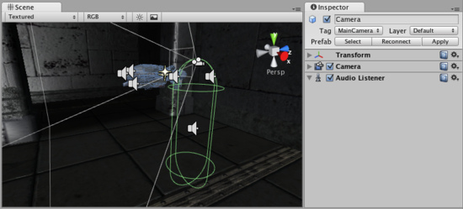

**Properties 属性**

The Audio Listener has no properties. It simply must be added to work. It is always added to the Main Camera by default. 音频侦听器没有属性。它仅必须被添加到工作。它总是被默认的添加到主摄像机。

**Details 详细资料**

The Audio Listener works in conjunction with [Audio Sources](http://unity3d.com/support/documentation/Components/class-AudioSource.html), allowing you to create the aural experience for your games. When the Audio Listener is attached to a **GameObject** in your scene, any Sources that are close enough to the Listener will be picked up and output to the computer's speakers. Each scene can only have 1 Audio Listener to work properly. 音频侦听器与音源协同工作，允许你创建你的游戏听觉体验。当音频侦听器是连接到一个在你场景里的GameObject时，任何足够接近侦听器的源将将被捡起并输出到计算机的扬声器。每个场景只能有1音频监听器去正常的工作。

As long as the Sources are in mono format, the Listener will automatically position the sound correctly in the stereo field, at the correct volume. Stereo Sources will automatically play in both speakers. For example, if your character walks off a street into a night club, the night club's music should probably be stereo, while the individual voices of characters in the club should be mono with their realistic positioning being handled by Unity.

只要来源是单声道格式，侦听器会自动正确的定位声音在立体声区段里，调整正确的音量。立体声源将自动发挥两个扬声器。例如，如果你的角色离开街道到一家夜总会里，在夜总会的音乐应该是立体声，而角色在俱乐部里的个人的声音应该是单声道，与它们当时的实际位置单被Unity处理。

You should attach the Audio Listener to either the Main Camera or to the GameObject that represents the player. Try both to find what suits your game best. 你应该附加音频侦听器到任何一个的主摄像机或GameObject代表的玩家。尝试发现适合你游戏的最好的方式。

**Hints 提示**

* Each scene can only have one Audio Listener. 每个场景只能有一个音频侦听器。
* You access the project-wide audio settings using the [Audio Manager](http://unity3d.com/support/documentation/Components/class-AudioManager.html), found in the **Edit->Project Settings->Audio** menu. 你访问的音频设置项目范围使用音频管理器，发现在**Edit->Project Settings->Audio 菜单里。**
* View the [Audio Clip](http://unity3d.com/support/documentation/Components/class-AudioClip.html) Component page for more information about Mono vs Stereo sounds.
* 查看音频剪辑组件页获得更多关于单声道与立体声。

**Audio Source 音频源**

The **Audio Source** takes an [Audio Clip](http://unity3d.com/support/documentation/Components/class-AudioClip.html) and plays it from a position in the world. 音频源携带一个音频剪辑并从世界的一个位置播放它。

*The Audio Source in the* ***Scene View*** *and* ***Inspector音频源在场景里和检视器***

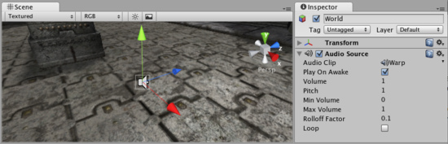

**Properties 属性**

|  |  |
| --- | --- |
| **Audio Clip**  **音频剪辑** | Reference to the sound clip file that will be played  引用将被播放的声音剪辑文件。 |
| **Play On Awake**  **播放唤醒** | If enabled, the sound will start playing the moment the scene launches. If disabled, you need to start it using the **Play()** command from scripting.  如果启用，声音将开始播放在场景启动的那一刻。如果禁止，你需要去开始它从脚本使用**Play()命令。** |
| **Volume**  **音量大小** | How loud the sound is at a distance of 1 world unit (1 meter) from the **Audio Listener**.  从音频监听器声音如何响亮是在世界的1单位（1米）的远处。 |
| **Pitch**  **音调** | Amount of change in pitch due to slowdown/speed up of the **Audio Clip**. Value 1 is normal playback speed. 在音调里的变化量由于放缓/加快音频剪辑。值1是正常的播放速度。 |
| **Min Volume**  **最小音量** | The minimum value of the sound. No matter how far away you get, the sound will not get softer than this value.  声音的最低值。无论距离多远你的声音不会得到比这个值柔和。 |
| **Max Volume**  **最大音量** | How loud the sound gets at the loudest. No matter how close you get, the sound will never get louder than this value.  如何响亮的声音得到最响亮。无论你如何接近，声音将永远不会得到超过此值。 |
| **Rolloff Factor**  滚降系数 | How fast the sound fades. The higher the value, the closer the Listener has to be before hearing the sound.  如何快速声音淡出。数值越高，必须先听到这种声音之前越接近监听器。 |
| **Loop**  **循环** | Enable this to make the **Audio Clip** loop when it reaches the end.  启用这个使音频剪辑循环当它到达时结束。 |

**Creating Audio Sources 建立音频源**

Audio Sources don't do anything without an assigned **Audio Clip**. The Clip is the actual sound file that will be played back. The Source is like a controller for starting and stopping playback of that clip, and modifying other audio properties. 音源不这样做没有任何指定的音频剪辑。剪辑是实际的声音文件将被播放。源就像是音频剪辑启动和停止播放的控制器以及修改其他音频属性。

To create a new Audio Source: 建立一个新的音源：

1. Import your audio files into your Unity Project. These are now Audio Clips. 导入你的音频文件到你Unity项目了。有些新的音频剪辑。
2. Go to **GameObject->Create Empty** from the menubar. 从菜单条执行**GameObject->Create Empty**
3. With the new GameObject selected, select **Component->Audio->Audio Source**. 选取新的GameObjext，选择**Component->Audio->Audio Source**
4. Assign the **Audio Clip** property of the Audio Source Component in the Inspector. 在检视器里指定音频源组件的音频剪辑属性

**Hints 提示**

* The key to a nice sound environment is tweaking the **Rolloff Factor**.良好声音环境的关键是调整的滚降系数。
* 3D audio effects will only work for mono Audio Clips. Stereo Audio Clips will be mixed as-is into the sound output. 3D音频效果只对单声道音频剪辑工作。立体声音频剪辑将混入到声音输出。

**Audio Clip 音频剪辑**

**Audio Clips** are used by [Audio Sources](http://unity3d.com/support/documentation/Components/class-AudioSource.html) to represent the audio asset imported into Unity. Unity supports both Mono and Stereo audio assets. Unity supports importing the following audio file formats: **.aif**, **.wav**, **.mp3**, and **.ogg**. 音频剪辑所使用的音源代表音频资产导入到Unity里。Unity同时支持单声道和立体声音频资产。Unity支持导入以下音频文件格式：.AIF、.Wav、.MP3和 .ogg。

*The Audio Clip* ***Inspector 音频剪辑检视器***



**Properties 属性**

|  |  |
| --- | --- |
| **Audio Format**  **音频格式** | The specific format that will be used for the sound at runtime.  具体格式将声音在运行时使用。 |
| **Native**  **原始的** | Larger file size, higher quality. Best for very short sound effects.  较大的文件大小，质量更高。很短的最佳音响效果。 |
| **Compressed**  **压缩的** | Smaller file size, lower/variable quality. Best for medium length sound effects and music.  较小的文件尺寸，降低/质量参差不齐。中等长度的最佳音效和音乐。 |
| **3D Sound**  **3D声音** | If enabled, the sound will play back in 3D space. In Unity 2.6, both Mono and Stereo sounds can be played in 3D  如果启用，将播放声音在三维空间里。在Unity2.6里，单声道和立体声都可以播放的声音在三维里。 |
| **Force to mono**  **强制单声道** | If enabled, the stereo audio clip will be condensed to a single channel mono sound.  如果启用，立体声音频剪辑将简化为单一通道单声道。 |
| **Decompress On Load**  **本地解压** | If enabled, this clip will be loaded into memory as soon as the scene containing it is loaded. It is suggested that you leave this on, otherwise your game may have reduced performance as the sound is decompressed real-time at runtime.  如果启用，这个剪辑将被加载到内存中只要场景里含有它就被加载。它建议你留下这个，否则，你的游戏可能减少的性能，声音是在运行时实时解压缩。 |
| **Compression**  **压缩** | Amount of Compression to be applied to a **Compressed** clip. Statistics about file size can be seen beneath the slider. It is suggested to drag the slider to a place that leaves the playback "good enough" but still at a small enough size to meet your file size/distribution needs.  压缩量将适用于压缩剪辑。统计有关文件的大小可以看到下面的滑块。它建议拖动滑块到一个地方，离开播放“足够好”，但在一个足够小的尺寸仍然以满足你的文件大小/分配需要。 |

**Importing Audio Assets 导入音频资产**

Unity supports both Compressed and Uncompressed Audio. Any type of file except .mp3 will be initially imported as Uncompressed. MP3 and Compressed audio files must be decompressed by the CPU while the game is running, but are smaller in file size. Native formats have the benefit of being higher fidelity without increasing CPU taxation, but create much larger files. Unity同时支持压缩和非压缩音频。任何类型的文件处除了.MP3播放将作为压缩导入.MP3和压缩的音频文件必须由CPU解压在游戏运行中，但文件小。本机格式在被高保真没有增加负担的CPU，而是建立更大的文件。

As a general rule of thumb, Compressed audio is best for long files like background music or dialog, and uncompressed is better for short sound effects that are under two seconds. However...

作为一般原则，压缩音频是对长文件最好的就像背景音乐或对话框，解压是对在两秒钟短音乐效果是好的。然而...

**If you are creating a web player game, you should Compress as much of your audio as possible.** This will help you attain the smallest file size for webplayer downloads. If you tweak the amount of Compression, the difference in sound quality won't be noticeable. 如果你要创建一个网络游戏的玩家，你应该为你的压缩尽可能多的音频。这将帮助你实现最小的WEPPLAYER下载文件的大小。如果你修改的压缩量，音质的差异不会明显。

**Using 3D Audio 使用3D音频**

If an audio clip is marked as a **3D Sound** then it will be played back to simulate its position in the game world's 3D space. 3D sounds simulate distance and location of sounds by fading volume and panning across speakers. Unity supports 3D audio, and any stereo or mono clip can be played back in 3D space. However, mono 3D sounds are the most common. 如果音频剪辑是明显的3D声音，然后将播放到模拟其在游戏世界的三维空间位置。三维模拟远处和本地的声音通过衰减量和交叉移动麦克风。Unity支持3D音频，任何剪辑立体声或单声道可以被播放在三维空间里。不过，单声道3D声音是最常见的。

**Loading Compressed Audio装入压缩音频**

Compressed audio files have an option to choose when the Clip will be decompressed. The option is set in the Import Settings: 压缩音频文件有一个选项去选择当剪辑被解压缩时。该选项在导入设置里被设置：

|  |  |
| --- | --- |
| **Decompress On Load** enabled 在装入时启用解压 | Decompress and load the Clip into RAM when the player is loading. 解压并装入剪辑到内存当玩家被装载时。 |
| **Decompress On Load** disabled (Live decompression) 在装入时禁用解压（现场解压） | Decompress and play the Clip real-time when the Clip is triggered to start. 解压并实时播放解压当剪辑被触发去启动时 |

Decompressing on load is the most commonly used option, and shouldn't really be disabled unless you have a special case. It means that the levels containing the Clip will take longer to load initially, and it will use up more of the end-user's RAM. Live decompression does not load the Clip data into RAM at level load. Instead, it requires the CPU to decompress the sound real-time. This means it is more CPU intensive rather than RAM intensive. 在装入时解压缩是最常用的选项，实际上不应被禁用，除非你有特殊情况。这意味着，最初各级包含的剪辑将需要更长的时间来加载，它会使用更多最终用户的内存。现场解压不加载剪辑数据到内存在装入级别。相反，它需要CPU来实时解压缩声音。这意味着它是要更多加强的CPU这样与其倒不如密集的内存型。

To summarize, enable decompression on load as much as possible, and definitely for all short Clips. Pick live decompression for longer Clips like music tracks. All Ogg Vorbis Clips using live decompression will increase CPU usage. It can use a substantial amount of CPU to live decompress multiple Clips at once, so you should avoid playing more than 2 live decompression Clips at once. 总之，尽可能的在加载时启用解压，并明确所有短剪辑。挑选喜欢的音乐曲目长剪辑现场解压。 所有的Ogg Vorbis的剪辑使用现场解压会增加CPU使用率。它可以使用大量的CPU去现场一次解压缩多个剪辑，所以你应该避免播放一次超过2个现场解压剪辑。

**Game Interface Elements 游戏界面元素**

[**Unity Manual**](http://unity3d.com/support/documentation/Manual/index.html) > [**User Guide**](http://unity3d.com/support/documentation/Manual/User%20Guide.html) > [**Creating Gameplay**](http://unity3d.com/support/documentation/Manual/Creating%20Gameplay.html) > [**Game Interface Elements**](http://unity3d.com/support/documentation/Manual/Game%20Interface%20Elements.html)

Unity手册->用户指南->建立可玩性游戏->游戏界面元素

To create interface elements for your game, you have some options to choose from. You can use [GUI Text](http://unity3d.com/support/documentation/Components/class-GuiText.html) and [GUI Texture](http://unity3d.com/support/documentation/Components/class-GuiTexture.html) objects, or you can use **UnityGUI**. UnityGUI is the Interface Scripting system introduced in Unity 2.0. 建立界面元素为你的游戏，你有一些选项可供选择。你可以使用GUI文本和GUI的纹理对象，或也可以使用Unity GUI。 UnityGUI是界面脚本系统引入到Unity2.0里。

The rest of this page contains a detailed guide for getting up and running with UnityGUI.

本页面的其余部分包含一个详细指南为学习和运行UnityGUI。

**GUI Scripting Guide GUI脚本指南**

**Overview 概述**

GUI stands for Graphical User Interface. Unity's GUI system is called **UnityGUI**. UnityGUI allows you to create a huge variety of GUIs complete with functionality very quickly and easily. Rather than creating a GUI object, manually positioning it, and then writing a script that handles its functionality, you do all of this at once in a small amount of code. This works by creating GUI **Controls**, which are instantiated, positioned, and defined all at once.

GUI（图形用户界面）代表图形用户界面。Unity的GUI系统被称为UnityGUI。 UnityGUI允许你非常快捷方便创建一个完整的功能的种类繁多图形用户界面。而不是创建一个GUI对象，手动定位它，然后编写一个脚本来处理它的功能，你能一次做这一切在一个少量的代码里。通过创建图形用户界面控制，这是实例化，并立即定义所有。

For example, the following code will create a fully functional button from scratch:

例如，下面的代码将从零开始创建一个完整的功能按钮：

function OnGUI () {

if (GUI.Button (Rect (10,10,150,100), "I am a button")) {

print ("You clicked the button!");

}

}

*This is the button created by the code above 通过上面的代码创建的按钮。*

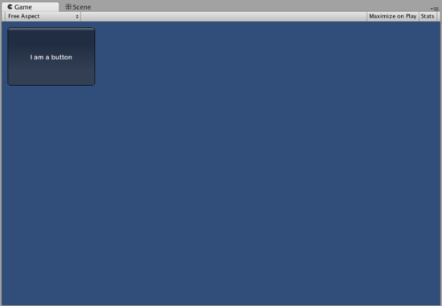

Although this example is very simple, there are very powerful and complex techniques available for use in UnityGUI. It is a broad subject, and the following sections will help you get up to speed as quickly as possible. This guide can be read straight through, or used as reference material. 虽然这个例子很简单，有非常强大和复杂的技术，在UnityGUI里使用。这是一个广泛的主题，以下各节将帮助你尽快加快速度。本指南可以直接通过阅读，或作为参考材料。

[**UnityGUI Basics**](http://unity3d.com/support/documentation/Components/gui-Basics.html) **UnityGUI基础**

This section covers the important concepts of UnityGUI, giving you an overview as well as a bunch of working examples you can paste into your own projects. UnityGUI is very friendly to play with, so this is a good place to get started. 本节涵盖UnityGUI的重要概念，为你提供的概述以及一堆的工作的例子，你可以粘贴到自己的项目里。 UnityGUI是非常友好的处理，所以这是一个好地方开始。

[**Controls**](http://unity3d.com/support/documentation/Components/gui-Controls.html) **控制**

This section lists every available Control in UnityGUI. It is complete with code examples and images.

本节列出每一个可用的控制在UnityGUI里。这是完整的代码实例和图片。

[**Customization**](http://unity3d.com/support/documentation/Components/gui-Customization.html) **定制**

Creating functional GUI controls would not be as useful if their appearances couldn't be customized. Thankfully, we've thought of this. All controls in UnityGUI can be customized with **GUIStyles** and **GUISkins**. This section explains how to use them.

创建GUI控制的功能将不会被视为有用的，如果他们的外表不能定制。谢天谢地，我们已经想到了这一点。在UnityGUI里的所有控制可定做GUIStyles和GUISkins。本节说明如何使用它们。

[**Layout Modes**](http://unity3d.com/support/documentation/Components/gui-Layout.html) **布局模型**

UnityGUI features two ways to arrange your GUIs. You can manually place each control on the screen, or you can use an Automatic Layout system which works a lot like HTML tables. Using one system or the other is as simple as using a different class, and you can mix the two together. This section explains the functional differences between the two systems, including examples.

UnityGUI的特性两种方式来安排你的图形用户界面。你可以手动地在屏幕上放置每个控制，也可以使用很多像HTML表格自动布局系统的工作方式。使用一个系统或其他很简单的使用不同的类，并且可以将两者混为一谈。本节说明两个系统之间包括实例性能上的差异。

[**Extending UnityGUI**](http://unity3d.com/support/documentation/Components/gui-Extending.html) **扩展UnityGUI**

UnityGUI is very easy to extend with new Control types. This chapter shows you how to make simple *compound* controls, then goes on to show you how to make a custom control - complete with integration into Unity's event system.

UnityGUI很容易扩展至新的控制类型。本章告诉你如何使简单的复合控制，然后向你展示如何使一个自定义控制-配套的集成到Unity的事件系统里。

[**Extending Unity Editor**](http://unity3d.com/support/documentation/Components/gui-ExtendingEditor.html) **扩充Unity 编辑器**

The main Unity editor is written using UnityGUI. It is completely extensible using the same code as you would use for in-game GUI. In addition, there are a bunch of Editor specific GUI widgets to help you out when creating custom editor GUI.

主要的Unity编辑器是使用UnityGUI。这是完全可扩展使用相同的代码，你会利用游戏中的图形用户界面。此外，有一些特定的GUI部件编辑小配件帮助你在创建自定义编辑器图形用户界面。

# Networked Multiplayer 网络多个玩家

# [Unity Manual](http://unity3d.com/support/documentation/Manual/index.html) > [User Guide](http://unity3d.com/support/documentation/Manual/User%20Guide.html) > [Creating Gameplay](http://unity3d.com/support/documentation/Manual/Creating%20Gameplay.html) > [Networked Multiplayer](http://unity3d.com/support/documentation/Manual/Networked%20Multiplayer.html)

# Unity手册->用户指南-> 建立可玩游戏-> 网络多个玩家

Realtime networking is a complex field, but with Unity we have made it extremely simple to achieve. However, it is still best to understand the breadth and depth involved with creating any kind of network game. This section will explain the fundamentals of networking concepts, and the Unity-specific executions of these concepts for you to use. If you have never created a network game before it is highly recommended that you read this guide in detail before attempting to create one.

实时网络是一个复杂的区域，但是有了Unity我们已经非常简单的实现。然而，最好还是了解创建任何类型的网络游戏所涉及的深度和广度。 本节将解释网络的基本概念，以及Unity具体执行这些概念为你使用。如果你从未创建一个网络游戏，强烈建议你仔细阅读本手册，在尝试创建一个网络游戏之前。

## High Level Overview 高级别概述

This section will outline all the concepts involved in networking. It will serve as an introduction to deeper topics.

本节将概述网络的所有涉及的概念。它将作为一个较深的主题介绍。

## [Networking Elements in Unity](http://unity3d.com/support/documentation/Components/net-UnityNetworkElements.html) Unity里的网络元素

This section of the guide will cover Unity's execution of the ideas discussed above.

本指南的这个章节将讨论上面所叙述的，涵盖Unity的可运行的观念。

### [RPC Details](http://unity3d.com/support/documentation/Components/net-RPCDetails.html) RPC的详细信息

RPC stands for Remote Procedure Call. It is a way of calling a function on a remote machine. This may be a client calling a function on the server, or the server calling a function on all or specific clients, etc. This page explains RPC concepts in detail.

RPC代表的远程过程调用。它是一个在远程机器上调用一个函数的方法。这将被作为一个客户端的函数调用在服务器上，或服务器调用一个函数在所有或指定的客户端上等等。本页详细解释RPC的概念。

### [State Synchronization](http://unity3d.com/support/documentation/Components/net-StateSynchronization.html) 状态同步

State Synchronization is a method of regularly updating a specific set of data across two or more game instances running on the network.

状态同步是一个定期更新两个或多个游戏在网络上运行的实例的一套具体数据的方法。

### [Minimizing Bandwidth](http://unity3d.com/support/documentation/Components/net-MinimizingBandwidth.html) 最小化带宽

Every choice you make about where and how to share data will affect the bandwidth your game uses. This page will share some details about bandwidth usage and how to keep it to a minimum.

每次选择你制定关于哪里或如何共享数据将影响你的游戏使用的带宽。本页将共享一些有关带宽使用的细节并如何保持它到一个最小值。

### [Network View](http://unity3d.com/support/documentation/Components/net-NetworkView.html) 网络视图

Network Views are Components you use to share data across the network. They are extremely important to understand. This page will explain them in detail.

网络视图是通过网络你用于共享数据的组件。它们是极其重要的了解。本页将详细讲述它们。

### [Network Instantiate](http://unity3d.com/support/documentation/Components/net-NetworkInstantiate.html) 网络实例

One difficult subject in networking is ownership of an object. Who controls what? Network Instantiation will determine this logic for you. This page will explain how to do this. It will also explain the complex alternatives, for situations when you just need more control.

在网络里一个困难的主题是一个对象的物住身份。谁控制什么？网络实例将为你确定这个逻辑。本页将说明如何做到这一点。

### [Master Server](http://unity3d.com/support/documentation/Components/net-MasterServer.html) 主服务器

The Master Server is like a game lobby where servers can advertise their presence to clients. It is also a solution to enabling communication from behind a firewall or home network. When needed it makes it possible to use a technique called NAT punchthrough (with help from a facilitator) to make sure your players can always connect with each other. This page will explain how to use the Master Server.

主服务器就像一个游戏大厅在那里服务器可以宣告它们的客户存才。它也是一个解决方案，启用通信从防火墙后面或家庭网络里。当需要它能够变成可用的技术称为NAT穿透（利用调制解调器）确信你的玩家可以总互相连接。本页将讲解如何使用主服务器。

# High Level Networking Concepts 高级别网络概念

The following information is a collection of concepts that are relevant to any kind of game network activity, and are not specific to Unity. It will be very helpful for you to understand these concepts before you begin using Unity networking.

下面的信息是一个概念，相关的任何一种游戏网络活动的集合，不是具体的Unity。这将非常有助于你理解这些概念，在你开始使用Unity的网络之前。

**What is Networking? 什么是网络**

The basic concept of networking is communication between multiple computers. To do this you need a **client** and a **server**. The server can either be a dedicated host machine for everyone, or a player running the game acting as the server for other players. Once a server has been established and a client has connected to it, the two computers can exchange data necessary for a multiplayer network game.

网络的基本概念是多个计算机之间的通信。做到这一点，你需要一个客户端与一个服务器。服务器可以是为每个人指定的主机，或一个玩家运行游戏担当其它玩家的服务器。一旦一个服务器已经被确定及一个客户端已经连接到它，两个计算机可以交换多人网络游戏所需的数据。

Creating a network game requires a lot of attention to some very specific details. Even in Unity, where most actions are easy to design and create, networking remains extremely complex. We chose to make networking in Unity very robust and flexible. This means that you as the game creator need to make a lot of choices which you normally don't have to think about. These choices will have a big effect on how you build your game, so it is best to make them as early as possible. This means learning about these concepts and planning them as much as possible, keeping long-term implications in mind.

创建一个网络游戏需要非常注意一些非常具体的细节。甚至在Unity里，在那里大多数的行为易于设计和创建，网络仍然非常的复杂。我们选择在Unity里构建网络非常健壮和灵活。这意味着，你作为游戏创建者需要作出很多选择，你通常不需要必须考虑。这些选择将会对你如何建立你的游戏有很大的影响，所以最好是让它们尽可能的快。这意味着学习这些概念和规划它们同样可能，保持长期考虑在头脑中。

**Networking Approaches 网络途径**

There are two common and proven approaches to structuring a network game. These approaches are called **Authoritative Server** and **Non-Authoritative Server**. Both approaches rely on a server connecting clients and passing information between them. Incidentally, they offer more privacy for end users since clients never actually connect directly with each other or have their IP addresses revealed to other clients.

有两个常见的和经过验证的方法来构建一个网络游戏。这些途径被称为 **授权服务器** 和 **非授权服务器**。这两种方法都依赖于一个连接的客户端和服务器之间传递的信息。顺便说一句，它们提供更多的最终用户隐私从未真正直接相互连接，或把它们的IP地址直接透露给其他客户。

**Authoritative Server 授权服务器**

The authoritative server approach requires the server to perform all world simulation, application of game rules, and processing of client player input. Each client sends their input (in the form of key presses or requested functions to perform) to the server and continuously receives the current state of the game from the server. The client never performs any game logic changes itself. Instead, it tells the server what it wants to do, and the server handles internal logic itself and informs the client exactly what has happened.

授权服务器处理需要服务器执行所有的虚拟世界，游戏规则的应用，和客户机输入。每个客户端发送的输入（在按键的形式或要求函数处理）到服务器，并不断地接收游戏的当前状态从服务器上。客户端没有执行任何游戏自身的逻辑变化。相反，它告诉服务器它想要做的，而服务器处理它自身的内部逻辑，并告知客户端到底发生了什么。

Fundamentally, this is a layer of separation between what the player wants to do and what actually happens. This allows the server to listen to what everyone wants to do, apply logic of game rules (which vary from game to game) and tell each client exactly what to do. Think of this as "Player tells Server what they want to do --> Server determines what happens --> Server tells client players how to update".

从根本上讲，这是在玩家想做什么与什么动作发生之间的分层。这使得服务器侦听每个人想做什么，适用的游戏规则的逻辑（即不同游戏的游戏），并告诉每个客户端该怎么做。认为这是“玩家告诉服务器他们想做的什么事- >服务器确定会发生什么- >服务器告诉客户端玩家如何更新”。

An advantage of using this approach is that it makes cheating much harder for clients. For example, they do not have the capabilities to tell the server (and thus all clients) "I killed your character" because of the technical limitations of the network communication. They can only tell the server "I fired my weapon" and the server determines whether or not a kill was made.

一个使用这种方法的优点在于，它使得欺骗困难得多对客户。例如，它们没有能力告诉服务器（因此所有的客户端）“我杀死你的角色，因为网络通信技术的限制”。它们只能告诉服务器“我的武器开火了”，然后服务器确定是否被杀死了。

Another example of an authoritative server would be the following for a physics game: "Player client sends input to the server --> Server runs physics simulation and determines all collisions & effects of collisions --> Server sends updates of object positions to the player client". This means that while each player client appears to be running a full physics simulation, they are not. They are only receiving the result of the physics simulation that was performed by the server.

另一个授权服务器的例子，是下面的一个物理学游戏：“客户端玩家发送输入到服务器- >服务器运行物理模拟，并决定所有的碰撞与碰撞的影响- >服务器发送的对象位置的更新给客户端的玩家“。这意味着，虽然每个客户端玩家显示正在运行一个完整的物理模拟，然而它们不是。它们只是接到了物理模拟的是在服务器上执行的结果。

With authoritative server local movement has no effect until the server has reacted to it, which can look unnatural to the player. So if you press the *go forward* button, nothing will happen for possibly 100 ms if there is a 50 ms trip time in each direction. To combat this a technique called **Client Side Prediction** is used. This guide will not explain Client Side Prediction in depth, as it is a very technical and specialized technique. Simply, it is a method of allowing each client to operate in the way that it believes it should, and receive corrections from the Server only if it calculates something incorrectly. The server can then override the actions of a client when it predicts something incorrectly. For more information on Client Side Prediction, simply Google the term.

利用授权服务器本地运行没有影响直到服务器已经起反应，这两个文件可以看到不正常的播放器的效果。因此，如果你按下 前进 按钮，任何事情都不会发生为可能在100毫秒，如果有一个50毫秒每个方向往返时间。为了解决这个一种称为 客户端预测的技术 被使用。本指南将无法解释深入客户端的预测，因为它是一个非常技术性和专业技术。简单地说，这是一种让每个客户在这个方法里操作，它相信它应该和接收来自服务器的修正方法只有当它的计算错误的东西。然后，服务器可以重写客户的行动当它不正确的预测一些事情时。欲了解更多有关客户端预测资料，只要Google它们。

Making the server authoritative requires a greater processing load on the server. Imagine the server receiving a variety of different processes and commands from 32 different players in an action game. He needs to process each user input and decide what is legal and not legal sometimes resolving conflicts between clients.

使服务器的授权，在服务器上需要一个生成处理。想象一下，服务器接收来自32个不同的动作游戏玩家的不同过程和各种命令。它需要处理每个用户输入，并决定什么是合法和不合法的，有时解决客户端之间的冲突。

**Non-Authoritative Server 非授权服务器**

A Non-Authoritative Server does not control the outcome of every user input. The clients themselves process user input and game logic locally, then send the result of any determined actions to the server. The server then synchronizes all actions with the world state. This is easier to implement from a design perspective, as the server really just relays messages between the clients, he does no extra processing above what the clients do.

非授权服务器无法控制每一个用户输入的结果。客户自己处理用户输入和游戏逻辑在本地，然后再发送任何行动结果到服务器。然后，服务器同步世界状态的一切行动。这种情况很容易实现从设计的角度，作为服务器实际上就是中继客户之间的信息，它确实没有什么额外的处理上面的客户端。

There is no need for any kind of *prediction* methods as they clients do all physics and events themselves and relay what happened to the server. They are the *owner* of their objects and are the only ones allow to send local modifications of those objects to the network.

没有任何一种需要 预测 客户端的方法，因为他们尽一切物理和事件本身和中继发生的事情到服务器。它们是它们对象的拥有者以及是唯一允许发送这些对象的本地修改到网络。

**Methods of Network Communication 网络通信方法**

Now that we've covered the basic architectures of networked games, we will explore the lower-levels of how clients and servers can talk to each other.

现在我们已经覆盖了网络游戏的基本架构，我们将探讨低级别的客户机和服务器如何能互相沟通。

There are two relevant methods: **Remote Procedure Calls** and **State Synchronization**. It is not uncommon to use both methods somehow in any particular game.

有两个相关的方法： **远程过程调用** 和 **状态同步**。在任何特别游戏里，它是并不少见同时使用的方法。

### Remote Procedure Calls 远程过程调用

Also called **RPCs**, Remote Procedure Calls are used to invoke functions on different machines across the network. This can include the player's local game instance as well. Clients can send RPCs to the server, and the server can send RPCs to one or more clients. Most commonly, they are used for actions that happen infrequently. For example, if a client flips a switch to open a door, it can send an RPC to the server telling it that the door has been opened. The server can then send another RPC to all clients, invoking their local functions to open that same door. They are used for managing and executing individual events.

也称为 RPCs，远程过程调用是用来调用网络上不同的机器的功能函数。这也包括玩家的本地游戏实例。客户端可以发送RPCs 到服务器，服务器可以发送RPCs到一个或多个客户端。最常见的，它们用于经常发生的行为。例如，如果一个客户端切换一个开关去打开门，它可以发送到服务器的RPC告诉它大门已经打开。服务器可以发送另外一个PRCs到其他所有客户端，调用它们本地的功能函数去打开相同的大门。它们用于管理和执行个别事件。

**State Synchronization 状态同步**

State Synchronization is used to share data that is constantly changing. The best example of this would be a player's position in an action game. The player is always moving, running around, jumping, etc. All the other players in the network, even the ones that are not controlling this player locally, need to know where he is, and what he is doing. By constantly relaying data about this player's position, the game can accurately represent that position to the other players.

状态同步是用来分享不断变化的数据。在一个动作游戏里，这样的一个最好的例子是玩家的位置。玩家总是移动，跑来跑去，跳跃等，全部在网络上的其他玩家，即使是那些未控制该玩家的地方，需要知道他在哪里，以及他在做什么。通过不断中继有关该玩家的位置数据，该游戏可以准确地表示位置对的其他玩家。

This kind of data is regularly and frequently sent across the network. Because this data is time-sensitive, and it requires time to travel across the internet tubes from one machine to another, it is important to reduce the amount of data that is sent as much as possible. In simpler terms, state synchronization naturally requires a lot of bandwidth, so you should do everything you can to use the least amount of bandwidth that you can.

这种类型的数据定期和经常地通过网络发送。由于这些数据是有时间性的，它需要时间来传播从一台计算机通过Internet管到另一个，重要的是要尽可能减少发送的数据量。简单来说，状态同步自然需要大量的带宽，因此，你应该做的一切你可以使用最少的带宽。

**Connecting servers and clients together 连接服务器与客户端一起**

How to connect servers and clients together can be a complex subject if all variables are to be considered. Machines can have private or public IP addresses and they can have local or external firewalls blocking access. Unity networking tries to provide methods for handling all situations but there is no \magic button\ for this.

如何在服务器和客户端连接在一起可以是一个复杂的问题，如果所有变量都被考虑。机器可以拥有私有的或公共的IP地址，他们可以有本地或外部防火墙阻止访问。Unity网络试图提供处理各种情况的方法，但没有神奇的按钮做这个\。

Private addresses are IP addresses which are not accessible directly from the internet, they are also called NAT addresses because of the method used to connect them to the internet (Network Address Translation). To explain this in greatly simplified terms, the private address goes through some local router which translates the address to a public address. This way a great number of private addresses can use a single public IP address to communicate with the internet. This is all good and fine until someone from the internet wants to initiate contact with a private address. He needs to go through the public address of the router which handles the private address and there is not way to do that except with a concept called NAT punchthrough. With NAT punchthrough some common server, called a facilitator, mediates communication in a way which allows a public address to contact a private address. This works by having the private address first contact the facilitator, which \punches\ a hole through the local router. The facilitator can now see the public IP address and port which the private address is using. Using this information any machine on the internet can now connect directly with the previously unconnectable private address. Bear in mind that this is a simplified explanation just to cover the basics.

私有的地址是IP地址，不能直接从互联网访问，他们也被称为是NAT的地址，因为使用它们连接到互联网（网络地址转换）。为了解释这大大简化了计算，私有地址将通过一些本地路由器的地址转换到一个公共地址。这样的大量私有地址可以使用一个单一的公共IP地址与Internet通信。这当然是好事，直到有人从互联网要主动与私有地址联络。他需要通过公共广播的路由器处理专用地址也没有办法做到这一点，除非有一个概念叫做NAT穿通。随着一些常见的NAT穿透服务器，称为调解器，居中通信方式，让公有地址联系专用地址的通信。通过让私有地址的第一次接触的调解器，透过本地路由器这工作。调解器现在可以看到的公用IP地址和端口的专用地址使用。使用互联网上的信息任何一台机器可以直接连接与先前不可连接的私有地址。请记住，这是一个简单的解释只是为了覆盖的基本知识。

Public addresses are more simple. Here the primary danger is that connectivity is blocked by an internal or external firewall. Internal firewall is understood as a firewall running locally on the machine. In this case the user can be asked to open a port to make the game server accessible. An external firewall is understood as a firewall running on the networks router or something similar which is outside the control of the users. In this case there might be nothing to do about connectivity except attempting to use the NAT punchthrough method to \punch\ a hole through the firewall. During testing this did work but there is no research available to indicate how successful this is.

公有地址更简单。这里的主要危险是由内部或外部防火墙封锁的连接。内部防火墙被理解为运行在本地计算机上的防火墙。在这种情况下，用户可以要求打开一个端口，以使游戏服务器的访问。外部防火墙被理解为网络上的路由器或是类似的东西以外的用户控制运行的防火墙。在这种情况下，可能没有什么可以做，除非连接尝试使用NAT的穿通方式到通过防火墙的一个洞。在测试工作，但是这并没有研究可以表明这能成功。

The above mentioned connectivity issues affect servers and clients differently. Clients are more simple as they just need to contact a server, which is outgoing traffic. If the client has a public address this almost always works, outgoing traffic is seldom blocked except on corporate networks where access is very limited. If the client has a private address he can connect to all servers except server with private addresses which cannot do NAT punchthrough. More on this later. Servers are more complicated as they need to able to accept incoming connections from unknown sources. With a public address the server needs to have the game port open to the internet, not blocked by a firewall. If a port is not open and accessible to the internet the server cannot accept any connections from clients and is thus unusable. If the server has a private address he must be able to do NAT punchthrough, or no one can connect to him. Clients which cannot do NAT punchthrough will regardless not be able to connect to the server.

上述连接问题的影响服务器和客户端不同。客户端更简单，他们只需要联系服务器，这是输出的流量。如果客户端有一个公有地址总是允许工作，对外交通受阻很少除了在企业网络在访问是非常有限的。如果客户端有一个私有地址，他可以连接到除私有地址外，不能做NAT穿通服务器上的所有服务器。更多关于这方面。服务器更为复杂，因为它们需要能够接受来源不明传入的连接。以公共地址的服务器需要有游戏端口开放到互联网，而不是被防火墙阻塞。如果端口未打开，并连到互联网服务器无法接受客户的任何联系，因而无法使用。如果该服务器有一个私有地址，他必须能够做NAT的穿通，还是没有人可以连接到他。客户不能做的NAT不管穿通将无法连接到服务器。

Unity provides tools to test all these different connectivity situations. When everything is resolved and you want to start connecting servers and clients together, there are two methods. Direct connections by which a client needs to know the DNS name or IP address of the server or connections with help from the Master Server. The Master Server allows servers to advertise their presence to clients. The clients in that case do not need to know about any servers beforehand.

Unity提供的工具来测试所有这些不同的连接情况。当一切都解决，要启动服务器和客户端连接在一起，有两种方法。其中一个客户端需要知道从主服务器帮助DNS名称或IP的服务器或连接地址直接连接。在主服务器允许服务器宣告它们的存在给客户。在这种情况下的客户端不需要事先知道任何服务器。

**Minimizing Network Bandwidth 最小化网络带宽**

When working with State Synchronization across multiple clients, you don't necessarily need to synchronize every single detail in order to make objects appear synchronized. For example, when synchronizing a character avatar you only need to send its position and rotation between clients. Even though the character itself is much more complex and might contain a deep **Transform** hierarchy, data about the entire hierarchy does not need to be shared.

当工作与状态同步在多个客户端，你不一定需要同步每一个细节，以使物体看起来同步。例如，当一个人物头像同步你只需要发送的位置和客户端之间旋转。即使角色本身更为复杂，可能包含了深刻的 变换 层次结构，对整个层次结构的数据并不需要共享。

A lot of data in your game can be viewed as static and clients neither have to transfer it initially nor synchronize it. Using infrequent or one-time RPC calls should be sufficient to make a lot of your functionality work. Take advantage of the data you know will exist in every installation of your game, and keep the client working on its own as much as possible. For example, you know that assets like textures and meshes exist on all installations, and they usually don't change. Therefore they never have to be synchronized. This is a simple example, but it should get you thinking about what data is absolutely critical to share from one client to another. This is the only data that you should ever share.

可在你的游戏很多数据可以被看作是静态的，客户端也没有变换它最初也没有进行同步。频繁使用或一次性RPC调用，应足以使你的功能很多工作。利用数据你知道会存在于每一个你的游戏安装的优势，并尽可能保持客户对自己的工作。例如，你知道像纹理和网格的资产所有装置存在，而他们通常也不会改变。所以他们从来没有进行同步。这是一个简单的例子，但它应该让你哪些数据是绝对关键的一个客户分享到另一个想法。这是你应该永远唯一的数据共享。

This is not an easy thing to do, especially if you have never made a network game before. Consider this: you can use a single RPC call with a level name to make all clients load the entire specified level and add their own networked elements automatically. Structuring your game to make each client be as self-sufficient as possible will result in reduced bandwidth.

这不是一件容易的事，特别是当你从来没有作出了网络游戏前。考虑一下：你可以使用一个级别的名称一个RPC调用，使所有的客户端加载整个指定级别并自动的添加自己的网络元素。构建你的游戏，使每个客户的自我是自给自足尽可能将导致降低带宽。

**Multiplayer Game Performance 多用户游戏处理**

The physical location and performance of the server itself can greatly affect the playability of a game running on it. Clients which are located a continent away from the server may experience a great amount of lag. That's just the way it is and there is really nothing one can do about that. No matter how beefy the server hardware is, the distance data has to travel to and from the server will always be a factor in your game. It's best if the server and clients are located on the same continent.

物理位置和服务器本身可以极大地影响游戏的可玩性在其上运行的性能。客户它位于远离大陆的服务器可能会遇到大量的滞后。这就是这样的，实在没有什么可以做的。无论怎样提高服务器硬件，数据的距离前往和从服务器将永远在你的游戏的一个因素。这是最好的服务器和客户端在同一大陆的位置。

**Extra Resources 额外资源**

We've collected some additional helpful links for learning about networking concepts. We recommend that you read as many networking resources as possible.

我们收集了一些有关的网络概念的学习更多有用的链接。我们建议您尽可能的阅读一些网络资源。

* <http://developer.valvesoftware.com/wiki/Source_Multiplayer_Networking>
* <http://developer.valvesoftware.com/wiki/Lag_Compensation>
* <http://developer.valvesoftware.com/wiki/Working_With_Prediction>
* <http://www.gamasutra.com/resource_guide/20020916/lambright_01.htm>